UNITED STATES SECURITIES AND EXCHANGE COMMISSION

Washington, D.C. 20549

FORM 10-K

- ANNUAL REPORT PURSUANT TO SECTION 13 OR 15(d) OF THE SECURITIES EXCHANGE ACT OF 1934 For the fiscal year ended December 31, 2025

- TRANSITION REPORT PURSUANT TO SECTION 13 OR 15(d) OF THE SECURITIES EXCHANGE ACT OF 1934

 |  |  | Commission file number: 001-37835
 |  |  | Indivior Pharmaceuticals, Inc.
 |  |  | (Exact name of registrant as specified in its charter)
 | Delaware |  |  | 41-2520873
State or other jurisdiction of incorporation or organization |  |  |  | (I.R.S. Employer Identification No.)
 |  |  | 10710 Midlothian Turnpike Suite 125
 |  |  | North Chesterfield, VA 23235
 |  |  | (address of principal executive offices)(zip code)
 |  |  | Registrant's telephone number, including area code:
 |  |  | (804) 379-1040
Securities Registered pursuant to Section 12(b) of the Act:
Title of each class |  |  | Trading Symbol(s) | Name of each exchange on which registered
Common stock, $0.001 par value per share |  |  | INDV | The Nasdaq Stock Market LLC
Securities registered pursuant to section 12(g) of the Act: None

Indicate by check mark if the registrant is a well-known seasoned issuer, as defined in Rule 405 of the Securities Act. Yes ☑ No ☐

Indicate by check mark if the registrant is not required to file reports pursuant to Section 13 or Section 15(d) of the Act. Yes ☐ No ☑

Indicate by check mark whether the registrant (1) has filed all reports required to be filed by Section 13 or 15(d) of the Securities Exchange Act of 1934 during the preceding 12 months (or for such shorter period that the registrant was required to file such reports), and (2) has been subject to such filing requirements for the past 90 days. Yes ☑ No ☐

Indicate by check mark whether the registrant has submitted electronically every Interactive Data File required to be submitted pursuant to Rule 405 of Regulation S-T (§ 232.405 of this chapter) during the preceding 12 months (or for such shorter period that the registrant was required to submit such files). Yes ☑ No ☐

Indicate by check mark whether the registrant is a large accelerated filer, an accelerated filer, a non-accelerated filer, a smaller reporting company, or an emerging growth company. See the definitions of “large accelerated filer,” “accelerated filer,” “smaller reporting company,” and "emerging growth company" in Rule 12b-2 of the Exchange Act.

☑ | Large accelerated filer | ☐ | Accelerated filer
☐ | Non-accelerated filer | ☐ | Smaller reporting company
 |  | ☐ | Emerging growth company

If an emerging growth company, indicate by check mark if the registrant has elected not to use the extended transition period for complying with any new or revised financial accounting standards provided pursuant to Section 13(a) of the Exchange Act. ☐

Indicate by check mark whether the registrant has filed a report on and attestation to its management’s assessment of the effectiveness of its internal control over financial reporting under Section 404(b) of the Sarbanes-Oxley Act (15 U.S.C. 7262(b)) by the registered public accounting firm that prepared or issued its audit report. ☑

If securities are registered pursuant to Section 12(b) of the Act, indicate by check mark whether the financial statements of the registrant included in the filing reflect the correction of an error to previously issued financial statements. ☑

Indicate by check mark whether any of those error corrections are restatements that required a recovery analysis of incentive-based compensation received by any of the registrant’s executive officers during the relevant recovery period pursuant to §240.10D-1(b). ☑

Indicate by check mark whether the registrant is a shell company (as defined in Rule 12b-2 of the Act). Yes ☐ No ☑

The aggregate market value of the voting and non-voting common equity held by non-affiliates at June 30, 2025 was approximately $1.83 billion based on the Nasdaq closing price for such shares on that date. For purposes of this calculation, the registrant has assumed that all of its directors and executive officers were affiliates.

As of January 31, 2026, the number of shares of common stock outstanding was 125,065,242.

DOCUMENTS INCORPORATED BY REFERENCE

Portions of the Registrant's proxy statement for the 2026 Annual Meeting of Stockholders

are incorporated by reference in Part III of this Form 10-K to the extent described herein.

TABLE OF CONTENTS
TABLE OF CONTENTS | i
GLOSSARY | 1
IMPORTANT CAUTIONARY NOTE REGARDING FORWARD-LOOKING STATEMENTS | 4
ABOUT THIS ANNUAL REPORT | 6
PART I | 7
Item 1. Business. | 7
Item 1A. Risk Factors. | 37
Item 1B. Unresolved Staff Comments. | 78
Item 1C. Cybersecurity. | 78
Item 2. Properties. | 79
Item 3. Legal Proceedings. | 80
Item 4. Mine Safety Disclosures. | 80
PART II | 80
Item 5. Market for Registrant’s Common Equity, Related Stockholder Matters and Issuer Purchases of Equity Securities. | 80
Item 6. [Reserved] | 81
Item 7. Management’s Discussion and Analysis of Financial Condition and Results of Operations. | 82
Item 7A. Quantitative and Qualitative Disclosures About Market Risk. | 92
Item 8. Financial Statements and Supplementary Data. | 94
Item 9. Changes in and Disagreements With Accountants on Accounting and Financial Disclosure. | 139
Item 9A. Controls and Procedures | 139
Item 9B. Other Information. | 139
Item 9C. Disclosure Regarding Foreign Jurisdictions that Prevent Inspections. | 139
PART III | 140
Item 10. Directors, Executive Officers and Corporate Governance. | 140
Item 11. Executive Compensation. | 140
Item 12. Security Ownership of Certain Beneficial Owners and Management and Related Stockholder Matters. | 140
Item 13. Certain Relationships and Related Transactions, and Director Independence. | 140
Item 14. Principal Accountant Fees and Services. | 140
PART IV | 141
Item 15. Exhibits and Financial Statement Schedules. | 141
Item 16. Form 10–K Summary. | 147
SIGNATURES | 148

i

GLOSSARY

ANDA means an abbreviated new drug application filed with the FDA.

Aquestive means Aquestive Therapeutics, a third-party CMO that manufactures and supplies SUBOXONE Film exclusively for us.

BARDA means the U.S. Biomedical Advanced Research and Development Authority.

BMAT means buprenorphine-medically assisted treatment, the process to treat OUD patients treated with Buprenorphine (as opposed to methadone or other medicines).

CHMP means the Committee for Medicinal Products for Human Use, which is the relevant scientific committee in most cases with which one files marketing authorization applications under the EMA.

CIA refers to the Corporate Integrity Agreement which Indivior Inc. entered into in July 2020 with HHS-OIG. The five-year CIA requires, among other things, that Indivior Inc. implement measures designed to ensure compliance with the statutes, regulations, and written directives of U.S. Medicare, U.S. Medicaid, and all other U.S. federal healthcare programs, as well as with the statutes, regulations, and written directives of the U.S. Food and Drug Administration.

CMO means a contract manufacturing organization.

CMS means the Centers for Medicare and Medicaid Services.

CRO means a contract research organization, a third-party that performs clinical research on our behalf.

Curia means Curia Burlington, Inc. or its affiliate Curia New Mexico, LLC, as the context requires, a third-party CMO who manufactures SUBLOCADE exclusively for us.

DEA means the United States Drug Enforcement Administration.

Demerger means the acquisition of the specialty pharmaceutical business unit of RB by Indivior PLC, which became effective on December 23, 2014.

Demerger Agreement refers to that certain agreement entered into on November 17, 2014 between Indivior PLC and RB, Reckitt Benckiser Healthcare ( U.K.) Limited, RB Pharmaceuticals Limited and RBP Global Holdings Limited to affect the Demerger and to govern the relationship between RB and Indivior PLC following the Demerger.

DOJ means the U.S. Department of Justice.

EMA means the European Medicines Agency.

EU means the European Union.

Exchange Act means the U.S. Securities Exchange Act of 1934, as amended.

FCP means our Fine Chemical Plant at which we manufacture the active pharmaceutical ingredient buprenorphine.

FDA means the U.S. Food and Drug Administration.

FFDCA means the Federal Food, Drug, and Cosmetic Act under which the FDA derives its authority to regulate pharmaceuticals.

FTC means the U.S. Federal Trade Commission.

1

FTC Order means that certain Stipulated Order for Permanent Injunction and Equitable Monetary Relief in the United States District Court for the Western District of Virginia, Abingdon, between the FTC and Indivior Inc. entered November 20, 2020. As part of the resolution with the FTC and as detailed in the text of the FTC Order, for a ten-year period Indivior Inc. is required to make specified disclosures to the FTC and is prohibited from certain conduct.

Group means Indivior Pharmaceuticals, Inc. and, as the context requires, its consolidated subsidiaries.

HCl means buprenorphine hydrochloride, the active pharmaceutical ingredient used in the formulation of SUBLOCADE long-acting injection, SUBOXONE Film, SUBUTEX Tablet, and SUBOXONE Tablet.

HCP means healthcare provider, and may refer to a physician, physician’s assistant, or nurse, under appropriate circumstances.

HHS-OIG means the Health and Human Services Office of the Inspector General.

HMRC means His Majesty's Revenue and Customs, the taxing authority in the U.K.

ICFR means internal control over financial reporting

ICH means International Conference on Harmonization, which publishes guidelines by which clinical trials of medicinal products in the EU must be conducted.

IND means an investigational new drug application filed with the FDA.

Indivior Inc. is an indirect wholly owned United States subsidiary of the Company and directly or through its subsidiaries the entity that commercializes our products and runs the Company’s operations in the U.S.

IPR&D means in-process research and development.

LAI means long-acting injectable.

MAT means medication-assisted treatment.

MHRA means the U.K. Medicines and Healthcare products Regulatory Agency.

MOUD means medication for opioid use disorder, which is the use of medications, in combination with counseling and behavioral therapies, to provide a “whole-patient” approach to the treatment of substance use disorders. Medications used in MOUD are approved by the FDA and MOUD programs are clinically driven and tailored to meet each patient’s needs.

Nasdaq means the Global Select Market of The Nasdaq Stock Market LLC.

NDA means a new drug application submitted to the FDA for review, which generally must include data from at least two well-controlled clinical trials demonstrating safety and effectiveness, as well as characterization of the drug product and a description of the manufacturing process, controls and facilities.

Note Purchase Agreement means the Company's 2024 debt agreement. See Item 8. Financial Statements—Audited Consolidated Financial Statements - Note 12. Debt.

NPV means net present value.

OHS means an Organized Health System, which is a network of physician organizations (such as a hospital system) that provides or manages the provision of a coordinated continuum of healthcare services to a defined population.

Opiant means Opiant Pharmaceuticals Inc., a specialty pharmaceutical company developing medicines for addictions and drug overdose. We completed our acquisition of Opiant on March 2, 2023.

2

Opioid MDL means the multi-district litigation in which the Company was named as a defendant in more than 400 civil lawsuits alleging that manufacturers, distributors, and retailers of opioids engaged in a longstanding practice to market opioids as safe and effective for the treatment of long-term chronic pain to increase the market for opioids and their own market share, or alleging individual personal injury claims.

OPVEE, means OPVEE® (nalmefene) nasal spray, which is an opioid receptor antagonist approved by the FDA to reverse opioid overdose. OPVEE is indicated for the emergency treatment of known or suspected opioid overdose induced by natural or synthetic opioids in adults and pediatric patients aged 12 years and older, as manifested by respiratory and/or central nervous system depression. OPVEE (nalmefene) nasal spray is intended for immediate administration as emergency therapy in settings where opioids may be present. OPVEE (nalmefene) nasal spray is not a substitute for emergency medical care.

OUD means opioid use disorder.

Raleigh Manufacturing Facility means the approximately 80,000 square foot facility in Raleigh NC which we purchased in November 2023 to provide additional manufacturing capacity.

RB means Reckitt, f/k/a Reckitt Benckiser Group PLC.

RB Group means RB and its subsidiaries.

REMS means a risk evaluation and mitigation strategy. The FDA has the authority to require the manufacturer to provide a REMS that is intended to ensure that the benefits of a drug product (or class of drug products) outweigh the risks of harm.

Resolution Agreement refers to an agreement by and among Indivior PLC, Indivior Inc., the United States Attorney’s Office for the Western District of Virginia, and the United States Department of Justice’s Consumer Protection Branch made as of July 24, 2020 by which the Company settled with DOJ, the FTC, and U.S. state attorneys general the criminal and civil liability in connection with a multi-count indictment brought in April 2019 by a grand jury in the Western District of Virginia, a civil lawsuit joined by the DOJ in 2018, and an FTC investigation.

Rest of World means all countries globally where Indivior sells or operates, excluding the United States and, where the U.K. is disclosed separately, the U.K.

SEC means the United States Securities and Exchange Commission.

Securities Act means the U.S. Securities Act of 1933, as amended.

SOFR means the Secured Overnight Financing Rate benchmark interest rate published by the Federal Reserve Bank of New York.

SUD means substance use disorder.

U.S. GAAP means accounting principles generally accepted in the United States of America.

3

IMPORTANT CAUTIONARY NOTE REGARDING FORWARD-LOOKING STATEMENTS

This annual report contains certain statements that are forward-looking. Forward-looking statements include, among other things, express and implied statements regarding: our financial guidance including revenue, operating and profit/gross margins for 2026, including revenue by product or geography, and our medium- and long-term growth outlook; our expectations regarding long‑term market growth, including the LAI category, and our ability to increase LAI penetration; strategic priorities, strategies for value creation, and operational goals; our product development pipeline and potential future products, expectations regarding clinical trials and the timing of such trials, regulatory approval of such product candidates, the timing of such approvals, and the timing of commercial launch of such products or product candidates, and eventual annual revenues of such future products; expectations regarding the adequacy of our raw materials and supply chain; expected levels of operating expenses including R&D expense, operational savings, and expected benefits from our reinvestment efforts; expectations regarding costs and future production at our Raleigh Manufacturing Facility; other expected capital expenses and investments; expectations regarding current estimates, including those related to exiting certain businesses; expected future levels of interest expense and income; our expectation that we will realize our deferred tax assets; our expectation that the ultimate resolution of our current legal matters will not have a material adverse effect on our financial position or liquidity; our expectation that we will meet our obligations as they come due over the next 12 months from cash on hand and operations, and other statements containing the words "believe," "anticipate," "plan," "expect," "intend," "estimate," "forecast," “strategy,” “target,” “guidance,” “outlook,” “potential,” "project," "priority," "may," "will," "should," "would," "could," "can," "outlook," "guidance," the negatives thereof, and variations thereon and similar expressions. By their nature, such forward-looking statements involve risks and uncertainties as they relate to events or circumstances that may or may not occur in the future. Actual results may differ materially from those expressed or implied in these forward-looking statements.

The forward-looking statements in this annual report are made based upon our current expectations and beliefs concerning future events and involve a number of known and unknown risks and uncertainties. Such forward-looking statements are based on numerous assumptions regarding our present and future business strategy and the environment in which we operate, which may prove to be inaccurate. In particular, our actual results, performance or achievements or industry results could be affected by, among other things:

- We are subject to risks related to the manufacture and distribution of our products and must adhere to stringent manufacturing processes.

- We rely heavily on SUBLOCADE for a significant portion of our revenues;

- Our revenues may grow at a slower than expected rate or decline due to many factors;

- Our reliance on third parties to manufacture commercial supplies of most of our products, conduct our clinical trials and at times to collaborate on products in our pipeline;

- The uncertainties related to the development of new products, including through acquisitions, and the related regulatory approval process;

- The litigation to which we are or may become a party;

- Our ability to comply with legal and regulatory settlements, healthcare laws and regulations, requirements imposed by regulatory agencies and payment and reporting obligations under government pricing programs;

- Risks related to the manufacture and distribution of our products, most of which contain controlled substances;

4

- Our ability to successfully execute acquisitions, partnerships, joint ventures, dispositions or other strategic acquisitions;

- Unintended side effects caused by the clinical study or commercial use of our products;

- Our dependence on third-party payors for the reimbursement of our products and the increasing focus on pricing and competition in our industry;

- Congress may reduce Medicaid funding;

- Competition;

- Actual costs to exit various businesses may differ materially from our estimates

- Our use of hazardous materials in our manufacturing facilities;

- Our ability to protect our intellectual property rights and the substantial cost of litigation or other proceedings related to intellectual property rights;

- The risks related to product liability claims or product recalls;

- The significant number of laws and regulations that we are subject to, including due to the international nature of our business;

- Macroeconomic trends and other global developments such as pandemics and government responses thereto;

- The terms of our debt instruments, changes in our credit ratings and our ability to service our indebtedness and other obligations as they come due;

- Changes in applicable tax rate or tax rules, regulations or interpretations and our ability to realize our deferred tax assets;

- Volatility in our share price due to factors unrelated to our operating performance; and

- Such other factors as set out in “Item 1A. Risk Factors” and “Item 7. Management's Discussion & Analysis—Operating Results.”

Forward-looking statements contained in this annual report apply only at the date of this annual report. We undertake no obligation to update or revise any forward-looking statement, whether as a result of new information, future developments, or otherwise.

5

ABOUT THIS ANNUAL REPORT

As used herein, references to “we,” “us,” the “Company,” “Indivior,” “Indivior Pharmaceuticals,” “Indivior Group” or the “Group,” or similar terms in this Form 10-K mean Indivior Pharmaceuticals, Inc. and, as the context requires, its consolidated subsidiaries. Our Consolidated Financial Statements appearing in this annual report on Form 10-K are prepared in U.S. dollars and in accordance with U.S. GAAP.

As discussed below, the corporate reorganization whereby Indivior Pharmaceuticals became successor registrant to Indivior PLC will be accounted for as a common-control transaction. As such, the historical financial statements of Indivior PLC will become the historical financial statements of Indivior Pharmaceuticals. The corporate reorganization will have no impact to historical revenues, expenses, assets, liabilities, or cash flows.

This annual report includes certain trademarks, service marks and trade names that we own or otherwise have the right to use. SUBLOCADE®, PERSERIS®, SUBOXONE® Film, SUBOXONE® Tablet, SUBUTEX® Tablet, and INDIVIOR® are registered trademarks of Indivior U.K. Limited, and OPVEE® is a registered trademark of Indivior Inc. All rights reserved. Solely for convenience, our trademarks, service marks and trade names referred to in this annual report may appear without the ® or ™ symbol, but such references are not intended to indicate, in any way, that we will not assert, to the fullest extent under applicable law, our rights to these trademarks, service marks and trade names. Also, this annual report contains additional trademarks, trade names, and service marks belonging to other parties, which are the property of their respective owners. We do not intend our use or display of other parties’ trademarks, trade names, or service marks to imply, and such use or display should not be construed to imply a relationship with, or endorsement or sponsorship of us by, these other parties.

Statements made in this annual report on Form 10-K concerning the contents of any contract, agreement or other document are summaries of such contracts, agreements or documents and are not intended to be complete; such descriptions are qualified in their entirety by reference to the full text of such contract, agreement or other document that may be filed as an exhibit to this annual report, and you may read the document itself for a complete description of its terms. Such exhibits may contain representations and warranties by the parties thereto, which were made only for purposes of that agreement and as of specified dates; are subject to limitations agreed upon by the contracting parties, including being qualified by confidential disclosure schedules; may have been made for the purposes of allocating contractual risk between the parties to the agreement instead of establishing these matters as facts; and are subject to standards of materiality applicable to the contracting parties that may differ from those applicable to investors. Investors should not rely on the representations, warranties and covenants or any descriptions thereof as characterizations of the actual state of facts or condition of the Company or any of its subsidiaries or affiliates. Moreover, information concerning the subject matter of the representations, warranties and covenants may have changed after the date of any such agreement, which subsequent information may or may not be fully reflected in the Company’s public disclosures.

6

PART I

Item 1. Business.

Overview

Indivior Pharmaceuticals, Inc. and its subsidiaries (together, "Indivior" or the "Company") is the market leader in long-acting injectable medications for opioid use disorder (OUD). Indivior is focused on delivering evidence-based pharmacotherapies for OUD and is committed to advancing the neurobiological understanding of OUD as a chronic, relapsing, but treatable brain disease. For more than 25 years, Indivior has led innovation in addiction medicine, developing differentiated therapeutic solutions that support long-term patient recovery, expand access to care, and drive sustainable value for patients, healthcare systems and stockholders.

Headquartered in the U.S. in Richmond, Virginia, Indivior and its portfolio of products is available primarily in the U.S. with additional products available in Canada, Australia, France, and Germany.

Our core products include the following approved treatments:

- SUBLOCADE (buprenorphine extended-release monthly injection); and

- SUBOXONE Film (buprenorphine and naloxone sublingual film);

both of which are treatments for OUD. Product availability varies across the countries in which Indivior treatments are available, including in terms of dosage, strength and indication. Our core geographic market (based on the country where the sale originates) is the U.S., which accounted for 85%, 85%, and 83% of net revenues for the years ended December 31, 2025, 2024, and 2023, respectively. In the U.S., we sell only SUBLOCADE and SUBOXONE Film.

Corporate History

Our business was initially developed and managed as a separate division of Reckitt Benckiser Group PLC (“RB” and, together with its subsidiaries, the “RB Group”), a public limited company incorporated under the laws of England and Wales. Indivior PLC was incorporated on September 26, 2014, for the purpose of acquiring the specialty pharmaceutical business unit from RB (the “Demerger”). Following the Demerger, which was effective on December 23, 2014, Indivior PLC operated as a standalone business.

On December 11, 2025, our stockholders approved a plan to change our domicile to the U.S. On January 23, 2026, Indivior Pharmaceuticals, Inc., a corporation formed in Delaware on October 28, 2025 (“Indivior Pharmaceuticals”), became the ultimate parent company of Indivior PLC, a public company limited by shares incorporated under the laws of England and Wales (“Indivior PLC”), and its subsidiaries pursuant to a court-approved scheme of arrangement under Part 26 of the U.K. Companies Act 2006 (the “Scheme of Arrangement”) as part of Indivior PLC’s previously announced intention to change its corporate domicile to the United States (the “U.S. Domestication”). Pursuant to the Scheme of Arrangement, each ordinary share in the capital of Indivior PLC was cancelled. In consideration for this cancellation, each stockholder received one share of common stock, par value $ 0.001 per share, of Indivior Pharmaceuticals, Inc. for every ordinary share they previously held in Indivior PLC. After the delivery of the order of the High Court of Justice in England and Wales sanctioning the Scheme of Arrangement to the Registrar of Companies in England and Wales, and after the close of market trading on January 23, 2026, the Scheme of Arrangement became effective and binding on all stockholders of Indivior PLC and Indivior PLC became a wholly-owned subsidiary of Indivior Pharmaceuticals, Inc., thereby completing the U.S. Domestication. After this order, Indivior PLC became Indivior Limited.

Previously, the ordinary shares of Indivior PLC were listed on the Nasdaq Global Select Market (“Nasdaq”) and registered pursuant to Section 12(b) of the Securities Exchange Act of 1934, as amended (the “Exchange Act”) prior to the U.S. Domestication. The issuance of shares of common stock of Indivior Pharmaceuticals, Inc. pursuant to the Scheme of Arrangement was exempt from registration under Section

7

3(a)(10) of the Securities Act of 1933, as amended (the “Securities Act”). Further, pursuant to Rule 12g-3(a) under the Exchange Act, Indivior Pharmaceuticals, Inc. is the successor issuer to Indivior PLC and Indivior Pharmaceuticals, Inc.'s common stock is therefore deemed to be registered under Section 12(b) of the Exchange Act.

Because the U.S. Domestication was completed after December 31, 2025, the financial statements included herein are those of Indivior PLC. The U.S. Domestication will be accounted for as a common-control transaction in Q1 2026 and the historical financial statements of Indivior PLC will become the historical financial statements of Indivior Pharmaceuticals, Inc. The corporate reorganization will have no impact to historical revenues, expenses, assets, liabilities, or cash flows.

Treatment of OUD

A significant breakthrough in the treatment of OUD occurred in the US during the 1960s with the expansion of methadone treatment and the creation of opioid treatment programs. In 1966, Reckitt & Colman (which would become RB) led the breakthrough discovery of buprenorphine. Throughout the 1970s and 1980s, Reckitt & Colman provided buprenorphine to scientists studying new therapeutic options for OUD. In 1994, a Cooperative Research and Development Agreement (CRADA) was signed between Reckitt & Colman and the U.S.

National Institute on Drug Abuse (“NIDA”) to develop a buprenorphine and a buprenorphine/naloxone transmucosal medication for the treatment of OUD. SUBUTEX Tablet (buprenorphine sublingual tablet) was our first approved product specifically indicated for the treatment of OUD. SUBUTEX Tablet first received marketing approval in France in July 1995 and was subsequently launched there in February 1996 by Schering-Plough under license from Reckitt & Colman. Shortly thereafter, SUBUTEX Tablet was approved in additional EU countries. SUBOXONE Tablet (buprenorphine/naloxone sublingual tablet) was approved across the EU by the EMA in September 2006.

Product Development

Launch of SUBUTEX Tablets, SUBOXONE Tablets, and SUBOXONE Film in the U.S.

The FDA approved SUBUTEX Tablet and SUBOXONE Tablet for the treatment of OUD in October 2002 and both products were launched in the U.S. in 2003. Subsequently, in August 2010, the FDA approved SUBOXONE Film (buprenorphine/naloxone sublingual film). We discontinued the U.S. distribution of SUBUTEX Tablets in 2011 and SUBOXONE Tablets in 2013. In 2020, the Company’s U.S. sales force ceased promoting SUBOXONE Film as part of the Resolution Agreement with the Department of Justice (“DOJ”), discussed below, and ceased all detailing of the product in that year, though it remains available for sale.

Launch of SUBLOCADE in the U.S.

The FDA approved SUBLOCADE (buprenorphine extended-release injection for subcutaneous use) in November 2017 and we launched sales of this product in 2018. As the first monthly buprenorphine-based injectable formulation of buprenorphine approved by the FDA for the treatment of moderate to severe OUD, SUBLOCADE became the largest product by net revenue for the Company by the second quarter of 2022.

Product Availability

We distribute SUBLOCADE primarily in the U.S., Australia, and Canada.

We distribute SUBOXONE Film primarily in the U.S., Australia, and Canada.

We distribute SUBUTEX Tablets primarily in Australia, France, and Germany, and continue to distribute SUBOXONE Tablets on a transition basis in a limited number of countries.

Development Pipeline

In addition to our commercially available products, our product pipeline includes two new drug candidates for the treatment of OUD.

8

Agreements with DOJ, FTC and HHS-OIG Regarding Marketing and Promotional Practices

In 2020 the Company and certain of its subsidiaries reached agreements with the DOJ, the U.S. Federal Trade Commission (“FTC”), the U.S. Attorney’s Office for the Western District of Virginia, and U.S. state attorneys general to resolve potential criminal and civil liability arising from an indictment brought in 2019 by a grand jury in the Western District of Virginia, a civil lawsuit in which the DOJ partially intervened and an investigation by the FTC, all of which generally concerned Indivior, Inc. and certain of its subsidiaries’ marketing and promotional practices related to SUBOXONE Film and SUBOXONE Tablet. The 2019 indictment followed a federal criminal grand jury investigation that began in 2013.

As part of the agreement with the DOJ (“Resolution Agreement”), a wholly owned subsidiary of Indivior PLC pleaded guilty to a single count of making false statements relating to healthcare matters in 2012 in violation of 18 U.S.C. Section 1035 related to SUBOXONE Film and was excluded from participating in government healthcare programs. The exclusion did not pertain to the rest of the Company and did not limit access to our medications for patients in the U.S. Under the terms of the agreements, DOJ dismissed all charges in the 2019 indictment against the rest of the Company and its subsidiaries and the Company agreed to make payments to federal and state authorities totaling $600 million. As part of the resolution, the Company and/or Indivior Inc. agreed to significant compliance and reporting obligations under (i) the Resolution Agreement with DOJ, (ii) a Corporate Integrity Agreement (“CIA”) with the U.S. Department of Health and Human Services Office of Inspector General (HHS-OIG”), and (iii) a stipulated injunction with the FTC. We completed our obligations under the CIA in July 2025 and await confirmation from HHS-OIG. The Company satisfied its remaining obligations under the Resolution Agreement in November 2025. The FTC Order expires in November 2030.

2025 Developments

CEO and Executive Transitions

On February 27, 2025, Joseph Ciaffoni was appointed CEO and on May 8, 2025, Mr. Ciaffoni formally succeeded Mark Crossley as CEO of the Company after shareholders approved his appointment. Mr. Ciaffoni also serves on our Board of Directors. In addition:

- In May 2025, the Company hired Patrick Barry as Chief Commercial Officer; and

- In July 2025, the Company hired Vanessa Procter as EVP for Corporate Affairs;

Label Expansion for SUBLOCADE

On February 24, 2025, we announced that the U.S. Food and Drug Administration (FDA) approved label changes in the U.S. for SUBLOCADE including a rapid initiation protocol and alternative injection sites. These FDA label changes can provide important benefits for patients and healthcare providers. Rapid initiation may lessen some of the practical obstacles to treatment induction. Additionally, the ability to select a different injection site may provide patients more flexibility so that they may be inclined to continue their treatment. More options for healthcare providers to administer SUBLOCADE may streamline the course of treatment and improve integration into different healthcare environments. For more information, see "Indivior Products—SUBLOCADE," below.

Cancellation of London Stock Exchange Listing

Effective June 27, 2024, we moved our primary stock exchange listing to Nasdaq from the London Stock Exchange ("LSE"). We continued to have a secondary listing on the LSE where our ordinary shares traded on the Equity Shares (Transition) category until July 24, 2025, after which we cancelled our LSE listing.

Restructuring of Research & Development and Medical Affairs organizations

In August 2025, we announced that we would restructure our Research & Development and Medical Affairs organizations. This included the closure of three related locations.

9

Rest of World Optimization

In October 2025, we announced that we would cease operations and discontinue the sale of our products in several markets, including the U.K., Ireland, Sweden, Israel, Finland, and Italy. Our plan is to maximize the potential of our business in Canada and Australia; to maintain operations in France; and to continue to sell product without local operations in Germany. We will continue to manufacture the active pharmaceutical ingredient at our Fine Chemical Plant in Hull, U.K., and will retain employees in Slough and Hull who support our U.S. business and remaining business outside the U.S.

U.S. Equity Index Inclusion

The Company's shares were included in the U.S. Russell 2000 and 3000 indices on June 30, 2025, and the S&P SmallCap 600 index on December 22, 2025.

Change of Domicile

As noted above, the Company changed its domicile from the U.K. to the U.S. effective after the close of business on January 23, 2026.

Industry Overview

Substance Use and its Impact

The United Nations Office on Drugs and Crime (UNODC) World Drug Report 2025 estimates that 316 million people worldwide used drugs in 2023, marking a 28% increase over the past decade—a rise that exceeds global population growth and signals a higher prevalence of drug use. In the same year, 64 million individuals were living with a substance use disorder (SUD), reflecting a 13% increase over the last 10 years. Opioids remain the deadliest category of drugs, responsible for about two-thirds of drug-related deaths, primarily due to overdoses. Despite this burden, only 1 in 12 people with SUD received any form of treatment in 2023, with access rates even lower in certain regions and among women.

People who use drugs regularly are likely to experience negative health consequences. They are also more at risk of contracting infectious diseases such as HIV and hepatitis C, and to experience overdose and suffer premature death. The association between mental health and SUD also reflects bidirectional risks and vulnerabilities, to the extent that mental health disorders (e.g., depression, anxiety or psychosis) can increase vulnerability to drug use to alleviate symptoms of those disorders, such as dysphoria or emotional distress. At the same time, SUD may increase the risk of developing a mental disorder. There is also an association between SUD and socioeconomic disadvantage, low educational attainment, increased difficulty in finding and remaining in employment, and financial instability and poverty.

The threat SUD poses to global health has long been recognized, and as such strengthening the prevention and treatment is included in the United Nations’ Sustainable Development Goals for 2030.

Substance Use Disorder: The Disease

SUD has been described as a “medical disorder that affects the brain and changes behavior.” Various substances may be involved including alcohol, illicit drugs, prescription medications, and even some over-the-counter medicines.

The National Institute on Drug Abuse ("NIDA”), the Substance Abuse and Mental Health Services Administration ("SAMHSA") and the National Institutes of Health ("NIH”) all describe SUD as a long-term and relapsing condition characterized by the individual compulsively seeking and using drugs despite adverse consequences.

Since SUD is marked by periods of recovery and symptom recurrence, or relapse, it resembles other chronic diseases like hypertension and type-2 diabetes. These diseases are lifelong conditions that require continual effort to manage. Symptoms will likely return during periods when treatment compliance is low or absent, and symptoms will likely diminish when compliance to treatment begins again in earnest.

10

In the U.S. in 2024, 48.4 million people aged 12 or older (or 16.8%) had a SUD in the past year, including 27.9 million people who had an alcohol use disorder (AUD), 28.2 million people who had a SUD, and 7.7 million people who had both an AUD and a SUD, according to SAMHSA’s 2024 Survey on Drug Use and Health.

There is no single cause of SUD; people begin using substances for many reasons and one person’s path to addiction may look drastically different from that of another. The prevailing view is that no one thing can predict someone’s risk of developing a SUD—rather, the interaction of the person’s unique biology and their environment influences how the drug will impact a person’s susceptibility to becoming addicted.

Opioid Use and Opioid Use Disorder (OUD)

Opioids are a major concern in many countries because of the severe health consequences associated with their use, including non-fatal and fatal overdose.

Opioid use in the U.S. remains high: among people aged 12 or older in 2024, 2.7% (or 7.8 million people) misused opioids in the past year. In 2024, 1.7% of people aged 12 or older (or 4.8 million people) had a past year OUD. Unfortunately, only 17.0% (or 818,000 people) received medication for opioid use disorder (MOUD) in the past year indicating that OUD still carries significant stigma and is often perceived as a moral failing and sign of personal weakness rather than a chronic and relapsing disease that can be managed and responds to treatment.

In addition, the number of deaths from opioid overdose in the U.S. continues to remain high, twice the level just a decade ago. The 12-month-ending provisional number of reported opioid overdose deaths as of August 2025 was approximately 47,000, which represents approximately 64% of all drug overdose deaths. Opioid-related overdose deaths in the U.S. are primarily driven by synthetic opioids such as fentanyl representing 96% (45,000) of all opioid overdose fatalities as a result of fentanyl being ingested as a substitute for heroin or with drugs such as cocaine and methamphetamine that had been adulterated, or “cut,” with the opioid. Fentanyl is 30 to 50 times more potent than heroin and can cause rapid and profound respiratory depression. Individuals may not be aware that they have been exposed to fentanyl-laced drugs including heroin, prescription opioids, or psychostimulants.

Approximately 10% of Canadian adults who used opioid medications, or 351,000 persons, reported problematic use, according to a 2022 report from Statistics Canada, and approximately 153,000 are in treatment, according to data from IQVIA (a health information provider).

In Australia in 2024, on an average day, 56,256 clients received pharmacotherapy treatment for their OUD across Australia, according to Australia's 2024 National Opioid Pharmacotherapy Statistics Annual Data Collection. There is increasing awareness among healthcare providers in Australia of the misuse of opioid analgesics and the need for treatment. Recent policy changes to address this concern in Australia include re-classifying products containing codeine so that they must be dispensed by a pharmacist rather than being available over the counter.

Treatment for Opioid Use Disorder

Medication for opioid use disorder ("MOUD") is the use of medications, in combination with counseling and behavioral therapies, to provide a “patient-centric” approach to the treatment of OUD. MOUD are approved by the FDA. MOUD programs are clinically-driven and tailored to meet each patient’s needs. Research shows that a combination of medication and psychosocial support can successfully treat OUD, and for some people struggling with addiction, MOUD can help sustain recovery. MOUD is also used to prevent or reduce opioid overdose. MOUD is primarily used for the treatment of addiction to opioids such as heroin and prescription pain relievers that contain opiates. The prescribed medication normalizes brain chemistry, blocks the euphoric effects of opioids, relieves physiological cravings, and normalizes body functions without the negative and euphoric effects of the substance. MOUD has been shown to be more effective than medication or counseling alone in treating OUD. A common misconception about MOUD is that some of the medicines used simply substitute one drug for another. However, these medications may

11

restore healthy brain function, which leads to improvements in behaviors associated with addiction. Longer-term use of these medications is associated with improved outcomes.

Indivior’s MOUD product, SUBLOCADE, contains buprenorphine, a partial μ-opioid receptor agonist, delivered as a monthly subcutaneous injection. It is designed to control the main drivers of OUD (withdrawal, craving, and drug liking) across the continuum of patients/treatment stages. (Laffont CM, et al., Front Pharmacol, 2022). SUBLOCADE provides an alternative to daily treatment, improves retention, and may help address the health, societal, and economic burden associated with OUD. (Greenwald MK, et al., Harm Reduct J. 2023). A single monthly dose of SUBLOCADE delivers sustained buprenorphine plasma concentrations at therapeutic levels (≥2 ng/mL) required to control OUD symptoms in most patients. (Haight BR, et al., Lancet, 2019). By delivering high sustained buprenorphine levels, SUBLOCADE may also minimize respiratory depression induced by synthetic opioids such as fentanyl. (Olosfen E, et al., JCI insight 2022). Patients on stable treatment with SUBLOCADE achieve greater treatment retention and report less illicit opioid use vs placebo. (Boyett B, et al., J Addict Med. 2023; Craft WH, et al., Addiction 2023).

Treatment access

People in urgent need of treatment are often unaware of their treatment options, have limited access to treatment and counseling, or simply do not seek it out because they are afraid of being stigmatized. Additionally, access may be limited by numerous legal restrictions for pharmacological treatment, inadequate training of clinicians, and the number of HCPs who are willing to treat this population.

In response, our INSUPPORT® Community Reentry Program (“CRP”) provides information aimed at helping eligible patients with the process of obtaining Indivior medicines and to enhance our existing patient transition of care offerings. CRP was designed for patients released from the criminal justice system experiencing a gap in insurance coverage. Eligible patients may receive up to two months of SUBLOCADE® (buprenorphine extended-release) subcutaneous injection at no cost while awaiting reinstatement of health insurance.

Indivior Products

Our marketed products are described below:

 |  | Active |  | Delivery |  | Main |  | 2025¹ Global
Product |  |  |  |  |  |  |  | Net Sales
Product |  | Ingredient(s) |  | Method |  | Markets |  | (in millions)
Long-Acting Injectable |  |  |  |  |  |  |  | $856
SUBLOCADE |  | Buprenorphine |  | Extended-release injectable |  | U.S., Australia,
 |  |  |  | suspension |  | and Canada
Sublingual |  |  |  |  |  |  |  | $346
SUBOXONE Film |  | Buprenorphine and |  | Sublingual film that adheres under the |  | U.S., Australia,
 |  | naloxone |  | tongue or on the inside of the cheek |  | and Canada
 |  |  |  | for direct absorption into the
 |  |  |  | bloodstream
SUBUTEX Tablet |  | Buprenorphine |  | Sublingual tablet that is placed under |  | Australia, France, and Germany
 |  |  |  | the tongue to dissolve

- See “Item 7. Management's Discussion & Analysis—Operating Results” for data for each of the last three financial years.

12

SUBLOCADE Long-acting injectable (buprenorphine) extended-release injection

As the first long-acting buprenorphine-based injectable approved by the FDA for the treatment of moderate to severe OUD, SUBLOCADE is a highly differentiated treatment, having treated over 475,000 patients since approval.

The logic underpinning this technology lies in the relationship between buprenorphine plasma levels, whole-brain mu-opioid receptor occupancy (MOR) in the brain, and the key clinical pharmacodynamic effects of withdrawal suppression and opioid blockade. Clinical studies confirmed the minimum threshold plasma concentration of buprenorphine needed to effectively block the subjective drug-liking effects of a full opioid agonist such as hydromorphone is 2 ng/mL, which translated into at least 70% MOR occupancy for the entire one-month period. SUBLOCADE 100mg is designed to deliver >2ng/mL and the 300mg dose delivers >5ng/mL at steady state. These unique pharmacokinetic and pharmacodynamic properties of SUBLOCADE also translated into clinical efficacy and safety and better patient outcomes.

The expected benefits of these levels of receptor occupancy/opioid blockade are that:

- Patients would likely experience substantially reduced levels of cravings associated with addiction;

- Patients should receive no gratification from abuse of opioids;

- Adherence and compliance with treatment should be significantly improved because it is administered once monthly and late administration of up to 14 days is not expected to affect clinical efficacy;

- Patients are protected right from the start of treatment, through every day of the month, including moments of vulnerability;

- For physicians, there should be positive clinical and patient outcomes using this technology;

- For physicians and wider society, there should be reduced levels of potential diversion and abuse compared to sublingual buprenorphine—once injected, the buprenorphine cannot easily be extracted and diverted; and

- For payors, the benefit should come in reduced costs from higher compliance, better clinical outcomes and reduced abuse and diversion.

Our RECOVER extension study, a 24-month observational study of individuals who participated in the Phase 3 SUBLOCADE study, assessed life changes in patients with OUD who received SUBLOCADE as part of a randomized clinical efficacy study. It showed that SUBLOCADE may translate into (1) increased abstinence from illicit opioids compared to placebo; (2) improved patient-reported quality-of-life outcomes (such as health status, employment and insurance status, and healthcare resource utilization); and (3) improved recovery post-treatment. Administration of monthly subcutaneous injections of SUBLOCADE also eliminates the risk of missing daily doses that might result in subtherapeutic plasma levels (see below), potentially leading to relapse to opioid-seeking and opioid-taking behaviors. Finally, because SUBLOCADE may only be administered by a healthcare practitioner via a closed distribution system whereby the patient never has access to the drug, it is expected to reduce the potential for diversion or misuse.

On February 24, 2025, we announced that the U.S. Food and Drug Administration (FDA) approved label changes for SUBLOCADE including a rapid initiation protocol and alternative injection sites, making it the only monthly LAI that can be initiated starting on day 1. Healthcare providers can now initiate treatment with SUBLOCADE after a single dose of transmucosal buprenorphine and a one-hour observation period to confirm tolerability. Also, SUBLOCADE can be administered with a second dose as early as one week after initiation, which helps maximize the time plasma concentrations are >2 ng/mL during the initiation period. SUBLOCADE can now also be administered subcutaneously in the abdomen, thigh, buttock, or back of the

13

upper arm, offering patients and healthcare providers increased flexibility in treatment administration starting at day 1.

These FDA label changes can provide important benefits for patients and healthcare providers. Rapid initiation may lessen some of the practical obstacles to treatment induction, which may increase the likelihood that patients and providers will start therapy quickly, thereby shortening the time to achieve SUBLOCADE's therapeutic levels providing continuous buprenorphine concentrations above 2ng/mL. Additionally, the ability to select a different injection site may provide patients more flexibility so that they may be inclined to continue their treatment. More options for healthcare providers to administer SUBLOCADE will streamline the course of treatment and improve integration into different healthcare environments.

Additional important data introduced in June 2025 include a post-hoc analysis demonstrating that buprenorphine exposure with 300 mg SUBLOCADE may improve treatment outcomes among OUD patients with heavy fentanyl use. These data are particularly important given the dynamic risks OUD patients face in the era of synthetic opioids. The findings align to the American Society of Addiction Medicine (ASAM) Clinical Considerations which indicates high plasma concentrations at steady state with continuous exposure offered by extended release buprenorphine may help stabilize individuals using high potency synthetic opioids.

In November 2025, Indivior presented new Real-World Evidence demonstrating economic benefits of adherence to monthly injectable buprenorphine, with lower relapse rates and reduced healthcare utilization for adherent patients insured by both Medicaid and Commercial plans. SUBLOCADE continues to have broad payor access in the U.S. with over 88% of insured lives covered and over 95% of patients enrolled in the SUBLOCADE co-pay program paying $0 out of pocket.

We currently distribute SUBLOCADE primarily in the U.S., Australia, and Canada.

SUBOXONE Film (buprenorphine and naloxone) sublingual film

SUBOXONE Film was initially launched in the U.S. in 2010. We currently distribute SUBOXONE Film primarily in the U.S., Australia, and Canada. It is one of only four products currently approved by the FDA for the treatment of OUD in both the induction and maintenance phases of treatment (although several are approved for “treatment of opioid dependence”). SUBOXONE Film was developed as an alternative to the sublingual tablet through an exclusive agreement with Aquestive (formerly known as Monosol), utilizing its proprietary technology to deliver buprenorphine in a fast-dissolving sublingual film.

SUBOXONE Film containing 2 mg buprenorphine and 0.5 mg naloxone, and 8 mg buprenorphine and 2 mg naloxone, was first approved for the maintenance treatment of OUD in the U.S. in 2010. Additional dosage strengths of SUBOXONE Film containing 4 mg buprenorphine and 1 mg naloxone, and 12 mg buprenorphine and 3mg naloxone, were subsequently approved in the U.S. in 2012 and in Australia in 2014. SUBOXONE Film was also approved in the U.S. in 2014 for use in the induction phase of buprenorphine-based treatment of OUD. In addition, in 2015 the FDA approved the buccal (against the cheek) route of administration for SUBOXONE Sublingual Film.

The Company’s U.S. sales force ceased promoting SUBOXONE Film as part of the Resolution Agreement with the DOJ and ceased all detailing of the product in 2020, though it remains available for sale.

SUBUTEX Tablet (buprenorphine) sublingual tablet

SUBUTEX Tablet containing 0.4 mg, 2 mg, and 8 mg buprenorphine was first approved for the treatment of opioid dependence in France in 1995 and was launched in the French market in 1996. In 2003, 2 mg and 8 mg tablets were subsequently approved in the U.S. and launched but were discontinued from sale in the U.S. market in 2011. We distribute SUBUTEX tablets primarily in Australia, France, and Germany.

14

SUBOXONE Tablet (buprenorphine and naloxone) sublingual tablet

SUBOXONE Tablet is a fixed-dose combination of buprenorphine and naloxone in the ratio of four parts buprenorphine to one part naloxone. SUBOXONE Tablet was designed to discourage intravenous abuse of the tablet formulation in patients dependent on full opioid agonists (e.g., heroin and morphine). Naloxone is a potent antagonist at opioid receptors. SUBOXONE Tablet containing 2 mg buprenorphine and 0.5 mg naloxone, and 8 mg buprenorphine and 2 mg naloxone, was approved in the U.S. by the FDA in 2002 as an orphan drug for maintenance treatment of opioid dependence. We distribute SUBOXONE Tablets on a transition basis in a limited number of countries. (We discontinued distribution of SUBOXONE and SUBUTEX Tablets in the U.S. market in 2013.)

Discontinuation of Marketing and Promotion of PERSERIS

The FDA approved PERSERIS as the first once-monthly subcutaneous extended-release injectable suspension of risperidone indicated for the treatment of schizophrenia in adults in 2018. We launched commercial sales of PERSERIS in the U.S. in 2019. However, in July 2024, the Company discontinued the marketing and promotion of PERSERIS due to expected market changes that would make the product no longer financially viable. The Company committed to continue to make available PERSERIS to avoid disruption to patient care but no longer deploys a dedicated sales force and has ceased manufacturing PERSERIS.

Discontinuation of Marketing and Promotion of OPVEE (nalmefene) nasal spray for Overdose Reversal

In May 2023, the FDA approved OPVEE (nalmefene) nasal spray for the emergency treatment of known or suspected opioid overdose induced by natural or synthetic opioids in adults and pediatric patients aged 12 years and older, as manifested by respiratory and/or central nervous system depression. We began marketing OPVEE in the U.S. in October 2023. However, during the third quarter of 2025, the Company made a strategic decision to discontinue the sales and marketing support for OPVEE. The Company will continue to distribute OPVEE upon request and meet all required contractual and regulatory obligations.

Competition

We operate in a highly competitive industry. While we seek patent and trademark protection where appropriate, several of our branded products face competition from generic products in key markets as well as competition from alternative products and treatments.

For example, SUBLOCADE is patent protected in the U.S., Australia, and Canada. However, Camurus, in partnership with its U.S. marketing partner Braeburn, obtained FDA approval of its LAI buprenorphine product BRIXADI® in the U.S. Outside the U.S., this product (marketed as BUVIDAL®) enjoys first mover advantage in all countries except Canada, and is well established in Australia.

Our SUBOXONE Film product faces four generic competitors in the U.S. We have seen the category share of our film product decline to an average of 14.2% in 2025 and expect further declines if other competing products become available or if existing participants choose to disrupt the market in line with industry analogs. We no longer promote SUBOXONE Film in the U.S. as discussed above. In contrast, no generic competition is present in Australia. In Europe and Canada, SUBOXONE Film enjoys patent protection until 2030.

In France and Germany, generic versions of the SUBUTEX Tablets have been available since 2010 and SUBOXONE Tablets since 2018. Additionally, we face competition from branded oral buprenorphine-based tablets and historically well-established methadone oral formulations. In Canada, our SUBOXONE Tablets product faces two generic competitors. Our category share of SUBOXONE Tablets has eroded over time.

The introduction of generic or branded products competing with the Company’s products or heightened competition amongst existing participants could impact both the category share of the Company’s products and pricing and, therefore, adversely impact its results of operations. The introduction of generic products typically leads to a loss of sales of a branded product and/or a decrease in the net price at which branded

15

products can be sold. Additionally, legislation enacted in the U.S. and several EU countries allows for, and in a few instances in the absence of specific instructions from the prescribing physician, mandates the dispensing of generic products rather than branded products where a generic version is available.

Research and Development (R&D)

Indivior’s R&D strategy is designed to deliver transformative therapies addressing unmet needs. By combining scientific rigor, patient-centric innovation, collaboration, and decades of leadership in addiction medicine, we strive to redefine standards of care for opioid use disorder (OUD) and related disorders.

OUD is a chronic, relapsing condition characterized by compulsive drug use, impaired control over drug-seeking behavior, and persistent cravings despite harmful consequences. From a psychiatric perspective, OUD shares features of both impulse-control and compulsive disorders. Dysfunction in cortical brain regions disrupts cognitive regulation, compromising decision-making and inhibitory control. This neurobiological complexity underscores the need for innovative pharmacotherapies that address both reward and regulatory systems.

Indivior has a long history of supporting the OUD treatment community: it discovered buprenorphine in 1966 and has been involved in manufacturing and supplying buprenorphine to patients as a treatment for OUD. See Heidbreder C, Fudala PJ, Greenwald MK (2023) History of the discovery, development, and FDA-approval of buprenorphine medications for the treatment of opioid use disorder. Drug and Alcohol Dependence Reports. https://doi.org/10.1016/j.dadr.2023.100133. Indivior has built a portfolio of treatments for OUD and a pipeline of new molecules. Indivior launched the first buprenorphine-based medication for the treatment of OUD in France in 1996. The Company’s medications are now available in the U.S., Canada, Australia, France, and Germany and include buprenorphine sublingual tablets (SUBUTEX), buprenorphine and naloxone sublingual film (SUBOXONE Film), and the first FDA-approved once-monthly injectable buprenorphine formulation (SUBLOCADE). All along, Indivior has invested in education programs on evidence-based treatment models that have helped change modern addiction medicine and transform the perception of SUD from a global human crisis to a chronic disease that should be recognized and treated.

Our R&D team is led by our Chief Scientific Officer, Dr. Christian Heidbreder, and consists of approximately 72 employees across three core sub-functions:

- Chemistry, Manufacturing, and Controls ("CMC") includes capabilities spanning formulation development, analytical and chemical development, process optimization, and technology transfer.

- Medicines Development (“MD”) encompasses all required functions to support clinical and nonclinical development, from early to late stage clinical development including pivotal Phase 3 trials and post-marketing commitment and requirement studies.

- Regulatory Affairs (“RA”) focuses on regulatory strategy, regulatory operations, labeling, and advertisement/promotion compliance.

Our R&D function endeavors to conduct all clinical trials (Phase I through Phase IV) in partnership with Clinical Research Organizations. During Phase II and Phase III clinical trials, we may also engage contractors with the relevant capabilities because the formulation of the medication must be finalized and the scalability of production proven. During the various phases of clinical trials, the number of participants in, and consequently the project expenses, increase significantly. See “Item 7. Management's Discussion and Analysis of Financial Condition and Results of Operations” for further details of R&D expenses during the financial periods included in this annual report.

Pipeline

Our R&D activities are focused on building on our leadership position in the treatment of OUD. However, our pipeline reflects only potential products, and any product requires completion of clinical trials to demonstrate safety and efficacy, and approval by the FDA. See “Item 1A—Risk Factors—Clinical trials

16

for the development of products, including our key pipeline products, may be unsuccessful and our product candidates may not receive authorization for manufacture and sale.” INDV-6001 Sustained Release LAI Prodrug of Buprenorphine
INDV-6001 is being developed as the first three-month LAI buprenorphine for the treatment of OUD. In 2023, the Company secured global rights (except for China, Taiwan, Hong Kong, and Macau) from Alar Pharmaceuticals to develop, manufacture, and commercialize INDV-6001 and a portfolio of buprenorphine-based LAIs. The Company made an upfront payment of $10 million and a $5 million option payment in the first quarter of 2023. The licensor would be entitled to potential milestone payments upon the achievement of various developmental, regulatory, and commercial goals, and entitled to royalties in the low double digit to mid-teens as a percentage of net revenue. In September 2024, we initiated a multiple dose clinical Phase 2 Pharmacokinetic study (NCT06576843). The last patient, last visit for this study occurred in the fourth quarter of 2025, and we expect to be able to announce results in the second quarter of 2026. The current U.S. patents for INDV-6001 expire in 2039.

INDV-2000 Selective Orexin-1 Receptor Antagonist

INDV-2000 (Selective Orexin-1 Receptor Antagonist), is a non-opioid treatment for moderate to severe OUD. In June 2024, we announced dosing of the first subject with INDV-2000 in a Phase 2 double-blind, placebo controlled, randomized, dose-ranging study (NCT06384157) to assess the safety and efficacy of INDV-2000 over 3 months in treatment-seeking individuals with OUD. The purpose of this proof-of-concept study is to assess the safety and efficacy of INDV-2000 and determine its dose-response relationship in participants with moderate to severe OUD who are treatment-naïve, have recently initiated or completed short-term medically supervised opioid withdrawal with transmucosal (TM) buprenorphine, and are interested in transitioning to a non-opioid treatment. The last patient, last visit for this study was achieved on November 3, 2025, and we expect to be able to announce results in the second quarter of 2026. The current U.S. patents for INDV-2000 expire in 2037.

Manufacturing and Supply

Raw Materials

Active Pharmaceutical Ingredients

The Company sources a large portion of its active pharmaceutical ingredients ("API") from its own manufacturing facilities. The primary API used in our buprenorphine products are manufactured at our Fine Chemical Plant ("FCP") located in Hull, United Kingdom. The FCP manufactures the buprenorphine HCl API used in the manufacture of SUBOXONE Film, SUBUTEX Tablet, and SUBOXONE Tablet, and the buprenorphine base API used in the formulation of SUBLOCADE long-acting injection. The FCP has the capacity to produce all of our current buprenorphine-related requirements. We believe adequate supplies of the raw materials used to manufacture buprenorphine are available, and the ingredients are readily available from other suppliers (although it would require significant time to qualify and obtain regulatory approval to change suppliers).

We procure the naloxone HCl active pharmaceutical ingredient mainly from a single supplier for both SUBOXONE Tablet and SUBOXONE Film. It is readily available from other suppliers (however it would require significant time to qualify and obtain regulatory approval to change suppliers).

Buprenorphine and products containing buprenorphine are classified as Schedule III controlled narcotics in the U.S. and require permits for import and export. An annual importation assessment value for buprenorphine and products containing buprenorphine is set by each importing country through the International Narcotics Control Board (the “INCB”). Once the assessment value has been reached for a given country, no additional import permits may be issued unless proper justification for an assessment value increase is provided to the respective country’s governing body, which reports to the INCB. While this process has not impacted product supply to our patients in the past, it presents a manufacturing and product supply risk that must be monitored and managed closely.

17

SUBLOCADE

SUBLOCADE (buprenorphine extended-release) injection for subcutaneous use is manufactured under an agreement with Curia. We provide the buprenorphine base, polymer and syringe assembly used in the manufacture of SUBLOCADE. In addition, we are improving our Raleigh Manufacturing Facility to manufacture SUBLOCADE to better secure its long-term supply. However, it will take time and investment in equipment and validation testing before we can make regulatory submissions to gain approval for commercial manufacture of SUBLOCADE at this site. See “Item 1A.—Risk Factors—We rely on third parties to manufacture commercial supplies of most of our products, whose facilities and processes must meet stringent regulatory requirements.”

SUBOXONE Film

SUBOXONE Film is manufactured under an exclusive license and supply agreement with Aquestive Therapeutics. Under the terms of the agreement, Aquestive is the exclusive global manufacturer and primary packager of SUBOXONE Film and is prohibited from developing any other film product containing buprenorphine without our written consent. We provide both the buprenorphine HCl and the naloxone HCl used in the manufacture of SUBOXONE Film. Aquestive has two manufacturing facilities located in Portage, Indiana. Manufacturing and primary packaging of all SUBOXONE Film output for most markets is approved at both facilities. Secondary packaging of SUBOXONE Film is performed at Sharp Packaging Services.

SUBOXONE and SUBUTEX Tablets

We contract with RB to manufacture SUBOXONE and SUBUTEX Tablets. We provide both buprenorphine HCl and naloxone HCl used in the manufacture of SUBOXONE and SUBUTEX Tablets. RB manufactures and performs the packaging of all SUBOXONE and SUBUTEX tablets globally at its facility in Hull, United Kingdom.

Additional Manufacturing and Distributions Processes

We outsource to third parties certain aspects of the manufacturing and distribution process, including packaging our products with tamper evident pouches or child resistant components, in serialized cardboard cartons, and securely storing products, fulfilling orders, and providing other customer service functions.

Sales, Marketing and Distribution

Our sales, marketing, and distribution processes begin with a focus on the patient. Our products are intended for patients who suffer from OUD, a highly stigmatized disease state. These patients are found not just in private physician offices, but also in emergency rooms, hospitals, addiction or rehabilitation centers, organized health systems and, frequently, as part of their journey with addiction, as incarcerated individuals in the criminal justice system. Accordingly, we focus our sales and marketing efforts not just on physicians in private practice but also to healthcare providers situated in these diverse treatment environments.

Our sales, marketing, and distribution efforts vary by market.

United States

We derive approximately 85% of our net revenues, and an even larger portion of our profitability, from the U.S. market. Unlike many markets in the Rest of World, the U.S. market is not a single payor market. Instead, our activities are directed at federal and state agencies, organized health systems, criminal justice systems, and healthcare providers who provide treatment and assistance for patients suffering from OUD.

Payors and Reimbursement

We have dedicated professionals responsible for obtaining access and eliminating barriers to care at the national, regional, and state payor level, including every state Medicaid program. We have coverage from approximately 90% of payors for our OUD products, including almost all commercial insurance payors, the Veterans’ Administration, the Department of Defense, and the Bureau of Indian Affairs. Also, a significant portion of our customers are reimbursed through the Medicaid plans of states and the District of

18

Columbia, primarily because most individuals suffering from OUD are not employed or do not have employer-based health coverage.

Organized Health Systems ("OHS")

Many patients who use our products are found at OHSs, such as large health systems including hospitals and addiction treatment centers. OHSs are an important channel for our products because they have the resources and administration to handle controlled substances that are prescribed, delivered, and stored, and are equipped to administer the requirements applicable to our products, including a risk evaluation and mitigation strategy ("REMS"). Our account teams call on key decision makers at OHSs to expand access to our products. Our goal is to ensure access to our products by establishing treatment protocols (both medical and logistical), removing barriers to access, gaining formulary access where needed, and ensuring that protocols are in place to ensure compliance with applicable DEA, state, and local requirements regarding the storage of controlled substances. As part of this process, the sales team focuses on effectively communicating the scientific rationale and the benefits of our products to HCPs, appropriately balanced with safety information. The account and medical team focus on educating key decision makers about adherence, continuity of care, and overall cost and resource optimization in the total treatment plan.

Criminal Justice Systems ("CJS")

We also have dedicated teams for customers in the CJS, including various types of prisons, such as state departments of corrections, county jails, and federal prisons, along with specialty treatment courts. A specialty treatment court is a court with expertise in substance abuse disorders which may offer alternative and deferred prosecution arrangements for appropriate persons.

For prisons, our dedicated teams attempt to increase access to our products, overcome logistical barriers to care, and promote particular products.

For specialty treatment courts, our Criminal Justice Access Directors, including trained and experienced professionals, educate judges, prosecutors, social workers, and patients about the benefits of our products. The patient is ultimately referred to an HCP, either in a private office or qualified health center, where the decision to use medication for OUD, such as SUBLOCADE, is the patient’s decision with the assistance of his or her HCP. At these referral sites and locations, our sales personnel coordinate with the HCPs and their staff to ensure understanding of the scientific rationale and the benefits of our products, appropriately balanced with safety information.

Commercialization Activities

Our commercial activities in the U.S. are currently focused on SUBLOCADE long-acting injectable. Our sales force does not promote SUBOXONE Film in the U.S. Our sales organization in the U.S. is comprised of experienced pharmaceutical professionals, which we call Clinical Specialists, who are managed by Area Sales Directors. Clinical Specialists act as a vital link between the various stakeholders within the addiction community, including key opinion leaders, counselors, treatment advocates, pharmacists, nurses and healthcare providers in specialized treatment centers. We believe our clear focus on patient needs helps deepen customer relationships which then allows the team the time to engage in clinical and logistical discussions that dramatically improve patient access to treatment with SUBLOCADE.

Our Clinical Specialists are supported by dedicated and experienced professionals in our managed care group who create access to treatment for patients by partnering with U.S.

commercial payors and federal, state, and local governmental payors.

Advocacy and Public Policy Engagement

We engage with policymakers and advocate organizations to support public policies that expand access to evidence-based treatment for opioid use disorder (OUD). Our advocacy efforts are focused on advancing policies that support timely access to care and promote continuity of care across patient populations and care settings.

19

We also advocate for policies that improve coverage and reimbursement for OUD treatment across public and private payers, including Medicaid, as well as engage on policy issues affecting access to care for underserved and high-risk populations involved in the criminal justice system. These efforts are intended to support a more effective, equitable treatment landscape for individuals living with OUD while reducing system level barriers that contribute to gaps in care.

Patient Access and Support Programs

We have various programs to help patients access our products. For example, we sponsor a commercial co-pay assistance program that helps patients meet co-payment obligations imposed by their commercial insurance.

Additionally, we sponsor an insurance reimbursement hub to facilitate the dispensing of our products that HCPs and pharmacies may access via telephone to confirm coverage and level of benefits. We also provide patient access specialists to problem solve access issues, coverage, and coding (after a product has been ordered).

There has been enhanced scrutiny of company-sponsored patient assistance programs, both from government enforcement and payors.

Medical Affairs Team

Our Medical Affairs Team, which supports HCPs and health administrators, includes Field Medical Advisors who are responsible for responding to unsolicited off-label questions, educating and disseminating data related to our products, working with study investigators, and developing and delivering real world evidence regarding the usage and potential benefits or risks of a medical product derived. Our Medical Affairs team is separate and independent from sales and marketing.

Marketing

Our marketing efforts are focused on reaching the sufferers of the diseases our products treat and the HCPs who treat them. In each of our markets, our commercial activities are supported by strategic planning, business analytics, and measurement ensuring that each market and sales territory is effectively resourced to maximize market access, and to increase appropriate use of our products.

In the U.S., our marketing team is responsible for developing marketing and sales materials, product websites, conference presentations, and media plans consisting of medical, regulatory, and legal team members to assess compliance with rules and regulations as appropriate. We also provide reimbursement support for our U.S. markets. In addition, we have established strong marketing expertise in increasing disease state and treatment awareness, embedded in various platforms including digital and traditional media. We employ third-party vendors, such as advertising agencies, market research firms and suppliers of marketing and other sales support-related services, to assist with our commercial activities.

The challenges we face in the sales process for our products include:

- Understanding of the science that underpins the SUBLOCADE value propositions,

- Considerations related to buprenorphine being a controlled substance that is subject to regulation in the countries where our products are marketed,

- SUBLOCADE having been approved by the FDA with a REMS, requiring that SUBLOCADE be administered by an HCP.

To assist our sales and marketing efforts, we invest in data infrastructure and related professionals to derive insights from our data. These insights allow us to prioritize our marketing efforts, identify obstacles and barriers to treatment, and suggest new approaches.

20

Distribution

Historically, we distributed our products in more than 30 countries. Based on the country where sales originate, we derived 85%, 85%, and 83% of our net revenues from the U.S. in 2025, 2024, and 2023, respectively. In the future, we expect to sell our products only in the U.S., Canada, Australia, France and Germany.

The distribution of our buprenorphine products is more complicated than other specialty pharmaceutical products because buprenorphine is regulated in the U.S. as a Schedule III drug by the FDA, and similarly restricted by law enforcement authorities in the Rest of World. Additionally, certain products, like SUBLOCADE, utilize a restricted delivery network. Additionally, to ensure proper administration, SUBLOCADE may only be administered by an HCP is not dispensed to the patient directly. To ensure that our products are available to HCPs and patients, we utilize specialty distributors and a network of specialty pharmacies that are equipped to adhere to these special requirements.

The FDA requires a REMS for SUBOXONE Film and for SUBLOCADE Injection. The goal of the SUBLOCADE REMS program is to mitigate the risk of serious harm or death that could result from intravenous self-administration by ensuring healthcare settings and pharmacies are certified and only provide SUBLOCADE directly to a healthcare provider for administration by a healthcare provider to the patient. SUBOXONE Film is part of the Buprenorphine Transmucosal Products for Opioid Dependence ("BTOD”) shared REMS program, the goals of which are to: 1) mitigate the risks of accidental overdose, misuse, and abuse, and 2) inform prescribers, pharmacists, and patients of the serious risks associated with buprenorphine-containing products).

In contrast, SUBOXONE Film may be dispensed directly to a patient by a pharmacy with an appropriate DEA license. Accordingly, a substantial portion of our sales are to pharmaceutical wholesalers, specialty pharmacies, and distributors who, in turn, sell our products to pharmacies, hospitals, and other customers, including federal and state entities.

Our three largest customers (which are wholesale pharmaceutical companies in the U.S.) accounted for 51%, 55%, and 54% of global net revenues in 2025, 2024, and 2023, respectively. Our largest customer in each year accounted for 20%, 19%, and 19% of our net revenues in 2025, 2024, and 2023, respectively. These customers are our primary purchasers of SUBOXONE Film in the U.S. As sales of SUBLOCADE grow, mostly through specialty pharmacies and specialty distributors, the relative importance of these three largest customers declines. Our fourth largest customer is one of these specialty pharmacies.

Logistics

We use central third-party logistics and warehouses that comply with applicable local regulations for storage and distribution of our products into the supply chain. Our third-party logistics provider specializes in integrated operations including warehousing and transportation services that can be scaled and customized to our needs based on market conditions and the demands and delivery service requirements for our medicines and materials. Their services eliminate our need to build dedicated internal infrastructure that would be difficult to scale without significant capital investment. Our third-party logistics provider warehouses all medicines in controlled FDA-registered facilities in the U.S., or which meet applicable requirements outside the U.S. Orders are prepared and shipped through an order entry system to ensure adequate supply and delivery of our medicines.

Rest of World

Our commercial activities are currently focused on SUBLOCADE long-acting injectable, SUBUTEX Tablet, and SUBOXONE Film. Depending on market size and demands, dedicated teams of clinical liaisons, health policy liaisons, or a combination of both, work to accelerate access to treatment.

In Canada and in Australia, we have a field force of sales specialists. In markets where these products either are not approved or are unable to be promoted under local regulation, we have medical affairs personnel responsible for responding to medical information requests and for providing information

21

consistent with local treatment protocols with respect to such products. Such medical affairs personnel are separate from sales and marketing personnel. In Canada we directly market SUBLOCADE and SUBOXONE Film. In Australia, we directly market SUBUTEX Tablets. Intellectual Property

We own or license several patents and patent rights in the U.S. and other countries covering or relating to certain of the products and pipeline products mentioned above and have created brand names and also registered trademarks where appropriate for our products. Generally, and where possible, we rely upon patent protection to ensure market exclusivity for the life of the patent. We consider the overall protection of our patents, trademarks, and license rights to be of material value and take actions to protect these rights from infringement or misuse where appropriate.

The majority of an innovative product’s commercial value is usually realized during the period in which the product has market exclusivity. In the branded pharmaceutical industry, an innovator’s product’s market exclusivity is generally determined by two forms of protection: patent rights held by the innovator company; and any regulatory forms of exclusivity to which the innovator is entitled. In the U.S. and some other countries, when market exclusivity expires and generic versions of a product are approved and marketed, there are often very substantial and rapid declines in the branded product’s sales. The rate of this decline varies by country and by therapeutic category; however, following patent expiration, branded products often continue to have some market viability based either upon the goodwill generated by the product name, which typically benefits from trademark protection, or upon the difficulties associated with replicating the product formulation or bioavailability.

Patents are a key determinant of market exclusivity for most branded pharmaceuticals as they can provide the innovator with the right to exclude others from practicing an invention related to the product. Patents may cover, among other things, the active ingredient(s), various uses of a drug product, pharmaceutical formulations, drug delivery mechanisms, the manufacture of products and processes for the manufacture of products, and intermediate compounds useful in the manufacture of products. Protection for aspects of individual products extends for varying periods in accordance with the expiry dates of patents in the various countries. The protection afforded, which may also vary from country to country, depends upon the type of patent, its scope of coverage and the availability of meaningful legal remedies in the country. However, patents and other forms of protection can never protect us from all forms of competition, such as from similar products or from alternatives. See, for example, “Item 1. Business—Competition.”

Many developed countries provide certain non-patent incentives for the development of pharmaceuticals. For example, the U.S., EU and Japan each provides for a minimum period of time after the approval of certain new drugs during which the regulatory agency may not rely upon the innovator’s data to approve a competitor’s generic copy. Regulatory exclusivity is also available in certain markets as incentives for research on new indications, orphan drugs (drugs that demonstrate promise for the diagnosis or treatment of rare diseases or conditions) and medicines that may be useful in treating pediatric patients. Regulatory exclusivity is independent of any patent rights and can be particularly important when a drug lacks broad patent protection. However, most regulatory forms of exclusivity do not prevent a second innovative competitor from gaining regulatory approval prior to the expiration of regulatory exclusivity when the second innovative competitor has conducted its own safety and efficacy studies on its drug, even when that drug is identical to that marketed by the first innovator.

We estimate the likely market exclusivity period for each of our branded products on a case-by-case basis. It is not possible to predict with certainty the length of market exclusivity for any of our branded products because of the complex interaction between patent and regulatory forms of exclusivity, the relative success or lack thereof of potential competitors’ experience in product development and inherent uncertainties concerning patent litigation. There can be no assurance that a particular product will enjoy market exclusivity for the full period of time that we currently estimate or that the exclusivity will be limited to the estimate.

22

We also rely on trade secrets, know‑how and inventions, which are not protected by patents and try to protect this information by entering into confidentiality agreements with parties that have access to it, such as our corporate partners, collaborators, licensees, employees, and consultants. We also license or assign certain intellectual property rights to third parties.

The Company (generally Indivior U.K. Limited) also owns or licenses, patent rights (i.e., granted patents or pending applications) in certain key jurisdictions in respect to our products and pipeline products. The patent rights listed below are those which are critical to our products:

 |  |  |  |  | Patent or Application No. |  | Expiration
 | Product |  | Patent Type |  |  |  |  |  | Date
 | SUBLOCADE |  | Method |  | 9,272,044 |  |  |  |  |  | June 6, 2031
 | SUBLOCADE |  | Method |  | 10,198,218 |  |  |  |  |  | June 6, 2031
 | SUBLOCADE |  | Method |  | 10,592,168 |  |  |  |  |  | June 6, 2031
 | SUBLOCADE |  | Formulation, Method of treatment |  | 9,498,432 |  |  |  |  |  | June 6, 2031
 | SUBLOCADE |  | Formulation, Method of treatment |  | 9,827,241 |  |  |  |  |  | June 6, 2031
 | SUBLOCADE |  | Formulation, Method of treatment |  | 9,782,402 |  |  |  |  |  | June 6, 2031
 | SUBLOCADE |  | Formulation |  | 10,558,394 |  |  |  |  | June 25, 2031
 | SUBLOCADE |  | Formulation, Method of treatment |  | 8,975,270 |  |  |  | September 5, 2031
 | SUBLOCADE |  | Formulation, Method of treatment |  | 8,921,387 |  |  |  |  | January 6, 2032
 | SUBLOCADE |  | Method |  | 11,000,520 |  |  |  | November 6, 2035
 | SUBLOCADE |  | Method |  | 11,839,611 |  |  |  | November 6, 2035
 | SUBLOCADE |  | Method |  | 10,646,484 |  |  |  |  | June 15, 2038
 | SUBLOCADE |  | Means Plus Function |  | 17/985,253 |  |  |  | November 6, 2035
 | SUBLOCADE |  | Method |  | 19/085,650 |  |  |  | November 6, 2035
 | SUBLOCADE |  | Method |  | 17/283,931 |  |  |  | October 11, 2039
 | SUBLOCADE |  | Method |  | 18/931,350 |  |  |  | October 18, 2044
 | SUBLOCADE |  | Method |  | 18/920,176 |  |  |  | October 18, 2044
 | SUBLOCADE |  | Method |  | 19/170,285 |  |  |  | October 18, 2044

Indivior Global Integrity & Compliance Program

Indivior maintains a Corporate Compliance Program that has demonstrated effectiveness. Key program elements include the following:

- Leadership & Governance: Chief Integrity and Compliance Officer reporting directly to the CEO, program oversight by the Indivior Compliance Committee, and regular reporting and assurance provided to the Board of Directors.

- Independent Evaluation: External consultants assess program effectiveness and benchmark against best practices.

- Resources & Expertise: A well-resourced Integrity & Compliance team led by experienced professionals, including three senior leaders with over 50 years of combined healthcare compliance experience. In addition to the experience and training, all team members hold professional certifications relevant to their responsibilities.

- Culture & Speak-Up: The program applies behavioral science principles to promote ethical decision-making across the organization. It also includes a robust ‘Speak-Up’ mechanism that empowers and encourages employees to report concerns or potential non-compliance confidentially and without fear of retaliation. Anonymous reporting options are available to further support transparency and trust.

23

- Framework & Activities: The Integrity & Compliance team oversees the Code of Conduct and healthcare compliance standards, conducts risk assessments, and implements and monitors key controls in alignment with government and industry guidance.

The Integrity & Compliance team collaborates with senior leadership to establish clear compliance expectations, reinforce a strong tone at the top, and ensures accountability for ethical conduct, as well as legal and regulatory adherence across all levels of the organization.

Regulatory Overview

Our activities are subject to a rigorous regulatory framework on a local and international level that conditions and affects our activities. The process of obtaining regulatory approvals and the subsequent compliance with applicable laws, regulations and other requirements require the expenditure of substantial time and financial resources. The following is a summary of the regulatory landscape applicable to our business and the reimbursement programs applicable to our products in the key markets in which we operate.

United States

Overview

Pharmaceutical companies operate in a highly regulated environment. In the U.S., we must comply with laws, regulations and other requirements promulgated by numerous federal and state authorities, including the FDA and other agencies and divisions of the Department of Health and Human Services, the Drug Enforcement Administration (“DEA”), and other agencies of the DOJ, the Consumer Product Safety Commission, the Environmental Protection Agency, the U.S. Customs and Border Protection (the “CBP”), and state agencies such as boards of pharmacy. Applicable legal requirements govern to varying degrees the research, development, manufacturing, commercialization and sale of our prescription pharmaceutical products, including pre-clinical and clinical testing, approval, production, labeling, sale, distribution, import, export, post-market surveillance, advertising, dissemination of information and promotion. Failure to comply with applicable legal requirements can result in product recalls, seizures, injunctions, refusal to approve or withdrawal of approval of product applications, monetary fines or criminal prosecution.

Food and Drug Administration

The FDA’s authority to regulate pharmaceuticals comes primarily from the Federal Food, Drug, and Cosmetic Act (“FFDCA”). In addition to reviewing NDAs for branded drugs and abbreviated new drug applications ("ANDAs") for generic drugs, the FDA has the authority to ensure that pharmaceuticals introduced into interstate commerce are neither “adulterated” nor “misbranded.” Adulterated means that the product or its manufacture does not comply with FDA quality and related standards. A drug is adulterated if, among other things: (i) it is prepared under unsanitary conditions such that it may have been contaminated or may cause injury to patients, (ii) its manufacture does not comply with cGMP, (iii) it does not comply with an official compendium, (iv) its strength, purity or quality differs from that which it purports to possess, or (v) if it is manufactured, processed or held in a facility which refuses FDA inspection. Misbranded means, among other things, that the labeling of, or advertising or promotional materials for, the product contains false or misleading information, fails to conform to the FDA approval for the drug, or fails to include required information about risks.

In order to market and sell a new drug product in the U.S., a drug manufacturer must file with the FDA an NDA that shows the safety and effectiveness of the new drug. In order to market and sell a generic version of an already-approved drug product, a drug manufacturer must file an ANDA that shows that the generic version is, with narrow exceptions, the same active ingredient, dosage form, strength and route of administration as a previously approved reference product, and “bioequivalent” to that reference product, meaning that it is absorbed at the same rate and to the same extent as the reference product. The FDA classifies certain generic drugs as “therapeutically equivalent,” meaning that they are expected to have the same clinical effect and safety as the branded drug product. Alternatively, a manufacturer may submit an NDA under FFDCA section 505(b)(2) for a drug product that has some differences from an already-

24

approved drug product, but that relies in whole or in part on the findings of safety and/or effectiveness of a previously approved reference product, or on medical literature. A section 505(b)(2) NDA must demonstrate that the proposed product is safe and effective notwithstanding the differences from the approved drug product.

Clinical Trials and Marketing Approval

The path leading to FDA approval of an NDA for a new drug begins when the drug product is merely a chemical formulation in the laboratory. In general, the process involves the following steps:

- completion of formulation, laboratory and animal testing in accordance with good laboratory practices (“GLP”), which characterizes the drug product from a pre-clinical perspective and provides preliminary evidence that the drug product is safe to test in human beings;

- filing with the FDA an Investigational New Drug Application ("IND") which once effective will permit the conduct of clinical trials (testing in human beings under adequate and well-controlled conditions) in the U.S.;

- designing and conducting clinical trials to show the safety and efficacy of the drug product in accordance with good clinical practice ("GCP") and other requirements;

- submitting the NDA for FDA review, which generally must include data from at least two well-controlled clinical trials demonstrating safety and effectiveness, as well as characterization of the drug product and a description of the manufacturing process, controls and facilities;

- satisfactory completion of FDA pre-approval inspections regarding the conduct of the clinical trials and manufacturing at the designated facility or facilities in accordance with current Good Manufacturing Practices ("cGMP");

- if applicable, completion of an FDA Advisory Committee meeting in which the FDA requests views and recommendations from outside experts in evaluating the NDA;

- final FDA approval of the full prescribing information, labeling and packaging of the drug product; and

- in some cases, commitments to meet post-approval requirements, including ongoing monitoring and reporting of adverse events related to the drug product, implementation of a REMS program, if applicable, and conduct of any agreed post-marketing requirement or post-marketing commitment studies.

Clinical trials are typically conducted in four sequential phases, although they may overlap. The four phases are as follows:

- Phase I trials are typically small (fewer than 100 study subjects and often involving healthy volunteers) and are primarily designed to determine the pharmacokinetics and toxicity of the drug product.

- Phase II trials usually involve 100 to 300 participants and are designed to determine whether the drug product produces any clinically significant effects in patients with the intended disease or condition and to provide further information about safety and dosing. If the results of these trials show promise, then larger Phase III trials may be conducted.

- Phase III trials are often multi-institution studies that involve a large number of participants and are designed to show efficacy and safety in the intended treatment population. Phase III (and some Phase II) trials are designed to be pivotal trials. The goal of a pivotal trial is to establish the safety and efficacy of a drug product with sufficient robustness for purposes of regulatory approval.

- Phase IV studies are conducted following approval. In some cases, the FDA requires post marketing requirement studies or post-marketing commitment studies after the NDA has been

25

approved. Such post-marketing clinical studies or surveillance programs are intended to obtain more information about the risks of harm, benefits and optimal use of the drug product by evaluating the results of the drug product in a larger number of patients. The FDA may require post-approval studies either at the time of approval or, if it becomes aware of new safety information, after approval.

A drug manufacturer may conduct clinical trials either in the U.S. or outside the U.S., but in all cases must comply with GCP and must ensure that there is: (i) a legally effective informed consent process when enrolling participants; (ii) an independent review by an Institutional Review Board or ethics committee to minimize and manage the risks of harm to participants; and (iii) ongoing monitoring and reporting of adverse events related to the drug product.

In addition, under the Pediatric Research Equity Act 2003 ("PREA") as amended, all NDAs must include assessments on a drug in pediatric patients unless the applicant receives a waiver or deferral. A drug sponsor may also seek to conduct a clinical trial of a drug product on pediatric patients based on a written request from the FDA in order to obtain a form of marketing exclusivity as permitted under the Best Pharmaceuticals for Children Act 2002, as amended. Under PREA, FDA may require post-approval studies to assess the safety and effectiveness of the indication in pediatric patients.

The path leading to FDA approval of a section 505(b)(2) NDA for a drug product that has differences from an already approved product is somewhat shorter. In a section 505(b)(2) NDA, the drug sponsor relies, in whole or in part, on investigations to which the sponsor does not have a right of reference to establish that its proposed product is safe and effective. For example, a section 505(b)(2) NDA may rely on published literature or on the FDA’s prior finding of safety and effectiveness of another company’s product. Section 505(b)(2) NDAs are typically used for new products with differences from previously approved products such as in dosage forms, dosage strengths, route of administration or indication and where, therefore, an ANDA may not be used. New clinical trial data may also be needed to establish that the proposed product is safe and effective given its differences.

Under the U.S. Prescription Drug User Fee Act 1992, as amended, the FDA has the authority to collect fees from drug manufacturers who submit NDAs and section 505(b)(2) NDAs for review and approval. For U.S. fiscal year 2026, the user fee rate has been set at $4,682,003 for an NDA and $2,341,002 for an NDA not requiring clinical data, generally certain section 505(b)(2) NDAs.

ANDA process

The path leading to FDA approval of an ANDA is very different from that of an NDA. By statute, the drug manufacturer does not complete pre-clinical studies and safety and efficacy clinical trials, and instead focuses on a showing of sameness and bioequivalence to a previously approved Reference Listed Drug (“RLD”), typically a branded drug approved under an NDA. Sameness means, with limited exceptions, the same active ingredient or ingredients, dosage form, strength, route of administration and labeling. Bioequivalence is generally established by studies that involve comparing the absorption rate and concentration levels of a generic drug in the human body to that of the RLD. In the event that the generic drug behaves in the same manner in the human body as the RLD, the two drug products are considered bioequivalent. The FDA considers a generic drug therapeutically equivalent, and therefore the drug is generally substitutable under state pharmacy dispensing law, where it is shown to be the same as and bioequivalent to the RLD. Legislation enacted in most states in the U.S. allows or, in some instances mandates, that a pharmacist dispense an available generic drug that has been rated therapeutically equivalent when filling a prescription for a branded product, in the absence of specific contrary instructions from the prescribing physician. ANDA filings must include information on manufacturing processes, controls, and facilities comparable to an NDA.

In 2012, Congress passed into law the Generic Drug User Fee Act to address the FDA’s backlog, which at the time was over 2,000 ANDA filings. This legislation granted the FDA authority to collect, for the first time, user fees from generic drug manufacturers who submit ANDA filings for review and approval, and the fees collected help the FDA fund the drug approval process. For U.S. fiscal year 2026, the user fee rate is set at $1,918,377 for an ANDA submitted by a large size operation generic applicant. The FDA will also

26

collect from generic drug manufacturers a separate fee where they reference a so-called Drug Master File for a contract manufacturer, and separate annual manufacturing facility fees for API and finished drug products.

Aside from the backlog described above, the timing of FDA approval of ANDA filings depends on other factors, including whether an ANDA holder has challenged any listed patents to the reference listed drug (the “RLD”) and whether the RLD is entitled to one or more periods of non-patent data or marketing exclusivity under the FFDCA, as discussed elsewhere in this section.

Patent and non-patent exclusivity periods

A sponsor of an NDA is required to identify in its application any patent that claims the drug or a use of the drug subject to the application. Upon NDA approval, the FDA lists these patents in a publication referred to as the Orange Book. Any person that files a section 505(b)(2) NDA that relies upon reference to an approved NDA for which the patents are listed, or an ANDA to secure approval of a generic version of the previously approved drug, must make a certification in respect of listed patents. If the ANDA or section 505(b)(2) NDA applicant certifies that there are no listed patents or that the listed patents have expired, the FDA may approve the application immediately. If the applicant certifies that the patents have not expired, the FDA may only approve the application upon expiry of the patents. Alternatively, the applicant may certify that the listed patents are invalid, unenforceable and/or not infringed by the proposed drug. The applicant must give notice to the holder of the NDA for the RLD and the patent holder (if different) of the bases upon which the patents are challenged. If the NDA holder or patent owner sues the applicant for infringement within 45 days, the FDA may not approve the ANDA or section 505(b)(2) NDA until the earliest of: (i) 30 months after receipt of the notice by the holder of the NDA for the RLD; (ii) entry of a district court of appellate court judgment holding the patent invalid, unenforceable or not infringed; (iii) such other time as the court may order; or (iv) the expiry of the patent. If an infringement suit is not initiated within 45 days of notice to the NDA holder, the FDA may approve the application immediately.

A key motivation for ANDA applicants to challenge patents is the 180-day market exclusivity period (“generic exclusivity”) granted to the developer of a generic version of a product that is the first to submit an ANDA with a Paragraph IV certification. For a variety of reasons, there are situations in which a company may not be able to take advantage of an award of generic exclusivity. The determination of when generic exclusivity begins and ends is complicated and is subject to several forfeiture provisions.

The holder of the NDA for the RLD may also be entitled to certain non-patent exclusivity during which the FDA cannot accept for filing or approve an application for a competing generic product or section 505(b)(2) NDA product. Generally, if the RLD is a new chemical entity, the FDA may not accept for filing any application that references the innovator’s NDA for five years from the approval of the innovator’s NDA. However, this five-year period is shortened to four years where an applicant’s ANDA includes a Paragraph IV certification, and the 30-month stay on FDA approval is lengthened accordingly. In other cases, where the innovator has provided certain clinical study information essential for approval, the FDA may accept for filing, but may not approve, an ANDA or section 505(b)(2) application that references the corresponding aspect of the innovator’s NDA for a period of three years from the approval of the innovator’s NDA. Certain additional periods of exclusivity may be available, such as orphan exclusivity if the RLD is indicated for use in a rare disease or condition, or pediatric exclusivity if the RLD is studied for pediatric patients based on a written request from the FDA.

Risk Evaluation and Mitigation Strategies ("REMS")

The FDA has the authority to require the manufacturer to provide a REMS that is intended to ensure that the benefits of a drug product (or class of drug products) outweigh the risks of harm. The FDA may require a REMS include elements to assure safe use to mitigate a specific serious risk of harm, such as requiring that prescribers have particular training or experience or that the drug product is dispensed in certain healthcare settings. The FDA has the authority to impose civil penalties on or take other enforcement action against any drug manufacturer who fails properly to implement an approved REMS.

27

Separately, drug manufacturers are prohibited from using an approved REMS to delay generic competition. The FDA has been active in instituting class-wide and product-specific REMS for opioid drug products.

The FDA requires a REMS for SUBOXONE Film and for SUBLOCADE Injection. SUBOXONE Film is part of the Buprenorphine Transmucosal Products for Opioid Dependence ("BTOD”) shared REMS program, the goals of which are to: 1) mitigate the risks of accidental overdose, misuse, and abuse, and 2) inform prescribers, pharmacists, and patients of the serious risks associated with buprenorphine-containing products. The goal of the SUBLOCADE REMS program is to mitigate the risk of serious harm or death that could result from intravenous self-administration by ensuring healthcare settings and pharmacies are certified and only provide SUBLOCADE directly to a healthcare provider for administration by a healthcare provider to the patient.

Other products in development may become subject to a REMS specific to the product or shared with other products in the same class of drug, if the FDA determines that additional steps beyond labeling are required to help ensure the benefits of the medication outweighs its risks.

Quality assurance requirements

The FDA enforces requirements to ensure the methods used in, and the facilities and controls used for, the manufacture, processing, packaging, and holding of drugs conform to cGMP. The cGMP requirements enforced by the FDA are comprehensive, covering all aspects of manufacturing operations, from receipt of raw materials to finished product distribution, and are designed to ensure that finished products meet all the required identity, strength, quality, and purity characteristics. Ensuring compliance requires an on-going commitment of time, money, and effort in all operational areas.

The FDA conducts pre-approval and post-approval inspections of facilities engaged in the development, manufacture, processing, packaging, testing, and holding of the drugs subject to NDAs and ANDA filings. Prior to approval, if the FDA concludes that the facilities to be used do not or did not meet cGMP, it will not approve the application. Corrective actions to remedy the deficiencies must be performed and are usually verified in a subsequent inspection.

The FDA also conducts periodic post-approval inspections of drug manufacturing facilities to assess their cGMP status. Adverse inspections can lead to FDA inspection observations, warning letters, seizure, recalls, injunctions, and shutdown of facilities. Additionally, where products or components for manufacturing are being imported into the U.S., the FDA may issue an import alert to prevent shipments into the country. If the FDA concludes a company is not in compliance with cGMP requirements, sanctions may be imposed that include preventing that company from receiving the necessary licenses to export its products, preventing further approvals for applications involving the facility or facilities and issue and classifying that company as an “unacceptable supplier,” thereby disqualifying that company from selling products to governmental agencies.

Reporting requirements

Pharmaceutical manufacturers are subject to adverse event reporting requirements during clinical trials and following approval, with expedited reporting for certain serious adverse events and periodic reporting for other adverse events. To comply with these requirements, manufacturers must have robust procedures for surveillance, receipt, evaluation, and reporting of adverse events. Manufacturers must also submit annual reports to FDA for each approved product and field alert reports where there is a quality or labeling issue with a product already distributed to the market.

Labeling and marketing

For all pharmaceuticals sold in the U.S., the FDA and other regulatory and law enforcement bodies also regulate sales and marketing to ensure that drug product claims made by manufacturers are not false, misleading or otherwise improper. Manufacturers are required to file copies of all product-specific promotional materials with the FDA’s Office of Prescription Drug Promotion at the time of their first use. Failure to implement a robust internal company review process and to comply with FDA requirements

28

regarding labeling and promotion increases the risk of enforcement action by the FDA, the DOJ, or the states.

The FDA has the authority to require labeling changes after approval of a drug if it becomes aware of new safety information.

Import and export requirements

To import pharmaceuticals into the U.S., the importer must file an entry notice and bond with the U.S. Customs and Board Protection (“CBP”). All drugs are subject to FDA examination before release by the CBP. Any article that appears to be in violation of the FFDCA may be refused admission and a notice of detention and hearing may be issued. If the FDA ultimately refuses admission, the CBP may issue a notice for redelivery and assess liquidated damages for up to three times the value of the drugs.

Products exported from the U.S. are subject to foreign countries’ import requirements and the exporting requirements of the FDA. For example, international sales of drugs manufactured in the U.S. not approved by the FDA for use in the U.S. are subject to FDA export requirements. FDA will provide a certificate of pharmaceutical product ("eCPP") directly to a requesting country to provide assurance that the product has been approved for export from the U.S. and that the manufacturing facilities are in compliance with cGMP. To obtain this certificate, the drug manufacturer must apply to the FDA.

Drug Enforcement Administration

The U.S. Drug Enforcement Administration (“DEA”) is the federal agency in the U.S. responsible for enforcement of the Controlled Substances Act (“CSA”). The CSA classifies drugs and other substances based on identified potential for dependence and abuse. Schedule I controlled substances are those with a high abuse potential and have no currently accepted medical use; thus, they cannot be lawfully marketed or sold. Schedule II/IIN substances have a high potential for abuse which may lead to severe psychological or physical dependence. Many narcotics and stimulants are Schedule II controlled substances. Schedule III/IIN substances have a potential for abuse less than substances in Schedules I or II and abuse may lead to moderate or low physical dependence or high psychological dependence. Examples of Schedule III substances are products containing not more than 90 milligrams of codeine per dosage (Tylenol® with codeine) and buprenorphine, the active ingredient in SUBLOCADE and SUBOXONE. Consequently, the manufacture, storage, distribution, and sale of these substances are all highly regulated.

DEA regulations make it extremely difficult for a manufacturer in the U.S. to import finished dosage forms of controlled substances manufactured outside the U.S., particularly for Schedule II controlled substances and narcotics in other Schedules. These rules reflect a broader enforcement approach by the DEA to regulate the manufacture, distribution and dispensing of legally produced controlled substances. Accordingly, drug manufacturers who market and sell finished dosage forms of controlled substances in the U.S. often manufacture or have them manufactured in the U.S.

The DEA also requires drug manufacturers to design and implement a system that identifies suspicious orders of controlled substances, such as those of unusual size, those that deviate substantially from a normal pattern and those of unusual frequency, prior to completion of the sale. A compliant suspicious order monitoring system includes well-defined due diligence, “know your customer” efforts and order monitoring.

To meet its responsibilities, the DEA conducts periodic inspections of registered establishments that handle controlled substances. Annual registration is required for any facility that manufactures, tests, distributes, dispenses, imports or exports any controlled substance. The facilities must have the security, control and accounting mechanisms required by the DEA to prevent loss and diversion. Failure to maintain compliance, particularly as manifested in loss or diversion, can result in regulatory action. The DEA may seek civil penalties, refuse to renew necessary registrations or initiate proceedings to revoke those registrations. In certain circumstances, violations could lead to criminal proceedings.

Individual states also regulate controlled substances, and manufacturers, distributors and third-party active pharmaceutical ingredient suppliers and manufacturers, are subject to such regulation by several states with respect to the manufacture and distribution of these products.

29

Government benefit programs

Statutory and regulatory requirements for Medicaid, Medicare, Tricare (the uniformed services healthcare program for active duty service members, active duty family members, National Guard and Reserve members and their family members, retirees and retiree family members, survivors, and certain former spouses worldwide) and other government healthcare programs govern provider reimbursement levels for government beneficiaries, including requiring that pharmaceutical companies pay rebates to individual states based on Medicaid utilization of the manufacturer’s products. The federal and state governments may continue to enact measures in the future aimed at containing or reducing payment levels for prescription pharmaceuticals paid for in whole or in part with government funds. Federal policy makers may offer proposals to reform the Medicaid program, which could affect the pharmaceutical industry.

From time to time, legislative or regulatory changes are made to government healthcare programs that impact our business. For example, the Medicare Prescription Drug Improvement and Modernization Act 2003 (“Medicare Part D”) created a new outpatient prescription drug coverage program for people with Medicare through a new system of private market drug benefit plans. This law provides an outpatient prescription drug benefit to seniors and individuals with disabilities in the Medicare program.

Further, the Inflation Reduction Act of 2022, or IRA, among other things, requires the U.S. Department of Health and Human Services Secretary to negotiate, with respect to Medicare units and subject to a specified cap, the price of a set number of certain high Medicare spend drugs and biologicals per year starting in 2026, penalizes manufacturers of certain Medicare Parts B and D drugs for price increases above inflation, and makes several changes to the Medicare Part D benefit, including a limit on annual out-of-pocket costs, and a change in manufacturer liability under the program. Congress continues to consider various policy proposals that may result in pressure on the prices of prescription drugs in the government health programs.

In addition, the Patient Protection and Affordable Care Act (“Affordable Care Act”) has changed the way healthcare services are delivered and financed by both government and private insurers in the U.S. The overall impact of the Affordable Care Act reflects several uncertainties; the impact to our business is largely attributable to changes in the Medicare Part D coverage gap, the imposition of an annual fee on branded prescription pharmaceutical manufacturers and increased rebates payable to state Medicaid programs. There are several other provisions in the legislation that collectively have additional impact, including originator average manufacturer price for new formulations and the expansion of the ceiling prices under section 340B of the Public Health Service Act, as amended (the “340B Program”) to new entities.

Further, federal policy makers have taken steps toward expanding healthcare coverage beyond the Affordable Care Act, which could have ramifications for the pharmaceutical industry. In 2025, some federal lawmakers may continue with these efforts. In the 119th Congress, however, there also may be renewed attempts to alter the Affordable Care Act. Additional legislative changes, regulatory changes, or guidance could be adopted, which may impact marketing approvals and reimbursement for our products. For example, there has been increasing legislative, regulatory, and enforcement interest in the U.S. with respect to drug pricing practices. There have been several inquiries by the U.S. Congress and proposed and enacted federal and state legislation and regulatory initiatives designed to, among other things, bring more transparency to product pricing, evaluate the relationship between pricing and manufacturer patient programs, and reform government healthcare program reimbursement methodologies for drug products.

Healthcare fraud and abuse laws; Privacy

Federal and state healthcare laws and regulations restrict business practices in the pharmaceutical industry. These laws may impact, among other things, our current and future business operations and proposed sales, marketing and education programs and constrain the business or financial arrangements and relationships with healthcare providers and other parties through which we market, sell and distribute our products. These laws include anti-kickback and false claims laws and regulations, data privacy and security, and transparency laws and regulations, including, without limitation, those laws described below.

30

The U.S. federal Anti-Kickback Statute (AKS) prohibits any person or entity from, among other things, knowingly and willfully offering, paying, soliciting or receiving remuneration to induce or in return for purchasing, leasing, ordering or arranging for or recommending the purchase, lease or order of any item or service reimbursable under federal healthcare programs, including Medicare and Medicaid. The term “remuneration” has been broadly interpreted to include anything of value. The AKS has been interpreted to apply to arrangements between pharmaceutical manufacturers on the one hand and prescribers, purchasers and formulary managers on the other. Although there are a number of statutory exceptions and regulatory safe harbors protecting some common activities from prosecution, the exceptions and safe harbors are drawn narrowly. Practices that involve remuneration that may be alleged to be intended to induce prescribing, purchases or recommendations may be subject to scrutiny if they do not qualify for an exception or safe harbor. Several courts have interpreted the AKS’s intent requirement to mean that if any one purpose of an arrangement involving remuneration is to induce referrals of federal healthcare covered business, the AKS has been violated.

A person or entity does not need to have actual knowledge of this statute or specific intent to violate it in order to have committed a violation. Violation of the AKS carries criminal penalties and fines as well as administrative sanctions under the Civil Money Penalties Law. In addition, the government may assert that a claim including items or services resulting from a violation of the AKS constitutes a false or fraudulent claim for purposes of the federal civil False Claims Act.

Federal civil and criminal false claims laws and civil monetary penalties laws, including the federal civil False Claims Act, which can be enforced by individuals through civil whistleblower and qui tam actions, prohibit any person or entity from, among other things, knowingly presenting, or causing to be presented, a false claim for payment to the federal government or knowingly making, using or causing to be made or used a false record or statement material to a false or fraudulent claim to the federal government. A claim includes “any request or demand” for money or property presented to the U.S. government. Several pharmaceutical and other healthcare companies have been prosecuted under these laws for allegedly providing free product to customers with the expectation that the customers would bill federal programs for the product. Other companies have been prosecuted for causing false claims to be submitted because of the companies’ marketing of products for unapproved, and thus non-reimbursable, uses. Most U.S. states have equivalents of these federal laws that apply to state healthcare programs, and those state laws may be broader than their federal counterparts.

The federal Health Insurance Portability and Accountability Act of 1996, or HIPAA, created additional federal criminal statutes that prohibit, among other things, knowingly and willfully executing a scheme to defraud any healthcare benefit program, including private third-party payors and knowingly and willfully falsifying, concealing or covering up a material fact or making any materially false, fictitious or fraudulent statement in connection with the delivery of or payment for healthcare benefits, items or services. Also, many states have similar fraud and abuse statutes or regulations that apply to items and services reimbursed under Medicaid and other state programs, or, in several states, apply regardless of the payor.

In addition, we may be subject to data privacy and security regulations promulgated by both the federal government and the states in which we conduct our business. HIPAA, as amended by the Health Information Technology for Economic and Clinical Health Act, or HITECH, and their respective implementing regulations, impose specified requirements on certain types of individuals and entities relating to the privacy, security and transmission of individually identifiable health information. Among other things, HITECH makes HIPAA’s security standards directly applicable to “business associates,” defined as independent contractors or agents of covered entities, which include certain healthcare providers, healthcare clearinghouses and health plans, that create, receive, maintain or transmit individually identifiable health information in connection with providing a service for or on behalf of a covered entity. HITECH also increased the civil and criminal penalties that may be imposed against covered entities, business associates and possibly other persons, and gave state attorneys general new authority to file civil actions for damages or injunctions in federal courts to enforce HIPAA and seek attorney’s fees and costs associated with pursuing federal civil actions.

31

The federal regulations addressing the Confidentiality of Substance Use Disorder Patient Records, codified at 42 C.F.R. Part 2 (Part 2), strictly restrict the circumstances under which patient records relating to diagnosis of or treatment for a substance use disorder may be used and disclosed by any person or organization other than the treating provider. Recently, the Part 2 regulations have been modified to permit increased sharing for approved purposes and to better align the requirements of Part 2 and HIPAA to reduce confusion about the interaction of those different regulations, but such modifications now require persons or entities holding Part 2 records and experiencing a breach of unsecured Part 2 records to notify affected individuals and the Secretary of HHS about such breach to the same extent as breaches of unsecured protected health information must be reported pursuant to HIPAA. In addition, state laws governing the privacy and security of health information in certain circumstances, including laws addressing behavioral health diagnosis and treatment —many of which are not pre-empted by HIPAA—differ from each other in significant ways and may not have the same effect, thus complicating compliance efforts. The federal Physician Payments Sunshine Act (Sunshine Act) requires certain manufacturers of drugs, devices, biologics and medical supplies for which payment is available under Medicare, Medicaid or the Children’s Health Insurance Program, with specific exceptions, to report annually to the Centers for Medicare & Medicaid Services (CMS) information related to payments or other transfers of value made to physicians, advanced practice providers, and teaching hospitals. The Sunshine Act also requires applicable manufacturers and applicable group purchasing organizations to report annually to CMS ownership and investment interests held by physicians and their immediate family members.

We may also be subject to state laws that require pharmaceutical companies to comply with the pharmaceutical industry’s voluntary compliance guidelines and the relevant compliance guidance promulgated by the federal government, state laws that require drug manufacturers to report information related to payments and other transfers of value to physicians and other healthcare providers, marketing expenditures or drug pricing, and state and local laws that require the registration of pharmaceutical sales representatives.

Because of the breadth of these laws and the narrowness of available statutory exceptions and regulatory safe harbors, it is possible that some of our business activities could be subject to challenge under one or more of such laws. If we were found to be in violation any of the federal and state laws described above or any other governmental regulations that apply to us, we may be subject to significant criminal, civil and administrative penalties including damages, fines, imprisonment, disgorgement, contractual damages, reputational harm, diminished profits and future earnings, disgorgement, exclusion from participation in government healthcare programs and the curtailment or restructuring of our operations, any of which could adversely affect our ability to operate our business and our results of operations.

We must comply with the FCPA worldwide and similar anti-bribery laws in non-U.S. jurisdictions such as the U.K. Bribery Act of 2010, which generally prohibit companies and their intermediaries from making improper payments to non-U.S. officials for the purpose of obtaining or retaining business. Because of the predominance of government-sponsored healthcare systems around the world, most of our customer relationships outside the U.S. are with governmental entities and are therefore subject to such anti-bribery laws. See also, “Item 1A. Risk Factors—We are subject, directly or indirectly, to a variety of U.S. and international laws and regulations related to fraud and abuse and transparency. Enforcement actions under such laws have increased in recent years. If we fail to comply, or have not fully complied, with such laws, we could face substantial penalties.”

European Union

Overview

In the EU, medicinal products are subject to extensive pre- and post-marketing regulation by regulatory authorities at both the EU and national levels. Additional rules also apply at the national level relating specifically to controlled substances.

Clinical trials and marketing approval

32

Clinical trials of medicinal products in the EU must be conducted in accordance with EU and national regulations and the International Council for Harmonization (“ICH”) guidelines on GCP. Prior to commencing a clinical trial, the sponsor must obtain a clinical trial authorization from the competent authority and a positive opinion from an independent ethics committee. The application for a clinical trial authorization must include, among other things, a copy of the trial protocol and an investigational medicinal product dossier containing information about the manufacture and quality of the medicinal product under investigation.

Under the EU Regulation on Clinical Trials (Regulation (EU) 536/2014) which came into force as of January 31, 2022, and replaces the existing Directive 2001/20/EC, a centralized procedure is in place where the sponsor submits the application for a clinical trial through an EU portal. The application is then evaluated and approved or rejected by the respective member state where the trial is to take place. If more than one member state is concerned, the application will be reviewed in a coordinated process with one member state acting as “reporting” member state. Any subsequent substantial changes to the trial protocol or other information submitted with the clinical trial applications must be approved by the member states concerned. The EU Regulation on Clinical Trials provides for certain transitional rules for clinical trials applied for before it came into effect and gives sponsors a choice as to whether to apply the previous rules until January 31, 2023.

After completion of the required clinical testing, a drug manufacturer must obtain a marketing authorization in line with Regulation EC 726/2004 (and as transposed into national laws) before it may place its medicinal product on the market in the EU. There are various application procedures available depending on the type of product involved. The centralized procedure gives rise to marketing authorizations that are valid throughout the EU and, by extension (after national implementing decisions), in Norway, Iceland and Liechtenstein, which, together with the EU member states, comprise the EEA. Applicants file marketing authorization applications with the EMA where they are reviewed by a relevant scientific committee, in most cases the Committee for Medicinal Products for Human Use (“CHMP”). The EMA forwards CHMP opinions to the European Commission, which uses them as the basis for deciding whether to grant a marketing authorization. The centralized procedure is compulsory for medicinal products that (i) are derived from biotechnology processes; (ii) contain a new active substance (not yet approved on November 20, 2005) indicated for the treatment of certain diseases, such as HIV/AIDS, cancer, diabetes, neurodegenerative disorders, viral diseases or autoimmune diseases and other immune dysfunctions; (iii) are orphan medicinal products; or (iv) are advanced therapy medicinal products, such as gene or cell therapy medicines.

For those medicinal products for which the centralized procedure is not available, the applicant must submit marketing authorization applications to the national medicines regulators through one of three procedures: (i) a national procedure, which results in a marketing authorization in a single EU member state; (ii) the decentralized procedure, in which applications are submitted simultaneously in two or more EU member states; and (iii) the mutual recognition procedure, which must be used if the product has already been authorized in at least one other EU member state, and in which the EU member states are required to grant an authorization recognizing the existing authorization in the other EU member state, unless they identify a serious risk to public health. A national procedure is only possible for one-member state; as soon as an application is submitted in a second member state the mutual recognition or decentralized procedure will be triggered. Marketing authorizations granted under a national procedure are also initially valid for five years but can be renewed indefinitely.

Marketing authorization applications for generic medicinal products do not need to include the results of pre-clinical and clinical trials but can instead refer to the data included in the marketing authorization of a reference product for which regulatory data exclusivity has expired. If a marketing authorization is granted for a medicinal product containing a new active substance, that product benefits from eight years of data exclusivity during which generic marketing authorization applications referring to the data of that product may not be accepted by the regulatory authorities, and a further two years of market exclusivity during which such generic products may not be placed on the market. The two-year period may be extended to three years if during the first eight years a new therapeutic indication with significant clinical benefit over existing therapies is approved.

33

In the EU, companies developing a new medicinal product must agree to a Pediatric Investigation Plan (“PIP”) with the EMA and must conduct pediatric clinical trials in accordance with that PIP unless a waiver applies, for example because the relevant disease or condition occurs only in adults. The marketing authorization application for the product must include the results of pediatric clinical trials conducted in accordance with the PIP, unless a waiver applies, or a deferral has been granted, in which case the pediatric clinical trials must be completed at a later date. Products that are granted a marketing authorization on the basis of the pediatric clinical trials conducted in accordance with the PIP are eligible for a six-month extension of the protection under a supplementary protection certificate (if any is in effect at the time of approval). This pediatric reward is subject to specific conditions and is not automatically available when data in compliance with the PIP are developed and submitted.

Pharmacovigilance and risk management

The holders of a marketing authorization are subject to extensive pharmacovigilance and risk management obligations under Directive 2001/83/EC and Regulation EC 726/2004.

According to EMA, pharmacovigilance “is the science and activities relating to the detection, assessment, understanding and prevention of adverse effects or any other medicine-related problem.” The holders of a marketing authorization must establish and maintain a pharmacovigilance system with the overall aim to monitor and ensure the safety of a medicinal product and appoint an individual qualified person for pharmacovigilance who is responsible for oversight of that system. They are also required to establish and maintain a pharmacovigilance system master file detailing the pharmacovigilance system. On request, the system master file must be made available to the competent authorities for inspection. Key pharmacovigilance obligations include the recording of suspected serious adverse reactions to the medicinal product in and outside the EU and promptly reporting them through the centralized EudraVigilance database. In addition, the holders of a marketing authorization are required to submit periodic safety update reports ("PSURs").

All new marketing authorization applications must include an RMP describing the risk management system that the holder of the marketing authorization will put in place and documenting measures to prevent or minimize the risks associated with the product. The regulatory authorities may also impose specific obligations as a condition of the marketing authorization. Such risk-minimization measures or post-authorization obligations may include additional safety monitoring, more frequent submission of PSURs or the conduct of additional clinical trials or post-authorization safety studies.

Promotional restrictions

In the EU, all advertising and promotional activities for the product must be consistent with the approved summary of product characteristics, and therefore all off-label promotion is prohibited. Direct-to-consumer advertising of prescription medicines is also prohibited. Although general requirements for advertising and promotion of medicinal products are established under EU legislation, the details are governed by national regulations and can differ from one country to another.

Manufacturing and importing

Medicinal products may only be manufactured in the EU, or imported into the EU from another country, by the holder of a manufacturing authorization. The manufacturer or importer must comply with the EU GMP and have a qualified person who is responsible for certifying that each batch of product placed on the market in a member state has been manufactured in accordance with the laws in force in that member state and in accordance with the requirements of the marketing authorization. If a medicinal product is imported from outside the EU, each batch of product must undergo a full qualitative analysis, a quantitative analysis of at least all the active substances and all the other tests or checks necessary to ensure the quality of medicinal products in accordance with the requirements of the marketing authorization. Manufacturing facilities are subject to periodic inspections by the competent authorities for compliance with EU GMP and may, if products are produced for another market, also be subject to inspections under the GMP requirements applicable in that market.

34

The manufacture, import, export, storage, distribution, and sale of controlled substances are subject to additional regulation at the national level in the EU. In many EU member states, the regulatory authority responsible for medicinal products is also responsible for controlled substances. Generally, any company manufacturing or distributing a medicinal product containing a controlled substance in the EU will need to hold a controlled substances license from the competent national authority and will be subject to specific record-keeping and security obligations. Separate import or export certificates are required for each shipment into or out of the country.

Pricing and reimbursement

Pricing and reimbursement remain mostly within the discretion of the respective member state. However, the member states must at least comply with the Transparency Directive (Directive 89/105/EEC), which primarily provides procedural obligations. Governments influence the price of medicinal products in the EU through pricing and reimbursement rules and control of national healthcare systems that fund a large part of the cost of those products to patients. Some member states operate positive and negative list systems under which products may only be marketed once a reimbursement price has been agreed. To obtain reimbursement or pricing approval, some of these member states may require the completion of clinical trials that compare the cost-effectiveness of a particular product candidate to currently available therapies. Other countries allow companies to fix their own prices for medicinal products but monitor and control company profits. Such differences in national pricing regimes may create price differentials across Europe. The downward pressure on healthcare costs in general, particularly prescription medicines, has become intense. As a result, barriers to entry of new products are becoming increasingly high and patients are unlikely to use a drug product that is not reimbursed by their government.

In addition, in most European countries, physicians are encouraged or even required to prescribe generic rather than branded products and many governments also advocate generic substitution by requiring or permitting pharmacists to substitute a different company’s generic version of the branded drug product that was originally prescribed.

Rest of World

Current markets

After the U.S., our largest markets are Canada and Australia, where we market our products pursuant to standards set by Health Canada and the Therapeutic Goods Administration, respectively. We also market our products in certain other developed countries. The laws, guidelines and standards promulgated by the relevant regulatory authorities that regulate the development, testing, manufacturing, marketing, and selling of pharmaceuticals in each of these jurisdictions are broadly similar to those in the U.S. and Europe, although the precise requirements vary from country to country.

We also market our products in various emerging markets, where regulatory review and oversight processes continue to evolve. At present, such countries typically require prior regulatory approval or marketing authorization from large, developed markets (such as the U.S., European Union, Canada and Australia) before they will initiate or complete their review. Some countries also require the applicant to conduct local clinical trials as a condition of marketing authorization. Many emerging markets continue to implement measures to control drug product prices, such as implementing direct price controls or advocating the prescribing and use of generic drugs.

Environmental

Our Fine Chemical Plant manufactures the buprenorphine hydrochloride (“HCl”) and buprenorphine base active pharmaceutical ingredient used in the formulation of SUBLOCADE long-acting injection, SUBOXONE Film, SUBUTEX Tablet, and SUBOXONE Tablet. The FCP stores and uses hazardous materials as part of the manufacturing process; however, these aspects of the process are tightly controlled and, we believe, represent low risk to the surrounding environment.

Our manufacturing plant in Raleigh, N.C. currently is performing trial runs in anticipation of future manufacture of SUBLOCADE. It uses hazardous materials as part of the manufacturing process; however,

35

these aspects of the process are tightly controlled and, we believe, represent low risk to the surrounding environment.

Our operations, like those of other pharmaceutical companies, involve the use of substances regulated under environmental laws, primarily in manufacturing processes and, as such, we are subject to numerous federal, state, local and non-U.S. environmental protection and health and safety laws and regulations. Environmental laws are complex, frequently amended and have generally become more stringent over time. Environmental agencies may require that we reimburse the government for costs incurred at these sites or otherwise pay for the cost of investigation and clean-up of these sites, including compensation for damage to natural resources. Also, certain environmental laws can impose liability on the current or former owners or operators of real property or facilities for the costs of investigation, removal or remediation of hazardous substances or materials at such properties, or at properties to which parties have disposed of hazardous substances. These laws can impose liability without regard to fault, and such liability may be joint or several with the previous owners or operators.

Human Capital

Our goal is to be an employer of choice and provide a fair, equitable, and conducive working environment free from discrimination and harassment. Indivior regards its employees as fundamental to its long-term success and provides a variety of training, development, and communication programs to ensure its business activities are always conducted in line with its guiding principles and stakeholder expectations.

At Indivior, we value our distinctive culture and believe it is a key source of sustainable competitive advantage. Our Culture Champions network is well established and has helped us to strengthen and build our culture. We also conduct an annual survey of employees to monitor engagement levels and act on feedback received through this process.

As of December 31, 2025, the Company employed 838 people worldwide, of which 827 were full-time employees. Of these, 593 were located in the U.S., and 245 were located outside the U.S.

Certain of our employees outside of the U.S. are represented by unions or works councils. We believe that we have a good relationship with our employees and with the unions and works councils that represent certain employees.

Other Information and Corporate Governance

The Company’s legal name is Indivior Pharmaceuticals, Inc. Indivior Pharmaceuticals, Inc. is a Delaware corporation that was incorporated on October 28, 2025. The registered office address of Indivior Pharmaceuticals, Inc. is 8 The Green, Ste R, Dover, DE 19901. The Company’s headquarters is located at 10710 Midlothian Turnpike, Suite 125, North Chesterfield, VA 23235, and its telephone number is +1 (804) 379-1090. The Company’s website is https://www.indivior.com/. Information on the Company’s website does not constitute a part of and is not incorporated by reference into this Annual Report.

Our common stock is listed on The Nasdaq Stock Market LLC under the ticker symbol “INDV.”

The Company is subject to the information reporting requirements of the Exchange Act and under those requirements files reports with the SEC. The SEC maintains a website at http://www.sec.gov from which this Annual Report and those other reports or other information may be accessed. We also make our electronic filings with the SEC available at no cost on the Company’s website, www.indivior.com/en/investors, as soon as reasonably practicable after we file such material with, or furnish it to, the SEC.

36

Item 1A. Risk Factors.

Summary of Risk Factors

You should carefully consider the risks described below, together with all of the other information in this annual report on Form 10-K. The risks below are not the only ones we face. Additional risks and uncertainties not presently known to us or that we believe to be immaterial may also adversely affect our business. If any of the following risks occur, our business, financial condition, and results of operations could be seriously harmed, our stock price might decline, and you could lose all or part of your investment.

Risks Related to our Company and Its Business

- We are subject to risks related to the manufacture and distribution of our products and must adhere to stringent manufacturing practices.

- We rely heavily on SUBLOCADE for a significant portion of our revenues.

- Our revenues may grow at a slower than expected rate or decrease due to many factors.

- We rely on third parties to manufacture commercial supplies of most of our products.

- Our ability to generate revenues from our products is subject to attaining significant market acceptance.

- We are subject to litigation.

- We must comply with the terms and conditions of various government agreements.

- We are subject to additional risks because we import, manufacture, and distribute controlled substances.

- Acquisitions, partnerships, joint ventures, dispositions, and other business combinations or strategic transactions involve several inherent risks.

- The clinical study or commercial use of our products may cause unintended side effects.

- We depend on third-party payors for reimbursement for our products.

- Congress may reduce spending on Medicaid funding.

- We operate in a highly competitive industry.

- Failure to retain key personnel or attract new personnel could have a material adverse effect on us.

- We are subject to a variety of laws and regulations related to fraud and abuse and transparency.

- We may be subject to adverse public opinion.

- We use hazardous materials in our manufacturing facilities.
- Actual costs to exit various businesses may differ materially from our estimates.

- Our product pipeline relies on collaborations with third parties.

- Clinical trials for the development of products may be unsuccessful.

Risks Related to Intellectual Property

- We may fail to obtain and maintain patents and protect other proprietary rights.

- We may incur substantial costs as a result of intellectual property litigation or other proceedings.

Risks Related to Regulatory or Legal Matters

- Regulatory agencies may impose limitations or post-approval requirements on our products.

- We are subject to ongoing obligations and continued regulatory inspection.

- Product liability and product recalls could have a material adverse effect on us.

- We are subject to federal, state, local, and foreign healthcare laws and regulations.

- Guidelines published by professional societies, insurance carriers, physician groups, science foundations, and other organizations may affect the use of the Company’s products.

- We may fail to comply with payment and reporting obligations under governmental pricing programs.

- Failure to comply with anti-corruption laws and regulations, anti-money laundering laws and regulations, and/or economic sanctions could result in us becoming subject to fines or penalties.

- The pharmaceutical industry faces significant government scrutiny regarding pricing and competition.

- The regulatory approval process is expensive, time-consuming, and uncertain.

37

Risks Related to our Financial Condition and Tax Matters

- Our balance sheet is leveraged, and any reduction in revenue may adversely affect our liquidity and profitability.

- Our business strategy may involve transactions which may dilute existing stockholders’ interests.

- Our effective tax rate may increase.

- Our deferred tax assets may not be realized.

- Tariffs on pharmaceutical products may adversely affect our revenues or profitability.

- We are subject to macroeconomic trends in the markets where we operate.

- Our operating results may fluctuate significantly.

- Any future pandemic, and governmental and societal responses thereto, may harm our business, results of operations, and financial condition.

- Our insurance coverage may not be adequate.

- Our term loan contains covenants that limit our ability to plan for or respond to changes in our business.

Risks Related to Our Common Stock

- Our common stock is subject to market price volatility.

- Securities or industry analysts may fail to publish research or may publish inaccurate or unfavorable research about our business.

- The Parent Company is a holding company with no business operations of its own and depends on its subsidiaries for cash, including in order to pay dividends or make share repurchases.
- We may not pay dividends in the future.
- We are subject to anti-takeover provisions in our certificate of incorporation, bylaws, and Note Purchase Agreement that could delay or prevent an acquisition of our company.

Risks Related to Information Security and Data Privacy

- We are at risk for business interruptions or breaches of data security.
- We are required to maintain the privacy and security of personal information.

- Artificial intelligence presents risks and challenges that can impact our business including posing security risks to our confidential information, proprietary information, and personal data.

Risks Related to Our International Status and Operations

- We are exposed to risks related to currency exchange rates. Risks Related to Being a Publicly-Traded Company in the U.S.

- We are subject to risks related to changes in accounting standards, assumptions, and estimates.

38

Risks Related to our Company and Its Business

We are subject to risks related to the manufacture and distribution of our products globally and must meet stringent current Good Manufacturing Practices.

All facilities and manufacturing techniques used for the manufacture of our products must be operated in conformity with the mandatory manufacturing standards (often referred to as current good manufacturing practice (cGMP)) of the FDA, Health Canada, the Australian Therapeutic Goods Administration, and other regulatory authorities. Manufacturing facilities are subject to periodic unannounced inspections by the FDA, MHRA, HPRA, and other regulatory authorities. Failure to comply with applicable legal and regulatory requirements, and with the manufacturing details filed as part of our marketing authorization, subjects our manufacturing facilities or the facilities of our third-party manufacturers to possible legal or regulatory action, such as inspectional observations (e.g., Form FDA 483 notices), warning letters, suspension of manufacturing, product seizure, withdrawal of the product from the market, administrative, civil and criminal penalties, among other enforcement remedies. Therefore, such enforcement actions may adversely affect our ability to manufacture, or our third-party suppliers’ ability to supply, finished products.

Also, the manufacturing and distribution of our products globally are highly exacting and complex, due in part to strict regulatory and manufacturing requirements. Problems may arise during manufacturing and distribution for a variety of reasons, including but not limited to equipment malfunction, failure to follow specific protocols and procedures, testing nonconformities (e.g., sterility failure), failure to follow and provide oversight in cGMP, defective raw materials, product theft or diversion within our legal chain of custody, restricted supply of raw materials or components due to geopolitical disruption or pandemic, and environmental factors.

We have either a single or dual source of supply for the raw materials, product components, and drug products used in most of our marketed products, drug product candidates under development, and their respective APIs (including buprenorphine). Single sourcing puts us at risk of a potential interruption to supply in the event of manufacturing, quality or compliance difficulties. In the event of any supply chain disruption or product quality issues, our suppliers or third-party manufacturers may not have adequate contingency plans in place that enable them to continue to supply or manufacture our products within contractual deadlines or at all. If any of our suppliers or third-party manufacturers fails or refuses to supply us for any reason, it would take a significant amount of time and expense to implement and execute the necessary technology and design transfer to, and to qualify, a new supplier or manufacturer, as applicable. Often, as a general guide, this transfer time averages 36 months and is based on several factors. The FDA and similar international or national regulatory bodies must approve our filings which identify the manufacturers of the active and inactive pharmaceutical ingredients and certain packaging materials used in our products. If there are delays in qualifying new suppliers or facilities or a new supplier is unable to meet the FDA’s or similar international regulatory body’s requirements for approval, there could be a shortage of the affected products for the marketplace or for use in clinical studies, or both, which could negatively impact our anticipated revenues and could potentially cause us to breach contractual obligations with customers or to violate local laws requiring us to deliver the product to those in need. Any delay in supplying, or any failure or refusal to supply, products to, or delays in manufacturing by, our suppliers, or any catastrophe or natural or man-made disaster affecting such third-party manufacturing facilities or suppliers, could result in our inability to meet current and future state commercial demands for our products, which in turn could materially adversely affect our business, prospects, results of operations and financial condition. The Company’s supply monitoring and contingency planning processes include proactive management of inventories throughout the supply-to-patient delivery process and initiatives to identify and qualify alternative sites and/or suppliers. Despite these mitigating measures, if major delays, interruptions, or quality events occur at those contracted suppliers, contracted manufacturers, or packaging organizations, the delivery of products to our patients could be significantly disrupted, which could materially adversely affect the sales of our products and accompanying revenues. Further, any interruption in supply could result in delays in meeting our contractual obligations and could damage our relationships with our licensees, including the loss of manufacturing and supply rights and/or revenues.

39

We rely heavily on SUBLOCADE for a significant portion of our revenues.

Historically, our business has been dependent on the sale of products containing buprenorphine. We developed SUBUTEX Tablets, SUBOXONE Tablets, SUBOXONE Film and SUBLOCADE for the treatment of OUD. In the last three years, SUBLOCADE has become increasingly important to our revenue growth and financial results. SUBLOCADE accounted for 69%, 64%, and 58% of our total net revenues in 2025, 2024, and 2023, respectively.

Our oral buprenorphine products, including SUBOXONE Film, SUBOXONE Tablets, and SUBUTEX Tablets, are subject to substantial competition. Revenues from film and tablet products are declining. Further, in the Resolution Agreement we agreed not to employ a sales force to promote or sell SUBOXONE Film in the U.S., and in our settlement agreement with the States for Opioid MDL we agreed to restrictions that effectively prohibit marketing of SUBOXONE FILM through 2032. See generally, "We are currently, in the past have been, and in the future may be, subject to substantial litigation that could cause us to incur significant legal expenses, divert management’s attention, and result in harm to our business," above. Further, we do not sell SUBOXONE Tablets or SUBUTEX Tablets in the U.S. As a result, sales of SUBLOCADE are very important to our revenue growth and financial results.

Our operating plan assumes that SUBLOCADE, SUBOXONE Film, and SUBUTEX Tablets will remain the treatment of choice for OUD patients who can benefit from MAT in the countries where we sell these products. There is no guarantee that we can maintain sales at or near historical levels, or that sales will continue to grow. In this regard, our ability to maintain or increase sales are subject to a number of risks and uncertainties including (i) competition from the introduction of branded competition or generic versions of our products; (ii) pricing pressure from, changes in policies by, or restrictions on reimbursement imposed by, third-party payors, including governments, and our ability to maintain adequate coverage and reimbursement for our products; (iii) increased rebates required to maintain access to our products; (iv) challenges to our intellectual property around SUBLOCADE; and (v) continued acceptance of SUBLOCADE by physicians and patients. In addition, Congress continues to consider various policy proposals that may result in pressure on the prices of prescription drugs in government healthcare programs in efforts to decrease government spending. See "Congressional action to reduce spending may result in cuts to Medicaid which in turn might impair access to our products in the U.S., thereby adversely affecting our revenues and results of operations," above. Further, as organized health systems consolidate, in part due to private equity activity, we may be required to increase rebates, which would reduce the profitability of our products. Any significant negative developments relating to these risks could have a material adverse effect on our revenues from these products and, in turn, on our business, financial condition, cash flows and results of operations and the market price of our common stock.

Further, the biopharmaceutical and biotechnology industries are characterized by rapidly advancing technologies. Our future success will depend in part on our ability to maintain a competitive position. If we fail to stay at the forefront of technological change to create and develop product candidates, we may be unable to compete effectively. Our competitors or technological change may limit the commercial value of our products by advances in existing technological approaches or the development of new or different approaches, potentially eliminating the advantages of our proprietary products and product candidates.

Our revenues may grow at a slower than expected rate or decrease due to many factors.

Sales may not grow, and may decline. Risks to revenue growth include:

- potential changes to government funding at the federal, state, and local levels;

- the perception of physicians and other members of the healthcare community as to our products’ safety and efficacy relative to that of competing products and the willingness or ability of physicians and other members of the healthcare community to prescribe, dispense and/or administer, and patients to use, our products;

- unfavorable publicity concerning us, our products, similar classes of drugs or the industry generally;

40

- the cost-effectiveness of our products, the impact of price changes in the market, and the reimbursement policies of government and third-party payors;

- patient and physician satisfaction with our products;

- significant changes in the competitive landscape for our products, including any approval of generic versions of our products or other branded products that may compete with our products;

- adverse event information relating to our products or to similar classes of drugs;

- changes to the labels of our products, or of products within the same drug classes, to add significant warnings or restrictions on use;

- regulatory developments and actions related to the manufacture, commercialization or continued use of our products, including FDA actions such as required changes to our REMS or a warning letter, or conduct of an audit by the FDA or another regulatory authority in which a manufacturing or quality deficiency is identified;

- U.S. and global political changes and/or instability, including trade relations, and any related changes in applicable laws and regulations, that may impact resources and markets for our products; and

- the potential negative impact of current and future healthcare laws and legislation and regulation controlling the conditions of treatment and the distribution of the product including, with respect to OUD treatments, new governmental or regulatory guidelines or policies limiting the prescription of opioids to patients.

We rely on third parties to manufacture, package, test, and distribute our products and their facilities and processes must meet stringent regulatory requirements.

The Company relies almost exclusively on third parties, including contract manufacturing organizations, to manufacture, package, test, and distribute our products. The manufacturing of our products, which include terminally sterilized and aseptically filled injectables, film products, and oral solid dose tablet products, is subject to stringent global regulatory, quality, and safety standards, including current Good Manufacturing Practice (“cGMP”). Some of our products, including SUBLOCADE long-acting injectable and SUBOXONE Film, are significantly more complicated to manufacture than tablet products. We have limited control over the performance of our third-party manufacturers and are currently dependent on our third-party contract manufacturing partners whom we manage via supply and quality agreements.

We or our third-party manufacturers may encounter difficulties in production, such as issues with production costs and yields, process controls, quality control, and quality assurance, including testing of stability, impurities and impurity levels, sterility, and other product specifications by validated test methods, compliance with strictly enforced global and regional regulations, and disruptions or delays caused by man-made or natural disasters, pandemics or epidemics, or other business interruptions.

Similarly, the Company relies on a third-party logistics vendor and a network of specialty pharmacists and specialty distributors to fulfill orders and distribute our products in the U.S. and logistics and distribution partners to distribute our products worldwide. This process is complicated because our products contain controlled substances that require special handling, such as import and export permits, adherence to a risk evaluation and mitigation strategy (“REMS”) protocol, and import restrictions on controlled substances. See below, “We are subject to additional risks because we import, manufacture, and distribute controlled substances.”

If we or any of our third-party manufacturers cannot successfully manufacture material that conforms to our specifications and the applicable regulatory authorities’ strict regulatory requirements or pass regulatory inspection, we or our third-party manufacturers will not be able to ensure an adequate supply of products and/or secure or maintain regulatory approval for the manufacturing facilities. In addition, we have no direct control over the ability of third-party manufacturers to maintain adequate quality control, quality assurance

41

and qualified personnel. If the FDA does not approve these facilities for the manufacture of our products or if they withdraw any such approval in the future, or if the supply of our primary active ingredients or manufacture of our products is somehow interrupted, we may need to find alternative manufacturing facilities, which may significantly impact our ability to develop, obtain regulatory approval for or market our products. To the extent our manufacturing facility or that of any third-party manufacturers that we engage with respect to our products are different from those currently being used for commercial supply in the U.S., studies will have to be completed, and the FDA will need to approve such facilities prior to our sale of any product manufactured using these facilities. Any delay or interruption in our ability to meet commercial demand for our products will result in the loss of potential revenues and could adversely affect our ability to gain market acceptance for these products. In addition, any delay or interruption in the supply of clinical trial supplies could delay the completion of clinical trials, increase the costs associated with maintaining clinical trials, and, depending upon the period of delay, require us to commence new clinical trials at additional expense or terminate clinical trials completely, which in turn could have a material adverse effect on our business financial condition, and results of operations.

Our ability to generate revenues from our products is subject to attaining significant market acceptance among key healthcare stakeholders and our ability to successfully develop and execute commercialization strategies for each of our products. Failure to do so would adversely impact our financial condition and prospects.

A substantial majority of our resources are focused on the commercialization of our current products. Our current and future products may not achieve market acceptance. If any of our commercial strategies are unsuccessful or we fail to successfully modify our strategies over time due to changing market conditions, our ability to increase category share for our products, grow revenues and sustain profitability will be harmed.

For example, SUBLOCADE was approved in 2017 as the first once-monthly subcutaneous extended-release injectable suspension of buprenorphine. We initiated commercial sales of SUBLOCADE in 2018. It took until 2020 to reach $100 million in annual net revenues for SUBLOCADE. In the U.S., a competitor introduced its own subcutaneous extended-release injectable suspension of buprenorphine in 2023.

We believe the degree of market acceptance and our ability to generate revenues from our products depends on several factors, including:

- the timing of market introduction of our products as well as competitive products;

- our ability to manufacture in sufficient quantities in compliance with requirements of regulatory agencies and at acceptable quality and pricing levels in order to meet commercial demand and where applicable demand for samples;

- our ability to secure formulary approvals for products at a substantial number of targeted hospitals and Organized Health Systems (“OHSs”);

- our ability to implement and maintain agreements with wholesalers and distributors on commercially reasonable terms, and their performance, over which we have limited control;

- our ability to receive adequate levels of coverage and reimbursement for products from commercial health plans and government health programs;

- our ability to train, deploy and support qualified customer-facing field teams which include a sales force, a managed care team, account teams that target OHSs, as well as a channel team;

- market demand for our products through our marketing and sales activities and other arrangements established for their promotion;

- the efficacy and safety of our products;

42

  - potential or perceived advantages or disadvantages of our products over alternative treatments, including the cost of treatment and relative convenience and ease of administration;

  - the prevalence of the disease or condition for which the product is approved and the projected growth of the markets in which our products compete;

  - the effect of current and future healthcare laws and legislation and regulation controlling the conditions of treatment and the distribution of the products for OUD;

  - our ability to increase overall public awareness of the opioid epidemic and approved treatments, as well as increasing access to BMAT treatments for patients via regulatory and legislative actions to increase access;

  - the extent to which physicians diagnose and treat the conditions that our products are approved to treat, physicians’ willingness to prescribe the product, and our ability to educate physicians with respect to new products;

  - the prevalence and severity of any side effects;

  - the price of our products, both in absolute terms and relative to alternative treatments, including the impact of past or expected future product price increases;

  - product labeling or product insert requirements of the FDA or other regulatory authorities;

  - the nature of any post-approval risk management plans mandated by regulatory authorities; see “We are subject to additional risks because we import, manufacture, and distribute controlled substances,” above,

  - the convenience of prescribing, administrating and initiating patients on the product, and

- our ability to communicate the benefits of our products, including through direct-to-consumer advertising.

Any factors preventing or limiting the market acceptance or commercialization of our products could have a material adverse effect on their sales and hence our business, results of operations and financial condition.

We are currently, in the past have been, and in the future may be, subject to substantial litigation that could cause us to incur significant legal expenses, divert management’s attention, and result in harm to our business.

We are currently subject to several significant unresolved matters, including:

- The Company has been named as a defendant in numerous lawsuits alleging that SUBOXONE Film was defectively designed and caused dental injury, and that the Company failed to properly warn of the risks of such injuries. The plaintiffs generally seek compensatory damages, as well as punitive damages and attorneys’ fees and costs. These claims follow a June 2022 required revision to the Prescribing Information and Patient Medication Guide about dental problems reported in connection with buprenorphine medicines dissolved in the mouth to treat opioid use disorder. This revision was required by the FDA of all manufacturers of these products. Applications to file class actions based on similar allegations as in the Dental MDL, but also relating to SUBOXONE Tablets, were filed in Quebec and British Columbia against various subsidiaries of the Company, among other defendants, in April 2024, following a required label change by Health Canada. Product liability cases such as these typically involve issues relating to medical causation, label warnings and reliance on those warnings, scientific evidence and findings, actual/provable injury, and other matters.

- On September 21, 2022, certain stockholders issued representative and multiparty claims against Indivior PLC in the High Court of Justice for the Business and Property Courts of England and

43

Wales, King’s Bench Division. The claims made in both the representative and multiparty actions generally allege that Indivior PLC violated the U.K. Financial Services and Markets Act 2000 (“FSMA 2000”) by making false or misleading statements or material omissions in public disclosures, including the 2014 Demerger Prospectus, regarding an alleged product-hopping scheme regarding the switch from SUBOXONE Tablets to SUBOXONE Film. The claims related to the multiparty are now proceeding in the High Court, although they remained pending while Indivior proceeded to successfully to strike out the representative action.

For a more detailed discussion involving the Company’s legal proceedings and associated accounting estimates, see Item 8. Financial Statements—Audited Consolidated Financial Statements - Note 16. Commitments and Contingencies, especially at the captions "Dental Allegations" and "U.K. Stockholder Claims," which provide information regarding additional matters that we believe may be significant to the Company as of the date of the filing of this annual report.

In the past we were, and in the future may be, subject to litigation that could cause us to incur significant legal expenses, divert management’s attention, and result in harm to our business. For example:

- In 2019, the U.S. Attorney’s Office for the Western District of Virginia brought an indictment, followed by a superseding indictment, against the Company in connection with our marketing and promotional practices related to SUBOXONE Film and SUBOXONE and SUBUTEX Tablets (the "2019 Indictment"). The indictment charged Indivior Inc. and Indivior PLC with health care fraud, mail fraud, wire fraud, and conspiracy to commit the same. It generally alleged that the Company had falsely represented that SUBOXONE film was safer and less susceptible to misuse, abuse, diversion, and inadvertent pediatric exposure than SUBOXONE tablets, purportedly to delay approval of generic versions of SUBOXONE tablets and retain category share. Pursuant to a Resolution Agreement made on July 24, 2020 as part of a global resolution with the U.S. Attorney’s Office for the Western District of Virginia, the DOJ’s Consumer Protection Branch, the FTC, and several U.S. state attorneys general, an indirect wholly owned subsidiary of Indivior PLC pleaded guilty to a single count of making false statements relating to healthcare matters in 2012 (the “Resolution Agreement”). The DOJ dismissed all charges in the indictment, and the Company agreed to a total of $600 million in fines and agreed to substantial reporting and compliance obligations related to its U.S. operations with the DOJ and HHS-OIG, among other things. The Company completed its obligations under the Resolution Agreement in November 2025 after it paid the final amounts owed.

- In July 2022, the Company settled antitrust, patent infringement, and wrongful injunction claims with the manufacturer of a generic buprenorphine/naloxone film drug product for approximately $72 million and approximately $15 million for similar claims made by a second manufacturer of such a generic film drug product in October 2023.

- During 2023, Indivior Inc. settled civil antitrust cases filed by a class of direct purchasers, a class of end payors, and 41 states and the District of Columbia that had been consolidated in multi-district litigation pending in the U.S. District Court for the Eastern District of Pennsylvania (the “Antitrust MDL”) for $385 million, $30 million, and $103 million, respectively. During 2024, Indivior settled state-court cases for a combined total of $125 million in Virginia, Kentucky, and Pennsylvania with all of the remaining insurance companies who had asserted claims similar to those asserted in the Antitrust MDL but opted out of the Antitrust MDL end payor class.

- The Company was named as a defendant in numerous civil lawsuits alleging that manufacturers, distributors, and retailers of opioids engaged in a longstanding practice to market opioids as safe and effective for the treatment of long-term chronic pain to increase the market for opioids and their own market share or alleging individual personal injury claims. Most of these cases were consolidated and stayed in a federal multi-district litigation in the U.S. District Court for the Northern District of Ohio (the "Opioid MDL"). Nearly two-thirds of the cases in the Opioid MDL were filed by cities and counties ("Subdivisions"), and Tribal Nations, while nearly one-third of the cases were filed by private individual plaintiffs, most of whom assert claims relating to neonatal abstinence syndrome ("NAS"). A small number of cases were filed by additional types of plaintiffs such as

44

schools, hospitals, third-party payors, and charitable organizations. In 2024, following mediation, the Company, the Plaintiffs' Executive Committee (PEC) that represented the Subdivisions, and an executive committee of state attorneys general reached a framework for a potential settlement which would allow Subdivisions, including those cities and counties that filed suit against Indivior, to participate. The States (except Maryland) and the Company finalized an agreement reflecting the terms of that potential settlement on April 4, 2025, and the settlement became final in January 2026. The Company separately executed a master settlement agreement with the Tribal Nations, and all Tribal Nations that sued the Company. In January 2026, the Company reached an agreement in principle with the State of Maryland related to the same allegations. The accrued cost of the settlements as of December 31, 2025 was $80 million. The proposed settlements would resolve claims by Subdivisions, public hospitals, public schools, and Tribal Nations, including those brought in courts outside of the Opioid MDL, but would not resolve third-party payor, charitable organization, or private individual plaintiff cases against the Company either within or outside of the Opioid MDL.

The amount of time that is required to resolve legal or regulatory proceedings is unpredictable and any litigation or claims against us, even those without merit, may cause us to incur substantial costs, divert management’s attention from the day-to-day operation of our business, and materially harm our stock price and reputation. In addition, we are obligated to indemnify and advance expenses to certain individuals and entities involved in certain of these and related proceedings. Any adverse judgment in or settlement of any pending or any future litigation could result in significant payments, fines and penalties that could have a material adverse effect on our business, results of operations, financial condition and reputation.

Moreover, the outcome of these legal proceedings may differ from the Company’s expectations because the outcomes of litigation, including regulatory matters, are often difficult to reliably predict. Although the Company maintains general liability insurance, the amount of liability that may result from certain of these risks may not be covered by, or could exceed, the applicable insurance coverage. See "Our insurance coverage may not be adequate," below. Various factors or developments can lead the Company to change current estimates of liabilities and, to the extent applicable, related insurance receivables, or make such estimates for matters previously not susceptible of reasonable estimates, such as a significant judicial ruling or judgment, a significant settlement, significant regulatory developments or changes in applicable law. A future adverse ruling, settlement or unfavorable development could result in future charges that could have a material adverse effect on the Company’s results of operations or cash flows in any particular period. In addition, negative publicity related to these proceedings may negatively impact the Company’s reputation.

We must comply with the terms and conditions of the Stipulated Order for Permanent Injunction and Equitable Monetary Relief with the U.S. Federal Trade Commission (“FTC”), along with a similar injunction with certain State Attorneys General related to certain product launches and applications for product approvals and we could be subject to criminal charges or penalties if we fail to comply.

We operate on a global basis and the pharmaceutical industry is both highly competitive and highly regulated. Complying with all applicable laws and regulations, industry standards, and our Code of Conduct are core to the Company’s mission, culture, and practices. The Company has policies and procedures to identify (e.g., through reporting of concerns and monitoring), analyze and investigate potential or actual violations of law, regulation, or policy and, if necessary, take appropriate remedial or corrective actions. Effective procedures and controls assist in helping to ensure that we provide reliable information and prevent and detect potential fraud or misconduct. Failure to comply with applicable laws and regulations may subject the Company to civil, criminal, and administrative liability, including but not limited to the imposition of substantial monetary penalties, fines, damages and restructuring of the Company’s operations through the imposition of compliance or integrity obligations, and have a potentially adverse impact on the Company’s prospects, reputation, results of operations and financial condition.

The FTC Stipulated Order contains specific notice and reporting requirements related to certain activities, including (i) notice of filing a Citizen Petition along with certain information;

- notice of filing of a New Drug Application for new drug formulations related to Indivior approved drugs; (iii) requirement to

45

provide additional information about certain launch activities related to the new drug formulation; (iv) certain restrictions on pricing of the old drug formulations and activities regarding those old drug formulations for a period of time; (v) notice of FDA Approval of a drug or if Indivior Inc. obtains a drug through a license, acquisition or through obtaining control of an entity; (vi) notice of certain corporate activities such as a dissolution, merger, acquisition of Indivior Inc.; (vii) an obligation to provide the States (defined below) with certain information and interviews necessary to evaluate compliance with the Settlement Order; and (viii) an obligation to provide reports to the States explaining how Indivior has complied with the Settlement Order, if requested. The Company may be punished for contempt of court, including, but not limited to criminal contempt, if it fails to comply with any terms of the FTC Stipulated Order or Resolution Agreement. The obligations in the FTC Stipulated Order expire in November 2030.

Similarly, in June 2023, Indivior Inc. reached agreement with the Attorneys General of 41 States and the District of Columbia (the “States”) to resolve allegations that Indivior Inc. violated the Sherman Act and laws of the States by engaging in anticompetitive activities designed to impede competition from generic equivalents of the brand-name drug SUBOXONE, which Indivior Inc. disputes. As part of the settlement, Indivior Inc. also agreed to certain compliance and reporting obligations under a Stipulated Final Judgment and Dismissal with Prejudice (the “Settlement Order”). These obligations are similar to those in the FTC Order. The obligations in the Settlement Order expire concurrently with those of the FTC Stipulated Order in November 2030.

We are subject to additional risks because we import, manufacture, and distribute controlled substances.

Our products for opioid use disorder, SUBLOCADE long-acting injectable extended-release injection, SUBOXONE Film sublingual film, and outside the U.S., SUBLOCADE, SUBOXONE and SUBUTEX sublingual tablets, contain the active ingredient buprenorphine, which is a controlled substance under the Controlled Substance Act (CSA) and similar laws in other countries. Buprenorphine is a partial agonist opioid. Compared to a full opioid agonist, buprenorphine has less maximal euphoric effect and a ceiling on its ability to cause respiratory depression. While we market these products only for the treatment of opioid use disorder, the use of any opioid is highly stigmatized. Many people who are non-prescribers may fail to distinguish between drugs of abuse and drugs intended for treatment. The lack of distinction between the types and mechanisms of opioids, like buprenorphine, versus other opioids which have indications for pain, is widely misunderstood. These perceptions and misunderstandings may cause a variety of problems for the Company, including adverse publicity and cause some people or entities to decline to do business with us. See for example, “We may be subject to adverse public opinion,” and “Failure to retain key personnel or attract new personnel could have an adverse effect on us," below.

Products designed to treat drug addiction, by their nature, face additional risks. Drug addiction is a difficult environment in which to market our products. Societally, there is a stigma that prevents many people who suffer from OUD or other types of addiction from coming forward to receive treatment because of potential reputational damage, societal scrutiny, and other factors. Patients with OUD often suffer from other co-morbidities, including poor general health and mental health issues like schizophrenia, which may impact one’s understanding of the disease or affect their ability to obtain treatment. Similarly, drug addiction can result in job loss or unemployment, indebtedness, and criminal problems including incarceration which may make it more difficult for someone to obtain treatment. Other challenges include the misuse, diversion, or abuse of our products.

Regulators may impose additional requirements because of the nature of our products. Buprenorphine and products containing buprenorphine are classified as Schedule III controlled substances in the U.S. by the Drug Enforcement Administration (DEA) and similarly restricted by law enforcement authorities in the Rest of World that are signatories to the United Nations Single Convention on Narcotic Drugs (1961). Other molecules considered as product candidates, such as INDV-6001, may have more stringent classification (e.g., Schedule II) or ambiguous classifications.

Products containing opioids often require a risk evaluation and mitigation strategy (REMS) to mitigate potential risks which may be associated with the use of a product and to inform patients and prescribers of those risks. For example, the FDA requires a REMS for SUBLOCADE and SUBOXONE Film. The

46

SUBLOCADE REMS restricts distribution so that SUBLOCADE is dispensed directly to certified healthcare settings and pharmacies for administration by a healthcare professional. This closed distribution system should help mitigate the risk related to the potential for misuse and diversion by the patient, since the product is not dispensed directly to the patient. Other products that we sell in the future may become subject to a REMS specific to the product or shared with other products in the same class of drug. The cost to implement the REMS may be high, which may in turn have a material adverse effect on our business, financial condition, and results of operations.

Individual states have also established controlled substance laws and regulations. Though state-controlled substance laws often mirror federal law, they may separately schedule our products or our product candidates as well. We or our partners may also be required to obtain separate state registrations, permits or licenses in order to be able to manufacture, distribute, administer or prescribe controlled substances for clinical trials or commercial sale, and a failure to meet applicable regulatory requirements could lead to enforcement and sanctions by the states in addition to those from the DEA or otherwise arising under federal law.

U.S. facilities conducting research, manufacturing, distributing, importing or exporting, or dispensing controlled substances must be licensed and must comply with the security, control, recordkeeping and reporting obligations under the CSA, DEA regulations, and corresponding state requirements. The ability to do so is considerably more difficult for molecules and product candidates with a Schedule I or II classification, or ambiguous classification. In addition, the DEA and state regulatory bodies conduct periodic inspections of certain registered establishments that handle controlled substances. Federal and state regulators have also increased scrutiny of buprenorphine prescribing, dispensing, distribution, and diversion control practices, and evolving requirements may impose additional compliance obligations or operational constraints. Obtaining and maintaining the necessary registrations and complying with regulatory obligations may result in the delay of the importation, manufacturing, distribution or clinical research of our commercial products and product candidates. Furthermore, a failure to comply with CSA, DEA or state regulations by us or any of our third-party manufacturers can result in regulatory action, which can lead to criminal or civil penalties, the refusal to renew necessary registrations or proceedings to restrict, suspend or revoke applicable registrations.

A partial or total loss of revenue due to these delays or failure to comply with these regulations could have a material adverse effect on our business, results of operations and financial condition. Further, individual distributors and pharmacies may have their own legal, regulatory or business policy requirements that could impose restrictions or limits the distribution of prescription products. A partial or total loss of revenue from one or more such shipments could have a material adverse effect on our business, results of operations and financial condition.

Acquisitions, partnerships, joint ventures, dispositions, and other business combinations or strategic transactions involve several inherent risks, any of which could result in the benefits anticipated not being realized and could have an adverse effect on our business, financial condition, and results of operations.

Acquisitions are an important part of our growth model and we regularly consider and enter into strategic transactions, including mergers, acquisitions, investments and other growth, market and geographic expansion strategies, with the expectation that these transactions will result in increases in sales, cost savings, synergies and various other benefits. In the future, our ability to acquire additional companies or products synergistic with our current businesses may be limited by antitrust regulators who

47

may be particularly vigilant in our markets because we serve at-risk populations and because we already market several products in the space.

An element of our long-term strategy is to acquire a portfolio of other products in addition to our current products, through business or product acquisitions. The success of this strategy depends in large part upon the combination of our regulatory, development and commercial capabilities and expertise and our ability to identify, select and acquire approved or clinically enabled products for therapeutic indications that complement or augment our current products, or that otherwise fit into our development or strategic plans on terms that are acceptable to us.

Identifying, selecting and acquiring promising products requires substantial technical, financial and human resources expertise. Efforts to do so may not result in the actual acquisition or license of a particular product, potentially resulting in a diversion of our management’s time and the expenditure of our resources with no resulting benefit. In addition, we face substantial competition from historically innovative companies, as well as companies with greater financial resources than us, for such acquisition targets. If we are unable to identify, select and acquire suitable products from third parties or acquire businesses at valuations and on other terms acceptable to us, or if we are unable to raise the capital required to acquire businesses or new products, our business and prospects will be limited.

We may fail to realize anticipated benefits from such transactions or partnerships, or any future ones, we may be exposed to additional liabilities or compliance violations of any acquired business or joint venture and we may be exposed to litigation in connection with any transaction. For example, in March 2023 we acquired Opiant Pharmaceuticals for $146 million. However, during the third quarter of 2025, the Company made a strategic decision to discontinue the sales and marketing support for OPVEE and failed to realize the expected benefits from the transaction.

Furthermore, we may have trouble identifying suitable acquisition targets in the future. Our ability to deliver the expected benefits from any strategic transactions is subject to numerous uncertainties and risks, including our acquisition assumptions; our ability to integrate personnel, labor models, financial, supply chain and logistics, IT and other systems successfully; disruption of our ongoing business and diversion of management time; the need to hire additional management and other critical personnel; and increasing the scope, geographic breadth and complexity of our operations.

In addition, the integration of acquired businesses may create complexity in our financial systems and internal controls and make them more difficult to manage or cause us to fail to meet our financial reporting obligations. Any impairment of goodwill or other assets acquired in a strategic transaction or charges to earnings associated with any strategic transaction as well as any failure by the acquired business to produce the expected margins or cash flows, may materially reduce our profitability. Furthermore, we may finance these strategic transactions by incurring additional debt or raising equity, which could increase leverage or impact our ability to access capital in the future.

The clinical study or commercial use of our products may cause unintended side effects or adverse reactions, or incidents of misuse may occur, which could adversely affect our products, business and share price.

The administration of drugs to humans carries the inherent risk of product liability claims whether or not the drugs are actually the cause of an injury. Our products may cause, or may be perceived to have caused, injury or clinically significant drug interactions or may produce undesirable or unintended side effects, and we may not learn about or understand those effects until the products have been administered to study participants or patients for a prolonged period of time. Additionally, incidents of product misuse may occur. We cannot be certain that the clinical or commercial use of our products will not produce undesirable or unintended side effects that have not been evident in the use of, or in clinical trials conducted for, such products to date. Risks can vary widely based on individual health conditions, demographics, and concurrent medications. Indivior follows strict regulatory guidelines and quality standards to ensure the safety and efficacy of our products via ongoing monitoring, including post-marketing safety surveillance. See "Product liability and product recalls could have a material adverse effect on us," below.

48

Additionally, simply sponsoring a clinical trial carries with it exposure for other tort liability. It is possible that an unrelated product or procedure required to be performed as part of the protocol for our clinical trial could cause harm or be perceived to cause harm to a subject, due to an adverse reaction or otherwise. In that case, we could be seen as being at fault because we sponsored the clinical trial and designed the protocol that required that the product be used or procedure be done.

Revenues generated by sales of our products depend on the availability from third-party payors for reimbursement for our products and the extent of cost-sharing arrangements for patients (e.g., patient co-payment, co-insurance, and deductible obligations) and cost-control measures imposed, and any reductions in payment rate or reimbursement or increases in our or in patients’ financial obligation to payors could result in decreased sales of our products and/or decreased revenues.

Revenues from our products depend on the availability, scope, and level of reimbursement from government and private payors in the U.S. and abroad. Any reduction of reimbursement, increase in patient cost-sharing obligations, delays in coverage determinations, or restrictions on coverage could reduce the utilization of our products and materially adversely affect our business, financial condition, cash flows and results of operations.

Third-party payors are under increasing pressure to control healthcare costs and are adopting measures that may limit or reduce reimbursement for pharmaceutical products, including our products. These measures include prior authorization requirements, step-therapy protocols, formulary exclusions or tiering, higher patient co-payments or deductibles, coverage limitations, mandatory discounts or rebates, and increased use of managed care arrangements. Payors may also encourage or require the use of lower-cost generic products or alternative therapies, which may reduce demand for our products.

Government authorities and private payors increasingly evaluate pharmaceutical products based on cost-effectiveness, in addition to safety and efficacy, when making coverage and reimbursement decisions. As a result, we may be required to generate additional pharmacoeconomic, real-world, or clinical data to support favorable reimbursement determinations, which could be costly and may not achieve the desired outcomes. If our competitors can demonstrate lower treatment costs or otherwise position their products as more cost effective, they may obtain broader or more favorable access than our products.

In addition, pricing, reimbursement, and coverage decisions are subject to significant regulatory and legislative scrutiny. U.S. federal and state governments continue to consider and implement initiatives to reduce healthcare spending, including drug pricing transparency laws, price controls, supplemental rebate requirements, and restrictions on coverage under Medicare and Medicaid programs. Similar cost-containment strategies are implemented by government-sponsored healthcare systems in other countries, including mandatory price reduction, reference pricing, and access restriction, any of which could reduce revenues or limit our ability to achieve acceptable pricing.

third-party payors, including pharmacy benefit managers, may further exert negotiating leverage by requiring increased rebates or other concessions as a condition of formulary inclusion or continued coverage. Failure to obtain or maintain favorable formulary placement could increase patient cost-sharing, delay treatment initiation, reduce adherence, or result in patients foregoing treatment altogether, which could negatively affect commercialization efforts and revenues. s

If we are unable to obtain and maintain adequate reimbursement, or if reimbursement is provided only on unfavorable terms, demand for our products could decline our business, prospects, and results of operations could be materially adversely affected. See also, “The pharmaceutical sector is facing increased government scrutiny from competition and pricing authorities around the world, and any failure to comply, may expose us to significant damages and commercial restrictions that can materially and adversely affect our business,” below.

49

Congressional action to reduce spending may result in cuts to Medicaid which in turn might impair access to our products in the U.S., thereby adversely affecting our revenues and results of operations.

Congressional action to reduce spending, such as the 2025 budget reconciliation act (OBBBA), could lead to Medicaid cuts. These cuts may reduce patient eligibility, limit coverage of higher-cost treatments for OUD, and impose Medicaid work or eligibility requirements. Such changes could impair patient access to our products, thereby adversely affecting our revenues and results of operations.

Any cuts in Medicaid may impair access to our products in the U.S., thereby adversely affecting our revenues and results of operations.

We operate in a highly competitive industry, which includes companies with greater resources than us. The approval and launch of generic or branded products that compete with SUBLOCADE, and an additional generic competitor for SUBOXONE Film, could have a material adverse effect on our business, prospects, results of operations and financial condition.

The manufacture and sale of pharmaceuticals are highly competitive. We face competition from a number of sources, some of which may target the same indications as do our products and product candidates. As our competitors develop or market alternatives for the treatment of our target indications, our commercial opportunities may be reduced or eliminated.

Our competitors may have substantially greater financial, operational and human resources than we do. Companies with more extensive resources and larger research and development expenditures have a greater ability to fund clinical trials and other development work necessary for regulatory applications. Competitors may also have a greater ability to offer higher rebates, discounts, chargebacks or other incentives to gain commercial advantage, and may be more successful than us in acquiring or licensing new products for development and commercialization. Smaller or earlier-stage companies may also prove to be significant competitors, particularly through collaborative arrangements with large, established companies.

If any product that competes with one of our products is approved, our sales of that product could decrease, the effect of which would be heightened by our product and geographic concentration, which could have an adverse impact on our business, prospects, results of operations and financial condition. For example, SUBLOCADE faces competition from BRIXADI in the U.S. Our products also compete with various alternatives including oral buprenorphine, methadone, and other drugs indicated for OUD and, in the future, may experience competition from other therapies or drugs.

Our SUBOXONE Film product has faced four generic competitors in the U.S. for some time. We have seen our category share of film decline from greater than 50% in 2018 to an average share of 14.2% in 2025 and expect further declines as other competing products become available or if existing participants choose to disrupt the market in line with industry analogs. Additionally, we no longer promote SUBOXONE Film in the U.S. For a discussion of the competition that we face with respect to our current marketed products, technology platforms and product indications, please see the section entitled “Competition” in “Item 1. Business” in this annual report. If we are unable to compete successfully in this highly competitive industry, our business, financial condition, cash flows and results of operations could be materially adversely affected.

In addition, some pharmaceutical companies may be able to deploy more personnel to market and sell their products than us. Each of our sales representatives is responsible for a territory of significant size. The continued growth of our current products may require the expansion of our sales force and sales support organization and we may need to commit significant additional funds, management and other resources to the growth of our field organization. We may not be able to achieve any such necessary growth in a timely or cost-effective manner or at all or realize a positive return on our investment.

The pharmaceutical and biotechnology industries are also characterized by continuous product development and technological change. Our products could, therefore, be rendered obsolete or

50

uneconomic through the development of new products with unique advantages (including, e.g., new medicines that may be safer, more effective, or more convenient than our products) or by technological advances in manufacturing or production by our competitors. Among other things, competition could continue to require us to increase further the level of rebates and other offsets to gross revenues, particularly in our U.S. operations, and could impact potential volume growth of any particular product, which could reduce our net revenues and therefore our results of operations in future periods.

Failure to retain key personnel or attract new personnel could have a material adverse effect on us.

We rely upon several key executives and employees who have an in-depth and long-term understanding of the industry and the disease space and our technologies, products, programs, collaborative relationships and strategic goals. Key personnel include experienced employees with specific expertise and the ability to compliantly interact with healthcare providers, key opinion leaders, and key decision-makers across the healthcare industry.

We compete with other pharmaceutical and life sciences companies to recruit, hire, train and retain sales and marketing personnel as well as research and development personnel. Competition for such personnel in the pharmaceutical and biotechnology industries is intense, and there can be no assurance that we will be able to recruit or retain such personnel. If our sales force and sales organization are not appropriately sized to promote any current or potential future products adequately, the commercial potential of our current products and any future products may be diminished.

We do not carry “key person” insurance. The loss of the services of any of our key executives or employees could delay or prevent the successful completion of some of our vital activities. Any employee may terminate his or her employment at any time without notice or with only short notice and without cause or good reason. The resulting loss of institutional knowledge may have a material adverse effect on our operations and future growth.

As a result of the above factors, any failure to retain key personnel or attract new personnel could have a material adverse effect on our business, prospects, results of operations and financial condition.

We are subject, directly or indirectly, to a variety of U.S. and international laws and regulations related to fraud and abuse, transparency, and privacy. Enforcement actions under such laws have increased in recent years. If we fail to comply, or have not fully complied, with such laws, we could face substantial penalties.

In the U.S., we are subject, directly or indirectly through our customers and other third parties, to various federal, state and local fraud and abuse and transparency laws. Our sales, marketing, patient support and medical activities may be subject to scrutiny under these laws. The U.S. federal Anti-Kickback Statute prohibits, among other things, knowingly and willfully offering, paying, soliciting or receiving anything of value to induce (or in return for) the referral of business, including the purchase, recommendation or prescription of a particular drug reimbursable under Medicare, Medicaid or other federally financed healthcare programs. The statute has been interpreted to apply to arrangements between pharmaceutical companies on one hand and patients, prescribers, purchasers and formulary managers on the other. Although there are several statutory exceptions and regulatory safe harbors protecting certain common manufacturer business arrangements and activities from prosecution and administrative sanction, the exceptions and safe harbors are drawn narrowly and are subject to regulatory revision or changes in interpretation by the DOJ and HHS-OIG. Practices or arrangements that involve remuneration may be subject to scrutiny if they do not qualify for an exception or safe harbor. Violations of the federal Anti-Kickback Statute may be established without providing specific intent to violate the statute. Several courts have interpreted the statute’s intent requirement to mean that if any one purpose of an arrangement involving remuneration is to induce referrals of federal healthcare covered business, the statute has been violated. Violations of the Anti-Kickback Statute may be punishable by civil, criminal, and administrative fines and penalties, damages, imprisonment, and/or exclusion from participation in federal healthcare programs.

51

The U.S. federal civil False Claims Act prohibits, among other things, any person from knowingly presenting, or causing to be presented, a false or fraudulent claim for payment of federal funds, or knowingly making, or causing to be made, a false statement to get a false claim paid. A claim resulting from a violation of the federal Anti-Kickback Statute constitutes a false or fraudulent claim. The False Claims Act also permits a private individual acting as a “whistleblower” to bring actions on behalf of themselves and the federal government alleging violations of the statute and to share in any monetary recovery. Violations of the False Claims Act may result in significant financial penalties (including mandatory penalties on a per claim or statement basis), treble damages and exclusion from participation in federal healthcare programs.

Pharmaceutical companies are subject to other federal false claims and statements laws, some of which extend to non-government health benefit programs. For example, the healthcare fraud provisions under the Health Insurance Portability and Accountability Act of 1996 and its implementing regulations, or HIPAA, impose criminal liability for, among other things, knowingly and willfully executing, or attempting to execute, a scheme to defraud any healthcare benefit program, including private third-party payors, or falsifying or covering up a material fact or making any materially false or fraudulent statement in connection with the delivery of or payment for healthcare benefits, items or services. Violations of HIPAA fraud provisions may result in criminal, civil and administrative penalties, fines and damages, including exclusion from participation in federal healthcare programs.

The majority of individual states also have statutes or regulations similar to the federal Anti-Kickback Statute and the False Claims Act, which apply to items and services reimbursed under Medicaid and other state programs, or, in several states, apply regardless of the payor. Other states restrict whether and when pharmaceutical companies may provide meals or other items of value to healthcare professionals or engage in other marketing-related activities, and certain states and cities require the identification or licensing of sales representatives.

The Physician Payment Sunshine Act requires tracking of payments and transfers of value to physicians and teaching hospitals and ownership interests held by physicians and their families, and reporting to the federal government and public disclosure of these data. Since 2022, reporting is also required regarding payments and transfers of value provided to physician assistants, nurse practitioners, clinical nurse specialists, certified nurse anesthetists, and certified nurse-midwives. A number of states also require pharmaceutical companies to report expenses relating to the marketing and promotion of pharmaceutical products and to report gifts and payments to healthcare providers in the states. Government agencies and private entities may inquire about our marketing practices or pursue other enforcement activities based on the disclosures in those public reports.

We may also be subject to state laws that require pharmaceutical companies to comply with the pharmaceutical industry’s voluntary compliance guidelines and the relevant compliance guidance promulgated by the federal government, state laws that require drug manufacturers to report information related to payments and other transfers of value to physicians and other healthcare providers, marketing expenditures or drug pricing, and state and local laws that require the registration of pharmaceutical sales representatives.

We are further subject in a similar manner to federal and state data privacy and security laws, such as HIPAA, as amended by the Health Information Technology for Economic and Clinical Health Act, the Confidentiality of Substance Use Disorder Patient Records (42 C.F.R. Part 2), state consumer privacy laws, and state breach reporting requirements. Collectively, these laws may affect, among other things, our current and proposed research, sales, marketing and educational programs, as well as other possible relationships with customers, pharmacies, physicians, payers, and patients. An expanding number of U.S. states have enacted comprehensive privacy laws imposing differing and increasingly stringent requirements, and regulators and state attorneys general have become more active in enforcing these laws, further increasing our compliance and enforcement risk. We are subject to similar data privacy and security laws in Europe and other countries, including the EU General Data Protection Regulation (2016/679), or GDPR, under which fines of up to €20.0 million or up to 4% of the annual global revenue of the infringer, whichever is greater, could be imposed for significant non-compliance. We are also subject to qui tam, or

52

whistleblower lawsuits, under the False Claims Act. Compliance with these laws, including the development of a comprehensive compliance program, is difficult, costly and time-consuming.

Outside the US, we are also subject to extensive and evolving laws and regulations, including those relating to anti-bribery and corruption. and product commercialization. Some of those requirements may be more rigorous than in the US, may differ significantly from country to country and may be enforced differently from comparable U.S. laws. If we are found to be in violation of these laws or regulations, we could be subject to fines, civil or criminal sanctions, exclusion from government healthcare programs, withdrawal of marketing authorizations, product seizures or injunctions, and other penalties that could materially harm our business and financial standing.

Because of the breadth and evolving interpretations and requirements of these laws, the narrowness of available statutory and regulatory exemptions, and the wide array of U.S. and international authorities with overlapping regulatory jurisdiction, it is possible that some of our business activities could be subject to challenge under one or more of such laws. Any action against us alleging violation of these laws, whether brought by law enforcement, regulatory agencies or private qui tam actions brought by individual whistleblowers in the name of the government, could cause us to incur significant legal expenses and divert our management’s attention from the operation of our business, even if we successfully defend against those actions. If any enforcement actions are instituted against us, and we are not successful in defending ourselves or asserting our rights, those actions could have an impact on our business, including the imposition of significant civil, criminal and administrative sanctions, damages, disgorgement, monetary fines, possible exclusion from participation in Medicare, Medicaid and other federal healthcare programs, imprisonment, integrity oversight and reporting obligations, contractual damages, reputational harm, diminished profits and future earnings, and curtailment or restructuring of our operations, any of which could adversely affect our ability to operate our business and our results of operations.

We have mechanisms in place to procure compliance with rules and regulations, and applicable self-regulatory industry codes by region that the Company has committed to follow. However, there can be no assurance that our policies and procedures will be followed at all times or will effectively detect and/or prevent violations of applicable compliance regimes by our employees and other relevant persons. Nevertheless, previously, we were subject to enforcement actions by the U.S. Department of Justice and the Federal Trade Commission. See "We are currently, in the past have been, and in the future may be, subject to substantial litigation that could cause us to incur significant legal expenses, divert management’s attention, and result in harm to our business," above, and "We must comply with the terms and conditions of the Stipulated Order for Permanent Injunction and Equitable Monetary Relief with the U.S. Federal Trade Commission (“FTC”), along with a similar injunction with certain State Attorneys General related to certain product launches and applications for product approvals and we could be subject to criminal charges or penalties if we fail to comply," below.

We may be subject to adverse public opinion.

The pharmaceutical industry often faces adverse publicity, whether from product recalls, pricing controversies, or other political and social issues. Since our products treat opioid use disorder and are opioid-based, negative public opinion about us, our medications, or the industry, could damage our reputation. This may limit acceptance of our products, lead to government intervention, or reduce the willingness of third parties to do business with us, ultimately impacting operations, financial condition, and our ability to engage policymakers.

We use hazardous materials in our manufacturing facilities, and any claims relating to the improper handling, storage, release or disposal of these materials could be time-consuming and expensive.

Our operations are subject to complex and increasingly stringent environmental, health and safety laws and regulations in the countries where we operate and, in particular, in the U.K. and U.S. where we have manufacturing and R&D facilities. The costs of compliance with environmental, health and safety laws and regulations are significant. If an accident or contamination involving pollutants or hazardous substances occurs, an injured party could seek to hold us liable for any damages that result, and any liability could

53

exceed the limits or fall outside the coverage of our insurance. We may not be able to maintain insurance with sufficient coverage on acceptable terms, or at all. Costs, damages and/or fines may result from the presence, investigation and remediation of such contamination at properties currently or formerly owned, leased or operated by us or at off-site locations, including where we have arranged for the disposal of hazardous substances or waste. In addition, we may be subject to third-party claims, including for natural resource damages, personal injury and property damage, in connection with such contamination, or in some cases for contamination or pollutants at properties we own caused by prior owners. Indivior has implemented risk mitigation activities at its manufacturing sites to identify and address environmental, health, and safety risks; however, there can be no assurance that a violation of current or future environmental, health or safety laws or regulations will not occur. Any violations, even if inadvertent or accidental, or the cost of compliance with any resulting order, fine or liability that may be imposed, could materially adversely affect our business, financial condition, cash flows and results of operations.

Actual costs to exit various businesses may differ materially from our estimates.

We have made various changes to our business and announced estimated exit costs related to those changes, but our estimates of those costs may differ materially from our estimates.

In August, 2025 and October 2025, we announced (i) the restructuring of our research and development and medical affairs organizations, (ii) the discontinuation of sales and marketing of OPVEE, (nalmefene) nasal spray for the emergency treatment of known or suspected opioid overdose, and (iii) the optimization of our Rest of World business, including the cessation of operations and discontinuation of the sale of our products in several markets, including the U.K., Ireland, Sweden, Israel, Finland, and Italy. Outside the U.S., we will focus on Australia, Canada, France and Germany, which generated 76% of our 2025 Rest of World net revenue.

As a result of these actions, we recognized exit costs of $127 million in 2025, including (i) severance and related employee exit charges, (ii) the consolidation and exit of certain real estate properties, including write-downs of leasehold improvements, fixed assets, and acceleration of leased property restoration costs, (iii) write-downs of intangible assets and inventory, (iv) contract termination and related costs, and (v) consulting services, among others. Actual costs could differ materially due to a number of factors including local law considerations in various jurisdictions related to employees exiting the business, changes to exit cost estimates for facilities based on greater or lesser demand for certain properties, changes in estimated demand for inventory in various countries and therefore changes to our estimates of inventory write-downs, and the requirements of various third parties including contract counterparties and ministries of health related to our exit and our estimates of exit costs.

To the extent that actual costs differ from our expectations, such differing costs could affect our results of operations.

Most of our pharmaceutical pipeline relies on collaborations with third parties, which may adversely affect the development and sale of our products.

We depend on alliances with other companies, including pharmaceutical and biotechnology companies, vendors and service providers, for the development of a portion of the products in our pharmaceutical pipeline and for the commercialization and sales of certain of our commercial products. For example, we have collaborations with third parties under which we share development rights, obligations and costs and/or commercial rights and obligations. See “Item 1. Business Overview—Pipeline.”

Our agreements with development partners typically require substantial up-front investments, potential milestone or option payments, and royalties on net sales to the development partner. For example, through our agreements with multiple collaboration partners, we have potential development milestone obligations of up to approximately $ 97 million, and potential sales milestone obligations of $250 million if all sales milestones are met. Development milestones generally are payable upon the attainment of certain milestones towards and including the approval of a new product and, by definition, would be triggered (if at all) prior to the sale of such products. Sales milestones are payable upon the attainment of specified commercial sales levels. While these payments, if triggered, would require substantial resources, at the

54

same time they reflect increased value of products or potential products as development or sales milestones are attained.

Failures by these parties to meet their contractual, regulatory, or other obligations to us, or any disruption in the relationships between us and these third parties, could have a material adverse effect on our pharmaceutical pipeline and business. In addition, our collaborative relationships for R&D and/or commercialization and sales often extend for many years and may in the future give rise to disputes regarding the relative rights, obligations and revenues of us and our collaboration partners, including the ownership or prosecution of intellectual property and associated rights and obligations. This could result in the loss of intellectual property rights or protection, delay the development and sale of potential pharmaceutical products, affect the effective sale and delivery of our commercialized products and lead to lengthy and expensive litigation, administrative proceedings or arbitration.

In addition, we rely on contract research organizations and other third parties to assist in managing, monitoring and otherwise carrying out our clinical trials, including with respect to site selection, contract negotiation and data management. We do not control these third parties and, as a result, may not be able to prevent delays, interruptions, or other issues with respect to the clinical trials conducted by such third parties. They may fail to perform their contractual duties, comply with regulations or meet expected deadlines. If we, contract research organizations, our clinical investigators, or other third parties assisting us or our study sites fail to comply with applicable GCP requirements, the clinical data generated in the relevant clinical trials may be deemed unreliable and the FDA or its non-U.S. counterparts may require us to perform additional clinical trials before approving our marketing applications.

Clinical trials must be conducted with products manufactured, labeled and supplied under the FDA’s and non-U.S. regulatory agencies’ cGMP regulations and in strict compliance with local regulatory requirements (e.g., compliance with Investigational New Drug (IND) application in the U.S. and Clinical Trial Application (CTA) in Europe). Our failure, or the failure of third parties conducting clinical trials on our behalf, to comply with these regulations may require us to repeat or redesign clinical trials, which would delay the regulatory approval process or expose us to regulatory sanctions.

If our clinical trials do not meet regulatory requirements, or if the third parties conducting our clinical trials need to be replaced, our clinical trials may be extended, delayed, suspended or terminated. In addition, any delay or interruption in the supply of clinical trial supplies could delay the completion of clinical trials, increase the costs associated with maintaining clinical trials, and, depending upon the period of delay, require us to commence new clinical trials at additional expense or terminate clinical trials completely. If any of these events occur, we may not be able to obtain regulatory approval for our product candidates or succeed in our efforts to create approved line extensions for our existing products or generate additional useful clinical data in support of these products, which would adversely affect our business, prospects, results of operations and financial condition.

See also, “If we fail to develop or acquire other new products or compounds for development, our business, prospects, results of operations and financial condition could be materially adversely affected,” below.

Clinical trials for the development of products, including our key pipeline products, may be unsuccessful and our product candidates may not receive authorization for manufacture and sale.

Before obtaining regulatory approvals for the commercial sale of each product under development, we must demonstrate, through pre-clinical, clinical and other studies, that the product is safe and effective for the claimed use or uses, and also demonstrate that the product is of appropriate quality. No assurance can be provided that a clinical study will demonstrate that a particular product candidate safely provided hypothesized benefits.

Our lead development products are INDV-6001 (buprenorphine based LAI) for which we initiated and completed multiple-dose pharmacokinetic Phase 2 clinical study in the third quarter of 2024 and in the fourth quarter of 2025, respectively, and INDV-2000 (selective orexin-1 receptor antagonist) for which two Phase 1 clinical trials (single and multiple ascending dose studies) have been completed and for which a

55

clinical Phase 2 proof-of-concept study was completed in the fourth quarter of 2025. We expect to announce results of both trials during the first half of 2026. However, Phase 1 clinical studies involve small groups of subjects and are intended to test the safety of the product under development; Phase 2 clinical studies involve a larger group of subjects than Phase 1 and are focused on the effectiveness and safety of the product under development. It is not until Phase 3 that the clinical study typically involves a much larger, more diverse group of subjects and looks not only at the safety and effectiveness of the product under development but also how the product compares to existing treatments. For that reason, the results from early clinical trials may not be indicative of results obtained in later and larger clinical trials, and therefore these product candidates may fail to show the desired safety and efficacy in later clinical trials despite having progressed successfully through initial clinical testing. In that case, the FDA or the equivalent regulatory authority in jurisdictions outside the U.S. may determine that our data are not sufficiently compelling to warrant marketing approval and may require us to engage in additional clinical trials or provide further analysis which may be costly and time-consuming and substantially delay the receipt of such regulatory approval, which may delay the launch of any potential product or ultimately decline to provide approval.

Also, the development process takes many years and can be very expensive. The number and duration of pre-clinical studies and clinical trials that are required vary depending on the product candidate, the indication being evaluated, the trial results and the regulations applicable to the particular product candidate. Many companies in the pharmaceutical industry have suffered significant setbacks in drug development and there can be no guarantee that FDA approval will ultimately be obtained for any given product. Such clinical and other studies can be delayed or halted for a variety of reasons, including:

- challenges in identifying clinical development pathways, including appropriate clinical trial protocol design, particularly where there is no regulatory precedent;

- delays or failures in obtaining regulatory authorization to commence a trial because of safety concerns of regulators relating to our product candidates or similar product candidates of our competitors or failure to follow regulatory guidelines;

- delays or failures in obtaining clinical materials and sufficient quantities of the product candidate for use in trials;

- delays or failures in reaching an agreement on acceptable terms with prospective study sites;

- delays or failures in obtaining approval of our clinical trial protocol from an institutional review board or ethics committees to conduct a clinical trial at a prospective study site;

- delays in identifying, recruiting, or enrolling patients to participate in a clinical trial;

- failure of clinical investigators to comply with FDA and other regulatory agencies’ good clinical practice (“GCP”) requirements;

- unforeseen safety issues, including negative results from ongoing pre-clinical studies and adverse events associated with product candidates;

- inability to monitor patients at multiple study sites adequately during or after treatment;

- disagreements with collaborative partners on the planning and execution of product development; or

- insufficient funds to complete the trials.

For example, in September 2024, following a Phase II clinical trial that failed to meet its primary endpoint, we made the decision to not exercise our option for AEF0117, a synthetic CB1-specific signaling inhibitor, which we had acquired in June 2021 from the French company Aelis Farma.

We rely on clinical investigators and clinical sites to enroll patients and conduct the clinical testing and sometimes third parties to manage our trials and to perform related data collection and analysis. However,

56

while we can set certain contractual expectations, we may be unable to control the amount and timing of resources that the clinical sites and third parties may devote to our clinical trials.

Our clinical trials also may be delayed or terminated due to the inability of our clinical investigators to enroll enough qualified patients. Patient enrollment depends on many factors, including the size of the patient population, the nature of the trial protocol, the proximity of patients to clinical sites and the eligibility criteria for the trial. If our clinical investigators and clinical sites fail to enroll a sufficient number of patients in our clinical trials or fail to enroll them on our planned schedule, we may face increased costs, delays or termination of the trials, which could delay or prevent us from obtaining regulatory approvals for our product candidates.

Our agreements with clinical investigators and clinical sites for clinical testing and for trial management services place substantial responsibilities on these parties, which could result in delays in, or termination of, our clinical trials if these parties fail to perform as expected. For example, if any of our clinical trial sites fail to comply with FDA-approved GCPs, we may be unable to use the data gathered at those sites. If these clinical investigators, clinical sites or other third parties do not carry out their contractual duties or obligations or fail to meet expected deadlines, or if the quality or accuracy of the clinical data they obtain is compromised due to their failure to adhere to our clinical protocols or for other reasons, our clinical trials may be extended, delayed or terminated, and we may be unable to obtain regulatory approval for, or successfully commercialize, our product candidates.

Risks Related to Intellectual Property

Failure to obtain and maintain patents and protect other proprietary rights, including in-licenses of such rights from third parties, may adversely affect us.

Our success depends, in large part, on our ability to obtain and maintain patent and other intellectual property protection, particularly for our drug, compound, product, delivery, formulation and methods of treatment technologies and associated manufacturing processes in relation to both our products and our product candidates. The process of obtaining patents can be lengthy and expensive. We own, or in-license, several patent rights in the U.S. and other countries covering certain products and have also developed brand names and trademarks for other products. We will be able to protect our proprietary rights from unauthorized use by third parties only to the extent that our proprietary technologies and future products are covered by valid and enforceable patents or are effectively maintained as trade secrets or confidential information within the Company. Our existing patents, and any future patents we obtain, may not be sufficiently broad to prevent others from using our technologies or from developing competing products and technologies. If third parties disclose or misappropriate our proprietary rights, it may materially and adversely impact our business, prospects, results of operations and financial condition. Moreover, our ability to obtain and enforce patents and other proprietary rights is critical to our business strategy and success.

The patent positions of many pharmaceutical and life sciences companies are highly uncertain and involve complex legal and factual questions. In some cases, the legal principles that apply to these cases may be changing or unresolved. As a result, the validity and enforceability of our patents cannot be predicted with certainty. In addition, we cannot guarantee that:

- we were the first to make the inventions covered by each of our issued patents and pending patent applications;

- we were the first to file patent applications for these inventions;

- patents will be granted in connection with any of our currently pending or future applications;

- other companies will not independently develop similar or alternative technologies or duplicate any of our technologies by inventing around our claims;

- a third-party will not challenge our proprietary rights, and if challenged that a court will hold that our patents are valid and enforceable;

57

- any patents issued to us or our collaboration partners will cover our products as ultimately developed, or provide us with any competitive advantages, or will not be challenged by third parties;

- we will develop additional proprietary technologies that are patentable; or

- the patents of others will not have an adverse effect on our business.

We also rely on trade secrets and other unpatented confidential information to maintain our competitive position but there can be no assurance that others may not independently develop the same or similar products or technologies, and may also obtain patents and other intellectual property protection for them. We have sought to protect trade secrets and confidential information in some cases through the provisions of confidentiality and non-use agreements with our employees, consultants, advisers and partners. Nevertheless, it may not always be possible to prevent the disclosure of our trade secrets and other confidential information or for us to obtain an adequate remedy in the event of unauthorized disclosure or use of such information. In addition, if our employees, consultants or partners develop inventions or processes independently that may be applicable to our products or technologies under development, such inventions and processes will not necessarily become our property, but may remain the property of those persons or their employers or the persons may be entitled to compensation in respect of those inventions. Protracted and costly litigation could be necessary to enforce and determine the scope of our proprietary rights.

We have entered into several collaborative arrangements for the development and commercialization of products including with Curia for the production of SUBLOCADE and Aquestive for the production of SUBOXONE Film. In connection with such arrangements, we have shared certain of our proprietary knowledge with our partners, and it may not be possible or practical to prevent our partners from developing similar or functionally equivalent products. Any disputes between us and such partners may threaten our ability to continue using such proprietary knowledge and, in turn, could impact our ability to market our products. We have also engaged in collaborations, sponsored research agreements and other arrangements with academic researchers and institutions, some of which have received and may receive funding from government agencies. Although we have sought to retain ownership of all intellectual property rights pertaining to inventions that may result from such collaborations, there can be no assurance that governments, institutions, researchers or other third parties will not also attempt to claim certain rights to such inventions.

If we fail to obtain and maintain sufficient intellectual property protection for our current and future products and technologies and if third parties disclose or misappropriate our proprietary rights, our ability to successfully and fully exploit these products and technologies could be adversely affected, which in turn would adversely affect our business, prospects, results of operations and financial condition.

We may incur substantial costs as a result of litigation or other proceedings relating to patents and other intellectual property rights, and we may be unable to protect our rights to, or commercialize our products.

Litigation and other similar proceedings, such as inter partes reviews in the U.S. (which are initiated by third parties to challenge the validity of a patent) relating to infringement, validity or misappropriation of patent and other intellectual property rights in the pharmaceutical and life sciences industry are common. We may receive notifications of challenges to the validity of our patents or alleged infringement of patents owned by third parties. For example, we incurred significant costs in connection with the ANDA proceedings relating to SUBOXONE Film in the U.S. from 2013 through 2023 and were ultimately unable to enforce our patents against two of the challengers. If we choose to go to court to prevent a third-party from infringing our patents, our licensed patents or our partners’ patents (where we have the right to do so), that allegedly infringing third-party has the right to ask the court to rule that these patents are invalid and/or should not be enforced against that third-party.

Separately, other third parties may allege that patents on our other products or product candidates are not valid. These lawsuits are expensive and, as with the SUBOXONE ANDA litigation, could cost the Company several million dollars per year. They are time-consuming and could divert management’s

58

attention from the day-to-day operation of our business. In addition, there is a risk that a court will decide that these patents are not valid or not infringed and that we do not have the right to prevent the other party from using the patented subject matter. There can be no assurance that these, or other litigation that we may file in the future, will be successful in preventing the infringement of our patents, that we will be able to successfully defend the validity of our patents, that any such litigation will be cost-effective, or that the litigation will have a satisfactory result for us. In addition, such litigation diverts the attention of management and development personnel. Failure to stop infringement of our patents or an unsatisfactory result in litigation would adversely affect our business and results of operations.

Additionally, when enforcing such patents, we risk being subject to potential liability as a result of counterclaims and related damages, including potential antitrust violations, among other things. For example, Dr. Reddy’s Laboratories (“DRL”) and Alvogen pursued claims for wrongful injunction damages, and further asserted antitrust counterclaims against the Company after the Company sought to enforce particular patent claims against DRL and Alvogen. The Company reached settlements with DRL and Alvogen in 2022 and 2023, respectively.

We may initiate or defend legal proceedings relating to our patents alongside a collaborator or third-party with an interest or right in the relevant patents. In this scenario, our strategy for asserting or defending our rights might be impacted by that of our co-claimant or co-defendant which, in turn, may have an adverse impact on our existing commercial relationship.

In the pharmaceutical and life sciences industry, like other industries, it is not always clear to industry participants, including the Company, which patents cover various types of products or methods. The coverage of patents is subject to interpretation by the courts, and the interpretation is not always uniform. If we are sued for patent infringement, we would need to demonstrate that our products or methods do not infringe the patent claims of the relevant patent and/or that the patent claims are invalid or unenforceable, which we may not be able to do, and which could in turn result in our being required to pay substantial sums. These sums potentially include damages, legal fees, and increased damages if we are found to have infringed such rights willfully. Further, if a patent infringement suit is brought against us, our research, development, manufacturing, or sales activities relating to the product or product candidate that is the subject of the suit may be delayed, materially affected, or terminated by the grant of an injunction against us.

We cannot be certain that others have not filed patent applications for inventions covered by our licensors’ or our issued patents or pending applications, or that we or our licensors were the first inventors. Our competitors may have filed, and may in the future file, patent applications covering subject matter similar to those of the Company. Any such patent application may have priority over our or our licensors’ patents or applications and could further require us to obtain rights to patent rights covering such subject matter. In the U.S., if another party has filed a patent application on inventions similar to those of the Company, we may have to participate in an interference or derivation proceeding declared by the US. Patent and Trademark Office to determine the priority of invention in the U.S. The costs of these proceedings could be substantial, and it is possible that such efforts would be unsuccessful, resulting in a loss of our U.S. patent position with respect to such inventions.

As a result of patent infringement claims, or in order to avoid potential infringement claims, we or our collaborators may choose to seek, or be required to seek, a license from the third-party, which would be likely to include a requirement to pay license fees or royalties or both. These licenses may not be available on acceptable terms, or at all. Even if a license can be obtained on acceptable terms, the rights may be non-exclusive, which would potentially give our competitors access to the same intellectual property rights. If we are unable to enter into a license on acceptable terms, we, or our collaborators, could be prevented from commercializing one or more of our product candidates, or forced to modify such product candidates, or cease some aspect of our business operations, which could adversely affect our business, prospects, results of operations or financial condition.

The cost to us of any patent litigation or other proceedings, even if resolved in our favor, could be substantial. Some of our competitors may be able to sustain the costs of complex patent and other intellectual property litigation more effectively than we can because they have substantially greater

59

resources than the Company. In addition, any uncertainties resulting from the initiation and continuation of any litigation could have a material adverse effect on our ability to raise the funds necessary to continue its operations.

Any of the foregoing could have a material adverse effect on our business, prospects, results of operations and financial condition.

Risks Related to Regulatory or Legal Matters

The FDA, the DEA, or other regulatory agencies may impose limitations or post-approval requirements on approvals for our products.

Labeling. The approved label for a product may not be consistent with our initial expectations or commercial plans, even if regulatory approval to market a product is granted by the FDA or other regulatory agencies, because of limitations on what can be discussed or limitations or requirements related to the labelling or indication. The FDA or other regulatory agencies may also impose limitations on the clinical data that may be included in the label for the product or the indicated uses for which, or the manner in which, the product may be marketed, or may impose additional post-approval requirements. Our business could be materially adversely affected if we do not complete these post-approval requirements and, as a result, the FDA or other regulatory agencies require us to change the label for such product or if there are limitations or requirements on such label, or if such post-approval requirements significantly restrict the marketing, sale or use of such product. For example, in January 2022 the FDA issued a warning about dental problems associated with buprenorphine medicines dissolved in the mouth to treat opioid use disorder and required that all manufacturers of these products provide a warning in their prescribing label and their patient Medication Guide. Following such change, the Company was named as a defendant in lawsuits filed in the Northern District of Ohio and other courts in which individual plaintiffs claim that SUBOXONE caused them to suffer dental cavities, tooth loss, or other damage to their teeth. See Item 8. Financial Statements—Audited Consolidated Financial Statements - Note 16. Commitments and Contingencies. Other regulatory agencies may follow the FDA on this change; for example, Health Canada required similar changes in 2023.

REMS. We may be required to include, as part of an NDA, a proposed REMS, the goal of which is to mitigate potential risks that may be associated with the use of a product and to inform patients and prescribers of those risks. We may also be required to include a plan for communication with healthcare providers, restrictions on a drug’s distribution, or a medication guide to provide information to consumers about the drug’s risks and benefits. For example, the FDA requires separate REMS for SUBLOCADE and SUBOXONE Film because they have distinct REMS goals. The goal of the REMS program for SUBLOCADE is to mitigate the risk of serious harm or death that could result from intravenous self-administration by a patient, whereas the goals for the shared Buprenorphine Transmucosal Products of Opioid Dependence (BTOD) REMS for which SUBOXONE is a part of are to
- mitigate the risks of accidental overdose, misuse and abuse and (2) inform prescribers, pharmacists and patients of the serious risks associated with buprenorphine-containing products. Other products that we sell in the future may become subject to a REMS specific to the product or shared with other products in the same class of drug. Depending on the nature of the REMS, the cost to implement the REMS may be high, and the impact to the business may be significant.

Post-Approval or Post-Marketing Studies. The FDA and other regulatory agencies may require post-approval or post-marketing studies as a condition for approval. For example, we were required to conduct seven post-marketing requirement studies and three post-marketing commitment studies in connection with the approval of SUBLOCADE. Further, although we are no longer marketing OPVEE, Indivior is still required to carry out two clinical pediatric studies unless and until it withdraws the NDA for OPVEE.

In addition, post-marketing obligations in the form of further clinical trials may be imposed to further expand on the evaluation of the risk/benefit profile of the product relative to any potential safety concerns. These trials typically occur after approval and according to pre-specified timelines set by regulatory authorities. Depending on the nature of the post-marketing commitment, trial completion can be a lengthy and expensive process. Failure to comply with any of these requirements may potentially lead to suspension of the marketing authorization for the product and other penalties. The costs and other

60

consequences of non-compliance with any of the post-approval obligations described above could have an adverse impact on its business, prospects, results of operations and financial condition.

Scheduling Under the Controlled Substances Act. Further, if a product for which we obtain regulatory approval is a controlled substance or has been shown to have a drug abuse liability, such as INDV-6001, it will not become commercially available until after the DEA (or other applicable regulatory authority) provides its final schedule designation for the product, and may take longer and may be more restrictive than we expect or may change after its initial designation. In addition, a final designation that is more restrictive than we expect could adversely affect our ability to commercialize such product and could materially adversely affect our business, financial condition, cash flows and results of operations.

Changes to Requirements. In addition, legislation and regulatory policies relating to post-approval requirements and restrictions on promotional activities for pharmaceutical products, or FDA, DEA or other regulatory agency regulations, guidance or interpretations with respect to such legislation or regulatory policy, may change, which may impact the development and commercialization of our products.

We are subject to ongoing obligations and continued regulatory inspection by the FDA and equivalent foreign regulatory agencies, and we may be subject to penalties and litigation and large incremental expenses if we fail to comply with regulatory requirements or experience problems with our products.

The FDA and other regulatory authorities track information on side effects and adverse events reported during clinical studies and after marketing approval. We are required to file periodic safety update reports with the authorities concerning adverse events. If, upon review, an authority determines that any events and/or reports indicate a trend or signal, they can require a change in a product label, restrict sales and marketing, require post-approval safety studies, require a labor-intensive collection of data regarding the risks and benefits of marketed products and ongoing assessments of those risks and benefits, and/or require other actions. Such safety findings could potentially lead to the withdrawal or suspension of the product from the market. The FDA also periodically inspects our records related to safety reporting. Following such inspections, the FDA may issue non-compliance notices on FDA Form 483 and warning letters that could cause us to modify certain activities. An FDA Form 483 notice, if issued, can list conditions FDA investigators believe may have violated relevant FDA standards. Failure to adequately and promptly correct the observations can result in a warning letter or other regulatory enforcement action. See also “We are subject to risks related to the manufacture and distribution of our products globally and must meet stringent current Good Manufacturing Practices.”

The FDA also regulates advertising and promotional activities for products in the U.S., requiring advertising, promotional materials and labeling to be truthful and not misleading, and products to be marketed only for their approved indications and in accordance with the provisions of the approved label. The FDA actively investigates allegations of pre-approval and off-label promotion in order to enforce regulations prohibiting these types of activities. The FDA routinely issues informal and more formal communications such as untitled letters or warning letters regarding companies’ activities.

The manufacture, quality control, labeling, packaging, safety surveillance, adverse event reporting, storage, advertising, promotion and record-keeping for products are subject to extensive and ongoing regulatory requirements which are becoming increasingly stringent. If we become aware of previously unknown problems or potential new safety risks associated with any of our products, a regulatory agency may impose restrictions on our products, our contract manufacturers or on us. If we, our products and product candidates, or the manufacturing facilities for our products and product candidates, fail to comply with applicable regulatory requirements, regulatory agencies have wide-ranging powers of enforcement, including the power to impose monetary penalties. In such instances, we could experience a significant drop in the sales of the affected products, our product revenues and reputation in the marketplace may suffer, and we could become the target of lawsuits, each of which could have a material adverse effect on our business, prospects, results of operations and financial condition.

61

The regulations, policies or guidance of regulatory agencies may change, and new or additional statutes or government regulations may be enacted that could prevent or delay regulatory approval of our product candidates or further restrict or regulate post-approval activities.

As a result of the breadth of these laws and regulations and the lack of definitive legal guidance in certain areas, it is possible that some of our business activities could be subject to challenge. Such challenges, irrespective of the underlying merit or the ultimate outcome of the matter, could have a material adverse effect on our business, prospects, reputation, results of operations and financial condition. Similarly, if we are unable to achieve and maintain regulatory compliance, we will not be permitted to market our drugs, which would materially adversely affect our business, results of operations and financial condition.

Product liability and product recalls could have a material adverse effect on us.

The testing, manufacturing, marketing and sale of pharmaceutical products entail a risk of product liability claims, product recalls, litigation and associated adverse publicity. Unanticipated side effects of, or manufacturing defects in, our products could exacerbate a patient’s condition or could result in serious injury or impairments or even death. This could result in product liability claims and/or recalls of one or more of our products. In many countries, including in EU member states, national laws provide for strict (no-fault) liability.

Product liability claims may be brought by individuals seeking relief for themselves, or by or on behalf of groups seeking to represent a class of injured patients. Further, third-party payors, either individually or as a putative class or group action, may bring actions seeking to recover monies spent on products. The risk of product liability claims may also increase if we are subject to regulatory action by the FDA, the European Medicines Agency (the “EMA”), or other competent authorities, or following a product recall. The cost of defending such claims is expensive even when the claims are without merit. A successful product liability claim against us could require us to pay a substantial monetary award. Moreover, an adverse judgment in a product liability suit, even if insured or eventually overturned on appeal, could generate substantial negative publicity about our products and business and inhibit or prevent the commercialization of other products.

For example, the Company has been named as a defendant in a large number of cases in the U.S., and proposed class actions in Quebec and British Columbia against various subsidiaries of the Company, among other defendants. These cases purport to represent a class of plaintiffs, which claim that SUBOXONE Film (and in Canada, both film and tablets) caused them to suffer dental cavities, tooth loss, or other damage to their teeth. The plaintiffs generally allege that the Company failed to properly warn physicians of the risk of dental injury, and further allege that SUBOXONE products were defectively designed. The plaintiffs generally seek compensatory damages, as well as punitive damages and attorneys’ fees and costs. Product liability cases such as these typically involve issues relating to medical causation, label warnings and reliance on those warnings, scientific evidence and findings, actual, provable injury and other matters. These cases are in their preliminary stages. See Item 8. Financial Statements—Audited Consolidated Financial Statements - Note 16. Commitments and Contingencies. The Company has been informed by its primary insurance carrier that it will reimburse defense costs for this matter (now that the Company's self-insurance retention has been exhausted) but has issued a reservation of rights against payment of any liability costs and certain causes of actions. In the event of a liability finding, depending on the claim, various factors could affect reimbursement or payment by insurers, if any, including (i) the scope of the insurers' purported defenses and exclusions to avoid coverage, (ii) the outcome of negotiations with insurers, (iii) delays in or avoidance of payment by insurers, and (iv) the extent to which insurers may become insolvent in the future. Moreover, although we carry product liability insurance, current coverage may not be adequate or may not be available at all or in part.

Product recalls may be issued at our discretion or at the discretion of our suppliers, government agencies, clients for whom we manufacture, and other entities that have regulatory authority over pharmaceutical sales. Any recall of our products could materially adversely affect our business by rendering us unable to sell that product for some time and by adversely affecting our reputation. In addition, product liability claims, product complaints or product quality issues reported by us (or others) to authorities as required by local regulations could result in an investigation (conducted by the FDA, the EMA, or the

62

competent authorities of EU member states or other national authorities) into the safety or efficacy of our products, our manufacturing processes and facilities, or our marketing programs. An investigation could potentially lead to a recall of our products or more serious enforcement actions including seizure, injunction or criminal charges, proposed changes to the indications for which they may be used or suspension or withdrawal of approval.

Any of the foregoing could have a material adverse effect on our business, prospects, results of operations and financial condition. Further, product liability insurance may not be available for many claims relating to our opioid drug products for a wide variety of reason, see generally, "Our insurance coverage may not be adequate," below.

We are subject to federal, state and foreign healthcare laws and regulations and implementation or changes to such healthcare laws and regulations could adversely affect our business and results of operations.

We are subject to extensive federal, state and foreign healthcare laws regulation governing the development, manufacture, marketing, sale, and reimbursement of pharmaceutical products. As a pharmaceutical company that participates in government-regulated healthcare programs, we operate in a highly regulated environment in the United States, the European Union, and other jurisdictions where we do business. Failure to comply with applicable healthcare laws or regulations could result in significant administrative, civil, or criminal penalties, including fines, damages, exclusion from government healthcare programs, additional reporting or compliance obligations, or other sanctions that could require changes to, or restructuring of our operations. Even if we are successful in defending against any enforcement action, we may incur substantial legal expenses and divert our management’s attention away from the operation of our business, any of which could materially adversely affect our business, financial condition, and result of operations.

Healthcare laws and regulations are subject to frequent change, and legislative and regulatory proposals in the U.S. and abroad continue to reshape healthcare systems in ways that could negatively affect our profitability. These are proposals are generally aimed at containing healthcare costs, expanding access, or increasing transparency, and the pharmaceutical industry has been a focus of these efforts. As a result, our products, pricing practices, and reimbursement arrangements may be subject to increased scrutiny and regulation.

In the U.S., for example, the Affordable Care Act and subsequent legislative and regulatory developments have significantly changed the healthcare landscape and continue to affect the U.S. pharmaceutical industry. Drug pricing practices have come under increased scrutiny, including congressional and regulatory inquiries into pricing, rebates, and the role of pharmacy benefit managers. Policymakers have also examined whether rebates and other pricing mechanisms contribute to higher drug costs, and Congress and regulatory agencies continue to consider reforms affecting Medicare Part B (physician-administered drugs) and Medicare Part D (prescription drug benefit), as well as broader managed care and institutional purchasing practices.

In addition, enhanced premium tax credits under the Affordable Care Act tax credits expired at the end of 2025 and, if not extended by Congress, the number of uninsured individuals could increase Although negotiations continued in Congress to reinstate these subsidies, there can be no assurance an agreement will be reached. Any increase in the uninsured population or further changes to healthcare coverage or reimbursement frameworks could reduce access to our products and adversely affect demand.

Collectively, existing and future healthcare regulatory and legislative developments could increase compliance costs, limit pricing or reimbursement flexibility, reduce patient access, or otherwise materially adversely affect our business, prospects, and results of operations.

The pharmaceutical industry faces ongoing uncertainty regarding drug pricing policy. In November 2020, HHS finalized the “rebate rule” regulations removing safe harbor protection for certain price reductions from pharmaceutical manufacturers to Medicare Part D plan sponsors, unless otherwise required by law, while creating new safe harbors for point-of-sale price reductions and certain fixed fee arrangements

63

between pharmacy benefit managers and manufacturers. The Inflation Reduction Act subsequently extended the moratorium on implementation, administration, or enforcement of this final rule until January 1, 2032.

The Inflation Reduction Act also requires the HHS Secretary to negotiate, subject to a statutory cap, the prices of a set number of high-spend Medicare drugs and biologicals each starting in 2026. Although we do not currently expect these provisions to apply to our products for several years, if at all, the Act also imposed inflation-based penalties on certain Medicare Part B and Part D drugs, and modifies in manufacturer liability under the Medicare Part D program. These and other legislative or administrative actions could adversely affect us,

Changes in Medicare reimbursement, pricing, or coverage policies could indirectly affect coverage, pricing, and utilization of our products in Medicaid and commercial markets. Although our products are primarily reimbursed through Medicaid and commercial payors and we currently have limited indirect exposure to Medicare reimbursement, Medicare policies frequently serve as benchmarks for other payors when establishing formularies, utilization management requirements, reimbursement levels, and coverage criteria. Any such changes could adversely affect our business, financial condition, and results of operations.

Governments in the U.S. and abroad continue to consider and implement measures to reduce drug prices. In the U.S., bi-partisan support exists for drug pricing reforms at both federal and state levels, including initiatives related to the import of drugs, international pricing reference, increased competition, and other cost-containment measures. These efforts, together with fiscal pressures on public health programs, could create direct and indirect downward pressure on drug prices. Although we continue to monitor and engage on legislative and regulatory developments, future drug pricing reforms could materially adversely affect our financial performance and results of operations.

In the U.S., in May 2025, an executive order was issued directing federal agencies to pursue actions intended to reduce prescription drug prices charged in other developed countries, including by directing the Department of Health and Human Services (HHS) to establish a most-favored-nation (MFN) price target applicable to Medicare and Medicaid programs. To date, we have not been contacted by federal officials regarding the pricing of any of our products, and it is not clear whether our products are within scope of this executive order.

Outside the U.S., including Europe, governments, policymakers, and healthcare payors continue to propose and implement cost-containing measures designed to keep healthcare costs down. These measures may limit the prices that can be charged for our products or any approved product candidates, reduce reimbursement from governmental or third-party payors, increase tax or other financial obligations applicable to pharmaceutical companies, or facilitate the introduction of generic competition.

In addition, U.S., federal and state governments have enacted and continue to consider legislation and regulations intended to lower prescription drug prices, including through international reference pricing, pricing restrictions, and the, importation of drugs from outside the U.S.

The implementation of these or other healthcare cost-containment reforms may prevent us from being able to generate revenue, maintain profitability, or commercialize our current products and/or those for which we may receive regulatory approval in the future.

Guidelines and coverage determinations published by the government, professional societies, insurance carriers, physician groups, science foundations, and other organizations may affect the use of the Company’s products.

Government agencies promulgate regulations and guidelines directly applicable to us and to our products. In addition, professional societies, practice management groups, insurance carriers, physicians’ groups, private health and science foundations, and organizations involved in various diseases also publish guidelines and recommendations to healthcare providers, administrators and payers, as well as patient

64

communities. Recommendations by government agencies or other groups and organizations may relate to such matters as usage, dosage, route of administration and use of related therapies.

In the U.S., for example, a growing number of organizations are providing assessments of the value and pricing of pharmaceutical products, and even organizations whose guidelines have historically been focused on clinical matters have begun to incorporate analyses of the cost effectiveness of various treatments into their treatment guidelines and recommendations. In addition, value assessments may come from private organizations that publish their findings and offer recommendations relating to the reimbursement of products by government and private payers. Some companies and payers have announced pricing and payment decisions based in part on the assessments of private organizations. In addition, government health technology assessment organizations in many countries make reimbursement recommendations to payers in their jurisdictions based on the clinical effectiveness, cost-effectiveness and service effects of new, emerging and existing medicines and treatments. Such recommendations have included and may in the future include reimbursement for certain of our products for a narrower indication than was approved by applicable regulatory agencies or may include recommending against reimbursement entirely.

Such recommendations or guidelines may affect our reputation, and any recommendations or guidelines that result in decreased use, dosage or reimbursement of our products could have a material adverse effect on our product sales, business and results of operations.

Failure to comply with payment and reporting obligations under the Medicaid Drug Rebate program or other governmental pricing programs in the U.S. could result in additional reimbursement requirements, penalties, sanctions and fines.

In the U.S., we participate in the Medicaid Drug Rebate and Medicare Part D programs and, by virtue of such participation, are also required by federal law to participate in the 340B Program and Federal Supply Schedule pricing program. These programs require us to pay certain rebates based on pricing data, such as (among others) average manufacturer price and best price, reported by us to the various federal agencies administering the programs.

Pricing and rebate calculations vary among products and programs. The calculations are complex and the calculation methodology is often subject to interpretation by us, governmental or regulatory agencies and the courts. If we become aware that our reporting for a prior period was incorrect or has changed as a result of the recalculation of the pricing data, we are obliged to resubmit the corrected data. Such restatements and recalculations can increase our costs for complying with the laws and regulations governing the various programs. Any corrections to our rebate calculations could result in either additional or reduced rebate liability for past periods, depending on the nature of the correction. Price recalculations may also affect the ceiling price at which we are required to offer our products to certain covered healthcare entities, such as safety-net providers under the 340B Program, as well as the prices under which our products are made available to federal government purchasers such as the U.S. Department of Veterans Affairs and the Department of Defense under the Veterans Health Care Act of 1992, as amended (“VHCA”).

We are liable for errors associated with our submission of pricing data. In addition to retroactive rebates and the potential for 340B Program and VHCA refunds, if we are found to have knowingly submitted any false price or product information to the government, we may be liable for civil monetary penalties. Any failure to submit data on a timely basis could result in a civil monetary penalty for each day the information is late beyond the due date. We are currently defending such allegations, which we deny, in the matter United States ex rel. Miller v. Reckitt Benckiser Group PLC et al. See Item 8. Financial Statements—Audited Consolidated Financial Statements - Note 16. Commitments and Contingencies. In the case of the Medicaid Drug Rebate program, such failure could also be grounds for CMS to terminate our Medicaid drug rebate agreement, pursuant to which we participate in the Medicaid program. In the event that CMS terminates our rebate agreement, no federal payments would be available under Medicaid or Medicare Part B for our covered outpatient drugs. As another example, we can be subjected to civil monetary penalties under, or termination from, the 340B Program if we knowingly and intentionally overcharge covered entities.

65

CMS and HHS-OIG have previously indicated that they intend to pursue more aggressively companies that fail to report pricing data to the government in a timely manner. Governmental agencies may also make changes in program interpretations or requirements or conditions of participation, some of which may have implications for amounts that we previously estimated or paid. There can be no assurance CMS or any other government agency will find that our submissions are complete and correct.

Any of the foregoing could have a material adverse effect on our business, prospects, results of operations and financial condition.

Failure to comply with anti-corruption laws and regulations, anti-money laundering laws and regulations, and/or economic sanctions could result in us becoming subject to fines or penalties.

We are subject to various federal and foreign laws and regulations regarding anti-bribery, anti-corruption, anti-money laundering, and economic sanctions. These include the U.S. Foreign Corrupt Practices Act of 1977, as amended, which prohibits, among other things, payments, offers, or promises made for the purpose of improperly influencing any act or decision of a foreign official. The nature of our business means that we engage in significant interactions with foreign officials. We are also subject to economic sanctions and export controls rules and regulations imposed by, amongst others, the U.S. Department of the Treasury’s Office of Foreign Assets Control, the U.S. Department of Commerce, other agencies of the U.S. government, the United Kingdom, the European Union, and the United Nations. Any expansion, broadened or changed interpretation, variation, or addition to these rules and regulations could impose significant compliance costs on us.

We have mechanisms in place to procure compliance with applicable anti-corruption, anti-money laundering, and economic sanctions rules and regulations, and applicable self-regulatory industry codes by region that the Company has committed to follow. However, there can be no assurance that our policies and procedures will be followed at all times or will effectively detect and/or prevent violations of applicable compliance regimes by our employees, consultants, sub-contractors, agents and partners. As a result, in the event of non-compliance, we could be subject to legal proceedings, fines and/or civil or criminal penalties, the disgorgement of profits, damage to our reputation and resulting loss of revenue and profits, which could have a material adverse impact on our business, financial conditions and operations.

The pharmaceutical sector is facing increased government scrutiny from competition and pricing authorities around the world, and any failure to comply, may expose us to significant damages and commercial restrictions that can materially and adversely affect our business.

We are required to comply with competition laws in the territories where we do business around the world. Compliance with these laws has been the subject of increasing focus and activity by regulatory authorities (and private plaintiffs, where they have enforcement rights under the law), both in the U.S. and Europe, in recent years. Violations of such laws may have a material adverse effect on our reputation, business, financial condition, and results of operations. Our company has faced and may in the future face investigations and/or legal proceedings alleging that actions purportedly taken by our company violated such laws. For example, we were a party to civil claims settled in 2023 brought by state officials and private plaintiffs alleging that we violated U.S. federal and/or state antitrust and consumer protection laws. See Item 8. Financial Statements—Audited Consolidated Financial Statements - Note 16. Commitments and Contingencies. We may face additional claims from state officials and private plaintiffs in the future, and any such claims could materially and adversely affect our business. Also, on November 20, 2020, we entered into a Stipulated Order for Permanent Injunction and Equitable Monetary Relief in the U.S. District Court for the Western District of Virginia, Abingdon Division, with the FTC. As part of the resolution with the FTC, for a ten-year period ending in 2030, Indivior Inc. is required to make specified disclosures to the FTC and is prohibited from certain conduct. We reached a similar settlement with the Attorneys General of 41 States and the District of Columbia on June 13, 2023 related to the civil claims settlement discussed above, which also expires in 2030.

Companies operating in the pharmaceutical industry also face challenges to the validity or enforceability of listed patents and frequently agree to settlements of patent litigation.

Regulatory authorities in the U.S. and Europe, including the FTC and the European Commission, increasingly scrutinize patent settlements.

66

Additionally, competition law authorities may send formal or informal requests for information about particular settlement agreements, and there is a risk that governmental authorities, customers, other downstream purchasers or others may commence actions alleging violations of antitrust laws based on our settlement agreements. The U.S. Congress and certain state legislatures in the U.S. have also passed, or proposed passing, legislation that could adversely impact the ability to settle patent litigation. For example, the State of California has enacted legislation that prohibits, with certain exceptions and safe harbors, various types of patent litigation settlements, and imposes substantial monetary penalties on companies and individuals who do not comply.

Following calls in recent years from policymakers and other stakeholders in many countries for governmental intervention to address the high prices of certain pharmaceutical products, we may become, from time to time, subject to governmental investigations, claims or other legal or regulatory actions regarding our pricing and/or other alleged exclusionary practices. It is not possible to predict the ultimate outcome of any such investigations, claims or proceedings or what other investigations or lawsuits or regulatory responses may result from such assertions, which could have a material adverse effect on our reputation, business, financial condition, and results of operations.

The regulatory approval process is expensive, time-consuming, and uncertain and may prevent us or our partners from obtaining approvals for the commercialization of some or all of our product candidates. Further, the FDA or other regulatory agencies may not agree with our regulatory approval strategies or components of our filings for our products and may not approve, or may delay the approval of, our products.

The research, development, testing, manufacturing, approval, labeling, advertising and promotion, distribution and import and export of pharmaceutical products are subject to extensive regulation, and regulations differ from country to country. We must obtain government approvals before marketing or selling our products. Approval in one jurisdiction does not ensure approval in other jurisdictions. The regulatory approval process is lengthy, expensive and uncertain, and we may be unable to obtain approval for our product candidates. The FDA in the U.S., and comparable regulatory agencies in other jurisdictions, impose substantial and rigorous requirements for the development, manufacture and commercialization of products, the satisfaction of which can take a significant number of years and can vary substantially based upon the type, complexity and novelty of the product.

For example, in the U.S., the process for obtaining marketing approval for a drug or biologic product candidate generally includes (a) conducting preclinical laboratory and animal testing and submitting the results to the FDA in an investigational new drug application (IND) requesting approval to test the product candidate in human clinical trials; (b) conducting adequate and well -controlled human clinical trials to establish the safety and efficacy of the product candidate in the desired indication; (c) submitting an NDA, biologics license application (BLA), or supplemental NDA/BLA, as appropriate, and (d) completing inspections by the FDA of the facilities where the product candidate is manufactured, analyzed and stored to demonstrate compliance with cGMP, and any requested FDA audits of the clinical trial sites that generated the data supporting the application.

In addition, regulation is not static, and regulatory agencies, including the FDA, evolve in their staff, interpretations, and practices and may impose more stringent requirements than currently in effect, which may adversely affect our plans for product development, approval, manufacture and/or commercialization. The approval procedure and the time required to obtain approval also vary among countries. Regulatory agencies may have varying interpretations of the same data, and approval by one regulatory agency does not ensure approval by regulatory agencies in other jurisdictions. In addition, the ultimate decision by the FDA or other regulatory agencies regarding drug approval may not be consistent with prior communications due to the evolution of new information or changes in clinical practice during the development and registration processes.

The product approval process can last many years, be very costly and still be unsuccessful. For example, the development of SUBLOCADE from concept to commercial launch took approximately eight years. Regulatory approval by the FDA or other regulatory agencies can be delayed, limited or not granted

67

at all. A product may fail to demonstrate safety and efficacy for each target indication in accordance with applicable regulatory agencies’ standards for many reasons, including:

- data from preclinical testing and clinical trials may be interpreted by applicable regulatory agencies in ways different from how we or our licensees interpret it;

- regulatory agencies may not agree with our or our licensees’ regulatory approval strategies, plans for accelerated development timelines, components of our or our licensees’ filings such as clinical trial designs, conduct and methodologies, or the sufficiency of our or our licensees’ submitted data to meet their requirements for product approval;

- regulatory agencies might not approve our or our licensees’ manufacturing processes or facilities, or those of the contract research organizations (CROs) and contract manufacturing organizations who conduct research or manufacturing work on our or our licensees’ behalf;

- failure by our clinical investigational sites and the records kept at such sites, including any clinical trial data, to be in compliance with the FDA’s good clinical practices (GCP), or other applicable legislation governing GCP, or to pass FDA, European Medicines Agency or other relevant regulatory agency’s inspections of clinical trials;

- regulatory agencies may change their requirements for approval or post-approval marketing; and

- adverse medical events during the trials could lead to requirements that trials be repeated or extended, or that a program be terminated or placed on clinical hold, even if other studies or trials relating to the program are successful.

In addition, disruptions at the FDA and other regulatory agencies that are unrelated to our Company or our products could cause delays to the regulatory approval process for our products. For example, if a prolonged U.S. government shutdown occurs as a result of political or economic conditions or if a future pandemic were to be more severe, the FDA’s ability to timely review and process regulatory submissions could be significantly impacted.

Further, any adverse events or other data generated during the course of clinical trials of our product candidates and/or our currently marketed products could result in action by FDA or an equivalent regulatory authority. Such safety findings may restrict our ability to sell or adversely affect the commercialization of currently marketed products. Specifically, clinical trial safety data could result in FDA requiring changes to the clinical development program, labeling, including additional warnings or additional boxed warnings, or requiring us to take other actions that could have an adverse effect on patient and prescriber acceptance of our products. See, “We are subject to ongoing obligations and continued regulatory review by the FDA and equivalent foreign regulatory agencies, and we may be subject to penalties and litigation and large incremental expenses if we fail to comply with regulatory requirements or experience problems with our products,” below.

Risks Related to our Financial Condition and Tax Matters

Our balance sheet is leveraged, and any reduction in revenue or change in our estimates may adversely affect our liquidity and profitability.

The Company offers rebates to healthcare authorities and under contractual arrangements with certain customers. The amount of the rebate varies based on sales channel and payor but can be significant. Generally, we are paid in full shortly after delivery and we accrue an estimate of our liability for rebates. Several months or quarters may pass between the original estimate of rebates due, confirmation of the amount, and subsequent payment of the liability. At December 31, 2025, the liability for accrued rebates and product returns was $582 million. As a result, our current liabilities exceed our current assets by over $ 250 million and total liabilities exceed our total assets by approximately $100 million. Until the final amount of the rebate or incentive is determined and paid, we benefit from the use of this cash. If our revenue were to decline, the corresponding reduction of rebates payable would negatively impact our liquidity. Additionally, we expect a decline in net revenues from SUBOXONE Film in 2026 due to increased generic pricing

68

activity. Any material change in net revenues, the timing of collections, and rebate payments may impact our liquidity and profitability in the near-term and our ability to meet our obligations in the long term. In addition, the liability we accrue is an accounting estimate based on a number of factors. This estimate may be more sensitive than others in our industry or in other industries, and can be impacted by the actions of third parties, for example states or municipalities who fail to provide invoices for rebates on a timely basis. See generally, “Item 7. Management's Discussion and Analysis of Financial Condition and Results of Operations—E. Critical Accounting Estimates.”

Our business strategy may involve future transactions that may harm the market price of our common stock or require us to seek additional funds, and such funding may not be available on commercially favorable terms or at all and may cause dilution to our existing stockholders. The issuance of additional common stock in connection with future acquisitions, any stock incentive or stock option plan, or otherwise, may dilute all other stock holdings.

In order to achieve our business strategy, we regularly review potential transactions related to technologies, products or product rights, and businesses that are complementary to our business, including mergers and acquisitions, licenses and collaborations, and development and supply, commercialization or co-promotion arrangements, among others. We may choose to enter into one or more of these or other transactions at any time, which may cause substantial fluctuations in the market price of our common stock. Moreover, depending upon the nature of any transaction, we may experience a charge to earnings, which could also materially adversely affect our results of operations and could harm the market price of our common stock.

In order to finance such transactions, we may require additional funds, and we may seek such funds through various sources, including debt and equity offerings, corporate collaborations, bank borrowings, arrangements relating to assets, monetization of royalty streams or other financing methods or structures. In particular, we may, for these and other purposes, issue additional equity or convertible equity securities which would cause our stockholders to suffer dilution to their percentage ownership of the Company, or the market price of our common stock may be adversely affected. The source, timing and availability of any financings will depend on global economic conditions, credit and financial market conditions, interest rates and other factors. If we issue additional equity securities or securities convertible into equity securities, our stockholders will suffer dilution of their investment, and it may adversely affect the market price of our common stock. If we issue additional debt securities, our existing debt service obligations will increase further. If we are unable to generate sufficient cash to meet these obligations and need to use existing cash or liquidate investments in order to fund our debt service obligations or to repay our debt, we may be forced to curtail our operations. We cannot be certain that additional financing will be available from any of these sources when needed or, if available, will be on acceptable terms. If we fail to obtain additional capital when we need it, we may not be able to execute our business strategy successfully and may have to give up rights to our product platforms, and/or products, or grant licenses on terms that may not be favorable to us.

Our effective tax rate may increase, and changes in tax rules and regulations, or interpretations thereof, may adversely affect our financial condition.

As a global biopharmaceutical company and following our reorganization into a U.S.-parented corporate structure, we are now subject to U.S. federal income taxation on our worldwide income, in addition to taxation in the various jurisdictions in which we operate. As a result, our effective tax rate is derived from a combination of applicable tax rates in the various places where we operate. In preparing our financial statements, we estimate the amount of tax that will become payable in each of these places. Our effective tax rate may fluctuate depending on several factors, including, but not limited to, the distribution of our earnings or losses between the jurisdictions where we operate and differences in the interpretation of tax laws. In addition, the tax laws of any jurisdiction in which we operate may change in the future, which could impact our effective tax rate. Tax authorities in the jurisdictions in which we operate may audit us. If we are unsuccessful in defending any tax positions adopted in our submitted tax returns, we may be required to pay taxes for prior periods, interest, fines or penalties, and may be obligated to pay increased taxes in the future, any of which could have a material adverse effect on our business, financial condition, cash flows and results of operations.

69

As a result of our becoming a U.S. corporation subject to worldwide taxation, this change may increase our overall effective tax rate, particularly as the distribution of earnings among taxing jurisdictions evolves. Further, our effective tax rate could be affected by numerous factors, such as changes in tax laws, regulations, administrative practices, principles and interpretations, or our ownership or capital structures. Any current or future proposed changes to the tax rules that apply to corporations could materially affect our tax obligations and effective tax rate. In addition, the Organisation for Economic Co-operation and Development (OECD) has achieved widespread political agreement to work towards the implementation of a global minimum tax. As a result, it is possible that the Company’s consolidated effective tax rate may be affected. It is difficult to predict whether and when tax law changes will be enacted that would have a material adverse effect on our business, financial condition, results of operations and cash flows.

The application of tax law is subject to interpretation and is subject to audit by taxing authorities. Additionally, administrative guidance can be incomplete or vary from legislative intent, and therefore the application of the tax law is uncertain. While we believe the positions taken by the Company comply with relevant tax laws and regulations, taxing authorities could interpret our application of certain laws and regulations differently. Future tax controversy matters may result in previously unrecorded tax expenses, higher future tax expenses, or the assessment of interest and penalties.

Our deferred tax assets may not be realized.

On December 31, 2025 we had $323 million of deferred tax assets, net of valuation allowance, including $211 million of net deferred tax assets in the U.S. and $111 million of net deferred tax assets in the U.K., respectively. It is possible that some or all of such deferred tax assets will not be realized, especially if we incur losses in either the U.S. or the U.K. in the future. Losses may arise from unforeseen operating events. Unless we are able to generate sufficient taxable income in the future, a substantial reduction in the carrying value of either our U.S. or U.K. deferred tax assets may be required, which would materially increase our expenses in the period the reduction is recognized and materially adversely affect our business, financial condition, and results of operations.

Tariffs on pharmaceutical products, and potential reciprocal responses by other countries, may adversely affect our revenues or profitability.

Proposed tariffs on pharmaceutical products, and potential reciprocal responses by other countries, may adversely affect our revenues or profitability. We import certain raw materials, components, and API from the U.K., EU, Australia, Japan, and the Philippines. Tariffs apply to both SUBLOCADE and SUBOXONE Film but with moderate impact based on the latest tariffs, especially since the main contributors (APIs) originate from our manufacturing plant in the U.K. and are currently exempt from tariffs for at least the next 3 years, following a recent U.K./US agreement. If U.S. tariffs on those countries were to increase, it could adversely affect our profitability. Further, we may face retaliatory tariffs levied by impacted countries which could adversely impact our revenues. We export finished products from the U.S. to Canada and Australia. We have limited ability to avoid any applicable tariffs in the short or medium term due to existing manufacturing commitments, availability of raw materials, and the time needed to validate new manufacturing sites by the FDA and other regulators. Also, we have limited capacity to raise prices to recover costs of tariffs because, for example, the federal Inflation Reduction Act limits U.S. pharma price increases.

Weakness in the economy, geopolitics, market trends, disruptions in our supply chain, uncertainty, and other conditions in the markets in which we operate, particularly in the U.S., may adversely affect our sales growth and results of operations.

Our financial performance depends in part on general economic and geopolitical conditions in the geographic markets in which we operate, particularly in the U.S., where we generated approximately 85% of our revenue in fiscal 2025. Further, we are also subject to changes in economic conditions and cost inflation, interest rates, credit and capital markets, foreign exchange rates, political conditions, and tax and trade relations. For example, in 2022, the U.S. experienced price inflation at its highest levels in 40 years, and inflation rates globally have been elevated. Global supply chain challenges continue to challenge all industries. Armed conflicts may compound supply chain challenges, possibly including shortages of

70

materials and labor, increased demand for goods and services, constricted logistics capacity, and rising commodity and energy prices. Our agreements with some customers and government purchasers may limit our ability to raise prices commensurate with these cost increases. Numerous industries have suffered from supply chain disruptions or labor shortages that may affect us in unexpected ways. If major delays or shortages occur, the delivery of products to our patients could be disrupted and impact the Company’s short-term financial performance. Any of these geopolitical or macroeconomic trends may have an adverse effect on our profitability, ability to generate revenue or fund operations, and ability to raise capital, which in turn could have a material adverse effect on our business, financial condition, and results of operations.

We may also be affected by other factors which ultimately might reduce demand for our products. While OUD prevalence remains elevated in the U.S., our largest market, recent data shows a reduction in overdose deaths. Further, authorities report increased abuse of other drugs including sedatives and anesthetics such as xylazine (also known as ‘tranq’) and ketamine, and amphetamines and stimulants such as methamphetamine, and our products are not indicated to treat the abuse of such non-opioid drugs. Also, the prevalence of OUD might also be affected by the actions of governments to better restrict the manufacture of opioids outside the U.S. and the illegal import of such drugs into the U.S.

Our operating results may fluctuate significantly.

We expect that any potential growth in revenue may fluctuate from quarter to quarter and year to year because of many factors, including the factors discussed in these Risk Factors. The results of any prior quarterly period should not be relied upon as an indication of our future operating performance. If our quarterly operating results fall below the expectations of investors or securities analysts, the price of our common stock could decline substantially. Furthermore, any quarterly fluctuations in our operating results may, in turn, cause the price of our stock to fluctuate substantially.

Any future pandemic, and governmental and societal responses thereto, may harm our business, results of operations, and financial condition.

The COVID-19 pandemic had a significant impact on the global healthcare delivery system. Many healthcare systems had to restructure operations to prioritize caring for COVID-19 patients and limit or cease other activities. Many governments, including in the U.S., U.K., and Canada, imposed stringent restrictions to seek to mitigate, or slow, the spread of COVID-19, including restrictions on international and local travel, public gatherings and participation in business meetings, as well as closures of workplaces, churches, schools, and other public sites. Possible future pandemics may negatively affect us in a variety of ways, including restrictions on access to HCPs by our sales force; disruptions to the supply of our products to patients if we experience either a significant absence of our employees and/or employees at our contract manufacturing organizations, vendors and service providers due to infection and/or government containment measures; and capacity issues at our airfreight and road logistics providers. In addition, possible future pandemics may result in overall fewer patient visits to healthcare provider offices for non-pandemic reasons or essential treatments, as patients become unable or unwilling to make visits due to overburdened healthcare systems, safety concerns, quarantines and other travel restrictions, or elect to have remote consultations with their providers. In the past, this also impaired our ability to enroll new patients in clinical trials and the development of real-world evidence for our existing products that are used for regulatory submissions and to supplement our label. Any of the above factors could have a material adverse effect on our business, financial condition, and results of operations.

Our insurance coverage may not be adequate.

Our business exposes us to potential product liability and professional indemnity claims and other risks which are inherent in the research, pre-clinical and clinical evaluation, manufacturing, sales and marketing and use of pharmaceutical products. We have public liability (general liability) and product liability insurance. However, product liability insurance may be unavailable for many claims involving our opioid drug products due to contractual exclusions in our insurance policies. We also have insurance covering losses from property damage and business interruption, third-party named suppliers, marine and cargo, directors’ and officers’ liability, clinical trials, automobile (fleet vehicles), employers’ liability, personal accident and travel, and cybersecurity.

71

We believe the insurance coverage currently in place generally is appropriate for a business of our current size, nature and financial position. However, our coverage limits and indemnity provisions may be insufficient to cover all potential claims arising from our business operations, may not apply to certain risks, and there is no assurance that we will be able to obtain appropriate coverage in the future due to cost, risk profile or other factors. There are additional factors that could affect reimbursement of payment by insurers, including (i) the scope of the insurers’ purported defenses and exclusions to avoid coverage, (ii) the outcome of negotiations with insurers, (iii) delays in or avoidance of payment by insurers and (iv) the extent to which insurers may become insolvent in the future. In addition, insurance coverage, while potentially available, may carry premiums that are not commercially reasonable and/or may be difficult to obtain or maintain on commercially reasonable terms. Product liability insurance, particularly for buprenorphine products, is difficult to obtain and may not be available in the future on acceptable terms or at all. A successful claim or claims against us in excess of or outside of our insurance coverage may have a material adverse effect on our business, prospects, results of operations and financial condition.

Our term loan contains certain covenants that could limit our ability to plan for or respond to changes in our business.

The Company has a term loan extended pursuant to a Note Purchase Agreement, which includes two financial covenants, the unpaid balance of which was $333 million at December 31, 2025. The first covenant requires that the Total Leverage Ratio of the consolidated borrower group to be less than 3.0 to 1.0 (through September 30, 2026), and then less than 2.50 to 1.0 from December 31, 2026 and thereafter. The Total Leverage Ratio is generally defined as the ratio of (i) total debt less cash and cash equivalents (up to $50 million) to (ii) Adjusted EBITDA for the preceding 12-month period. (See Item 8. Financial Statements—Audited Consolidated Financial Statements - Note 12. Debt for an explanation of Adjusted EBITDA). The second requires that the Interest Coverage Ratio of the consolidated borrower group to be at least 2.50 to 1.00. The Interest Coverage Ratio generally is defined as the ratio of Adjusted EBITDA to interest expense for the preceding 12-month period.

The Note Purchase Agreement also has several other affirmative covenants and generally subjects the Company to negative covenants customary for facilities of this nature, including a limitation on disposal of assets, a limitation on prepayments and redemptions of certain indebtedness, a limitation on further indebtedness, a limitation on liens, a limitation on further negative pledges, limitations on share buybacks and redemptions, dividends and other “restricted payments,” a limitation on subsidiary distributions, limitations on investments, a limitation on mergers and acquisitions and other fundamental changes, limitations on sale and lease-back transactions, a restriction on changes to any material line of business (including the business of the restricted subsidiaries of the Borrower), restrictions on modifying the terms of certain debt and general restrictions on the organizational documents and fiscal year of the Borrower. These negative covenants are subject to various carve-outs, grace periods and qualifications and, in some instances, are also applicable to most subsidiaries of Indivior Pharmaceutical.

Risks Related to Our Common Stock

Our common stock is subject to market price volatility and the market price may decline disproportionately in response to developments that are unrelated to our operating performance.

The market price of our common stock has been, and in the future may be, volatile and subject to wide fluctuations as a result of a variety of factors including, but not limited to: general economic conditions; developments with our pending litigation; period to period variations in operating results or changes in revenue or earning estimates by us, market and industry participants, and/or financial analysts; our failure to meet our stated guidance; our failure to comply with the rules under the Sarbanes-Oxley Act related to accounting controls and procedures; the discovery of material weaknesses and other deficiencies in our internal control and accounting procedures; and the other factors discussed in these risk factors. The market price could also be adversely affected by developments unrelated to our operating performance, such as the operating and share price performance of other companies that investors may consider comparable to us, speculation about us in the press and/or the investment community, unfavorable press, strategic actions by competitors (including acquisitions and restructurings, new competing products, and new generic products), changes in market conditions, regulatory changes and broader market volatility and

72

movements. Any or all of these factors could result in material fluctuations in the price of our common stock, which could result in investors getting back less than they invested or a total loss of their investment.

In addition, when the market price of a company’s shares has been volatile, the stockholders of such company may file securities class action litigation against that company based on various claims, such as securities fraud and other violations of securities laws. For example, although ultimately dismissed during the third quarter of 2025, an amended purported securities class action lawsuit was filed against Indivior PLC, Mark Crossley (the CEO of the Company), Ryan Preblick (the CFO of the Company), and Richard Simkin (the Chief Commercial Officer of the Company) in December 2024 alleging violations of certain U.S. federal securities laws following a sudden drop in the market price of the Company’s common stock. See Item 8. Financial Statements—Audited Consolidated Financial Statements - Note 16. Commitments and Contingencies. See also the discussion of similar, but less common, U.K. litigation under the caption “ U.K. stockholder claims” in Item 8. Financial Statements—Audited Consolidated Financial Statements - Note 16. Commitments and Contingencies.

If securities or industry analysts do not publish research or publish inaccurate or unfavorable research about our business, our stock price and trading volume could decline.

The trading market for our common stock depends in part on the research and opinions that securities or industry analysts publish about us or our business which we do not control. If one or more of the analysts who cover us downgrade our rating, lower our price target, or publish inaccurate or unfavorable research about our business, our stock price could decline. If one or more of these analysts cease coverage of our company or fail to publish reports on our company regularly, demand for our common stock could decrease, which might cause our stock price and trading volume to decline.

The Parent Company is a holding company with no business operations of its own and depends on its subsidiaries for cash, including in order to pay dividends or repurchase shares.

The Parent Company is a holding company with no independent operations and is dependent on earnings and distributions of funds from its operating subsidiaries for cash, including in order to pay dividends to its stockholders or repurchase shares. The Parent Company’s ability to pay dividends to its stockholders or repurchase shares therefore depends on the ability of its subsidiaries to distribute earnings or pay dividends to the Parent Company, general economic conditions, restrictions under our Note Purchase Agreement and other factors the Board deems significant from time to time. Also, Delaware law limits the ability of the Parent Company to pay dividends only from its capital surplus or its net profits for the fiscal year in which the dividend is declared and/or the preceding fiscal year. The Parent Company’s distributable reserves also can be affected by reductions in profitability, impairment of assets and severe market turbulence.

We may not pay dividends or repurchase our shares in the future. Our ability to pay dividends, repurchase our shares, or make other returns of capital in the future depends, among other things, on our financial performance.

There can be no guarantee that our historical performance will be repeated in the future, particularly given the competitive nature of the industry in which we operate, and our revenue, income and cash flow may significantly underperform market expectations. If our cash flow underperforms market expectations, then our capacity to pay a dividend, repurchase shares, or make other returns of capital may be adversely impacted. Any decision to declare and pay dividends or to make other returns of capital will be made at the discretion of the Board and will depend on, among other things, applicable law, regulation, restrictions (if any) on the payment of dividends and/or capital returns in our financing arrangements, our financial position, retained earnings, working capital requirements, finance costs, general economic conditions and other factors that the Board deems significant from time to time.

We last paid a dividend in July 2016. We currently anticipate that we will retain future earnings for the development, operation and expansion of our business and do not anticipate declaring or paying any cash dividends for the foreseeable future, including due to limitations that are currently imposed by our Note

73

Purchase Agreement. Any return to stockholders therefore likely will be limited to the increase in the price of our common stock, if any.

Similarly, while we have completed four share repurchase programs with an aggregate value of approximately $400 million between July 2021 and January 2025, any future repurchase of shares is subject to the discretion of our Board and will depend on similar factors as those that affect decisions to pay dividends. There can be no assurance the Company will repurchase any additional shares beyond the programs already announced.

We are subject to anti-takeover provisions in our certificate of incorporation and bylaws and under Delaware law that could delay or prevent an acquisition of our company, even if the acquisition would be beneficial to our stockholders.

Certain provisions of Delaware law, the state in which we are incorporated, and our certificate of incorporation and bylaws could hamper a third-party’s acquisition of us, or discourage a third-party from attempting to acquire control of us. These provisions could limit the price that certain investors might be willing to pay in the future for shares of our common stock. In addition, these provisions make it more difficult for our stockholders to remove our Board of Directors or management or elect new directors to our Board of Directors. These provisions include the following:

- Our Board of Directors may issue, without stockholder approval, shares of preferred stock. This makes it possible for our Board of Directors to issue preferred stock with voting or other rights or preferences that could impede the success of any attempt to acquire us;

- Stockholders must comply with advance notice procedures to nominate individuals for election to the Board of Directors or to propose matters that can be acted upon at a stockholders' meeting. These provisions may discourage or deter a potential acquirer from conducting a solicitation of proxies to elect such acquirer's own slate of directors or otherwise attempting to obtain control of our Company;

- Our stockholders may not act by written consent. As a result, a holder, or holders, controlling a majority of our capital stock would not be able to take certain actions outside of a stockholders' meeting;

- Special meetings of stockholders may be called only by the chairman of our Board of Directors, our chief executive officer, a majority of our Board of Directors, or the holders of 20% or more of our outstanding shares who follow specified procedures;

- Our Board of Directors has the right to set the size of the Board of Directors and to elect a director to fill a vacancy, which prevents stockholders from being able to fill vacancies on our Board of Directors; and

- Our Board of Directors has the ability to amend our bylaws without obtaining stockholder approval.

In addition, we are governed by the provisions of Section 203 of the Delaware General Corporation Law, which may prohibit certain business combinations with stockholders owning 15% or more of our outstanding voting stock. These and other provisions in our certificate of incorporation, our bylaws, and in the Delaware General Corporation Law could make it more difficult for stockholders or potential acquirers to obtain control of our Board of Directors or initiate actions that are opposed by the then-current Board of Directors.

Provisions of our Note Purchase Agreement may deter or prevent an otherwise beneficial takeover attempt of us.

Provisions of the Note Purchase Agreement could deter or prevent an otherwise beneficial takeover attempt of us. For example, a change of control constitutes an Event of Default under the Note Purchase Agreement. The Note Purchase Agreement generally defines a Change of Control to mean (i) the acquisition by any Person or group of Capital Stock representing more than 35% of the total voting power of

74

all of the outstanding voting stock of Indivior Pharmaceutical, or (ii) the occupation of a majority of the seats on the Board of Directors of Indivior Pharmaceutical by persons who were not members of the Board of Directors of Indivior PLC when we entered into the Note Purchase Agreement and whose election to the Board of Directors of Indivior Pharmaceutical was not approved by a majority of our Board. Because a Change of Control would trigger an Event of Default under the Note Purchase Agreement, otherwise beneficial takeover attempts may be discouraged or delayed.

Risks Related to Information Security and Data Privacy

Business interruptions or breaches of data security could disrupt our product sales and delay the development of our product candidates.

We are dependent on information technology systems and infrastructure, including mobile technologies, to operate our business. In the ordinary course of our business, we collect, store and transmit confidential information, including intellectual property, proprietary business information and personal information. It is critical that we do so in a secure manner to maintain the confidentiality and integrity of such confidential information. While we have implemented processes and controls to collect, store, and transmit such information in a secure manner, there can be no assurance that any measures we take will prevent potential cyber-attacks or other security breaches that could adversely affect the confidentiality and integrity of such confidential information.

Like many companies, we have experienced breaches of our data security, including phishing attacks and malware. To date, none has had a material effect on our business strategy, results of operations or financial condition. Were we to have a cybersecurity incident, it is reasonably likely that it could have a material adverse effect on our business and financial results. While we have taken a number of steps to prevent further cybersecurity incidents, we cannot estimate how likely any such incident would be.

We also use a number of third-party vendors who have or could have access to our confidential information. The size and complexity of our information technology systems, and those of third-party vendors with whom we contract, make such systems potentially vulnerable to breakdown, malicious intrusion, insider threat attacks, security breaches, ransomware, and other cyber-attacks, all of which would be costly to remedy. In addition, the use of mobile devices or cloud-based systems that access confidential information increases the risk of data security breaches, which could lead to the loss of confidential information, trade secrets or other proprietary information. Failures of or disruptions to our systems or the systems of third parties on whom we rely, particularly if prolonged, could result in breaches of data security and/or a loss of key data which would adversely affect our reputation, business and results of operations. While we have implemented security measures to protect our data security and information technology systems, our visibility into the data security processes and controls in place at our third-party vendors is inherently limited and, as a result, such measures may not prevent the adverse effect of such events.

In addition, we may be impacted by data breaches or business interruptions occurring within our supply chain, with our customers, or their business partners. For example, in February 2024, a data breach occurred at a leading provider of revenue and payment cycle management that connects payors, providers, and patients within the U.S. healthcare system. Although we did not contract with this provider, the impact of this data breach significantly disrupted payers, providers and their patients which subsequently impacted SUBLOCADE revenue in the first and second quarters of 2024, particularly affecting new patient and refill adjudications, which contributed to a decrease in SUBLOCADE's sequential dispense growth in the U.S. in the second quarter of 2024. For additional information regarding how we manage information resources and threats, see “Item 1.C. Cybersecurity.”

75

We are required to maintain the privacy and security of personal information in compliance with privacy and data protection regulations worldwide. Failure to meet the requirements could result in fines, penalties, or private actions, harm our business and damage our reputation with customers, suppliers, and associates.

We rely on systems, networks, products, and services, some of which are managed by third-party service providers to protect our information. Increased information security threats, more sophisticated cyber-attacks and a growing base of diversified threat actors continually pose a risk to all systems and data.

Additionally, we collect, store, and process personal information relating to many stakeholders, including our customers, suppliers, and associates. This information is increasingly subject to a variety of U.S. laws, including an increasing number of comprehensive and health-care-specific laws across various U.S. states, and other emerging privacy and cybersecurity laws internationally, at the federal level in the U.S., and across various U.S. states, that may carry significant potential penalties for noncompliance. We are also subject to a variety of international laws and regulations, such as the General Data Protection Regulation, as enacted in the European Union, the Data Protection Act in the U.K., Canada’s Personal Information Protection and Electronic Documents Act, the Australian Privacy Act 1988 and its amendments, that may carry significant potential penalties for noncompliance.

The FTC also sets expectations surrounding the privacy and security of consumers’ personal information. It asserts that failing to take appropriate steps to keep consumers’ personal information secure or failing to provide a level of security commensurate to promises made to individuals about the security of their personal information (such as in a privacy notice) may constitute unfair or deceptive acts or practices in violation of Section 5(a) of the Federal Trade Commission Act (“FTC Act”). The FTC expects a company’s data security measures to be reasonable and appropriate in light of the sensitivity and volume of consumer information it holds, the size and complexity of its business, and the cost of available tools to improve security and reduce vulnerabilities. Individually identifiable health information is considered sensitive data that merits stronger safeguards. With respect to privacy, the FTC also sets expectations that companies honor the privacy promises made to individuals about how a company handles consumers’ personal information; any failure to honor promises, such as the statements made in a privacy policy or on a website, may also constitute unfair or deceptive acts or practices in violation of the FTC Act. While we do not intend to engage in unfair or deceptive acts or practices, the FTC has the power to enforce promises as it interprets them, and events that we cannot fully control, such as data breaches, may result in FTC enforcement. Enforcement by the FTC under the FTC Act can result in civil penalties or enforcement actions.

These data privacy and data protection laws and regulations are typically intended to protect the privacy of personal information that is collected, processed, transmitted, and stored. In many cases, these laws apply not only to third-party transactions, but also to transfers of information between a company and its subsidiaries. While we have invested and continue to invest significant resources to comply with data privacy regulations, many of these regulations are new, complex, and subject to interpretation. Noncompliance with these laws could result in negative publicity, damage to our reputation, penalties, or significant legal liability. We could be adversely affected if legislation or regulations are revised or extended to require changes in our business practices or if governing jurisdictions interpret or implement their legislation or regulations in ways that negatively affect our business. The landscape of federal and state laws regulating personal information is constantly evolving, and compliance with these laws requires a flexible privacy framework and substantial resources, and compliance efforts will likely be an increasing and substantial cost in the future.

Artificial intelligence presents risks and challenges that can impact our business including by posing security risks to our confidential information, proprietary information, and personal data.

Issues in the development and use of artificial intelligence, combined with an uncertain regulatory environment, may result in reputational harm, liability or other adverse consequences to our business operations. We may adopt and integrate generative artificial intelligence tools into our systems for specific use cases reviewed by legal and information security. Our vendors may incorporate generative artificial intelligence tools into their offerings without disclosing this use to us, and the providers of these generative

76

artificial intelligence tools may not meet existing or rapidly evolving regulatory or industry standards with respect to privacy and data protection and may inhibit our or our vendors’ ability to maintain an adequate level of service and experience. If we, our vendors or our third-party partners experience an actual or perceived breach or privacy or security incident because of the use of generative artificial intelligence, we may lose valuable intellectual property and confidential information and our reputation and the public perception of the effectiveness of our security measures could be harmed. Further, bad actors around the world use increasingly sophisticated and rapidly evolving methods, including the use of artificial intelligence, to engage in illegal activities involving the theft and misuse of personal information, confidential information and intellectual property. Any of these outcomes could damage our reputation, result in the loss of valuable property and information, and adversely impact our business.

Risks Related to Our International Status and Operations

We are exposed to risks related to currency exchange rates.

We present our financial statements in this report in U.S. dollars. Based on the country where sales originate, we derived 85%, 85%, and 83% of our net revenues from the U.S. in 2025, 2024, and 2023, respectively (although we expect the share of revenues from outside the U.S. to decline as a result of the growth of SUBLOCADE and the operational changes we announced in 2025). We also conduct business in Canada, Europe and Australia, among other places. Our agreements with customers outside the U.S. often involve payments denominated in currencies other than U.S. dollars, which creates foreign currency translation risk. Our operating results are therefore subject to currency fluctuations in translating revenues and costs from those foreign currencies to U.S. dollars. Additionally, if in the future we expand our sales and operations into new markets, different currencies could expose us to additional currency translation risks. These risks increase with the varying strength of the U.S. dollar.

We generally do not actively hedge exchange rate fluctuations, although we attempt to balance large non-U.S. dollar liabilities with similarly sized monetary assets in the same currency, which is sometimes referred to as a natural hedge. To the extent that we do not hedge our exposure to foreign currency exchange rate fluctuations, or to the extent that such hedging is structured ineffectively or does not fully offset our exposure to exchange rate fluctuations, our business, financial condition, and results of operations could be materially adversely affected.

Exchange rate fluctuations between local currencies and the U.S. dollar also create risk in other ways, including but not limited to: (i) increasing the U.S. dollar cost of non-U.S. research and development expenses and the cost of sourced product components outside the U.S. (in the case of a weakening U.S. dollar); (ii) decreasing the value of our revenues denominated in other currencies (in the case of a strengthening U.S. dollar); (iii) distorting the value of non-U.S. dollar transactions and cash deposits; and (iv) affecting commercial pricing and gross margins of our products. These effects can have an adverse impact on our results of operations and financial condition and may also make it more difficult for investors to understand the relative strengths or weaknesses of our underlying business on a period-over-period comparative basis.

Risks Related to Being a Publicly-Traded Company in the U.S.

Changes in accounting standards and subjective assumptions, estimates and judgments by management related to complex accounting matters, could significantly affect our financial results or financial condition.

Accounting standards and related accounting pronouncements, implementation guidelines and interpretations with regard to a wide range of matters that are relevant to our business, such as revenue recognition, asset impairment, inventories, lease obligations, self-insurance, tax matters, pensions and litigation, and impairment of goodwill and other intangible assets are complex and involve many subjective assumptions, estimates and judgments. See, for example, “Item 7. Management's Discussion and Analysis of Financial Condition and Results of Operations—E. Critical Accounting Estimates.” These estimates may be more sensitive, particularly regarding assumptions pertaining to the difference between gross revenue and net revenue, than others in our industry or in other industries. Changes in accounting standards or their

77

interpretation or changes in underlying assumptions and estimates or judgments could significantly change our reported or expected financial performance or financial condition.

Item 1B. Unresolved Staff Comments.

None.

Item 1C. Cybersecurity.

Risk management and strategy

The Company recognizes the increasing sophistication of cyber threats, including phishing, malware attacks, and ransomware, affecting industries worldwide. Because we collect, store and transmit confidential information, including intellectual property, proprietary business information, and personal information in the ordinary course of our business, we are often the subject of various cyber-attacks. We may also be targeted by organized crime because of the nature of our products. Therefore, the Company has a number of processes for assessing, identifying, and managing material risks from cybersecurity threats as outlined below. In particular, the Company’s cybersecurity risk management and strategy efforts encompass various measures, including:

- Risk Assessment Framework: The Company endeavors to assess cyber risks in an ever-evolving cybersecurity threat landscape and seeks to grow the maturity of its infrastructure to defend against these ever-evolving cybersecurity threats. The Company uses a risk assessment framework as part of its risk management process related to cybersecurity, which includes the evaluation of potential vulnerabilities, threats, and impacts on the organization's information systems and data. This includes assessing the likelihood and potential consequences of identified cyber risks and threats to the enterprise.

- Business Operating Standards: The Company has established business operating standards, monitoring processes, and a business resilience program to support the continuity of operations in the face of potential disruptions.

- IT Strategy and Governance: The Company maintains IT strategies, governance frameworks, policies, processes, and disaster recovery plans which are aligned with overall business continuity objectives.

- Incident Response Plan: The Company maintains an incident response plan that outlines specific steps to be taken in the event of a cybersecurity incident. This plan includes procedures for containing the incident, mitigating its impact, and recovering affected systems and data.

- Security Measures: The Company deploys a large number of processes and tools to attempt to secure its systems and protect sensitive data. Indivior’s information security program is aligned with the NIST Cybersecurity Framework (CSF) and the controls outlined in NIST SP 800-53.

- Employee Training and Awareness: The Company actively works to promote a culture of security awareness including by investing in ongoing employee training and awareness programs. The Company conducts security exercises and provides training modules that cover topics like recognizing phishing attempts and maintaining strong password practices.

- Third-Party Risk Management: We also use a number of third-party vendors who have or could have access to our confidential information. The Company has established

processes to evaluate and manage cybersecurity threats associated with certain third-party service providers. The Company continues to evolve its third-party risk review processes for new and existing, critical third-party service providers.

- Regular Audits and Assessments: Periodic internal and external audits and assessments are conducted periodically to evaluate the effectiveness of the cybersecurity measures in place. These audits help in identifying areas for improvement and compliance with industry standards and regulations.

- Incident Simulations: The Company conducts periodic incident simulation exercises to test the effectiveness of its incident response plans and the readiness of personnel to contain, remediate and

78

minimize the impact in the event of a cybersecurity incident. These exercises help in refining response strategies and improving preparedness.

- Use of Experts: From time to time, the Company engages a variety of third parties with expertise in cybersecurity to conduct independent assessments and provide recommendations for enhancing its cybersecurity posture.

- ERM Integration: The Company integrates the results of the Company’s cyber risk assessment into its Enterprise Risk Management process, which is designed to identify, assess, manage, report, and monitor risks and opportunities affecting the achievement of the Company's strategy and objectives.

Following a cybersecurity incident, and during its investigation and the formulation of a response, our processes also envision measures designed to contain and/or eradicate the incident and prevent further effects. Once it is determined that the incident has been resolved, we then work to establish appropriate controls (if applicable) to address similar future events and/or prevent another similar event from occurring in the future. To date, we have not experienced any previous cybersecurity incidents that have materially affected or are reasonably likely to materially affect our business strategy, results of operations, or financial condition.

Governance

The Audit & Risk Committee of the Board oversees the Company’s cybersecurity efforts. The Company's cybersecurity efforts are managed by the Chief Information Security Officer (“CISO”) who has over 20 years of experience as a security professional in the pharmaceutical industry.

The CISO reports directly to the Chief Information and Innovation Officer (“CIIO”), who has over 30 years of experience as an Information Technology (“IT”) professional including 15 years in leadership roles in the pharmaceutical, medical device and diagnostics industry, and was formerly Chief Information Officer and VP Global Supply Chain, Immucor, VP Global Information Services, Smith & Nephew, Sr. IT Director, Medtronic, and Sr. Manager, Deloitte Consulting.

The Audit & Risk Committee receives updates on an annual basis from the CIIO and CISO on the Company’s Cybersecurity strategy approach to IT and cybersecurity, including on the prevention, detection, mitigation, and remediation of cybersecurity incidents. The Audit & Risk Committee also receives briefings as necessary on cyber risks and current threats directly from external cybersecurity experts. The CISO oversees the Company’s governance programs, tests compliance with standards, works to remediate known risks, and leads our employee training program.

The CISO is informed and monitors the latest developments in cybersecurity, including potential threats and innovative risk management techniques. In the event of a cybersecurity incident, the CISO is equipped with a specific incident response plan. This plan includes immediate actions to mitigate the impact and long-term strategies for remediation and prevention of future incidents. As is necessary, the CISO and the CIIO, working at the direction of the Chief Legal Officer and outside counsel, inform the Audit & Risk Committee of any cybersecurity incidents and inform the Board directly of any material cybersecurity incidents. See also “Item 1A. Risk Factors—Business interruptions or breaches of data security could disrupt our product sales and delay the development of our product candidates.”

Item 2. Properties.

The following table contains information regarding the Company's principal physical properties.

79

Location |  | Tenure |  | Principal use
Richmond, Virginia |  | Leased |  | Office space
Hull, England |  | Owned⁽¹⁾ |  | Fine Chemical Plant manufacturing facility
Hull, England |  | Owned⁽²⁾ |  | Chapleo Building research and development facility
Raleigh, North Carolina |  | Owned |  | Manufacturing and warehousing
Fort Collins, Colorado |  | Leased⁽²⁾ |  | Office space and research facility
Slough, England |  | Leased⁽²⁾ |  | Office space
_____________
- The Hull, England property is leased for 150 years and accounted for as owned.

- The Company is actively marketing these properties in connection with the optimization of its operations.

Item 3. Legal Proceedings.

The descriptions of our litigation and regulatory matters, and other matters, contained in Item 8. Financial Statements—Audited Consolidated Financial Statements - Note 16.

Commitments and Contingencies to our financial statements are incorporated herein by reference.

Item 4. Mine Safety Disclosures.

Not applicable.

PART II

Item 5. Market for Registrant’s Common Equity, Related Stockholder Matters and Issuer Purchases of Equity Securities.

Market for common stock

The principal trading market for the Company’s common stock is the Global Select Market of The Nasdaq Stock Market LLC. The Company’s common stock trades under the symbol “INDV.”

Holders

Based upon information supplied from our transfer agent, there were approximately 139 stockholders of record of our common stock as of January 31, 2026.

Dividends

We have not paid any dividends during the past three fiscal years and do not anticipate declaring or paying any cash dividends on our common stock in the foreseeable future. Until January 23, 2026, we were incorporated under the laws of England and Wales and, under English law, any payment of dividends would be subject to relevant legislation and our articles of association, which provide that payment of dividends be approved by our Board of Directors and, in some cases, our stockholders, and may only be paid from our distributable earnings available for the purpose, determined on an unconsolidated basis.

Five-Year Common Stock Performance

The following graph and table compare the cumulative total shareholder return of the Company’s common stock, the S&P 600 SmallCap Index, and the Nasdaq Biotech Index for the five-year period ended December 31, 2025. The Company is a component of both indexes. The graph and table assume an initial investment of $100 was made on December 31, 2020 in each of the Company’s common stock and the two indexes, as well as reinvestment of all dividends without commissions.

80

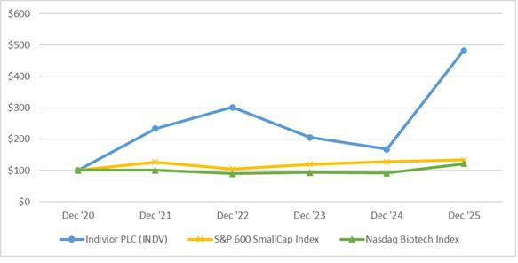

 |  |  |  | Cumulative Total Stockholder Return
As of/Through Dec. 31 |  | Amount Invested |  |  |  |  | Cumulative Total Return
As of/Through Dec. 31 |  | 2020 |  |  | 2021 |  | 2022 |  | 2023 |  | 2024 |  | 2025
Indivior | $ | 100.00 |  | $ | 233.85 | $ | 301.40 | $ | 205.42 | $ | 167.21 | $ | 483.00
S&P 600 SmallCap Index | $ | 100.00 |  | $ | 126.77 | $ | 105.22 | $ | 119.71 | $ | 127.93 | $ | 133.00
Nasdaq Biotech Index | $ | 100.00 |  | $ | 100.48 | $ | 89.63 | $ | 92.95 | $ | 91.74 | $ | 121.00

Recent Sales of Unregistered Securities

None.

Purchases of Equity Securities by the Issuer and Affiliated Purchases

 | Total Number of shares | Average price | Total number of shares purchased as | Maximum number of shares that
Period | Total Number of shares | Average price | part of publicly announced plans or | may yet be purchased under the
Period | purchased | paid per share | part of publicly announced plans or | may yet be purchased under the
 | purchased | paid per share | programs | plans or programs
Oct. 1 to Oct. 31 | 0 | n/a | 0 | 0
Nov. 1 to Nov. 30 | 0 | n/a | 0 | 0
Dec. 1 to Dec. 31 | 0 | n/a | 0 | 0

Item 6. [Reserved]

Not applicable.

81

Item 7. Management’s Discussion and Analysis of Financial Condition and Results of Operations.

Management’s discussion and analysis of financial condition and results of operations is provided as a supplement to and should be read in conjunction with the consolidated financial statements and related notes in Item 8. Financial Statements—Audited Consolidated Financial Statements to enhance the understanding of our results of operations, financial condition and cash flows.

Discussion of 2023 results and year-to-year comparisons between 2024 and 2023 that are not included in this Form 10-K can be found in Part II, Item 7. “Management’s Discussion and Analysis of Financial Condition and Results of Operations” in the Company’s Annual Report on Form 10-K for the year ended December 31, 2024.

Overview

As the leader in long-acting injectable treatments for opioid use disorder (OUD), Indivior is singularly focused on delivering evidence-based treatment and advancing understanding of OUD as a chronic but treatable brain disease. For more than 25 years, we have revolutionized the science of addiction medicine — developing treatments that help people move toward long-term recovery with independence and dignity. Building on this heritage, we are ushering in a new era, renewing our commitment to individuals living with OUD and carrying forward what matters most: compassion, integrity, and science. Together – with science, people living with OUD, public health champions, and communities, we are powering recovery and renewing hope.

References below to “2025,” “2024,” and “2023” are for the financial years ended December 31, 2025, 2024, and 2023, respectively.

Operating Results

The following table summarizes our key measures of financial condition and results of operations for the periods under review:

(in millions, except per share data) |  | Twelve Months Ended December 31,
(in millions, except per share data) |  | 2025 |  | 2024 | % Change
Net revenue | $ | 1,239 | $ | 1,188 | 4 %
Operating income |  | 262 |  | 38 | 594 %
Net income |  | 210 |  | 7 | NM
Earnings per share—diluted | $ | 1.64 | $ | 0.05 | NM

The Company operates as one business segment, which is predominantly the development, manufacture and sale of buprenorphine-based prescription drugs for the treatment of opioid dependence and related disorders. Substantially all our net revenue for 2025 and 2024 was derived from sales of SUBLOCADE and other buprenorphine-based sublingual products (including SUBOXONE Film and SUBOXONE Tablet). SUBLOCADE accounted for 69% and 64% of our net revenue in 2025 and 2024, respectively. Other buprenorphine-based sublingual products accounted for 28% and 32% of our net revenue in 2025 and 2024, respectively.

Key factors affecting operating results

Market growth

Our net revenue is affected by patient awareness, patient willingness to seek treatment, and the number of eligible healthcare providers available to administer treatment. Competitive dynamics may exert pricing pressure and may also affect decisions by third‑party payors regarding formulary placement and reimbursement coverage. To support increased patient access, we engage with governmental agencies, key opinion leaders in addiction medicine, and healthcare professionals to inform policy development and highlight patient outcomes.

82

In 2025, U.S. buprenorphine medication‑assisted treatment (BMAT) volume continued to grow at a mid‑single‑digit rate. The Company continues to expect long‑term U.S. BMAT market growth to remain within the mid‑single‑digit percentage range, reflecting public awareness of the opioid epidemic and approved treatments, as well as regulatory and legislative actions intended to expand access to BMAT therapies. The U.S. long‑acting injectable (LAI) segment grew in the high‑teens percentage range during the period. SUBLOCADE remains the primary long‑acting injectable treatment utilized for opioid use disorder. The Company’s share of the LAI segment has stabilized in the mid‑seventy percent range. The Company expects to continue investing at sustained levels to support further LAI penetration by increasing patient awareness and advancing policies designed to improve patient access to treatment.

Distribution channels

In the U.S., we have distribution agreements with the three largest wholesalers, which accounted for 51% and 55% of our global net revenue in 2025 and 2024, respectively. These wholesalers, in turn, distribute our products through various channels including the following:

- Commercial managed care. This category comprises insurance programs intended to reduce the cost of providing health benefits and improve the quality of care to their members. One of the most common forms of managed care is the use of a panel or network of healthcare providers that provide care to enrollees. Also within commercial managed care is the Medicare Part D Program, a program regulated and funded by the U.S. government generally for senior citizens and administered by private insurance companies.

- Medicaid. Medicaid is a jointly funded, Federal-State health insurance program that covers children, the aged, blind, and/or disabled and other people who are eligible to receive federally assisted income maintenance payments, including prescription drugs. We are obligated to offer “Best Price” under Medicaid, being the lowest price at which the manufacturer sells a drug to any purchaser in any pricing structure (inclusive of discounts and rebates).

- Federal. This channel encompasses the provision of outpatient drugs to federal government purchasers, including the U.S. Department of Veterans Affairs and the Department of Defense, or under the 340B Program. Pricing discounts are provided separately for drugs provided under these programs.

- Pharmacy. This channel covers end-customers paying cash directly at the pharmacy. Often, we provide discount coupons to customers who buy our products without pharmaceutical benefit coverage.

In the Rest of World, distribution channels differ by country and we may engage with different wholesalers, pre-wholesalers, hospitals, pharmacies and individuals.

Pricing

We offer various types of price reductions for our products, particularly in the U.S., which are reflected in net revenue. In the U.S., we primarily offer:

- Medicaid, Medicare Part D, and Commercial rebates. These are rebates granted to Medicaid, U.S. federal agencies and commercial managed care providers that purchase products from us. The level of these rebates varies by channel and product. Patients covered by commercial insurance often benefit from coupons to reduce out-of-pocket payments they would otherwise be required to make.

- Fees under distribution agreements. Wholesalers, specialty pharmacies and specialty distributors of the Company’s products are generally offered various forms of consideration, including allowances/discounts, service fees and prompt payment discounts, for distributing the products. Wholesaler and specialty distributor allowances and service fees arise from contractual agreements and are estimated as a percentage of the price at which the Company sells product to

83

them. In addition, customers are offered a prompt pay discount for payment within a specified contractual period.

- Chargebacks. Discounts are provided when contracted indirect customers purchase directly from wholesalers and specialty distributors. Contracted customers generally purchase a product at its contracted price. The wholesaler or specialty distributor, in turn, then generally charges back to the Company the difference between the wholesale acquisition cost and the contracted price paid to the wholesaler or specialty distributor by the customer.

- Returns. Returns are generally made if the product is damaged, defective, or otherwise cannot be used by the customer. In the U.S., the Company typically permits returns six months prior to and up to twelve months after the product expiration date. Outside the U.S., returns are only allowed in certain countries on a limited basis.

In Europe, changes to government policy or practices could adversely affect the level of reimbursement through government programs. In the U.S., proposals by legislators at both federal and state levels, regulators, and third-party payors continue to emerge with the aim of keeping healthcare costs down while expanding healthcare benefits. Similarly, in Europe, legislators, policymakers and healthcare insurance funds continue to propose and implement cost-containing measures to keep healthcare costs down, due in part to the attention being paid to healthcare cost containment and other austerity measures in Europe. Certain of these changes could impose limitations on the prices that the Company will be able to charge for its products and any approved product candidates. Further, an increasing number of EU member states and other foreign countries use prices for products established in other countries as “reference prices” to help determine the price of the product in their own territory. Consequently, a downward trend in prices of products in some countries could contribute to similar downward trends elsewhere.

Legal proceedings

The Company is involved in various lawsuits, claims, and other legal proceedings that arise in the ordinary course of business. These proceedings may involve compliance and trade practices, antitrust, commercial claims, product liability claims, intellectual property rights and securities, among others.

For further information regarding accrued litigation settlement expenses and other legal proceedings, refer to Item 8. Financial Statements—Audited Consolidated Financial Statements— Note 2: Summary of Significant Accounting Policies, Note 11. Accrued Litigation Settlement Expenses and Note 16. Commitments and Contingencies.

Results of operations

Corporate Initiatives

In July 2025, the Company introduced the Indivior Action Agenda, a three-phased, multi-year operational roadmap intended to maximize the potential of the business and make a positive difference in the lives of people living with OUD while creating value for our shareholders.

In August, 2025, the Company undertook major initiatives as part of Phase I of the Indivior Action Agenda — Generate Momentum — to simplify the organization and establish Indivior's "go forward" operating model.

In October 2025, the Company continued to execute key strategies against the Action Agenda, announcing optimization of the Rest of World business with plans to exit several non-U.S. markets, including the U.K., Ireland, Sweden, Israel, Finland and Italy. The Company will continue to own and operate its Fine Chemicals Plant in Hull, U.K. and will also continue to sell product and maintain operations

84

in Canada, Australia and France, and sell product in Germany. Collectively, these countries represent 76% of 2025 Rest of World net revenue for the year.

During the third quarter of 2025, the Company made the strategic decision to discontinue the sales and marketing support for OPVEE, its opioid overdose reversal product. The Company will continue to distribute OPVEE upon request and meet all required contractual and regulatory obligations.

In relation to these initiatives, the Company recognized $127 million in 2025 primarily relating to headcount reductions, real estate consolidations, asset impairments, consulting services, and contractual termination and related costs. As a result, the Company's total operating expenses are expected to decrease substantially in 2026 compared to 2025.

Comparison of the years ended December 31, 2025 and December 31, 2024:
 |  | Twelve Months Ended December 31,
(in millions) |  | 2025 |  |  | 2024 |  |  | % Change
Net revenue | $ | 1,239 |  | $ | 1,188 |  |  | 4 %
Cost of sales |  | 246 |  |  | 231 |  |  | 7 %
Gross profit |  | 994 |  |  | 957 |  |  | 4 %
Gross margin |  | 80 % |  |  | 81 % |  |  | — %
Selling, general and administrative |  | 634 |  |  | 612 |  |  | 4 %
Research and development |  | 97 |  |  | 107 |  |  | (9)%
Acquired in-process research and development |  | — |  |  | 1 |  |  | (100)%
Litigation settlement¹ |  | 3 |  |  | 195 |  |  | NM
Other operating (income) expense, net |  | (3) |  |  | 4 |  |  | (174)%
Operating income |  | 262 |  |  | 38 |  |  | 594 %
Net interest expense |  | 23 |  |  | 18 |  |  | 27 %
Income before income taxes |  | 239 |  |  | 20 |  |  | NM
Income tax expense |  | 29 |  |  | 13 |  |  | 126 %
Net income | $ | 210 |  | $ | 7 |  |  | NM

________________

- See Item 8. Financial Statements—Audited Consolidated Financial Statements—Note 11. Accrued Litigation Settlement Expenses.

Net revenue

Our 2025 and 2024 net revenue was driven by sales of SUBLOCADE. In 2025 and 2024, SUBLOCADE accounted for 69% and 64% of our net revenue, other buprenorphine-based sublingual products accounted for 28% and 32%, and PERSERIS accounted for 2% and 3%, respectively.

The following table shows the Company’s net revenue by major product line:
 |  | Twelve Months Ended December 31,
(in millions) |  | 2025 |  |  | 2024 |  |  | % Change
SUBLOCADE | $ | 856 |  | $ | 756 |  |  | 13 %
Sublingual & other |  | 351 |  |  | 377 |  |  | (7)%
OPVEE |  | 8 |  |  | 15 |  |  | (49)%
PERSERIS |  | 24 |  |  | 40 |  |  | (39)%
Total net revenue | $ | 1,239 |  | $ | 1,188 |  |  | 4 %

Total net revenue increased by $51 million, or 4%, to $1,239 million in 2025 from $1,188 million in 2024. The increase was primarily driven by year-over-year SUBLOCADE volume growth which offset expected

85

net revenue declines in Sublingual, and PERSERIS. Except for the impact of gross-to-net adjustments discussed below, pricing was not material to net revenue growth.

The following table presents net revenue between the U.S. and Rest of World.

 |  | Twelve Months Ended December 31,
(in millions) |  | 2025 |  |  | 2024 |  |  | % Change
United States | $ | 1,053 |  | $ | 1,008 |  |  | 4 %
Rest of World |  | 186 |  |  | 179 |  |  | 4 %
Total net revenue | $ | 1,239 |  | $ | 1,188 |  |  | 4 %

U.S. net revenue

The U.S. is our largest market. Rebates, discounts and returns and other offsets to gross revenues are reflected in net revenue. In 2025, U.S. net revenue increased by 4% to $1,053 million as compared to $1,008 million in 2024, primarily driven by U.S. SUBLOCADE, which increased by $91 million, or 13%, to $794 million in 2025 compared to $704 million in 2024. Of the 13% increase in U.S. SUBLOCADE revenues, 7% was driven by dispense unit volume growth and 6% was driven primarily by gross-to-net adjustments. U.S. net revenue from other products declined $46 million in 2025, primarily reflecting the impact of increased competitive activity resulting in lower category share in the U.S. for SUBOXONE Film, partially offset by favorable gross-to-net adjustments in 2025. SUBOXONE Film had an oral buprenorphine medically assisted treatment (BMAT) average share of 14% and 16% in 2025 and 2024, respectively, according to data from IQVIA. Lower OPVEE volumes in 2025 and the decline in PERSERIS net revenue following the decision to discontinue commercial sales support in July 2024 also partially offset the increase in net revenue. During the third quarter of 2025, the Company made a strategic decision to discontinue sales and marketing support for OPVEE. The Company will, however, continue to distribute OPVEE upon request and meet all required contractual and regulatory obligations.

Rest of World net revenue

In 2025, net revenue attributable to Rest of World increased 4% from 2024 to $186 million. In 2025, positive contributions from newer products (SUBLOCADE and SUBOXONE Film) were partially offset by the ongoing generic erosion of the legacy tablet business. In 2025 and 2024, SUBLOCADE net revenue in Rest of World was $ 61 million and $52 million, respectively. Rest of World net revenue in 2026 will be impacted by our plans to exit several non-U.S. markets. The countries in which we will continue operations or product distribution represent 76% of 2025 Rest of World net revenue.

We expect continued LAI category growth and stable category share to result in U.S. SUBLOCADE net revenue growth in 2026. However, competitive pressures are expected to continue to adversely impact both SUBOXONE Film pricing and volume, resulting in an expected decline in SUBOXONE Film net revenue in 2026. Rest of World net revenue is expected to decline as a result of the exit from certain non-U.S. markets, as described above. We expect negligible revenues from PERSERIS and OPVEE in 2026, as the Company is no longer actively marketing these products. As a result of these factors, the Company's total net revenue in 2026 is expected to decline compared to 2025.

We estimate provisions for rebates, discounts and returns based on contractual arrangements with customers or terms of the regulations and/or agreements applicable for transactions with healthcare authorities, and in some cases on assumptions about the attainment of targeted volumes. We recognize returns, discounts, incentives and rebates in the period in which we recognize the underlying sales, as a reduction of gross revenues and as current liabilities on our Consolidated Balance Sheets as accrued rebates and product returns or reductions of accounts receivable. The outstanding amounts are affected by the provision for net product sales deductions which management reassesses based on historical data and estimated future activities and the timing of payments/credits. Estimates, assumptions and judgements applied to determine the provision for rebates, discounts and returns are set out in Item 8. Financial Statements—Audited Consolidated Financial Statements—Note 2. Summary of Significant Accounting Policies.

86

The following table provides a summary of activities with respect to accrued rebates and product returns and prompt pay discounts for the years ended December 31, 2025 and 2024:

(in millions) |  | 2025 |  |  | 2024
Opening balance at beginning of period | $ | 565 |  | $ | 535
Provision related to sales made in:
Current period |  | 1,526 |  |  | 1,494
Prior period |  | (87) |  |  | (28)
Payments and credits |  | (1,420) |  |  | (1,436)
Closing balance at end of period | $ | 585 |  | $ | 565

Accrued rebates and product returns includes chargebacks as these are paid by Indivior. Prompt pay discounts are recorded as offsets to accounts receivable as of December 31, 2025. Accrued rebates and product returns and prompt pay discounts increased to $585 million as of December 31, 2025, from $565 million as of December 31, 2024, primarily due to increased SUBLOCADE volume growth.

Cost of sales

Cost of sales increased by $15 million, or 7%, to $246 million in 2025 from $231 million in 2024. The increase reflects higher sales volumes as well as $39 million of expenses related to the discontinuation of sales and marketing of OPVEE, $10 million of SUBLOCADE inventory write-downs for finished goods expected to approach expiration prior to sale, $9 million of inventory write-downs and other costs related to the exit from certain non-U.S. markets, and $5 million for the manufacturing transition of the Company's aseptic facility. Cost of sales in 2024 includes $41 million of expenses related to the discontinuation of marketing and promotion of PERSERIS.

Gross margin

Gross margin, defined as gross profit divided by net revenue, was 80% in 2025 as compared to 81% in 2024. The decrease in 2025 gross margin included the impact of the 2025 and 2024 cost of sales factors described above, partially offset by improved product mix reflecting SUBLOCADE volume growth and the benefit of changes in estimates related to rebate accruals.

Selling, general and administrative expenses

Selling, general and administrative expenses increased by $ 22 million, or 4%, to $634 million in 2025 from $ 612 million in 2024. In 2025, selling, general and administrative costs include $61 million associated with corporate initiatives, due to headcount reductions and external legal and consulting support primarily related to Phase I of the Indivior Action Agenda announced in August 2025. The 2025 increase also reflected $62 million higher investments in U.S. SUBLOCADE marketing, including the launch of a new direct to consumer campaign for SUBLOCADE in October 2025. Selling, general and administrative expenses in 2025 also benefited from streamlining actions taken in 2024, including narrowing the Company's commercial focus on OUD treatments and discontinuing marketing and promotion of PERSERIS. Prospectively, savings resulting from restructuring actions and discontinuation of sales and marketing of OPVEE will be used to support long-term SUBLOCADE growth.

Research and development expenses

Research and development expenses decreased by $ 10 million, or 9%, to $97 million in 2025 from $107 million in 2024. The decrease is primarily due to the Company's actions to refocus its development pipeline on the Phase 2 OUD assets (INDV-2000 and INDV-6001) and the absence of a $4 million contract termination fee incurred in 2024. These reductions were partly offset by $17 million in restructuring and impairment charges recorded in 2025 related to Phase I of the Indivior Action Agenda announced in August 2025. We expect 2026 research and development expenses to be substantially lower than historic levels.

87

Acquired in-process research and development expenses

The Company incurred no acquired in-process research and development expenses in 2025, compared to $1 million in 2024.

Litigation settlement expenses

Litigation settlement expenses decreased by $192 million, to $3 million in 2025 from $195 million in 2024. The decrease is primarily due to variability in, and unpredictability of, the timing of settlements of major contingencies. See Item 8. Financial Statements—Audited Consolidated Financial Statements - Note 11. Accrued Litigation Settlement Expenses.

Other operating (income) expense, net

In 2025, the Company recorded net other operating income of $3 million, compared to net other operating expense of $4 million in 2024. Other operating income in 2025 reflects $1 million of realized losses on the sale of equity investments, while other operating expense in 2024 reflected $9 million of mark-to-market losses related to the decline in value of those equity investments.

Net interest expense

Net interest expense was $23 million in 2025 as compared to $18 million in 2024. Higher net interest expense in 2025 reflects interest expense on the larger amount borrowed under the Company's new borrowing arrangement secured in late 2024. Net interest expense in 2025 includes $4 million related to an expected U.K. tax settlement, and net interest expense in 2024 reflects a $4 million write-off of unamortized deferred financing costs due to early extinguishment of the previous term loan. We expect interest expense on our borrowings to continue to exceed investment income.

Income tax expense

Income tax expense in 2025 was $29 million, resulting in an effective tax rate of 12%, on the Company's earnings for 2025, driven primarily by tax incentive innovation benefits of which $45 million is related to a one-time royalty payment, offset by an HMRC tax settlement and changes in valuation allowances. Income tax expense of $13 million in 2024 reflected an effective tax rate of 65% on the Company’s earnings for 2024, driven primarily by changes in valuation allowances, offset by a net finance structure benefit.

Liquidity and Capital Resources
Overview
The Company's financial condition is summarized as follows:
(In millions) |  | December 31, 2025 |  |  | December 31, 2024
Financial assets:
Cash and cash equivalents |  | 195 |  | $ | 319
$ |  | 195 |  | $ | 319
Investments - short-term |  | — |  |  | 1
Investments - long-term |  | 28 |  |  | 27
Total cash and investments |  | 222 |  | $ | 347
$ |  | 222 |  | $ | 347
Borrowings:
Short-term borrowings |  | 29 |  | $ | 18
$ |  | 29 |  | $ | 18
Long-term borrowings |  | 290 |  | $ | 315
$ |  | 290 |  | $ | 315

88

Cash flows

Twelve Months Ended December 31,

(in millions) |  | 2025 |  | 2024
Net cash provided by (used in):
Operating activities | $ | (27) | $ | 36
Investing activities |  | (66) |  | 69
Financing activities | $ | (30) | $ | (102)

Operating activities

Net cash used in operating activities was $ 27 million in 2025, a decrease of $63 million, compared to net cash provided by operating activities of $36 million in 2024. The decrease was driven by $208 million higher litigation settlement payments in 2025, including the optional prepayment of the Company's remaining liability with the U.S. Department of Justice (DOJ), partly offset by higher cash generated from operations in 2025. Refer to Item 8. Financial Statements—Audited Consolidated Financial Statements—Note 10. Accrued Litigation Expenses for additional details on litigation-related settlement payments.

Investing activities

Net cash used in investing activities was $66 million in 2025, a decrease of $ 135 million, compared to net cash provided by investing activities of $69 million in 2024. The decrease primarily reflects lower proceeds from maturities of investments, partly offset by an increase in capital expenditures in 2025 related to the Raleigh Manufacturing Facility SUBLOCADE suite.

We expect $30 million to $40 million of capital expenditures in 2026, primarily related to our Manufacturing Facility in Raleigh, NC.

Financing activities

Net cash used in financing activities decreased by $ 72 million, from $102 million in 2024 to $30 million in 2025. Net cash used in financing activities in the current period primarily reflects lower cash outflows for shares repurchases and the settlement of tax on equity awards in 2025 compared to 2024. These lower financing cash outflows are partially offset by higher scheduled repayments under the Company's Note Purchase Agreement (see Debt below). In 2025 and 2026, the annual scheduled repayments are 5% of the original gross loan balance.

Current Liabilities

Our current liabilities exceed our current assets by over $ 250 million and total liabilities exceed our total assets by approximately $100 million. The Company sustains negative working capital because of the timing of rebate payments relative to the collection of accounts receivable. See Item 1A Risk Factors, "Our balance sheet is leveraged, and any reduction in annual sales may adversely affect our liquidity.".

Debt

As of December 31, 2025, the Company is subject to a Note Purchase Agreement term loan with an outstanding balance of $ 333 million. The Note Purchase Agreement matures in November 2030 and includes a committed, revolving credit facility of $50 million of which $50 million is available to be drawn. The Note Purchase Agreement contains financial and non-financial covenants customary for facilities of this nature, including a maximum leverage ratio, a minimum interest coverage ratio, a limitation on disposal of assets, prepayments and redemptions of certain indebtedness, further indebtedness, liens, negative pledges, and limits on share buybacks and redemptions, dividends and other “restricted payments,” subsidiary distributions, investments, mergers and acquisitions and other fundamental changes, sale and lease-back transactions, and a restriction on changes to any material line of business, most of which are subject to various carve-outs, grace periods and qualifications. The Company was in compliance with all covenants as of December 31, 2025. See Item 1A. Risk Factors at "Our term loan contains certain

89

covenants that could limit our ability to plan for or respond to changes in our business." and Item 8. Financial Statements—Audited Consolidated Financial Statements - Note 12. Debt for additional information. In addition, substantially all of the assets of the Company are pledged to secure this debt, and the restrictions under the Note Purchase Agreement substantially limit our ability to obtain other financing, other than the $50 million revolving credit facility.

Capital Resources

The Company believes its existing cash and cash equivalents and investments, together with cash generated from operations, will meet its anticipated cash needs, including working capital, capital expenditures, litigation settlement payments, milestone payments, income taxes, repurchase of common stock, debt repayments and other funding requirements, for at least the twelve-month period following the issuance of this Form 10-K. The Company relies on cash generated from operation to meet our obligations. The Company is also subject to contingent liabilities as described in Item 8. Financial Statements—Audited Consolidated Financial Statements - Note 16. Commitments and Contingencies.

Capital Expenditures

Capital expenditures of $66 million in 2025 and $29 million on in 2024 primarily reflect investments in the expansion of the Raleigh Manufacturing Facility. The Company funded these expenditures from its existing cash balances.

Contractual Obligations

The table below sets forth the Company’s anticipated contractual cash flows on an undiscounted basis as of December 31, 2025.

 |  |  |  |  | December 31, 2025
 |  | Total |  |  | 1 year or less |  |  | 2-5 years |  |  | More than
(in millions) |  |  |  |  |  |  |  |  |  |  | 5 years
Debt¹ | $ | 459 |  | $ | 59 |  | $ | 399 |  | $ | —
Litigation settlement liabilities² |  | 8 |  |  | 8 |  |  | — |  |  | —
Commercial commitments |  | 68 |  |  | 47 |  |  | 22 |  |  | —
Capital expenditures |  | 18 |  |  | 18 |  |  | — |  |  | —
Lease liabilities |  | 37 |  |  | 12 |  |  | 21 |  |  | 5
Employee-related liabilities |  | 39 |  |  | 27 |  |  | — |  |  | 12
Total | $ | 629 |  | $ | 170 |  | $ | 442 |  | $ | 17

- Cash outflows related to debt include payment of the outstanding balance of the note purchase agreement of $333 million as well as estimated interest payments

- Cash outflows related to Civil Opioid litigation of approximately $86 million, expected to be paid over the next four years, are excluded from the table as they were not contractual obligations as of December 31, 2025. See Item 8. Financial Statements—Audited Consolidated Financial Statements, Note 16. Commitments and Contingencies.

Potential milestone and royalty payments

The Company is party to collaboration and license arrangements for the development of pharmaceutical products. Milestone payments will be due if various developmental, regulatory and commercial goals are achieved and in certain cases royalties will be payable as a percentage of net revenue, although the Company generally has the right to terminate these agreements at no cost. No material milestone payments are expected in 2026.

Agreements for contract manufacturing and supply of materials

The Company is obligated to purchase specified amounts of goods or services under various contract manufacturing and material supply agreements over periods ranging from 1 to 4 years. These agreements

90

could require us to pay approximately $68 million in total over the next 4 years (before annual price index adjustments).

Research and Development Expenses, Patents and Licenses, etc.

See “Item 1. Business—Research and Development,” “Item 1. Business—Intellectual Property,” and “Item 7. Management’s Discussion and Analysis of Financial Condition and Results of Operations—Operating Results.”

Trend Information

For a discussion of trend information, see “Item 7. Management’s Discussion and Analysis of Financial Condition and Results of Operations—Operating Results.”

Critical Accounting Estimates

Management makes several estimates and assumptions regarding the future and significant judgments in applying the Company’s accounting policies. Estimates and assumptions may affect the reported amount of assets and liabilities, disclosure of contingent assets and liabilities, and the reported amounts of revenues and expenses. These estimates are based on the Company’s knowledge of the amount, events or actions; however, actual results may ultimately differ from those estimates. Estimates and underlying assumptions are reviewed on an ongoing basis and revisions to estimates are recognized prospectively. The key estimates and assumptions used in the financial statements are set out below.

Returns, incentives and rebates

The Company offers various types of reductions from list prices on its products. Products sold in the U.S. are covered by various programs (such as Medicare and Medicaid) under which products are provided at a discount. Rebates are granted to healthcare authorities, and under contractual arrangements with certain customers. Some wholesalers are entitled to chargeback incentives under specific contractual arrangements. Cash discounts may also be granted for prompt payment.

The discounts, incentives and rebates described above are estimated based on contractual arrangements with customers or terms of the relevant regulations and/or agreements applicable for transactions with healthcare authorities. Several months may pass between the original estimate of rebates due and confirmation of the amount, which may increase the estimation risk. Please refer to the revenue accounting policy for further details.

Accruals for product returns are estimated based primarily on analysis of the Company’s historical product return patterns, supplemented by expected future returns and contractual agreement terms. Estimated returns are accrued in the period the related revenue is recognized.

During 2025 and 2024, net revenue was increased by $87 million and $28 million, respectively, from performance obligations satisfied in prior years, primarily relating to changes in payor mix, actual invoices received and payments made, and resolution of aged accruals for U.S. government and commercial programs. The estimates for U.S. governmental and commercial end-payor accruals are also reasonably expected to vary due to shifts between U.S. governmental end-payor sales and U.S. commercial end-payor sales. A one percentage point shift between these channels would impact the accrual by $4 million. Due to the number of variables contributing to the accruals for returns, incentives and rebates, further meaningful sensitivity is not able to be provided. Accruals for returns, incentives and rebates are disclosed in Item 8. Financial Statements—Audited Consolidated Financial Statements—Balance Sheet.

Provision for income taxes

Significant judgment is required in determining our provision for income taxes. These judgments and estimates occur in the calculation of tax credits, benefits, and deductions and in the calculation of certain tax assets and liabilities, which arise from differences in the timing of recognition of revenue and expense for tax and financial statement purposes, as well as the interest and penalties related to uncertain tax

91

positions. Changes to these estimates may result in a material increase or decrease in our tax provision in the current period or subsequent periods. Recoverability of deferred tax assets

We assess the likelihood of recoverability our deferred tax assets. If all or part of our deferred tax assets are not recoverable in the future, we increase our provision for taxes and reduce our net deferred tax assets to the amount that is more likely than not to be recoverable. To recover deferred tax assets, we must generate sufficient taxable income in the jurisdictions where the deferred tax assets are located. We consider forecasted income, including income that may be generated as a result of certain tax planning strategies, together with future reversals of existing taxable temporary differences, in determining the need for a valuation allowance. As of December 31, 2025, we believe our deferred tax assets are more likely than not to be recovered, with the exception of valuation allowance items as detailed in Item 8. Financial Statements—Audited Consolidated Financial Statements - Note 4. Income Tax. The realization of our deferred tax assets depends on the generation of sufficient taxable income in future periods. If actual results differ from our estimates or if our assumptions regarding future taxable income change, we may conclude that some or all of our deferred tax assets are no longer 'more likely than not' to be realized. In that event, we would be required to record an increase to our valuation allowance, which could materially affect our income tax provision and results of operations in the period such determination is made.

Litigation

Litigation, arbitration and other legal proceedings against the Company may relate to compliance and trade practices, commercial claims, product liability claims, intellectual property rights, and employment and wrongful discharge claims. For each claim or grouping of similar claims, management makes judgments regarding the relative merits and risks within the claims. These judgments inform the Company’s defense strategies, whether a loss or settlement from the claims is probable and whether sufficient information exists to make a reliable estimate of the likely outcome of the claims. Provisions are recognized when it is probable that a liability will be incurred, and the amount of the loss can be reasonably estimated. Management has assessed as “contingent” matters that cannot be reliably estimated or are not considered probable at the current time. For more details of all the outstanding legal proceedings including those that have been deemed contingent, see Item 8. Financial Statements—Audited Consolidated Financial Statements - Note 16. Commitments and Contingencies.

Item 7A. Quantitative and Qualitative Disclosures About Market Risk.

a. Quantitative Information about Market Risk

See Item 7. Management’s Discussion and Analysis of Financial Condition and Results of Operations—Liquidity and Capital Resources. In addition to the risks inherent in our operations, we are exposed to a variety of financial risks, such as market risk (including foreign currency exchange, cash flow and interest rate risk), credit risk and liquidity risk.

b. Qualitative Information about Market Risk

We invest cash equivalents and investments with the primary objective to preserve principal while also maximizing the income that we receive. We invest in highly-rated corporate bonds, commercial paper, and U.S. Treasuries for purposes other than trading which are reported at fair value or amortized cost, which approximates fair value for the nature and duration of instruments we use. These securities are subject to interest rate risk and credit risk. See Item 8. Financial Statements—Audited Consolidated Financial Statements - Note 13. Financial Instruments and Fair Value Measurements.

Interest on our Note Purchase Agreement is subject to fluctuation based on SOFR, which may impact future expense and cash flows. See Item 8. Financial Statements—Audited Consolidated Financial Statements - Note 12. Debt.

92

We operate in different territories around the world. Generally, the functional currency of our operations is that of the country in which it operates. One USD functional currency subsidiary has significant exposure to assets in Canadian Dollars and liabilities in British Pounds Sterling. The Canadian Dollar assets turn quickly and our strategy is to mitigate exposure to British Pounds with offsetting assets. However, we could be exposed to material foreign currency risk in these currencies.

93

Item 8. Financial Statements and Supplementary Data.

94

Indivior PLC

Consolidated Statements of Operations

(In millions, except per share data)

 |  | Twelve Months Ended December 31,
 | 2025 |  |  |  | 2024 |  |  | 2023
Net revenue | $ | 1,239 |  | $ | 1,188 |  | $ | 1,093
Cost of sales |  | 246 |  |  | 231 |  |  | 174
Gross profit |  | 994 |  |  | 957 |  |  | 919
Operating expenses:
Selling, general and administrative |  | 634 |  |  | 612 |  |  | 565
Research and development |  | 97 |  |  | 107 |  |  | 116
Acquired in-process research and development |  | — |  |  | 1 |  |  | 162
Litigation settlement |  | 3 |  |  | 195 |  |  | 239
Other operating (income) expense, net |  | (3) |  |  | 4 |  |  | (9)
Operating income (loss) |  | 262 |  |  | 38 |  |  | (152)
Other (income) and expenses:
Interest income |  | (22) |  |  | (23) |  |  | (43)
Interest expense |  | 45 |  |  | 41 |  |  | 35
Income (loss) before income taxes |  | 239 |  |  | 20 |  |  | (145)
Income tax expense (benefit) |  | 29 |  |  | 13 |  |  | (19)
Net income (loss) | $ | 210 |  | $ | 7 |  | $ | (126)
Earnings (loss) per share
Basic | $ | 1.68 |  | $ | 0.05 |  | $ | (0.92)
Diluted | $ | 1.64 |  | $ | 0.05 |  | $ | (0.92)
Shares used in computing earnings (loss) per share
Basic |  | 125 |  |  | 132 |  |  | 137
Diluted |  | 128 |  |  | 133 |  |  | 137

See accompanying notes to consolidated financial statements.

95

Indivior PLC

Consolidated Statements of Comprehensive Income (Loss)

(In millions)

 | Twelve Months Ended December 31,
 | 2025 |  |  | 2024 |  |  | 2023
Net income (loss) | $ | 210 |  | $ | 7 |  | $ | (126)
Other comprehensive income, net of tax
Foreign currency translation |  | 6 |  |  | (6) |  |  | 2
Other comprehensive income (loss) |  | 6 |  |  | (6) |  |  | 2
Total comprehensive income (loss) | $ | 216 |  | $ | 1 |  | $ | (124)

See accompanying notes to consolidated financial statements.

96

Indivior PLC

Consolidated Balance Sheets

(In millions, except per share data)

 |  | December 31, 2025 |  |  | December 31, 2024
Assets
Current assets
Cash and cash equivalents | $ | 195 |  | $ | 319
Short-term investments |  | — |  |  | 1
Accounts receivable, net of allowances of $4 (2025) and $3 (2024) |  | 253 |  |  | 254
Inventories |  | 153 |  |  | 167
Prepaid expenses |  | 34 |  |  | 31
Current tax receivable |  | 2 |  |  | 33
Other current assets |  | 16 |  |  | 21
Total current assets |  | 652 |  |  | 827
Long-term investments |  | 28 |  |  | 27
Property, plant and equipment, net |  | 144 |  |  | 100
Operating lease right of use assets, net |  | 26 |  |  | 39
Goodwill and other intangible assets, net |  | 2 |  |  | 6
Deferred tax assets |  | 323 |  |  | 277
Other noncurrent assets |  | 27 |  |  | 39
Total assets | $ | 1,201 |  | $ | 1,316
Liabilities and stockholders' deficit
Current liabilities
Accrued rebates and product returns | $ | 582 |  | $ | 562
Accounts payable and accrued expenses |  | 250 |  |  | 216
Accrued litigation settlement expenses, current |  | 42 |  |  | 99
Current portion of long-term debt |  | 29 |  |  | 18
Operating lease liabilities, current |  | 10 |  |  | 10
Income taxes payable |  | 2 |  |  | 7
Other current liabilities |  | — |  |  | 11
Total current liabilities |  | 914 |  |  | 924
Long-term debt, less current portion |  | 290 |  |  | 315
Accrued litigation settlement expenses, noncurrent |  | 52 |  |  | 365
Operating lease liabilities, noncurrent |  | 22 |  |  | 32
Other noncurrent liabilities |  | 21 |  |  | 18
Total liabilities | $ | 1,300 |  | $ | 1,652
Commitments and contingencies (Note 16)
Stockholders' deficit
Common stock, par value $0.50 per share |  | 62 |  |  | 62
Issued shares: 125 (2025) and 125 (2024) |  | 62 |  |  | 62
Additional paid-in capital |  | 112 |  |  | 90
Share repurchase commitment |  | — |  |  | (10)
Accumulated other comprehensive loss |  | (30) |  |  | (36)
Accumulated deficit |  | (243) |  |  | (443)
Total stockholders' deficit |  | (98) |  |  | (337)
Total liabilities and stockholders' deficit | $ | 1,201 |  | $ | 1,316

See accompanying notes to consolidated financial statements.

97

Indivior PLC

Consolidated Statements of Stockholders' Deficit

(In millions)

 | Common Stock |  |  |  |  |  |  |  |  | Share
 | Shares |  | Amount |  |  | Additional paid- |  |  |  |  |  | Accumulated other |  |  | Accumulated deficit |  |  | Total stockholders’
 |  |  | Amount |  |  |  |  |  |  | repurchase |  |  | comprehensive
 |  |  |  |  |  |  | in capital |  | commitment |  |  |  | loss |  |  |  |  |  | deficit
Balance at December 31, 2022 | 136 |  | $ | 68 |  | $ | 87 |  | $ | (9) |  | $ | (32) |  | $ | (130) |  | $ | (15)
Net loss | — |  |  | — |  |  | — |  |  | — |  |  | — |  |  | (126) |  |  | (126)
Other comprehensive income | — |  |  | — |  |  | — |  |  | — |  |  | 2 |  |  | — |  |  | 2
Common stock issued | 2 |  |  | 1 |  |  | 2 |  |  | — |  |  | — |  |  | — |  |  | 3
Common stock repurchased and canceled | (2) |  |  | (1) |  |  | — |  |  | — |  |  | — |  |  | (32) |  |  | (33)
Stock-based compensation | — |  |  | — |  |  | 21 |  |  | — |  |  | — |  |  | — |  |  | 21
Settlement of tax on equity awards | — |  |  | — |  |  | (22) |  |  | — |  |  | — |  |  | — |  |  | (22)
Share repurchase liability movement, net | — |  |  | — |  |  | — |  |  | (14) |  |  | — |  |  | — |  |  | (14)
Balance at December 31, 2023 | 137 |  | $ | 68 |  | $ | 88 |  | $ | (23) |  | $ | (30) |  | $ | (288) |  | $ | (184)
Net income | — |  |  | — |  |  | — |  |  | — |  |  | — |  |  | 7 |  |  | 7
Other comprehensive loss | — |  |  | — |  |  | — |  |  | — |  |  | (6) |  |  | — |  |  | (6)
Common stock issued | 1 |  |  | 1 |  |  | 2 |  |  | — |  |  | — |  |  | — |  |  | 3
Common stock repurchased and canceled | (13) |  |  | (7) |  |  | — |  |  | — |  |  | — |  |  | (161) |  |  | (168)
Stock-based compensation | — |  |  | — |  |  | 24 |  |  | — |  |  | — |  |  | — |  |  | 24
Settlement of tax on equity awards | — |  |  | — |  |  | (22) |  |  | — |  |  | — |  |  | — |  |  | (22)
Share repurchase liability movement, net | — |  |  | — |  |  | — |  |  | 13 |  |  | — |  |  | — |  |  | 13
Other | — |  |  | — |  |  | (2) |  |  | — |  |  | — |  |  | — |  |  | (2)
Balance at December 31, 2024 | 125 |  | $ | 62 |  | $ | 90 |  | $ | (10) |  | $ | (36) |  | $ | (443) |  | $ | (337)
Net income | — |  |  | — |  |  | — |  |  | — |  |  | — |  |  | 210 |  |  | 210
Other comprehensive income | — |  |  | — |  |  | — |  |  | — |  |  | 6 |  |  | — |  |  | 6
Common stock issued | 1 |  |  | — |  |  | 1 |  |  | — |  |  | — |  |  | — |  |  | 2
Common stock repurchased and canceled | (1) |  |  | — |  |  | — |  |  | — |  |  | — |  |  | (10) |  |  | (11)
Stock-based compensation | — |  |  | — |  |  | 26 |  |  | — |  |  | — |  |  | — |  |  | 26
Settlement of tax on equity awards | — |  |  | — |  |  | (5) |  |  | — |  |  | — |  |  | — |  |  | (5)
Share repurchase liability movement, net | — |  |  | — |  |  | — |  |  | 10 |  |  | — |  |  | — |  |  | 10
Balance at December 31, 2025 | 125 |  | $ | 62 |  | $ | 112 |  | $ | — |  | $ | (30) |  | $ | (243) |  | $ | (98)

See accompanying notes to consolidated financial statements.

98

Indivior PLC

Consolidated Statements of Cash Flows

(In millions)

 | Twelve Months Ended December 31,
 | 2025 |  |  | 2024 |  |  | 2023
Cash flows from operating activities:
Net income (loss) | $ | 210 |  | $ | 7 |  | $ | (126)
Adjustments to reconcile net income to net cash from operating activities:
Depreciation and amortization |  | 10 |  |  | 16 |  |  | 15
Amortization of right-of-use assets |  | 10 |  |  | 12 |  |  | —
Stock-based compensation expense |  | 26 |  |  | 24 |  |  | 21
Impairment of tangible and intangible assets |  | 19 |  |  | 8 |  |  | —
Unrealized loss on equity investments |  | — |  |  | 9 |  |  | —
Deferred income taxes |  | (46) |  |  | 7 |  |  | (64)
Acquired in-process research and development |  | — |  |  | 1 |  |  | 162
Impact from foreign exchange movements |  | 1 |  |  | (2) |  |  | (10)
Change in operating assets and liabilities:
Accounts receivable |  | 3 |  |  | (1) |  |  | (33)
Current inventories |  | 18 |  |  | (43) |  |  | (6)
Other current and noncurrent assets |  | 49 |  |  | 377 |  |  | (418)
Accrued legal and settlement expenses |  | (368) |  |  | (387) |  |  | 50
Other current and noncurrent liabilities |  | 41 |  |  | 8 |  |  | 110
Net cash (used in) provided by operating activities |  | (27) |  |  | 36 |  |  | (300)
Cash flows from investing activities:
Purchases of property and equipment |  | (66) |  |  | (29) |  |  | (8)
Purchases of in-process research and development and intangible assets |  | (1) |  |  | (2) |  |  | (45)
Acquisitions, net of cash acquired |  | — |  |  | — |  |  | (129)
Purchases of investments in debt securities |  | (20) |  |  | (17) |  |  | (45)
Sales of equity securities |  | 1 |  |  | — |  |  | —
Sales and maturities of debt securities |  | 19 |  |  | 117 |  |  | 129
Other proceeds from investing activities |  | — |  |  | — |  |  | 3
Net cash (used in) provided by investing activities |  | (66) |  |  | 69 |  |  | (95)
Cash flows from financing activities:
Proceeds from the issuance of common stock |  | 2 |  |  | 3 |  |  | 3
Cash paid for repurchases of common stock |  | (11) |  |  | (173) |  |  | (33)
Proceeds from debt, net |  | — |  |  | 332 |  |  | —
Repayments of debt |  | (17) |  |  | (240) |  |  | (12)
Transaction costs related to debt refinancing |  | — |  |  | (2) |  |  | —
Settlement of tax on equity awards |  | (5) |  |  | (22) |  |  | (22)
Net cash used in financing activities |  | (30) |  |  | (102) |  |  | (64)
Net (decrease) increase in cash and cash equivalents |  | (124) |  |  | 3 |  |  | (459)
Exchange differences |  | (1) |  |  | — |  |  | 1
Cash and cash equivalents at beginning of period |  | 319 |  |  | 316 |  |  | 774
Cash and cash equivalents at end of period | $ | 195 |  | $ | 319 |  | $ | 316

See accompanying notes to consolidated financial statements.

99

Indivior PLC

Notes to the Consolidated Financial Statements

(In millions)

1. Business Overview

Indivior PLC and its subsidiaries is the market leader in long-acting injectable medications for opioid use disorder (OUD). Indivior is focused on delivering evidence-based pharmacotherapies for OUD and is committed to advancing the neurobiological understanding of OUD as a chronic, relapsing, but treatable brain disease. For more than 25 years, Indivior has led innovation in addiction medicine, developing differentiated therapeutic solutions that support long-term patient recovery, expand access to care, and drive sustainable value for patients, healthcare systems and stockholders.

In December 2025, our stockholders approved a plan to change our domicile to the U.S. In January 2026, Indivior Pharmaceuticals, Inc., a corporation formed in Delaware in October 2025, became the ultimate parent company of Indivior PLC, a public company limited by shares incorporated under the laws of England and Wales (“Indivior PLC”), and its subsidiaries pursuant to a court-approved scheme of arrangement under Part 26 of the U.K. Companies Act 2006 (the “Scheme of Arrangement”) (the “U.S. Domestication”). Pursuant to the Scheme of Arrangement, each ordinary share in the capital of Indivior PLC was cancelled in exchange for one share of common stock, par value $0.001 per share, of Indivior Pharmaceuticals, Inc. After the close of market trading on January 23, 2026, the Scheme of Arrangement became effective and binding on all shareholders of Indivior PLC and Indivior PLC became a wholly-owned subsidiary of Indivior Pharmaceuticals, Inc., thereby completing the U.S. Domestication. The issuance of common stock of Indivior Pharmaceuticals, Inc. pursuant to the Scheme of Arrangement was exempt from registration under Section 3(a)(10) of the Securities Act of 1933, as amended (the “Securities Act”). Indivior Pharmaceuticals, Inc. is the successor issuer to Indivior PLC pursuant to Rule 12g-3(a) under the Exchange Act, and Indivior Pharmaceuticals, Inc.'s common stock is therefore deemed to be registered under Section 12(b) of the Exchange Act. Indivior PLC’s ordinary shares ceased trading prior to the open of trading on January 26, 2026, and Indivior Pharmaceuticals, Inc.'s common stock began trading on Nasdaq at the start of trading on January 26, 2026 under the symbol “INDV,” which is the same symbol under which Indivior PLC ordinary shares previously traded.

Because the U.S. Domestication was completed after December 31, 2025, the financial statements included herein are those of Indivior PLC. The U.S. Domestication will be accounted for as a common-control transaction in Q1 2026 and the historical financial statements of Indivior PLC will become the historical financial statements of Indivior Pharmaceuticals, Inc. The corporate reorganization will have no impact to historical revenues, expenses, assets, liabilities, or cash flows.

The principal accounting policies adopted in the preparation of these financial statements are set out below. Unless otherwise stated, these policies have been consistently applied to all years presented.

2. Summary of Significant Accounting Policies

Basis of Presentation and Principles of Consolidation

The consolidated financial statements include the accounts of all the Company’s subsidiaries and are prepared in conformity with accounting principles generally accepted in the United States (“U.S. GAAP”). All intercompany balances and transactions have been eliminated in consolidation. Columns and rows within tables may not add due to rounding. Percentages and per share data have been calculated using actual, non-rounded figures.

Fair Value Measurements

Fair value is the exchange price that would be received for an asset or paid to transfer a liability (an exit price) in the principal or most advantageous market for the asset or liability in an orderly transaction between market participants on the measurement date. See Note 13. Financial Instruments and Fair Value Measurements for additional information on the fair value hierarchy used by the Company.

100

Indivior PLC

Notes to the Consolidated Financial Statements

(In millions)

Foreign Currency Translation

The financial statements of each of the Company’s subsidiaries are measured using the currency of the primary economic environment in which the entity operates (the functional currency), which is generally the local currency with the exception of manufacturing, treasury and holding companies where the functional currency is the U.S. dollar. The Company’s presentation currency is the U.S. dollar. The financial statements of subsidiaries with functional currencies other than the U.S. dollar are translated into U.S. dollars using period-end exchange rates for assets and liabilities, historical exchange rates for stockholders' equity and weighted average exchange rates for operating results. Translation gains and losses are recognized in Consolidated Statements of Comprehensive Income (Loss).

Use of Estimates and Judgments

The preparation of Consolidated Financial Statements in conformity with U.S. GAAP requires management to make estimates and assumptions that affect the amounts reported. Significant estimates are used in determining items such as accruals for returns, incentives and rebates; provisions for income taxes; recoverability of deferred tax assets; and litigation. Actual results may differ from those estimates.

Cash and Cash Equivalents

Cash and cash equivalents comprise cash in hand, current balances with banks and similar institutions, and short-term highly liquid investments with original maturities of less than three months and are recognized at cost, which approximates fair value.

Accounts Receivable, Net

Accounts receivables are initially recognized at their invoiced amounts less any adjustments for estimated deductions such as cash discounts. Allowances for expected credit losses are established using an expected credit loss (“ECL”) model taking into account individual customer’s credit risk based on financial position, past experience, and other relevant factors.

Charges for ECL are recognized in the Consolidated Statements of Operations within selling, general and administrative expense. Allowances for ECL were approximately $4 million and $3 million at December 31, 2025, and 2024, respectively.

Concentration of Credit Risk

Financial instruments that potentially expose the Company to concentrations of credit risk are limited to cash and cash equivalents deposited with banks and other financial institutions, investment in debt securities, accounts receivable and other assets. The Company maintains its cash and cash equivalents with high-credit-quality financial institutions. Financial institution counterparties are subject to approval under the Company’s counterparty risk policy and such approval is limited to financial institutions with a BBB rating or above. Investments in debt securities are of low credit risk based on investment-grade credit ratings from Standard and Poor’s or Moody’s (BBB-/Baa3 or higher).

As of December 31, 2025, 2024 and 2023 the Company had four separate customers representing greater than 10% of the net accounts receivable balance.

 | Percent of accounts receivable |  |  |  | December 31
 |  |  | 2025 |  | 2024 |  | 2023
 | Customer A |  | 22 % |  | 25 % |  | 21 %
 | Customer B |  | 21 % |  | 18 % |  | 23 %
 | Customer C |  | 13 % |  | 17 % |  | 17 %
 | Customer D |  | 10 % |  | 10 % |  | 8 %

101

Indivior PLC

Notes to the Consolidated Financial Statements

(In millions)

Investments

The Company’s investments comprise holdings in debt securities and, in prior periods, equity securities. Investments in debt securities are initially recorded at fair value and remeasured based on the intended holding period. Investments classified as held to maturity investments are reported at amortized cost and realized gains or losses are reported in earnings. Held to maturity investments are classified as long-term investments, except for those with maturities less than 12 months from the end of the reporting period and not subject to other restrictions, which are classified as short-term investments. Declines in fair value below amortized cost related to credit losses (i.e., impairment due to credit losses) are included in the Consolidated Statements of Operations, with a corresponding allowance established. If estimated ECLs decrease in subsequent periods, the Company will reverse the credit losses through current period earnings and adjust the allowance accordingly.

Investments in equity securities were initially recorded and subsequently remeasured at fair value through earnings.

Inventories

Inventories are stated at the lower of cost or net realizable value determined by the first in, first out method. Cost comprises materials, direct labor, and an appropriate allocation of overhead expenses based on normal operating capacity required to get the inventory to its present location and condition. Net realizable value is the estimated selling price less applicable selling expenses.

Excess, obsolete or unsalable inventories are written down to their realizable value in the period in which the impairment is identified.

Property, Plant and Equipment

Property, plant, and equipment are carried at cost less accumulated depreciation and impairment, with the exception of land, which is stated at cost less impairment. Depreciation is provided over the estimated useful lives of the assets using the straight-line method. For this purpose, useful lives are determined within the following limits:

 | Assets |  | Expected useful life
 | Buildings |  | Not more than 20 years
 | Plant and Equipment |  | Not more than 10 years
 | Motor Vehicles and Computer Equipment |  | Not more than 4 years
 | Leasehold Improvements |  | Up to the expected lease term

The estimated useful lives and residual value of property, plant and equipment are assessed periodically and adjusted as required.

Intangible Assets

Intangible assets are carried at cost less accumulated amortization and accumulated impairment. Intangible assets with finite useful lives are amortized over their useful lives.

Acquired computer software licenses and related implementation costs are capitalized at cost. These costs are amortized on a straight-line basis, generally over a period of up to five years. Amortization expense is included in selling, general and administrative expenses.

Marketed products include acquired distribution rights and post-approval milestone payments. These costs are amortized on a straight-line basis generally over the expected patent life of not more than 15 years. Amortization expense is recorded in cost of sales.

102

Indivior PLC

Notes to the Consolidated Financial Statements

(In millions)

Leases

The Company leases various buildings and equipment (including vehicles). Lease contracts are typically made for fixed periods of 3 to 10 years but may have termination or extension options. All leased buildings and equipment have been determined to be operating leases and the expense is recognized on a straight-line basis over the lease term. Options to extend or terminate the lease are included in the lease term when it is reasonably certain the Company will exercise that option. The Company accounts for lease and non-lease components separately.

Leases with a term of 12 months or less (short-term leases) are not recognized on the balance sheet. For short-term leases, the Company recognizes the lease payments as an operating expense on a straight-line basis over the term of the lease.

For leases other than short-term leases, the Company recognizes a right-of-use asset (“ROU asset”) and a corresponding liability (“lease liability”) at the lease commencement date, measured on a present value basis.

Lease liabilities are measured at the present value of the remaining minimum lease payments over the lease term using the discount rate at lease commencement. Where the interest rate implicit in the lease can be determined, it is used to measure the liability. Where the interest rate implicit in the lease cannot be determined, the incremental borrowing rate at the lease commencement date is used. The incremental borrowing rate is the rate of interest the lessee would have to pay to borrow on a collateralized basis over a similar term and amount in a similar economic environment. Generally, the Company uses its incremental borrowing rate as the starting point for determining the discount rate, resulting in a range of rates from 5% to 12% depending upon type of lease and country of origin.

ROU assets are initially measured at cost, which comprises the initial amount of the lease liability, plus any initial direct costs incurred, less any lease incentives received.

Subsequent to initial measurement, operating lease expense is recognized on a straight-line basis over the term of the lease.

Impairment of Long-Lived Assets

The Company periodically assesses potential impairments of its long-lived assets, namely, intangible assets, property, plant, and equipment and ROU assets. The carrying value of long-lived assets (both intangible and tangible) is reviewed for potential impairment whenever events or changes in circumstances indicate the carrying value of an asset (or asset group) may not be recoverable. Long-lived assets are reviewed for potential impairment by comparing the projected undiscounted cash flows to be generated by the asset (or asset group) to its carrying value. If an impairment is identified, a loss is recorded equal to the excess of the asset's net book value over its fair value, and the cost basis is adjusted. Goodwill and indefinite-lived intangible assets are reviewed for impairment at least annually during the fourth quarter, or more frequently if impairment indicators are present, by first assessing qualitative factors to determine whether it is more likely than not the fair value of the asset is less than its carrying amount. If we conclude it is more likely than not the fair value is less than the carrying amount, a quantitative test that compares the fair value of the intangible asset to its carrying value is performed to determine the amount of any impairment.

Employee and Retirement Benefits

Liabilities for wages and salaries, including non-monetary benefits, vacation and accumulating sick leave are recognized as the employees’ services are delivered and are measured at the amounts expected to be paid when the liabilities are settled. These employee benefits are expected to be settled in the next twelve months and are included within accrued expenses.

Some of the Company’s subsidiaries operate defined contribution plans and/or provide post-retirement benefits to their retirees. The cost of providing defined contribution benefits is charged to the income statement as services relating to the contributions are delivered. The Company has no further payment obligations in respect of such plans once the contributions have been paid. Other post-retirement benefits are not material.

103

Indivior PLC

Notes to the Consolidated Financial Statements

(In millions)

Debt

Debt is initially recognized at fair value less attributable transaction costs, including legal and advisory and original issue discount costs. Transaction costs related to the debt placement are deferred against the loan balance and amortized over the term of the debt using the effective interest method. Transaction costs related to the undrawn revolving credit facility are deferred as a prepaid asset and amortized on a straight-line basis over the period the credit facility will be available. Subsequent to initial recognition, debt is stated at amortized cost, with any difference between cost and redemption value being recognized within interest expense in the Consolidated Statements of Operations over the term of the loan on an effective interest basis. Debt is classified as current or noncurrent based on timing of payments and expected maturity.

Contingencies

In the normal course of business, the Company is subject to loss contingencies such as legal proceedings and claims that arise out of our business that cover a wide range of matters, including, among others, government investigations, product liability and tax matters. Accruals are recognized when it is probable that a liability will be incurred, and the amount of loss can be reasonably estimated. Gain contingencies are not recognized until realized. Legal fees are expensed as incurred.

Revenue Recognition

Net revenue is generated from sales of pharmaceutical products, net of discounts and accruals for returns, incentives and rebates ("gross-to-net revenue deductions"). Direct customers are often wholesalers, specialty pharmacies and specialty distributors of pharmaceutical products; indirect customers are often government-sponsored programs or commercial insurers with whom the Company has separate pricing and formulary agreements.

Net revenue is recognized when a contractual promise to a customer (performance obligation) has been fulfilled by transferring control over pharmaceutical products to the direct customer, substantially all of which is upon receipt of the products by the customer, and therefore all revenue is recognized at a “point in time.” The amount of net revenue recognized is based on the consideration expected in exchange for pharmaceutical products, including reductions in revenue for rebates expected to be paid to indirect customers. The consideration Indivior receives may be fixed or variable. Variable consideration is recognized only when a significant reversal is not probable or when the uncertainty associated with the variable consideration is subsequently resolved. The Company has no material contracts with more than one performance obligation. During 2023, U.S. Biomedical Advanced Research and Development Authority (BARDA) awarded the Company a contract which included initial purchase and options for purchases and delivery of OPVEE at guaranteed pricing.

Shipping and handling activities are not considered to be a separate performance obligation. All taxes assessed by a governmental authority imposed on our sales of product and collected from a customer are excluded from measurement of the transaction price.

Management is required to determine the net transaction price in respect of each of its contracts with direct and indirect customers. In making such judgment, management assesses the impact of any variable consideration in the contract due to gross-to-net revenue deductions. These are estimated and recognized in the period in which the underlying performance obligation is fulfilled as a reduction of net revenue.

The following are the Company’s significant categories of gross-to-net revenue deductions:

Government and commercial rebates

The Company records accruals for rebates for governmental programs as a reduction of sales when the product is sold into the distribution channel. For all eligible units purchased under the Medicaid Drug Rebate Program in the U.S. ("Medicaid"), the Company pays rebates based on the Company’s average manufacturer prices and applicable supplemental agreements.

104

Indivior PLC

Notes to the Consolidated Financial Statements

(In millions)

Management estimates expected unit sales under Medicaid and adjusts its rebate accrual based on actual utilization, rebate rates and changes in trends in Medicaid utilization.

Commercial rebates include amounts payable to payers and healthcare providers under contractual arrangements and may vary by product.

Government and commercial rebates are estimated using contracted rates, historical and estimated payer mix, historical utilization trends and payment processing time lag. In developing estimates, management considers statutory rebate requirements, estimated patient mix, known market events or trends, channel inventory data obtained from third parties and other pertinent internal or external information. Management assesses and updates estimates each reporting period to reflect billing trends and other current information.

Chargebacks

Chargebacks relate to discounts that occur when contracted indirect customers purchase directly from wholesalers and specialty distributors at a contracted price. The wholesaler or specialty distributor, in turn, then charges back the difference between the wholesale acquisition cost and the contracted price paid to the wholesaler or specialty distributor by the indirect customer.

Management estimates the accrual for chargebacks based on historical and expected utilization of these programs. Accruals for chargebacks are recorded within Accrued Rebates and Product Returns as they are settled by payment and not net-settled.

Sales returns

Returns are generally made if the product is damaged, defective or otherwise cannot be used by the customer. In the U.S., the Company typically permits returns six months prior to and up to twelve months after the product expiration date. Outside the U.S., returns are only allowed in certain countries on a limited basis.

Accruals for product returns are estimated based primarily on the Company’s historical product return patterns, expected future returns, and contractual agreement terms. Accruals for product returns are recorded in the period the related revenue is recognized.

Sales discounts

The Company generally offers wholesalers, specialty pharmacies and specialty distributors various forms of consideration, including discounts, allowances, service fees and prompt payment discounts, for distributing the products. Wholesaler and specialty distributor allowances and service fees arise from contractual agreements and are estimated as a percentage of the price at which the Company sells product to them. Accruals for wholesaler allowances and services fees are recorded within Accrued Rebates and Product Returns as they are settled by rebate payment and not net-settled.

Prompt pay discounts are offered for payment within a specified contractual period and are classified as reductions of accounts receivable.

In evaluating Accruals for Rebates and Product Returns, management takes account of factors such as levels of inventory in its various distribution channels, product expiry dates and information about potential entry of competing products into the market. In each case, the accruals noted above are subject to continuous review and adjustment as appropriate, based on the most recent information available to management.

Adjustments to the accruals may be necessary based on actual utilization information submitted to the Company (in the case of accruals for rebates related to sales targets or contractual rebates), claims/invoices received (in the case of regulatory rebates and chargebacks) and actual return rates.

105

Indivior PLC

Notes to the Consolidated Financial Statements

(In millions)

Government and commercial rebates, chargebacks, sales returns and sales discounts to customers are recorded as a reduction in sales. As on December 31, 2025 and 2024, accruals for rebates and product returns totaled $582 million and $562 million, of which 81% and 83% originated in the U.S.

Cost of Sales

The cost of goods sold primarily consists of raw materials, third-party manufacturing costs, freight and distribution costs, direct labor, cost of write-down of inventory and manufacturing overhead costs. Idle capacity is expensed as incurred within cost of sales. During 2025, a portion of the Company's aseptic manufacturing facility was idle, resulting in $5 million of idle capacity costs.

Advertising Expense

Advertising expense includes the cost of promotional materials and activities, such as printed materials and digital marketing, marketing programs and speaker programs. Advertising expenses are expensed as incurred and are included in selling, general and administrative expenses. Advertising expenses were $124 million in 2025, $68 million in 2024, and $53 million in 2023.

Stock-based Payments

Incentives in the form of shares are provided to employees under restricted share award plans. Restricted share awards are subject to either service conditions only or service and market conditions, specifically total stockholder return or relative to selected indices. Stock-based compensation expense is recorded ratably over the vesting period, regardless of whether the market condition has been satisfied, as an expense in selling, general and administrative expense in the Consolidated Statements of Operations with a corresponding increase in additional paid-in-capital. Forfeitures are estimated based on historical experience at the time of grant and revised in subsequent periods if actual forfeitures differ from those estimates. See Note 15. Stock-Based Payments for more information.

Research and Development Expenses

Research and development costs are expensed as incurred. Research and development expenses are comprised of costs incurred in performing research and development activities including payroll and benefits, pre-clinical, clinical trial and related clinical manufacturing costs, manufacturing development and scale-up costs, product development and regulatory costs, contract services and other outside contractor costs, research license fees, depreciation and amortization of lab facilities and lab supplies costs incurred for the acquisition of assets for which there is no alternative future use beyond the development of unapproved pharmaceutical products. Reimbursement of costs by governmental agencies is presented net of the cost incurred.

For compounds acquired or licensed before regulatory approval, the Company records acquisition costs, upfront and milestone payments as IPR&D expense in the Consolidated Statements of Operations. Acquisition costs and upfront payments are recorded when incurred. The cost of milestones is recorded when probable, which for milestones with regulatory approval requirements is generally when the specific milestone has been achieved. Once a compound receives regulatory approval, any further milestone payments are recorded as acquired distribution rights within intangible assets, less accumulated amortization on a straight-line basis over the remaining agreement term or the expected product life cycle, whichever is shorter.

The Company accrues costs for clinical trial activities based upon estimates of the services received and related expenses incurred not yet invoiced by the contract research organizations, clinical study sites, laboratories, consultants, or other clinical trial vendors performing the activities.

106

Indivior PLC

Notes to the Consolidated Financial Statements

(In millions)

Restructuring Costs

Restructuring charges are recognized as a result of significant changes in market conditions and actions taken to streamline operations and realize operational synergies. One-time employee termination costs are recognized at the time of communication to employees, unless future service is required, in which case the costs are recognized ratably over the future service period. Employee termination benefits are recognized when the liability is probable and the amount is reasonably estimable. The Company periodically evaluates and, if necessary, adjusts its estimates based on currently available information.

Interest Expense

Interest expense includes stated interest and amortization of deferred financing costs and debt discount incurred by the Company in connection with the refinancing of its term loan as discussed within Note 12. Debt. The Company amortizes the deferred financing costs and debt discount over the term of the debt, using the effective interest method.

Income Taxes

The Company accounts for income taxes under the asset and liability method, which requires the recognition of deferred tax assets (“DTAs”) and deferred tax liabilities (“DTLs”) for the expected future tax consequences of events that have been included in the financial statements. Under this method, the Company determines DTAs and DTLs on the basis of the differences between the financial statement and tax bases of assets and liabilities using enacted tax rates in effect for the year in which the differences are expected to reverse. The effect of a change in tax rates on DTAs and DTLs is recognized in income in the period of the enactment date.

The Company recognizes DTAs to the extent that it believes these assets are more likely than not to be realized. In making such a determination, the Company considers all available positive and negative evidence, including future reversals of existing taxable temporary differences, projected future taxable income, tax-planning strategies, carryback potential if permitted under the tax law, and results of recent operations. If the Company determines that future realization of DTAs in excess of their net recorded amount is likely, the DTA valuation allowance would be appropriately adjusted, which would reduce the provision for income taxes.

The Company records uncertain tax positions on the basis of a two-step process: (1) it determines whether the tax positions are more likely than not to be sustained on the basis of the technical merits of the position and (2) for those tax positions that meet the more-likely-than-not recognition threshold, the Company recognizes the largest amount of tax benefit that is more than 50% likely to be realized upon ultimate settlement with the related tax authority.

Interest and penalties related to unrecognized tax benefits are included in interest expense and SG&A expense, respectively. Accrued interest and penalties payable for unrecognized tax benefits are included in either current or non-current liabilities.

Earnings (Loss) Per Share

Basic earnings (loss) per share is computed by dividing earnings available to common stockholders by the weighted average number of common shares outstanding for the period. Diluted earnings (loss) per share is computed using the weighted-average number of outstanding shares of common stock and, when dilutive, the weighted-average number of potential common shares outstanding during the period which consist primarily of contingently issuable shares, assuming the vesting of restricted stock and current expected vesting of performance shares, which are added net of applying the treasury stock method.

Recently Adopted Accounting Standards

No new accounting standards were adopted during the twelve months ended December 31, 2025.

107

Indivior PLC

Notes to the Consolidated Financial Statements

(In millions)

Recently Issued Accounting Standards Not Yet Adopted

ASU 2024-03: Income Statement—Reporting Comprehensive Income—Expense Disaggregation Disclosures (Subtopic 220-40)—Disaggregation of Income Statement Expenses (as clarified by ASU 2025-01) was issued in November 2024, requires disclosure of specified information about certain costs and expenses in the notes to the financial statements and is required to be applied by the Company for fiscal periods beginning after December 15, 2027. As this accounting standard only impacts disclosures, it is not expected to have a material impact on the Company’s financial statements.

ASU 2025-05: Measurement of Credit Losses for Accounts Receivable and Contract Assets Financial Instruments-Credit Losses (Topic 326): Measurement of Credit Losses for Accounts Receivable and Contract Assets was issued in July 2025 and allows entities to elect a practical expedient that assumes that the current conditions as of the balance sheet date do not change for the remaining life of the asset. ASU No. 2025-05 is effective for annual and interim periods beginning after December 15, 2025, is to be applied on a prospective basis and allows for early adoption. Adoption is not expected to have a material impact on the Company's financial statements.

ASU No. 2025-06, Intangibles-Goodwill and Other-Internal Use Software (Subtopic 350-40): Targeted Improvements to the Accounting for Internal-Use Software was issued in September 2025 and removes all references to software development project stages. Software capitalization will begin when management has authorized and committed to funding the software project and when it is probable that the project will be completed and the software will be used to perform the function intended. ASU 2025-05 is effective for interim and annual periods beginning after December 15, 2027. The guidance may be applied on a prospective basis, a modified transition approach or a retrospective transition approach and allows for early adoption. Adoption is not expected to have a material impact on the Company's financial statements.

3. Segment, Geographic and Other Revenue Information

The Company derives revenues from customers through the development, manufacture and sale of buprenorphine-based prescription drugs for treatment of opioid dependence and related disorders. The Company offers two primary product lines, with the financial results reported on a consolidated basis and reviewed as a single component. The CEO is responsible for assessing performance of the business, establishing and approving budgets, setting and evaluating performance goals, and making all key decisions aligned with strategic objectives of the Company. Accordingly, the CEO has been identified as the chief operating decision maker (“CODM”). The CEO reviews the Company's financial information on a consolidated basis for purposes of allocating resources and evaluating performance. Accordingly, the Company has concluded that it operates in a single operating and reportable segment for all periods presented. Please refer to Note 1. Business Overview for more information on the products and services of the Company.

The CODM uses income from operations to measure the profitability of the segment. This amount is determined in accordance with the accounting policies of the consolidated entity as described in Note 2. Summary of Significant Accounting Policies. These amounts are reported on the Consolidated Statements of Operations. The measure of segment assets is reported on the Consolidated Balance Sheets as total consolidated assets.

The CODM reviews net revenue and operating income (loss) on a consolidated basis and compares to forecasted totals to evaluate financial performance. In addition, the CODM reviews the total disaggregated U.S. net revenue by product line. No additional financial information is provided by product line. The financial data provided to the CODM is as follows:

108

Indivior PLC

Notes to the Consolidated Financial Statements

(In millions)

 | Twelve Months Ended December 31,
 | 2025 |  |  | 2024 |  |  | 2023
US:
SUBLOCADE* | $ | 794 |  | $ | 704 |  | $ | 588
Sublingual & other |  | 226 |  |  | 250 |  |  | 282
OPVEE¹ |  | 8 |  |  | 15 |  |  | —
PERSERIS² |  | 24 |  |  | 40 |  |  | 42
Total US |  | 1,053 |  |  | 1,008 |  |  | 912
Rest of World |  | 186 |  |  | 179 |  |  | 181
Net revenue |  | 1,239 |  |  | 1,188 |  |  | 1,093
Cost of sales |  | 246 |  |  | 231 |  |  | 174
Gross profit |  | 994 |  |  | 957 |  |  | 919
Operating expenses:
Selling and marketing |  | 315 |  |  | 255 |  |  | 236
Administrative and general |  | 319 |  |  | 357 |  |  | 329
Total selling, general and administrative |  | 634 |  |  | 612 |  |  | 565
Research and development |  | 97 |  |  | 107 |  |  | 116
Acquired in-process research and development |  | — |  |  | 1 |  |  | 162
Litigation settlement |  | 3 |  |  | 195 |  |  | 239
Other operating (income) expense, net |  | (3) |  |  | 4 |  |  | (9)
Total operating expenses, net |  | 732 |  |  | 919 |  |  | 1,072
Operating income (loss) |  | 262 |  |  | 38 |  |  | (152)
Other (income) and expenses:
Interest income |  | (22) |  |  | (23) |  |  | (43)
Interest expense |  | 45 |  |  | 41 |  |  | 35
Income (loss) before income taxes |  | 239 |  |  | 20 |  |  | (145)
Income tax expense (benefit) |  | 29 |  |  | 13 |  |  | (19)
Net income (loss) | $ | 210 |  | $ | 7 |  | $ | (126)
*Total SUBLOCADE net revenue | $ | 856 |  | $ | 756 |  | $ | 630
Depreciation and amortization |  | 10 |  |  | 16 |  |  | 15
Stock-based compensation expense |  | 26 |  |  | 24 |  |  | 21

¹Marketing and promotion activities for OPVEE were discontinued in the third quarter of 2025.
2Marketing and promotion activities for PERSERIS were discontinued in 2024.

Significant segment expenses within net income (loss) include cost of sales, selling and marketing, general and administrative, research and development, and litigation settlement at the consolidated level. Other segment items within net income (loss) include acquired in-process research and development, other operating expense (income), net, interest (income), interest expense, and income tax expense (benefit). Our CODM is also regularly provided depreciation and amortization and stock-based compensation

109

Indivior PLC

Notes to the Consolidated Financial Statements

(In millions)

expense information, both of which are presented above and are recorded within cost of sales and selling, general and administrative expenses.

During 2025 and 2024, net revenue was increased by $87 million and $28 million, respectively, from recognition of performance obligations satisfied in prior years. During 2023, net revenue was decreased by $9 million from recognition of performance obligations satisfied in prior years.

Significant customers that amount to 10% or more of the Company’s net revenues are as follows (in percentages of total net revenue for each year):

Twelve Months Ended December 31,

 | 2025 | 2024 |  |  |  |  | 2023
Customer A |  | 20 % |  |  | 18 % |  | 19 %
Customer B |  | 18 % |  |  | 19 % |  | 19 %
Customer C |  | 13 % |  |  | 18 % |  | 16 %
Customer D |  | 13 % |  |  | 11 % |  | 9 %

The following table summarizes the Company's long-lived assets, which include property, plant and equipment and right of use assets, by geographic area:

 |  | December 31, 2025 |  |  | December 31, 2024
United States | $ | 113 |  | $ | 74
Rest of World |  | 57 |  |  | 65
Total long-lived tangible assets | $ | 170 |  | $ | 139

Total capital expenditures were $66 million, $29 million and $8 million for year ended December 31, 2025, 2024 and 2023, respectively.

4. Income Tax

Income (loss) before income tax expense (benefit) by geographical area consisted of the following:

(in millions) |  | Twelve Months Ended December 31,
 | 2025 |  |  |  | 2024 |  |  | 2023
Domestic | $ | 255 |  | $ | 34 |  | $ | 6
Foreign
United States |  | (23) |  | $ | (31) |  |  | (158)
Rest of World excluding United Kingdom |  | 7 |  | $ | 17 |  | $ | 7
Total income (loss) before tax | $ | 239 |  | $ | 20 |  | $ | (145)

Income tax expense (benefit) consisted of the following:

110

Indivior PLC

Notes to the Consolidated Financial Statements

(In millions)

(in millions) |  | Twelve Months Ended December 31,
(in millions) |  | 2025 |  |  | 2024 |  |  | 2023
Current
Domestic | $ | 76 |  | $ | (5) |  | $ | 48
Foreign
United States |  | (2) |  |  | 8 |  |  | (4)
Rest of World excluding United Kingdom |  | 1 |  |  | 3 |  |  | 1
Total current income tax expense | $ | 75 |  | $ | 6 |  | $ | 45
Deferred
Domestic | $ | 28 |  | $ | 26 |  | $ | (64)
Foreign
United States |  | (76) |  |  | (18) |  |  | —
Rest of World excluding United Kingdom |  | 2 |  |  | (1) |  |  | —
Total deferred income tax (benefit) expense | $ | (46) |  | $ | 7 |  | $ | (64)
Total income tax expense (benefit) | $ | 29 |  | $ | 13 |  | $ | (19)

In 2023, Finance (No. 2) Act 2023 (Pillar Two) was enacted in the U.K., introducing a global minimum effective tax rate of 15%. The legislation was also enacted in other jurisdictions in which the Company operates. The Pillar Two legislation was effective for the Company’s financial year beginning January 1, 2024. The Company performed an assessment exposure to Pillar Two income taxes and qualifies for one of the transitional safe harbors provided in territories with material pretax income in which it operates.

111

Indivior PLC

Notes to the Consolidated Financial Statements

(In millions)

The following is a reconciliation of income tax expense with income taxes at the U.K. statutory rate:

 |  |  |  | Twelve Months Ended December 31,
(in millions) |  | 2025 |  |  |  | 2024 |  |  |  | 2023
 |  | Amount | Percent |  |  | Amount | Percent |  |  | Amount | Percent
U.K. Federal Statutory Tax Rate1 | $ | 60 | 25.0 % | $ |  | 5 | 25.0 % |  | $ | (34) | 23.5 %
Nontaxable or Nondeductible Items
Imputed Expense |  | (10) | (4.1)% |  |  | (13) | (64.2)% |  |  | (12) | 8.3 %
Innovation Incentives |  | (73) | (30.7)% |  |  | — | — % |  |  | — | — %
Royalty Income |  | 79 | 33.0 % |  |  | — | — % |  |  | — | — %
Other Permanent Differences |  | 8 | 3.4 % |  |  | 2 | 10.1 % |  |  | (5) | 3.4 %
Effect of Changes in Tax Laws or Rates Enacted in the Current |  | (1) | (0.5)% |  |  | — | — % |  |  | (3) | 2.1 %
Period |  | (1) | (0.5)% |  |  | — |  |  |  | (3) | 2.1 %
Effect of Cross-Border Tax Laws |  | — | — % |  |  | 3 | 15.1 % |  |  | 3 | (2.1)%
Changes in Valuation Allowances |  | 6 | 2.5 % |  |  | 15 | 76.7 % |  |  | 1 | (0.7)%
Other Adjustments
Statutory Adjustments |  | — | — % |  |  | 2 | 10.1 % |  |  | (2) | 1.4 %
Changes in Unrecognized Tax Benefits |  | 33 | 14.0 % |  |  | (2) | (10.1)% |  |  | 1 | (0.7)%
Foreign Tax Effects
United States
Statutory Tax Rate Difference Between United States and United |  | — | — % |  |  | 1 | 5.0 % |  |  | 4 | (2.8)%
Kingdom |  | — | — % |  |  | 1 | 5.0 % |  |  | 4 | (2.8)%
Nontaxable or Nondeductible Items
Imputed Income |  | 9 | 3.9 % |  |  | 12 | 61.3 % |  |  | 12 | (8.3)%
Non-deductible Intangible Amortization |  | — | — % |  |  | — | — % |  |  | 26 | (17.9)%
Royalty Payment |  | (77) | (32.1)% |  |  | — | — % |  |  | — | — %
Other Permanent Differences |  | 7 | 2.8 % |  |  | — | — % |  |  | 4 | (2.8)%
Tax Credits
Research and Development Tax Credit |  | (4) | (1.7)% |  |  | (2) | (10.1)% |  |  | (2) | 1.4 %
Foreign Tax Credits |  | (10) | (4.4)% |  |  | (16) | (79.0)% |  |  | (16) | 11.0 %
Changes in Valuation Allowance |  | 2 | 0.7 % |  |  | 4 | 20.1 % |  |  | 4 | (2.8)%
Other Foreign Jurisdictions |  | 1 | 0.4 % |  |  | 1 | 5.0 % |  |  | — | — %
Total Effective Tax Rate | $ | 29 | 12.2 % | $ |  | 13 | 65.0 % |  | $ | (19) | 13.1 %

¹The enacted U.K. Statutory Corporation Tax rate increased to 25.0% as of April 1, 2023, providing a blended rate of 23.5% for the year ended December 31, 2023.

112

Indivior PLC

Notes to the Consolidated Financial Statements

(In millions)

Deferred Taxes
Significant components of the Company’s deferred tax assets and liabilities are as follows:
(in millions) |  | Twelve Months Ended December 31,
(in millions) |  | 2025 |  |  | 2024
Deferred tax assets:
Property, plant and equipment | $ | 2 |  | $ | —
Intangibles |  | 15 |  |  | 15
State income taxes |  | 1 |  |  | —
Share-based compensation |  | 6 |  |  | 7
Lease liabilities |  | 4 |  |  | 5
Accruals and general expenses |  | 33 |  |  | 22
Capitalized research and development |  | 2 |  |  | 7
Inventory reserves |  | 156 |  |  | 70
Litigation |  | 3 |  |  | 24
Foreign tax credit carryforwards |  | 12 |  |  | 10
Interest expense carryforwards |  | 18 |  |  | 14
Outside basis in Investments |  | 2 |  |  | 3
Tax loss carryforwards |  | 128 |  |  | 153
Total deferred tax assets |  | 381 |  |  | 330
Valuation allowance |  | (55) |  |  | (47)
Total deferred tax assets, net of valuation allowance |  | 326 |  |  | 283
Deferred tax liabilities:
Property, plant and equipment |  |  |  |  | (1)
Right of use assets |  | (3) |  |  | (5)
Total deferred tax liabilities |  | (3) |  |  | (6)
Total net deferred tax assets | $ | 323 |  | $ | 277

As of December 31, 2025, the Company had foreign tax credit carryforwards of $12 million, which if not used, will expire in 2031 through 2035, and R&D Credit carryforward of $5 million, which if not used, will expire in 2042 through 2045.

Valuation Allowances

As of December 31, 2025, 2024 and 2023, the Company had valuation allowances of $55 million, $47 million and $28 million, respectively.

A reconciliation of the beginning and ending valuation allowance was as follows:
(in millions) |  | Twelve Months Ended December 31,
(in millions) |  | 2025 |  |  | 2024 |  |  | 2023
Balance at beginning of year | $ | 47 |  | $ | 28 |  | $ | 23
Additions to valuation allowance charged to income tax expense |  | 8 |  |  | 19 |  |  | 5
Balance at end of year | $ | 55 |  | $ | 47 |  | $ | 28

Additions to valuation allowances of $8 million, $19 million, and $5 million for 2025, 2024 and 2023, respectively, were due to deferred tax assets recorded in connection with corporate interest expense restriction, impairments, net operating and capital losses in the U.K. and foreign tax credits in the U.S.

113

Indivior PLC

Notes to the Consolidated Financial Statements

(In millions)

Unrecognized Tax Benefit

We are subject to income taxation in many jurisdictions. Unrecognized tax benefits reflect the differences between tax positions we have taken or expect to take on income tax returns and the amounts recognized in our financial statements. Resolution of the related tax positions with the relevant tax authorities may take many years to complete, and such timing is not entirely within our control.

The following table reconciles the beginning and ending amount of our gross unrecognized tax benefits that, if recognized, would impact the effective tax rate:

(in millions) |  | Twelve Months Ended December 31,
(in millions) |  | 2025 |  |  | 2024 |  |  | 2023
Balance at beginning of year | $ | 4 |  | $ | 9 |  | $ | 7
Additions for tax positions of prior years |  | 34 |  |  | — |  |  | 5
Reductions for tax positions due to lapse of statutes of limitations |  | — |  |  | (2) |  |  | —
Tax settlements |  | (32) |  |  | (3) |  |  | (3)
Balance at end of year | $ | 5 |  | $ | 4 |  | $ | 9

As of December 31, 2025, the Company accrued interest of $ 1 million, $1 million and $2 million for 2025, 2024 and 2023, respectively relating to its tax positions. For the years ended December 31, 2025, 2024 and 2023, interest expense relating to tax positions was $6 million, nil, and $1 million, respectively. As of December 31, 2025, the Company had accrued income tax penalties of $1 million, $1 million and $1 million for 2025, 2024 and 2023, respectively. For the years ended December 31, 2025, 2024 and 2023, expense related to income tax penalties was nil, nil, and $1 million, respectively.

The total amount of unrecognized tax benefits relating to the Company’s tax positions is subject to change based on future events including, but not limited to, the settlement of ongoing tax audits and assessments and the expiration of applicable statutes of limitations.

Income Taxes Paid
Income taxes paid, net of (refunds) received, consisted of the following:
(in millions) |  | Twelve Months Ended December 31,
(in millions) |  | 2025 |  |  | 2024 |  |  | 2023
Domestic | $ | 32 |  | $ | 40 |  | $ | 33
Foreign
US Federal |  | (1) |  |  | 2 |  |  | (9)
US State and Local |  | 2 |  |  | 2 |  |  | 5
New York state |  | * |  |  | * |  |  | 3
Rest of World |  | 4 |  |  | 2 |  |  | —
Total Taxes Paid | $ | 38 |  | $ | 46 |  | $ | 32

* The amount of income taxes paid during the year does not meet the 5% disaggregation threshold.

Reinvestment of Unremitted Earnings

We consider foreign earnings of specific subsidiaries to be indefinitely reinvested. There is no deferred tax liability, recorded, if any on such amounts. If at some future date, the Company ceases to be permanently reinvested in these specific foreign subsidiaries, the Company may be subject to foreign withholding and other taxes on these undistributed earnings and may need to record a deferred tax liability for any outside basis difference on these specific foreign subsidiaries. At December 31, 2025, 2024 and 2023, we estimate the unrecorded, deferred tax liability to be $2 million for each of the respective years.

114

Indivior PLC

Notes to the Consolidated Financial Statements

(In millions)

The withholding and other tax impact from the Company's decision to exit certain Rest of World markets in 2025 was not material.

Tax Return Examination Status

The Company files income tax returns in the U.K., U.S. and in various foreign, state and local jurisdictions. We are subject to tax audits in the various jurisdictions until the respective statutes of limitation expire. The Company is no longer subject to U.K. examinations by tax authorities for fiscal years before 2020 and U.S. federal income tax examinations by tax authorities for fiscal years before 2022. The current U.S. federal income tax examination covers 2023. U.K. and U.S. state and local audits are ongoing covering 2018-2023. Reasonably possible additional tax liabilities and interest that could arise on resolution of these examinations, is estimated to be in the range of nil to $12 million.

5. Inventories
Inventories are comprised of:
 |  | December 31, 2025 |  |  | December 31, 2024
Raw materials and consumables | $ | 31 |  | $ | 33
Work in progress |  | 49 |  |  | 51
Finished goods |  | 75 |  |  | 94
Total Inventories, net | $ | 154 |  | $ | 178

Inventory expected to be sold more than one year from the balance sheet date is classified as noncurrent inventory and recorded in other noncurrent assets on the condensed consolidated balance sheets. At December 31, 2025 and December 31, 2024, the noncurrent portion of inventory was $2 million and $10 million, respectively and consisted primarily of raw materials and consumables (see Note 19. Revision of Previously Issued Financial Statements).

In the year ended December 31, 2025, inventory write downs primarily consisting of $17 million related to the discontinuation of sales and marketing support for OPVEE, $10 million related to SUBLOCADE, and $7 million related to the exit from certain non-U.S. markets were recorded within cost of sales.

6. Property, Plant and Equipment, Net
A summary of property, plant and equipment is as follows:
 |  | December 31, 2025 |  |  | December 31, 2024
Land and buildings | $ | 111 |  | $ | 76
Plant and equipment |  | 76 |  |  | 76
Construction in progress |  | 64 |  |  | 38
Gross Property, Plant and Equipment |  | 251 |  |  | 190
Less: Accumulated depreciation |  | (107) |  |  | (90)
Total Property, Plant and Equipment, net | $ | 144 |  | $ | 100

The Company capitalizes interest expense, if material, as part of the cost of construction of property, plant and equipment. Interest expense capitalized in 2025 and 2024 was $5 million and $3 million, respectively.

Depreciation expense was $10 million, $12 million, and $7 million for the years ended December 31, 2025, 2024 and 2023, respectively. Depreciation expense is included in cost of sales, research and development, and selling, general and administrative expenses within the Consolidated Statements of Operations.

115

Indivior PLC

Notes to the Consolidated Financial Statements

(In millions)

Property, plant and equipment impairment charges related to the planned facility closures of $12 million were recognized in research and development expense within the Consolidated Statements of Operations in the year ended December 31, 2025. $8 million of property, plant, and equipment impairment charges were recognized in cost of sales in the year ended December 31, 2024.

Capital expenditures of $6 million and $9 million were included in accounts payable and accrued expenses at December 31, 2025 and December 31, 2024, respectively.

7. Goodwill and Intangible Assets
 |  | December 31, 2025 |  |  | December 31, 2024
Goodwill | $ | 2 |  | $ | 2
Marketed products |  | 213 |  |  | 213
Software |  | 38 |  |  | 38
Gross Intangible Assets |  | 253 |  |  | 253
Less: Accumulated amortization |  | (251) |  |  | (246)
Total Goodwill and Intangible Assets, net | $ | 2 |  | $ | 6

Acquired distribution rights for marketed products were fully amortized before 2022. Amortization of software is included in selling, general and administrative expenses within the Consolidated Statements of Operations and was nil, $3 million, and $3 million in 2025, 2024 and 2023, respectively. In 2025, impairment of marketed products of $5 million was recorded related to the discontinuation of OPVEE sales and marketing support. The estimated annual amortization expense for intangible assets, before tax, for the next five years is not material.

8. Investments

The Company has investments in corporate debt securities which are initially recorded at fair value, plus or minus directly attributable transaction costs, and remeasured based on the intended holding period. Interest income on debt securities is included in interest income within the Consolidated Statements of Operations using the effective interest method. The Company’s investments are classified as held to maturity investments and reported at amortized cost. Realized gains or losses are reported in earnings. The following table summarizes the amortized cost and fair value of corporate debt securities, disaggregated by underlying investment contractual maturity:

 |  | Amortized Cost Basis |  |  | Fair Value
December 31, 2025
Corporate Debt Securities
Less than 1 year | $ | 17 |  | $ | 17
1 year to 2 years |  | 11 |  |  | 11
December 31, 2024
Corporate Debt Securities
Less than 1 year | $ | 17 |  | $ | 17
1 year to 2 years |  | 10 |  |  | 10

Gross unrealized gains and gross unrealized losses were not material in 2025 or 2024.

At December 31, 2025 and 2024, $28 million and $27 million, respectively, of debt securities were held by a separate cell of an insurance company as part of an agreement to fund insurance coverage. These debt securities are classified as non-current as access to the investments is subject to contractual restrictions through at least December 31, 2027, regardless of the underlying investment maturity.

116

Indivior PLC

Notes to the Consolidated Financial Statements

(In millions)

Actual maturities may differ from contractual maturities because certain borrowers have the right to call or prepay certain obligations and as noted above for debt securities held by a separate cell of an insurance company. No impairment charges were incurred on any held-to-maturity securities in 2025, 2024 or 2023.

9. Accounts Payable and Accrued Expenses
Accounts payable and accrued expenses include:
 |  | December 31, 2025 |  |  | December 31, 2024
Accounts payable | $ | 48 |  | $ | 63
Accrued employee-related obligations |  | 103 |  |  | 60
Accrued indirect tax and government fees |  | 20 |  |  | 23
Accruals for third-party services |  | 76 |  |  | 64
Accrued other expenses |  | 3 |  |  | 6
Total accounts payable and accrued expenses | $ | 250 |  | $ | 216

10. Leases

Operating lease expense was $12 million, $12 million, and $11 million, in 2025, 2024, and 2023, respectively.

Cash paid for amounts included in the measurement of operating lease liabilities was $13 million in 2025, $13 million in 2024, and $11 million in 2023. Right-of-use assets recorded in exchange for executing new operating lease agreements were $5 million in 2025, $10 million in 2024, and $14 million in 2023.

Supplemental information related to leases is as follows:
 |  | December 31, 2025 |  |  | December 31, 2024
 | Weighted average remaining lease term (years) | 4.16 |  |  | 4.49
 | Weighted average discount rate | 7 % |  |  | 8 %
Future lease payments for non-cancellable operating leases as of December 31, 2025, were as follows:
 | 2026 | $ |  |  | 12
 | 2027 |  |  |  | 11
 | 2028 |  |  |  | 8
 | 2029 |  |  |  | 1
 | 2030 |  |  |  | 1
 | Thereafter |  |  |  | 5
 | Total future lease payments |  |  |  | 37
 | Less: Imputed interest |  |  |  | (5)
 | Total lease liability | $ |  |  | 32

At December 31, 2025, the Company had no leases entered into that had not yet commenced.

117

Indivior PLC

Notes to the Consolidated Financial Statements

(In millions)

11. Accrued Litigation Settlement Expenses
 |  |  | December 31, 2025 |  |  |  |  |  |  |  |  |  | December 31, 2024
 | Current |  |  |  |  | Non current |  |  | Total |  |  | Current |  |  |  | Non current |  |  | Total
Accrued litigation settlement expenses
DOJ-related | $ | — | $ |  |  | — |  | $ | — |  | $ | 52 | $ |  |  | 296 |  | $ | 348
Antitrust matters |  | — |  |  |  | — |  |  | — |  |  | 24 |  |  |  | — |  |  | 24
Opioid litigation |  | 28 |  |  |  | 52 |  |  | 80 |  |  | 15 |  |  |  | 61 |  |  | 76
Other |  | 14 |  |  |  | — |  |  | 14 |  |  | 8 |  |  |  | 8 |  |  | 16
Total accrued litigation settlement expenses | $ | 42 |  |  | $ | 52 |  | $ | 94 |  | $ | 99 |  |  | $ | 365 |  | $ | 464

DOJ-Related

DOJ Resolution Agreement

In July 2020, the Company settled criminal and civil liability with the U.S. Department of Justice (DOJ), the U.S. Federal Trade Commission (FTC), and U.S. state attorneys general with aggregate payments of $600 million (plus interest) due from 2020 through 2027. In November 2025, the Company opted to prepay the remaining liability of $295 million with a resulting gain on early settlement of $4 million recorded in litigation settlement expenses on the consolidated statement of operations. Indivior has no further financial obligation with respect to this matter.

Antitrust matters

The final installment of $25 million related to the last remaining antitrust litigation settlement was paid during 2025. The Company has no remaining liabilities related to antitrust litigation.

Opioid litigation

The accrual of $80 million at December 31, 2025 reflects the present value of the agreed amount in a settlement between Indivior, the plaintiffs' executive committee and certain state attorneys general covering certain opioid litigation (including cases in the Opioid MDL) brought by municipalities and tribes, as well as a separate settlement with the State and subdivisions of Maryland. The outflow of resources for the Opioid MDL is expected to occur over five years.

Other

At December 31, 2025, Other includes the remaining $8 million liability related to an indemnity settlement with Reckitt Benckiser and an accrual of $6 million for probable claims related to contract terminations associated with the exit of several non-U.S. markets.

See Note 16. Commitments and Contingencies for additional information on legal matters.

118

Indivior PLC

Notes to the Consolidated Financial Statements

(In millions)

12. Debt

The Company has a note purchase agreement with original principal amount of $350 million and a committed, revolving credit facility of $ 50 million, both of which mature in November 2030. None of the $50 million revolving credit facility has been drawn upon. Substantially all of the assets of the Company are pledged to secure this debt.

The outstanding balance of the note purchase agreement of $333 million and $350 million in 2025 and 2024, respectively, is secured by the assets of certain subsidiaries of the Company, primarily in the form of guarantees issued by respective subsidiaries. In relation to these debts, interest paid was $34 million, $28 million, and $26 million in 2025, 2024, and 2023, respectively. Interest expense was $38 million, $30 million, and $27 million in 2025, 2024, and 2023, respectively.

The terms of the loan in effect at December 31, 2025, are as follows:

 |  |  |  | Required | Required
 | Period | Interest | Required | Total | Interest
 | Period | Payable | Amortization | Leverage | Coverage
 |  |  |  | Ratio | Ratio
 | Through | SOFR + 5.5% | 5% | No more than 3:1 | At least 2.5:1
 | Sept. 30, 2026
Note Purchase Agreement | Sept. 30, 2026
Note Purchase Agreement | From
 | Dec. 31, 2026 | SOFR + 5.5% | 7.5% | No more than 2.5:1 | At least 2.5:1
 | and thereafter
 | Through | SOFR + 5.5%; | N/A | No more than 3:1 | At least 2.5:1
 | Sept. 30, 2026 | 0.5% undrawn fee | N/A | No more than 3:1 | At least 2.5:1
Revolving Credit Facility | Sept. 30, 2026 | 0.5% undrawn fee
Revolving Credit Facility | From | SOFR + 5.5%;
 | Dec. 31, 2026 | SOFR + 5.5%; | N/A | No more than 2.5:1 | At least 2.5:1
 | Dec. 31, 2026 | 0.5% undrawn fee | N/A | No more than 2.5:1 | At least 2.5:1
 | and thereafter | 0.5% undrawn fee

The total leverage ratio is calculated as total debt less up to $50 million in cash, divided by Consolidated Adjusted EBITDA. The Note Purchase Agreement generally defines the interest coverage ratio to mean Consolidated Adjusted EBITDA divided by interest expense. For purposes of the Note Purchase Agreement and Revolving Credit Facility only, the Note Purchase Agreement generally defines "Consolidated Adjusted EBITDA" to mean Consolidated Net Income for such period plus, without duplication, amounts paid or expensed for: taxes; interest; depreciation or amortization; debt, equity, and similar capital issuance costs; letters of credit; capital leases; the acquisition or repayment of any debt securities; board of director fees and expenses; transaction costs and charges incurred in connection with transactions permitted under the Note Purchase Agreement; non-recurring litigation or claim settlement charges; non-cash compensation charges associated with any stock options, restricted stock or other equity instruments; any net after-tax extraordinary, nonrecurring or unusual gains or losses; expected cost savings reasonably anticipated to be realized within 18 months related to transactions, and related charges and costs; provided that each is counted only to the extent deducted in calculating Consolidated Net Income for such period, and minus certain items such as certain non-cash gains or income to the extent they increased Consolidated Net Income. The Company is in compliance with these and all other covenants.

Aggregate maturities of long-term debt obligations (including estimated interest) are as follows:

2026 |  | 2027 |  | 2028 |  | 2029 |  | 2030 | Thereafter
$59 |  | $55 |  | $52 |  | $50 |  | $243 | $—

119

Indivior PLC

Notes to the Consolidated Financial Statements

(In millions)

13. Financial Instruments and Fair Value Measurements

Financial instruments include cash and cash equivalents, accounts receivable, accounts payable, debt, investments in corporate debt securities and investments in equity securities. The carrying value of these financial instruments, excluding debt instruments and the Company’s investments in corporate debt and equity securities, approximates fair value because of the short-term nature of these instruments.

Fair value is defined as the exchange price that would be received for an asset or paid to transfer a liability (an exit price) in the principal or most advantageous market for the asset or liability in an orderly transaction between market participants on the measurement date. The Company uses a fair value hierarchy which maximizes the use of observable inputs and minimizes the use of unobservable inputs when measuring fair value. There are three levels of inputs used to measure fair value with Level 1 having the highest priority and Level 3 having the lowest:

- Level 1 — Quoted prices (unadjusted) in active markets for identical assets or liabilities.

- Level 2 — Observable inputs other than Level 1 prices, such as quoted prices for similar assets or liabilities, or other inputs that are observable or can be corroborated by observable market data for substantially the full term of the assets or liabilities.

- Level 3 — Unobservable inputs that are supported by little or no market activity. Level 3 assets or liabilities are those whose values are determined using pricing models, discounted cash flow methodologies, or similar techniques with significant unobservable inputs, as well as assets or liabilities for which the determination of fair value requires significant judgment or estimation.

If the inputs used to measure the financial assets and liabilities fall within more than one level described above, the categorization is based on the lowest level input that is significant to the fair value measurement of the instrument.

The Company’s only financial instruments which are measured at fair value on a recurring basis are equity securities. The fair value of the equity securities is based on quoted market prices on the measurement date. Financial instruments measured at fair value on a recurring basis at December 31 are summarized below:

 |  |  | December 31, 2025 |  |  |  |  |  |  | December 31, 2024
 | Level 1 |  |  | Level 2 |  | Level 3 |  |  | Level 1 |  | Level 2 |  | Level 3
Equity securities | $ | — | $ | — | $ | — |  | $ | 1 | $ | — | $ | —
Total | $ | — | $ | — | $ | — |  | $ | 1 | $ | — | $ | —

The Company recognized unrealized losses on the remeasurement of equity securities of nil and $9 million in 2025 and 2024, respectively, which was recorded in other operating expense (income), net.

The fair value of the Company’s corporate debt securities was $28 million and $27 million at December 31, 2025, and 2024. The fair value of the corporate debt securities held at amortized cost was calculated based on quoted market prices which would be classified as Level 1 in the fair value hierarchy above.

The fair value of long-term debt was $333 million as of December 31, 2025 and was valued using Level 2 inputs which are based upon the quoted market prices for the same or similar debt instruments. The fair value of short-term debt approximates the carrying value due to the short maturities of the debt instruments.

Financial assets and liabilities are offset, and the net amount reported in the Consolidated Balance Sheets when there is a legally enforceable right to offset and net settlement is intended.

120

Indivior PLC

Notes to the Consolidated Financial Statements

(In millions)

14. Earnings (Loss) Per Share

The following table summarizes the calculation of basic and diluted earnings (loss) per share for years ended December 31, 2025, 2024 and 2023:

 | Twelve Months Ended December 31,
 | 2025 |  |  | 2024 |  |  | 2023
Net income (loss) | $ | 210 |  | $ | 7 |  | $ | (126)
Basic weighted-average shares outstanding |  | 125 |  |  | 132 |  |  | 137
Effect of potentially dilutive securities:
Restricted stock awards¹ |  | 3 |  |  | — |  |  | —
Diluted weighted-average shares outstanding |  | 128 |  |  | 133 |  |  | 137
Basic earnings (loss) per share | $ | 1.68 |  | $ | 0.05 |  | $ | (0.92)
Diluted earnings (loss) per share | $ | 1.64 |  | $ | 0.05 |  | $ | (0.92) | ¹The
potential shares excluded from the diluted earnings (loss) per share computation because of the antidilutive impact were nil in 2025 and in 2024, and 4 million in 2023.

The weighted average number of shares is adjusted for the number of shares granted to the extent market conditions have been met at the balance sheet date and determined using the treasury stock method.

Conditional awards of 5 million and 2 million shares were granted under the Company’s Long-Term Incentive Plan in 2025 and 2024, respectively. For 2025 and 2024, nil and 3 million share awards were excluded from the computation of diluted weighted average shares, after application of the treasury method, because the market criteria were not met at the balance sheet date.

15. Stock-based compensation

The Company operates three equity-settled executive and employee long-term incentive stock plans and two other employee plans. For stock-based payment awards, the fair value at the grant date is calculated using appropriate pricing models.

Total pretax stock-based compensation cost recorded in 2025, 2024, and 2023 was $ 26 million, $24 million and $ 21 million, respectively. Income tax expense and benefits for stock-based compensation expense recognized in 2025, 2024, and 2023 were an expense of $2 million and benefits of $5 million and $3 million, respectively.

Indivior Long-Term Incentive Plan (LTIP)

In 2015, a stock-based incentive plan was introduced for employees including executive directors of the Company ("2015 Plan"). The awards are conditional upon the satisfaction of both market conditions and a service period, generally of three years. Awards granted to executive directors are subject to a further post-vesting holding period of two-years.

Awards granted in 2023 under the 2015 Plan vest based on a comparison of the share performance of the Company and the share performance of other companies (“Comparators”) within two indices: (1) The FTSE 250 and (2) the S&P 1500 Pharmaceutical and Biotech Index. The conditions are based on calculation of the Total Shareholder Return (“TSR”) for the Company and the Comparators in the FTSE 250, and the TSR for the Comparators in the S&P 1500 Pharmaceutical and Biotech Index and into what percentile the Company falls as compared to the Comparators in each index. The vesting is as follows: a threshold (12.5% payout) for 50th percentile performance and maximum (100% payout) for 75th percentile performance; with interpolation in between. If the Company's TSR falls below the 50th percentile of the index, none of the shares will vest. Equal weighting is given to the performance compared to the FTSE 250 and S&P 1500 Pharmaceutical and Biotech Index.

121

Indivior PLC

Notes to the Consolidated Financial Statements

(In millions)

Awards granted in 2024 under the 2015 Plan vest based on a comparison of the share performance of the Company and the share performance of Comparators within the S&P 1500 Pharmaceutical and Biotech Index. The conditions are based on calculation of the TSR for the Company and the Comparators in the index and into what percentile the Company falls as compared to the Comparators. The vesting is as follows: a threshold (12.5% payout) for 50th percentile performance and maximum (100% payout) for 75th percentile performance; with interpolation in between. If Company's TSR falls below the 50th percentile of the index, none of the units will vest.

In 2024, the Indivior 2024 Long Term Incentive Plan was introduced for employees including executive directors of the Company ("2024 Plan"). The awards are conditional upon the satisfaction of market conditions, performance conditions, and/or a service period, generally of three years. Awards granted to executive directors are subject to a further post-vesting period of two-years.

Awards granted in 2025 under the 2024 Plan with market conditions vest based on a comparison between the share performance of the Company and the share performance of Comparators within the NASDAQ Biotechnology Index. The conditions are based on calculation of the TSR for the Company and the Comparators in the index and into what percentile the Company falls as compared to the Comparators. The vesting is as follows: a threshold (25% payout) for 25th percentile performance and maximum (100% payout) for 75th percentile performance; with interpolation in between. If the Company's TSR falls below the 25th percentile of the index, none of the shares will vest. Awards granted in 2025 with performance conditions vest based on the achievement of certain non-market performance conditions as specified in the awards.

The fair values of awards with market performance conditions granted under both the 2015 and 2024 plans are calculated using a Monte Carlo simulation method. As vesting of the LTIP award units is based on relative market conditions, an open form model such as the Monte Carlo is required to take into consideration the parameters of the awards. The key assumptions in the simulation model are share price of the Company, expected volatilities of the Company considering a combination of historic and implied volatility, risk-free rate, and dividend yield.

A summary of the service-based restricted stock units and market-based stock awards activity under the LTIP as of December 31, 2025, is presented below (values in thousands):

 | Outstanding Service-Based |  | Outstanding Performance-Based
 | Restricted Stock Awards |  | Stock Awards
December 31, 2023 | 1,167 |  | 5,328
Granted | 473 |  | 1,304
Issued | (335) |  | (973)
Canceled/forfeited/adjusted | (268) |  | (941)
December 31, 2024 | 1,036 |  | 4,717
Granted | 2,354 |  | 3,011
Issued | (354) |  | (286)
Canceled/forfeited/adjusted | (922) |  | (2,475)
December 31, 2025 | 2,114 |  | 4,968

The weighted average fair value per share of the service-based restricted stock units granted was $10.26, $19.44 and $19.25 in fiscal years 2025, 2024, and 2023, respectively, based on the fair market value at the date of grant. The total fair value of restricted stock units issued was $3 million, $12 million and $12 million in 2025, 2024, and 2023, respectively.

The weighted average fair value per share of the market-based stock awards granted per share was $8.79, $14.58 and $11.72 in fiscal years 2025, 2024, and 2023, respectively, calculated using the weighted average fair market value for each of the component goals at the date of grant. The total fair value of

122

Indivior PLC

Notes to the Consolidated Financial Statements

(In millions)

market-based stock awards issued was nil, $44 million, and $44 million in fiscal years 2025, 2024, and 2023, respectively.

Total compensation cost for unvested awards not yet recognized at December 31, 2025 was approximately $19 million and $12 million for service-based restricted stock units and performance-based restricted units, respectively. Compensation cost is expected to be recognized over the remaining weighted-average period of 2 years for market-based stock awards and 1 year for service-based restricted stock units.

Other Employee Plans

The Company operates a His Majesty's Revenue and Customs approved (“HMRC-approved”) save as you earn (“SAYE”) plan for U.K. employees and U.S. Employee Share Purchase Plan (ESPP) for U.S. employees. The amounts recognized for these plans are not material for disclosure.

Stock Options

The Company did not grant any stock options in 2025, 2024, or 2023. The total fair value of stock options exercised was nil, $3 million, and nil in 2025, 2024, and 2023, respectively.

16. Commitments and Contingencies

Commercial Commitments

The Company has non-cancelable manufacturing and supply agreements with various suppliers and contract manufacturing organizations that extend beyond one year. As of December 31, 2025, these agreements require future minimum purchases of approximately $52 million, including $37 million for contract manufacturing services and $16 million for raw materials.

Future minimum payments under these commitments are approximately $31 million in 2026, $14 million in 2027 and $4 million in each of 2028 and 2029. Purchases under these agreements were $49 million in 2025, $70 million in 2024 and $33 million in 2023.

Legal Proceedings and Contingencies

The Company is involved in various lawsuits, claims, and other legal proceedings that arise in the ordinary course of business. These proceedings may involve compliance and trade practices, antitrust, commercial claims, product liability claims, intellectual property rights and securities, among others.

The Company records accruals for loss contingencies associated with legal matters when it is probable that a liability will be incurred, and the amount of the loss can be reasonably estimated. The Company has accrued for these matters and will continue to monitor each related legal issue and adjust accruals as might be warranted based on new information and further developments. Developments in legal proceedings and other matters that could cause changes in the amounts previously accrued are evaluated each reporting period. Amounts accrued for legal contingencies often result from a complex series of judgments about future events and uncertainties that rely heavily on estimates and assumptions including timing of related payments.

Where the amount and timing of the payment is fixed, the obligation is not interest-bearing, and the impact of discounting is significant, these obligations are recorded at their present value, generally using a discount rate appropriate to the obligation or approximating the risk-free rate at the time the Company incurred the obligation.

The Company does not believe that any of the legal matters discussed below, except as otherwise specifically noted, will have a material adverse effect on its financial position or liquidity as the Company believes it has substantial defenses in the matters. However, the outcomes of the Company’s legal proceedings and other contingencies are inherently unpredictable and subject to significant uncertainties. There can be no assurance that there will not be an increase in the scope of one or more of these pending

123

Indivior PLC

Notes to the Consolidated Financial Statements

(In millions)

matters or that any other future legal matters will not be material to Company’s financial position, results of operations or cash flows for a particular period.

Certain ongoing legal proceedings or threats of legal proceedings to which the Company is a party, but in which the Company believes the possibility of an adverse impact is remote, are not discussed in this Note.

Civil Opioid Litigation

The Company was named as a defendant in more than 400 civil lawsuits alleging that manufacturers, distributors, and retailers of opioids engaged in a longstanding practice to market opioids as safe and effective for the treatment of long-term chronic pain to increase the market for opioids and their own market shares for opioids, or alleging individual personal injury claims. Most of these cases were consolidated and are pending in a federal multi-district litigation in the U.S. District Court for the Northern District of Ohio. See In re National Prescription Opiate Litigation, MDL No. 2804 (N.D. Ohio) (the “Opioid MDL”).

Nearly two-thirds of the cases in the Opioid MDL were filed by cities and counties and other government subdivisions (including, in some instances, school districts and hospitals), while a substantial number of cases were filed by private individual plaintiffs, most of whom assert claims relating to neonatal abstinence syndrome (“NAS”).

Following mediation, the Company, the Opioid MDL Plaintiffs’ Executive Committee and certain state attorneys general finalized a settlement agreement dated April 4, 2025 (the “State/Subdivision MSA”). The settlement framework provides a process through which states and their political subdivisions may elect to participate and, if participation thresholds and other conditions are satisfied, would resolve opioid-related claims brought (or that could have been brought) by participating states and participating subdivisions, including cases pending in the Opioid MDL and certain cases pending outside the Opioid MDL.

Following the States’ approval process and an agreed extension of certain settlement milestones, the Company delivered its notice of determination to proceed under the State/Subdivision MSA on January 23, 2026, and received acknowledgments of receipt from the relevant State and Plaintiffs’ leadership contacts. Other than Maryland and its subdivisions (discussed below), all States and their participating subdivisions participated in the settlement. The Company completed the transfer of Year 1 settlement funds from the escrow structure to the settlement fund administrator arrangements by the applicable settlement transfer date of January 29, 2026. The Company has obtained (or is in the process of finalizing and collecting) State Attorney General releases for 49 of 50 states (excluding Maryland) and certain U.S. territories, and the current focus has shifted to the coordinated filing of consent judgments and dismissals in the Opioid MDL. The Master Stipulation of Dismissal as to all MDL plaintiffs that elected to participate in the MSA was filed on February 19, 2026, dismissing with prejudice a total of 254 cases (all brought by subdivisions) against the Company.

The Company separately executed a final settlement agreement dated April 4, 2025, with the Tribal Leadership Committee (the “Tribal MSA”). During 2025, as participation increased, dismissals of tribal cases were filed and granted with prejudice, including global dismissals that brought participation by litigating tribes to 100% among the settling defendants.

As of December 31, 2025, the Company had deposited the first installment of $15 million into escrow accounts in July 2025 in connection with the settlement framework. Of this amount, $ 0.5 million due to tribes was deposited into a qualified settlement trust account and, during the fourth quarter of 2025, those funds were transferred to the tribes. The remaining $14 million payable to the states was deposited into a separate bank account controlled by the Company and remained in cash and cash equivalents and accrued litigation settlement expenses as of December 31, 2025. These funds were distributed to the states in early 2026.

The Company recorded a related provision of $ 78 million as of December 31, 2025, reflecting the net present value of the expected payment stream under the settlement framework, inclusive of discounting assumptions applied at period end. See Note 11. Accrued Litigation Settlement Expenses.

124

Indivior PLC

Notes to the Consolidated Financial Statements

(In millions)

The settlement includes injunctive relief obligations applicable to the Company. Those obligations include restrictions and requirements relating to (among other things): (i) limits on certain promotion of oral opioid use disorder (“OUD”) treatment drugs (including SUBUTEX and SUBOXONE tablets/film), but not including SUBLOCADE, (ii) prohibitions on financial reward or discipline tied to volume of OUD treatment drug sales, (iii) prohibitions on sales of opioid products for pain, (iv) lobbying restrictions, (v) requirements for contracting with third parties responsible for monitoring and reporting (including requiring DEA registrations and suspicious order monitoring programs and sharing evidence of diversion with third-party logistics providers), (vi) obligations to provide copies of lawsuits, subpoenas, or civil investigative demands to states upon request, and (vii) annual training requirements for relevant personnel and certain external-facing programs (including sales force and speaker/key opinion leader programs and related communications).

In January 2026, Maryland confirmed it would not join the State/Subdivision MSA as it relates to the Company, reducing the Company’s total settlement commitment under the State/Subdivision MSA by approximately $2 million, reflecting reductions across remediation payments, certain fee components, and cash conversion amounts.

As of December 31, 2025, the Company reduced the Opioid MDL litigation settlement accrual by $2 million (before discounting) to reflect Maryland’s non-participation and recorded a separate litigation settlement accrual of $2 million representing the Company’s best estimate for a settlement with Maryland. Because the Company anticipated reaching a near-term settlement with Maryland, that separate accrual was not discounted.

In January 2026, the Company reached an agreement in principle with Maryland on a separate settlement addressing opioid‑related claims on the same general subject matter as the State/Subdivision MSA. The agreement in principle contemplates that Maryland would receive economic consideration aligned to the multistate framework and settlement product with an aggregate value of $2 million at wholesale acquisition cost, to be made available over a period of time. Maryland has also requested that the Company cover certain settlement administration costs and that the settlement include a process to secure participation and releases from Maryland political subdivisions. The Company is continuing to negotiate definitive documentation and implementation details, and the settlement has not been finalized as of the date of this filing.

The State/Subdivision MSA and the Tribal MSA are not expected to resolve private plaintiff cases against the Company (whether in the Opioid MDL or proceeding separately), including NAS-related claims. As of February, 24, 2026 there are over 130 private plaintiff cases not involving the subdivisions filed against the Company in the Opioid MDL.

Certain opioid-related matters pending outside the Opioid MDL have been stayed or are subject to status conferences, and the parties have sought extensions or continuances in light of the settlement process.

With respect to specific non-MDL cases and proceedings, the Company has previously disclosed: (i) San Miguel Hospital Corp. d/b/a Alta Vista Regional Medical Center v. Johnson

- Johnson, et al., No. 1:23-cv-00903 (D.N.M.), which case was dismissed as to Indivior on March 19, 2025. With respect to the West Virginia NAS matters, the plaintiffs filed a notice of appeal in the West Virginia Supreme Court on February 27, 2025. Briefing on this matter was completed in August 2025. As of the date of this filing, there has been no decision by the West Virginia Supreme Court.

The Company has begun its evaluation of all of the claims, believes it has meritorious defenses, and intends to vigorously defend itself in all actions that are not resolved by settlement agreements. Given the status and preliminary stage of litigation in the non-settled matters, no estimate of possible loss for those matters can be made at this time.

False Claims Act Allegations

125

Indivior PLC

Notes to the Consolidated Financial Statements

(In millions)

In August 2018, the U.S. District Court for the Western District of Virginia unsealed a declined qui tam complaint alleging causes of action under the Federal and state False Claims Acts against certain entities within the Company predicated on best price issues and claims of retaliation. See United States ex rel. Miller v. Reckitt Benckiser Group PLC et al., Case No. 1:15-cv-00017 (W.D. Va.). The suit also seeks reasonable attorneys’ fees and costs. The Company filed a Motion to Dismiss in June 2021, which was granted in part and denied in part on October 17, 2023. The relator filed a sixth amended complaint against only Indivior Inc. on December 7, 2023, which Indivior answered on March 18, 2024. Discovery has been stayed pending resolution of certain discovery disputes.

The Company is evaluating the claims, believes it has meritorious defenses, and intends to vigorously defend itself. Given the status and preliminary stage of the litigation, no estimate of possible loss can be made at this time.

U.K. Shareholder Claims

On September 21, 2022, certain shareholders issued representative and multiparty claims against Indivior PLC in the High Court of Justice for the Business and Property Courts of England and Wales, King’s Bench Division. The claims generally allege violations of the U.K. Financial Services and Markets Act 2000 (“FSMA 2000”) by making false or misleading statements or material omissions in public disclosures, including the 2014 Demerger Prospectus, regarding an alleged product-hopping scheme regarding the switch from SUBOXONE Tablets to SUBOXONE Film.

The representative action was struck out in December 2023 and was affirmed on appeal in January 2025. The claimants applied for permission to appeal to the Supreme Court on February 19, 2025. The Company opposed, and the court refused the application on February 27, 2025. On August 8, 2025, the claimants served their Particulars of Claim on Indivior PLC related to the multiparty action. On October 6, 2025, the Company served its Defence. The multiparty action remains pending. The first case management conference has been set for July 23-24, 2026.

The Company has begun its evaluation of the remaining claims, believes it has meritorious defenses, and intends to vigorously defend itself. Given the status and preliminary stage of the remaining litigation, no estimate of possible loss can be made at this time.

U.S. Shareholder Claims

A class action lawsuit was filed against Indivior PLC, Mark Crossley (the former CEO of the Company), and Ryan Preblick (the CFO of the Company) on August 2, 2024, alleging violations of certain U.S. federal securities laws, and the lead plaintiff filed an amended complaint on December 5, 2024, which also named Richard Simkin (the former CCO of the Company) as a defendant. The defendants moved to dismiss. On September 15, 2025, the court granted the motion to dismiss. The defendants did not file an appeal by the deadline of October 15, 2025.

Opiant Stockholder Claims

On November 8, 2023, plaintiff James Litten filed a class action complaint in the Delaware Court of Chancery alleging that former officers and directors of Opiant Pharmaceuticals, Inc. breached fiduciary duties of care, loyalty, and good faith in connection with Indivior PLC's 2022 acquisition of Opiant. The court granted Opiant's motion to dismiss on June 6, 2025. The plaintiff's time to appeal has expired.

Dental Allegations

The Company has been named as a defendant in numerous lawsuits alleging that SUBOXONE Film was defectively designed and caused dental injury, and that the Company failed to properly warn of the risks of such injuries. The plaintiffs generally seek compensatory damages, as well as punitive damages and attorneys’ fees and costs.

Plaintiffs and potential plaintiffs related to these lawsuits generally can be grouped as follows:

126

Indivior PLC

Notes to the Consolidated Financial Statements

(In millions)

Dental MDL Plaintiffs: Approximately 2,000 of these cases, naming more than 25,000 plaintiffs, have been consolidated in multi-district litigation in the Northern District of Ohio. See In Re Suboxone (Buprenorphine/Naloxone) Film Products Liability Litigation, MDL No. 3092 (N.D. Oh.) (the “Dental MDL”).

Dental MDL Schedule A Plaintiffs: One complaint filed in the Dental MDL on June 14, 2024, attached a schedule of nearly 10,000 plaintiffs (the “Schedule A Plaintiffs”). The parties negotiated a tolling agreement for the Schedule A Plaintiffs that would permit plaintiffs’ counsel additional time to investigate issues such as whether any Indivior product was used before determining whether to file individual complaints to be coordinated with the Dental MDL. Plaintiffs have been dismissing Schedule A claimants pursuant to a mechanism provided by the court. As of February 24, 2026, the plaintiffs had reduced the number of Schedule A claimants to approximately 5,400.

State Court Plaintiffs: One complaint has been filed in New Jersey state court, and the parties have agreed to toll the claims of more than 975 other individuals in Delaware, New Jersey, and Virginia. Complaints have not yet been filed on behalf of the tolled individuals.

Product liability cases such as these typically involve issues relating to medical causation, label warnings and reliance on those warnings, scientific evidence and findings, actual/provable injury and other matters.

These lawsuits and claims follow a June 2022 required revision to the Prescribing Information and Patient Medication Guide about dental problems reported in connection with buprenorphine medicines dissolved in the mouth to treat opioid use disorder, which was required by the FDA of all manufacturers of these products.

These cases are in their preliminary stages. Any bellwether trials would not occur until the fourth quarter of 2027 at the earliest.

The Company has been informed by its primary insurance carrier that defense costs for the Dental MDL should be reimbursed now that the Company's self-insurance retention has been exhausted. Additionally, the Company's primary insurance carrier and secondary carriers have issued a reservation of rights against payment of any liability costs. In the event of a liability finding, various factors could affect reimbursement or payment by insurers, if any, including (i) the scope of insurers’ purported defenses and exclusions to avoid coverage, (ii) the outcome of negotiations with insurers, (iii) delays in or avoidance of payment by insurers and (iv) the extent to which insurers may become insolvent in the future.

The Company has begun its evaluation of the claims, believes it has meritorious defenses, and intends to vigorously defend itself. Given the status and preliminary stage of the litigation, no estimate of possible loss can be made at this time.

Proposed class actions based on similar allegations as in the Dental MDL, but also relating to SUBOXONE Tablets, were filed in Quebec and British Columbia against various subsidiaries of the Company, among other defendants, in April 2024. The Company has begun its evaluation of the claims, believes it has meritorious defenses, and intends to vigorously defend itself. Given the status and preliminary stage of the litigation, no estimate of possible loss can be made at this time.

- Stockholder's Equity Common Stock

A summary of common stock outstanding is as follows:

127

Indivior PLC

Notes to the Consolidated Financial Statements

(In millions)

Twelve Months Ended December 31,

 | 2025 |  |  | 2024 |  | 2023
Balance at beginning of year |  | 125 |  | 137 |  | 136
Common stock issued |  | 1 |  | 1 |  | 2
Common stock repurchased and canceled |  | (1) |  | (13) |  | (2)
Balance at end of year |  | 125 |  | 125 |  | 137

The Company has one class of common stock which carries the right to one vote at stockholder meetings of the Company. Incremental costs directly attributable to the issue of common stock, net of any tax effects, are recognized as a deduction from equity. The Company does not hold any shares as treasury shares.

The Company does not anticipate the payment of dividends for the foreseeable future.

Accumulated other comprehensive loss

The accumulated other comprehensive loss includes the accumulated foreign exchange differences from the translation of the financial statements of the Company’s foreign operations arising when the Company’s entities are consolidated.

Accumulated deficit

At the inception of Indivior as an independent publicly-listed company, accumulated deficit of $1,295 million was recognized, representing the difference between the nominal value of the shares issued by the Company and the net investment in the Company by the former owner.

128

18. Restructuring

Charged to Cost of sales

Impairment of Property, Plant, and Equipment, net Inventory write-downs and other

Contract termination and related expenses Intangible Asset impairment

Sub-total: Cost of sales

Charged to Research and development Impairment of Long-Lived Assets Severance, legal, consulting, and other

Indivior PLC

Notes to the Consolidated Financial Statements

(In millions)

Twelve Months Ended
December 31,

 | 2025 |  | 2024
$ | — |  | $ | 8
 | 26 |  |  | 21
 | 18 |  |  | 12
 | 5 |  |  | —
 | 48 |  |  | 41
 | 15 |  |  | —
 | 2 |  |  | —

Sub-total: Research and development |  | 17 |  |  | —
Charged to Selling, general and administrative
Severance, legal, consulting, and other |  | 56 |  |  | 12
Sub-total: Selling, general and administrative |  | 56 |  |  | 12
Charged to Litigation settlement
Litigation and legal costs |  | 6 |  |  | —
Sub-total: Litigation settlement |  | 6 |  |  | —
Total charges | $ | 127 |  | $ | 53

Restructuring charges in 2025 related to major initiatives as part of Phase I of the Indivior Action Agenda — Generate Momentum, as well as the discontinuation of OPVEE. Within cost of sales, $48 million of charges were recorded, consisting of $39 million of charges related to the discontinuation of OPVEE and $9 million primarily related to inventory write-downs in Rest of World. The $ 39 million of charges related to the discontinuation of OPVEE recorded in cost of sales consisted of inventory write-downs of $17 million, expenses related to contract termination of $18 million, and the impairment of intangible assets of $5 million. Also, $73 million of charges were recognized within research and development and selling, general, and administrative expenses consisting of the impairment of long-lived assets, severance charges including headcount reductions, and consulting, legal and tax expenses. Additionally, $6 million of charges were recognized within litigation settlement related to legal and litigation settlement costs incurred as a result of the Rest of World optimization. As of December 31, 2025, remaining obligations for these restructuring costs included within accounts payable and accrued expenses on the consolidated balance sheet were $18 million for contract termination and related expenses and $36 million for severance, legal, consulting, and other corporate initiative transition costs. No additional costs are expected to be incurred.

Restructuring charges in 2024 related to the discontinuation of promotion and marketing support for PERSERIS announced in July 2024, resulting in a headcount reduction of approximately 130 employees and termination of related contract manufacturing agreements. Charges of $53 million recorded in 2024 included inventory provisions and impairment of tangible assets, contract termination costs and severance. No significant additional costs are expected to be incurred.

19. Revision of Previously Issued Financial Statements

During the first quarter of 2025, the Company identified an error in the methodology used to accrue for Indivior's share of the annual U.S. fee imposed on drug manufacturers (the "Branded Fee"). This resulted in

129

Indivior PLC

Notes to the Consolidated Financial Statements

(In millions)

an overstatement of the Branded Fee accrual for the periods presented in the Company's Annual Report on Form 10-K for the year ended December 31, 2024.

The overstatement of the Branded Fee accrual did not materially impact the Company's previously issued financial statements for any of the prior quarters or the annual periods in which they occurred. However, in accordance with Staff Accounting Bulletin No. 108 of the Securities and Exchange Commission, the Company concluded that correcting the cumulative misstatement in the current period would be material to its results of operations for the quarter ended March 31, 2025. Accordingly, the Company has revised its previously issued Consolidated Financial Statements as of December 31, 2024 and 2023 and for the years ended December 31, 2024 and 2023 to correct this accrual overstatement. Additionally, the Company has revised its quarterly financial data for the three months ended March 31, June 30, September 30, 2024, and December 31, 2024, as well as Schedule 1, to reflect these revisions. A summary of the corrections to the impacted financial statement line items is presented below. An adjustment to reclassify a portion of inventories as other noncurrent assets as of December 31, 2024 and 2023 has also been reflected below.

Consolidated Balance Sheets
 | As reported |  |  | Adjustment |  | Revised
 |  |  |  | December 31, 2024
Inventories | $ | 178 | $ | (10) | $ | 167
Current tax receivable |  | 34 |  | (1) |  | 33
Total current assets |  | 839 |  | (12) |  | 827
Deferred tax assets |  | 280 |  | (3) |  | 277
Other noncurrent assets |  | 29 |  | 10 |  | 39
Total assets |  | 1,319 |  | (4) |  | 1,316
Accounts payable and accrued expenses |  | 232 |  | (16) |  | 216
Total current liabilities |  | 939 |  | (16) |  | 924
Total liabilities |  | 1,668 |  | (16) |  | 1,652
Accumulated deficit |  | (454) |  | 12 |  | (443)
Total shareholders' deficit |  | (348) |  | 12 |  | (337)
Total liabilities and shareholders' deficit | $ | 1,319 | $ | (4) | $ | 1,316
 |  |  |  | December 31, 2023
Inventories | $ | 135 | $ | (9) | $ | 126
Total current assets |  | 1,266 |  | (9) |  | 1,257
Deferred tax assets |  | 288 |  | (2) |  | 286
Other noncurrent assets |  | 28 |  | 9 |  | 36
Total assets |  | 1,760 |  | (2) |  | 1,758
Accounts payable and accrued expenses |  | 204 |  | (10) |  | 195
Total current liabilities |  | 1,290 |  | (10) |  | 1,281
Total liabilities |  | 1,951 |  | (9) |  | 1,942
Accumulated deficit |  | (295) |  | 7 |  | (288)
Total shareholders' deficit |  | (191) |  | 7 |  | (184)
Total liabilities and shareholders' deficit | $ | 1,760 | $ | (2) | $ | 1,758

130

Indivior PLC

Notes to the Consolidated Financial Statements

(In millions)

Consolidated Statements of Operations
 | As reported |  |  | Adjustment |  | Revised
 |  | Year ended December 31, 2024
Selling, general and administrative expenses | $ | 618 | $ | (6) | $ | 612
Total operating expenses, net |  | 925 |  | (6) |  | 919
Operating income |  | 32 |  | 6 |  | 38
Income before income taxes |  | 14 |  | 6 |  | 20
Income tax expense |  | (11) |  | (2) |  | (13)
Net income | $ | 2 | $ | 5 | $ | 7
Earnings per Share
Basic | $ | 0.02 | $ | 0.03 | $ | 0.05
Diluted | $ | 0.02 | $ | 0.03 | $ | 0.05
 |  | Year ended December 31, 2023
Selling, general and administrative expenses |  | 569 |  | (4) |  | 565
Total operating expenses, net |  | 1,076 |  | (4) |  | 1,072
Operating loss |  | (156) |  | 4 |  | (152)
Loss before income taxes |  | (149) |  | 4 |  | (145)
Income tax benefit |  | 20 |  | (1) |  | 19
Net loss | $ | (129) | $ | 3 | $ | (126)
Loss per Share
Basic | $ | (0.94) | $ | 0.02 | $ | (0.92)
Diluted | $ | (0.94) | $ | 0.02 | $ | (0.92)

The consolidated statements of comprehensive income (loss) and the consolidated statements of shareholders' deficit were also revised to reflect the net income (loss) noted above for the years ended December 31, 2024 and 2023.

131

Indivior PLC

Notes to the Consolidated Financial Statements

(In millions)

Consolidated Statements of Cash Flows
 | As reported |  |  | Adjustment |  | Revised
 |  |  |  | December 31, 2024
Net income | $ | 2 | $ | 5 | $ | 7
Deferred income taxes |  | 6 |  | 1 |  | 7
Change in operating assets and liabilities:
Inventories |  | (45) |  | 2 |  | (43)
Other current and noncurrent assets |  | 378 |  | (1) |  | 377
Other current and noncurrent liabilities |  | 14 |  | (6) |  | 8
Net cash provided by operating activities | $ | 36 | $ | — $ |  | 36
 |  |  |  | December 31, 2023
Net loss | $ | (129) | $ | 3 | $ | (126)
Deferred income taxes |  | (65) |  | 1 |  | (64)
Change in operating assets and liabilities:
Inventories |  | (15) |  | 9 |  | (6)
Other current and noncurrent assets |  | (410) |  | (9) |  | (418)
Other current and noncurrent liabilities |  | 114 |  | (4) |  | 110
Net cash used in operating activities | $ | (300) | $ | — $ |  | (300)

132

Indivior PLC

Notes to the Consolidated Financial Statements

(In millions)

Revisions to unaudited selected quarterly financial data presented in our Annual Report on Form 10-K for the year ended December 31, 2024 are summarized as follows:

 | As reported |  |  | Adjustment |  | Revised
 |  | Three months ended March 31, 2024
Selling, general and administrative expenses | $ | 145 | $ | (2) | $ | 143
Total operating expenses, net |  | 172 |  | (2) |  | 171
Operating income |  | 73 |  | 2 |  | 75
Income before income taxes |  | 71 |  | 2 |  | 73
Income tax expense |  | (11) |  | — |  | (11)
Net income | $ | 60 | $ | 1 | $ | 61
 |  | Three months ended June 30, 2024
Selling, general and administrative expenses | $ | 153 | $ | (2) | $ | 152
Total operating expenses, net |  | 340 |  | (2) |  | 338
Operating loss |  | (119) |  | 2 |  | (118)
Loss before income taxes |  | (122) |  | 2 |  | (121)
Income tax benefit |  | 24 |  | — |  | 23
Net loss | $ | (98) | $ | 1 | $ | (97)
 |  | Three months ended September 30, 2024
Selling, general and administrative expenses | $ | 144 | $ | (2) | $ | 142
Total operating expenses, net |  | 207 |  | (2) |  | 206
Operating income |  | 34 |  | 2 |  | 35
Income before income taxes |  | 28 |  | 2 |  | 30
Income tax expense |  | (8) |  | — |  | (8)
Net income | $ | 21 | $ | 1 | $ | 22
 |  | Three months ended December 31, 2024
Selling, general and administrative expenses | $ | 177 | $ | (2) | $ | 175
Total operating expenses, net |  | 206 |  | (2) |  | 205
Operating income |  | 44 |  | 2 |  | 46
Income before income taxes |  | 36 |  | 2 |  | 38
Income tax expense |  | (16) |  | — |  | (17)
Net income | $ | 20 | $ | 1 | $ | 21

133

Indivior PLC

Notes to the Consolidated Financial Statements

(In millions)

20. Subsequent Events

In January 2026, Indivior Pharmaceuticals, Inc., a corporation formed in Delaware in October 2025, became the ultimate parent company of Indivior PLC and its subsidiaries pursuant to a court-approved scheme of arrangement under Part 26 of the U.K. Companies Act 2006. Pursuant to the Scheme of Arrangement, each ordinary share in the capital of Indivior PLC was cancelled in exchange for one share of common stock, par value $0.001 per share, of Indivior Pharmaceuticals, Inc. After the close of market trading on January 23, 2026, the Scheme of Arrangement became effective and binding on all shareholders of Indivior PLC and Indivior PLC became a wholly-owned subsidiary of Indivior Pharmaceuticals, Inc., thereby completing the U.S. Domestication. The issuance of common stock of Indivior Pharmaceuticals, Inc. pursuant to the Scheme of Arrangement was exempt from registration under Section 3(a)(10) of the Securities Act of 1933, as amended. Indivior Pharmaceuticals, Inc. is the successor issuer to Indivior PLC pursuant to Rule 12g-3(a) under the Exchange Act, and Indivior Pharmaceuticals, Inc.'s common stock is therefore deemed to be registered under Section 12(b) of the Exchange Act. Indivior PLC’s ordinary shares ceased trading prior to the open of trading on January 26, 2026, and Indivior Pharmaceuticals, Inc.'s common stock began trading on Nasdaq at the start of trading on January 26, 2026 under the symbol “INDV,” which is the same symbol under which Indivior PLC ordinary shares previously traded.

134

Report of Independent Registered Public Accounting Firm

To the Board of Directors and Stockholders of Indivior Pharmaceuticals, Inc.

Opinions on the Financial Statements and Internal Control over Financial Reporting

We have audited the consolidated financial statements, including the related notes, as listed in the index appearing under Item 15. a) 1., and schedule of condensed financial information of Indivior PLC as of December 31, 2025 and 2024 and for each of the three years in the period ended December 31, 2025 appearing under Item 15, of Indivior PLC and its subsidiaries (the "Company") (collectively referred to as the "consolidated financial statements"). We also have audited the Company's internal control over financial reporting as of December 31, 2025, based on criteria established in Internal Control - Integrated Framework (2013) issued by the Committee of Sponsoring Organizations of the Treadway Commission (COSO).

In our opinion, the consolidated financial statements referred to above present fairly, in all material respects, the financial position of the Company as of December 31, 2025 and 2024, and the results of its operations and its cash flows for each of the three years in the period ended December 31, 2025 in conformity with accounting principles generally accepted in the United States of America. Also in our opinion, the Company maintained, in all material respects, effective internal control over financial reporting as of December 31, 2025, based on criteria established in Internal Control - Integrated Framework (2013) issued by the COSO.

Basis for Opinions

The Company's management is responsible for these consolidated financial statements, for maintaining effective internal control over financial reporting, and for its assessment of the effectiveness of internal control over financial reporting, included in the accompanying Management’s Report on Internal Control over Financial Reporting. Our responsibility is to express opinions on the Company’s consolidated financial statements and on the Company's internal control over financial reporting based on our audits. We are a public accounting firm registered with the Public Company Accounting Oversight Board (United States) (PCAOB) and are required to be independent with respect to the Company in accordance with the U.S. federal securities laws and the applicable rules and regulations of the Securities and Exchange Commission and the PCAOB.

We conducted our audits in accordance with the standards of the PCAOB. Those standards require that we plan and perform the audits to obtain reasonable assurance about whether the consolidated financial statements are free of material misstatement, whether due to error or fraud, and whether effective internal control over financial reporting was maintained in all material respects.

Our audits of the consolidated financial statements included performing procedures to assess the risks of material misstatement of the consolidated financial statements, whether due to error or fraud, and performing procedures that respond to those risks. Such procedures included examining, on a test basis, evidence regarding the amounts and disclosures in the consolidated financial statements. Our audits also included evaluating the accounting principles used and significant estimates made by management, as well as evaluating the overall presentation of the consolidated financial statements. Our audit of internal control over financial reporting included obtaining an understanding of internal control over financial reporting, assessing the risk that a material weakness exists, and testing and evaluating the design and operating effectiveness of internal control based on the assessed risk. Our audits also included performing such other procedures as we considered necessary in the circumstances. We believe that our audits provide a reasonable basis for our opinions.

Definition and Limitations of Internal Control over Financial Reporting

A company’s internal control over financial reporting is a process designed to provide reasonable assurance regarding the reliability of financial reporting and the preparation of financial statements for external purposes in accordance with generally accepted accounting principles. A company’s internal control over financial reporting includes those policies and procedures that (i) pertain to the maintenance of

135

records that, in reasonable detail, accurately and fairly reflect the transactions and dispositions of the assets of the company; (ii) provide reasonable assurance that transactions are recorded as necessary to permit preparation of financial statements in accordance with generally accepted accounting principles, and that receipts and expenditures of the company are being made only in accordance with authorizations of management and directors of the company; and (iii) provide reasonable assurance regarding prevention or timely detection of unauthorized acquisition, use, or disposition of the company’s assets that could have a material effect on the financial statements.

Because of its inherent limitations, internal control over financial reporting may not prevent or detect misstatements. Also, projections of any evaluation of effectiveness to future periods are subject to the risk that controls may become inadequate because of changes in conditions, or that the degree of compliance with the policies or procedures may deteriorate.

Critical Audit Matters

The critical audit matter communicated below is a matter arising from the current period audit of the consolidated financial statements that was communicated or required to be communicated to the audit committee and that (i) relates to accounts or disclosures that are material to the consolidated financial statements and (ii) involved our especially challenging, subjective, or complex judgments. The communication of critical audit matters does not alter in any way our opinion on the consolidated financial statements, taken as a whole, and we are not, by communicating the critical audit matter below, providing a separate opinion on the critical audit matter or on the accounts or disclosures to which it relates.

Medicaid Rebate Accruals

As described in Note 2 to the consolidated financial statements, the Company records accruals for rebates for governmental programs as a reduction of sales when the product is sold into the distribution channel. For all eligible units purchased under the Medicaid Drug Rebate Program in the U.S. (“Medicaid”), the Company pays rebates based on the Company’s average manufacturer prices and applicable supplemental agreements. Management estimates expected unit sales under Medicaid and adjusts its rebate accrual based on actual utilization, rebate rates and changes in trends in Medicaid utilization. These rebates are estimated using contracted rates, historical and estimated payer mix, historical utilization trends and payment processing time lag. Additionally, in developing estimates, management considers statutory rebate requirements, estimated patient mix, known market events or trends, channel inventory data obtained from third parties and other pertinent internal or external information. As of December 31, 2025, the Company’s accrued rebates and product returns balance was $582 million, of which a majority relates to Medicaid.

The principal considerations for our determination that performing procedures relating to the Medicaid rebate accruals is a critical audit matter are (i) the significant judgment by management when developing the estimate of the Medicaid rebate accruals and (ii) a high degree of auditor judgment, subjectivity, and effort in performing procedures and evaluating management’s significant assumptions related to expected unit sales under Medicaid and the actual unit, per unit rebate amounts and changes in trends in Medicaid utilization.

Addressing the matter involved performing procedures and evaluating audit evidence in connection with forming our overall opinion on the consolidated financial statements. These procedures included testing the effectiveness of controls relating to Medicaid rebate accruals. These procedures also included, among others (i) developing an independent estimate of the Medicaid rebate accruals by utilizing third-party data related to product demand and price changes, the terms of the specific rebate programs, the historical trend of actual rebate claims paid, and known market events; (ii) comparing the independent estimate to management’s estimate to evaluate the reasonableness of management’s estimate; and (iii) testing, on a sample basis, rebate claims paid by the Company.

136

/s/ PricewaterhouseCoopers LLP

Richmond, Virginia

February 26, 2026

We have served as the Company’s auditor since 2022.

137

Management's Report on Internal Control over Financial Reporting

Management is responsible for establishing and maintaining adequate internal control over financial reporting as defined in Rules 13a-15(f) and 15d-15(f) under the Securities Exchange Act of 1934, as amended. Indivior’s internal control over financial reporting is a process designed to provide reasonable assurance regarding the reliability of financial reporting and the preparation of financial statements for external purposes in accordance with generally accepted accounting principles. Internal control over financial reporting includes those policies and procedures that:

- pertain to the maintenance of records that, in reasonable detail, accurately and fairly reflect the transactions and dispositions of the assets;

- provide reasonable assurance that transactions are recorded as necessary to permit preparation of financial statements in accordance with generally accepted accounting principles;

- provide reasonable assurance that receipts and expenditures are being made only in accordance with the authorizations of management and directors; and

- provide reasonable assurance regarding prevention or timely detection of unauthorized acquisition, use or disposition of assets that could have a material effect on the Consolidated Financial Statements.

Because of its inherent limitations, internal control over financial reporting may not prevent or detect misstatements. Also, projections of any evaluation of effectiveness to future periods are subject to the risk that controls may become inadequate because of changes in conditions, or that the degree of compliance with the policies or procedures may deteriorate.

Management assessed the effectiveness of the Company's internal control over financial reporting as of December 31, 2025. Management based this assessment on criteria for effective internal control over financial reporting described in Internal Control—Integrated Framework (2013) issued by the Committee of Sponsoring Organizations of the Treadway Commission (“COSO”).

Based on this assessment, management determined that, as of December 31, 2025, the Company maintained effective internal control over financial reporting.

PricewaterhouseCoopers LLP, an independent registered public accounting firm, who audited the Consolidated Financial Statements of the Company included in this report, has audited the effectiveness of the Company’s internal control over financial reporting as of December 31, 2025, as stated in their report which appears herein.

138

Item 9. Changes in and Disagreements With Accountants on Accounting and Financial Disclosure.

None.

Item 9A. Controls and Procedures.

Disclosure Controls and Procedures

Management, with the participation of the Chief Executive Officer and Chief Financial Officer, carried out an evaluation of the effectiveness of Indivior PLC's disclosure controls and procedures as defined in Rules 13a-15(e) and 15d-15(e) of the Securities Exchange Act of 1934, as amended, as of the end of the period covered by this report. Based on that evaluation, the Chief Executive Officer and Chief Financial Officer concluded that Indivior PLC's disclosure controls and procedures were effective as of December 31, 2025.

Management’s Report on Internal Control over Financial Reporting

Management’s Report on Internal Control over Financial Reporting is included in Item 8. Financial Statements and Supplementary Data.

Changes in Internal Control over Financial Reporting

There was no change in the Company’s ICFR that occurred during the year ended December 31, 2025 that has materially affected, or is likely to materially affect, the Company’s ICFR.

Item 9B. Other Information.

During the quarter ended December 31, 2025, no director or officer of the Company adopted or terminated a “Rule 10b5-1 trading arrangement” or “non-Rule 10b5-1 trading arrangement,” as each term is defined in Item 408(a) of SEC Regulation S-K.

Item 9C. Disclosure Regarding Foreign Jurisdictions that Prevent Inspections.

Not applicable.

139

PART III

Item 10. Directors, Executive Officers and Corporate Governance.

Information required by this Item will be contained in our definitive proxy statement relating to our 2026 Annual Meeting of Stockholders under the captions “Executive Officers,” “Election of Directors” and “Delinquent Section 16(a) Reports,” or similar captions which are incorporated herein by reference.

Item 11. Executive Compensation.

Information required by this Item will be contained in our definitive proxy statement relating to our 2026 Annual Meeting of Stockholders under the captions “Stock Ownership,” “Executive Compensation,” and “Equity Compensation Plan Information,” or similar captions which are incorporated herein by reference.

Item 12. Security Ownership of Certain Beneficial Owners and Management and Related Stockholder Matters.

Information required by this Item will be contained in our definitive proxy statement relating to our 2026 Annual Meeting of Stockholders under the captions “Executive Compensation —Compensation Tables," "Equity Compensation Plan Information," and "Securities Ownership,” or similar captions which are incorporated herein by reference.

Item 13. Certain Relationships and Related Transactions, and Director Independence.

Information required by this Item will be contained in our definitive proxy statement relating to our 2026 Annual Meeting of Stockholders under the captions “Certain Relationships and Related Party Transactions,” and "Election of Directors" or similar captions which are incorporated herein by reference.

Item 14. Principal Accountant Fees and Services.

Information required by this Item will be contained in our definitive proxy statement relating to our 2026 Annual Meeting of Stockholders under the captions “Ratification of Appointment of Independent Registered Public Accounting Firm” and “Election of Directors,” or similar captions which are incorporated herein by reference.

140

PART IV

Item 15. Exhibits and Financial Statement Schedules.

a)

1. Financial Statements: The following financial statements for Indivior are included in Item 8, Financial Statements and Supplementary Data:

Consolidated Statements of Operations for the Years Ended December 31, 2025, 2024 and 2023

Consolidated Statements of Comprehensive Income (Loss) for the Years Ended December 31, 2025, 2024 and 2023
Consolidated Balance Sheets as of December 31, 2025 and 2024

Consolidated Statements of Stockholders' Deficit for the Years Ended December 31, 2025, 2024 and 2023
Consolidated Statements of Cash Flows for the Years Ended December 31, 2025, 2024 and 2023

Notes to Consolidated Financial Statements
Report of Independent Registered Public Accounting Firm (PCAOB Firm 238)

- Financial Statement Schedules: The following financial statement schedule is attached to this report. Schedule I – Condensed Financial Information of the Registrant

All other schedules are omitted because they are not applicable, not required, or the information is included in the financial statements or the notes thereto.

- Exhibits: Certain of the following Exhibits have been previously filed with the Securities and Exchange Commission pursuant to the requirements of the Securities Act of 1933 and the Securities Exchange Act of 1934. Such exhibits are identified by the parenthetical references following the listing of each such exhibit and are incorporated herein by reference.

Exhibit No. Description

3.1

3.2

4.2

Certificate of Incorporation of Indivior Pharmaceuticals, Inc. (incorporated by reference to Exhibit 3.1 to current report on Form 8-K filed January 26, 2026).

Bylaws of Indivior Pharmaceuticals, Inc. (incorporated by reference to Exhibit 3.2 to current report on Form 8-K filed January 26, 2026).

Description of Securities registered under Section 12 of the Exchange Act (incorporated by reference to Item 8.01 of current report on Form 8-K filed January 26, 2026).

10.1† | Note Purchase Agreement, first made as of November 4, 2024, by and among by and among RBP Global Holdings Limited, Indivior Global Holdings Limited,
 | Piper Sandler Finance LLC, | as Administrative Agent and the lenders from time to time party thereto, as amended by that certain First Amendment to Note
 | Purchase Agreement effective January 26, 2026 (incorporated by reference to Exhibit 10.1 to current report on Form 8-K filed January 26, 2026).
10.2 | Stipulated Order for Permanent Injunction and Equitable Monetary Relief in the United States District Court for the Western District of Virginia, Abingdon,
 | between the Federal Trade Commission and Indivior Inc. entered November 20, 2020 (incorporated by reference to Exhibit 4.5 to Annual Report on Form 20-
 | F filed March 6, 2024).
10.3 | Final Judgment and Dismissal with Prejudice with Attorneys General of 41 states and the District of Columbia in Antitrust MDL made June 2, 2023
 | (incorporated by reference to Exhibit 4.25 to |  | Annual Report on Form 20-F filed March 6, 2024).
 | 141

Exhibit No. | Description
10.4 | Settlement Agreement | among Indivior Inc. and a class of direct purchasers made October 22, 2023 (incorporated by reference to Exhibit 4.26 to Annual
 | Report on Form 20-F | filed March 6, 2024).
10.5 | Lease of Land and Buildings at Dansom Lane, Hull HU8 7DS, by and between Reckitt Benckiser Healthcare (U.K.) Limited and RB Pharmaceuticals Limited,
 | dated December 1, 2014 (incorporated by reference to Exhibit 4.7 to registration statement on Form 20-F filed May 23, 2023).
10.6† | Master Development and Supply Agreement effective the August 1, 2023 by and between Curia New Mexico, LLC and Indivior U.K. Limited (incorporated by
 | reference to Exhibit 4.17.2 to Annual Report |  |  |  |  | on Form 20-F filed March 6, 2024).
10.7.1† | Commercial Exploitation Agreement by and between Aquestive Therapeutics (f/k/a MonoSol Rx), LLC, Reckitt Benckiser Pharmaceuticals Inc., and Indivior
 | UK Limited dated August 15, 2008 (as amended on August 19, 2009, November 13, 2009, March 30, 2010, October 13, 2010, December 15, 2010, December
 | 9, 2011, December 1, 2012, October 14, 2013 (by Addendum A), July 30, 2014 (by Addendum B), January 12, 2017, November 25, 2019, December 29,
 | 2020, and March 2, 2023)(incorporated by reference to Exhibit 4.15.1 to registration statement on Form 20-F filed May 23, 2023).
10.7.2† | Supplemental Agreement by and between MonoSol Rx, LLC, Indivior Inc., and Indivior U.K. Limited, dated September 24, 2017 (incorporated by reference to
 | Exhibit 4.15.2 to registration statement on Form 20-F filed May 23, 2023).
10.8.1† | Copacker Supply Agreement by and between Reckitt Benckiser Healthcare (U.K.) Limited and RB Pharmaceuticals Limited, dated December 23, 2014
 | (incorporated by reference to Exhibit 4.14.1 to registration statement on Form 20-F filed May 23, 2023).
10.8.2† | First Amendment to Copacker Supply Agreement Reckitt Benckiser Healthcare (U.K.) Limited and Indivior U.K. Limited, formerly known as RB
 | Pharmaceuticals Limited, as amended and restated on March 29, 2019 (incorporated by reference to Exhibit 4.14.2 to registration statement on Form 20-F
 | filed May 23, 2023).
10.9† | Master Packaging and Supply Agreement effective as of October 1, 2023 by and between Sharp Packaging Services, LLC, Indivior Inc., and Indivior U.K.
 | Limited (incorporated by reference to Exhibit 10.10 to Annual Report on Form 10-K filed March 3, 2025).
10.10* | Rules of the Indivior PLC Long-Term Incentive Plan (incorporated by reference to Exhibit 4.9 to registration statement on Form 20-F filed June 5, 2023).
10.11* | Rules of the Indivior 2024 Long-Term Incentive Plan, incorporated by reference to Exhibit 10.17 to Annual Report on Form 10-K filed March 3, 2025.
10.12.1* | Indivior Pharmaceuticals, Inc. 2026 Omnibus Equity Incentive Plan (incorporated by reference to Exhibit 10.6.1 to current report on Form 8-K filed January 26,
 | 2026).
10.12.2* | Form of Restricted Stock Unit Award Agreement (Non-Employee Directors) under the Indivior Pharmaceuticals, Inc. 2026 Omnibus Equity Incentive Plan
 | (incorporated by reference to Exhibit 10.6.2 to current report on Form 8-K filed January 26, 2026).
10.12.3* | Form of Restricted Stock Unit Award Agreement under Indivior Pharmaceuticals, Inc. 2026 Omnibus Equity Incentive Plan (incorporated by reference to
 | Exhibit 10.6.3 to current report on Form 8-K filed |  |  |  |  |  | January 26, 2026).
10.12.4* | Form of Performance Stock Unit Award Agreement under Indivior Pharmaceuticals, Inc. 2026 Omnibus Equity Incentive Plan (incorporated by reference to
 | Exhibit 10.6.4 to current report on Form 8-K filed |  |  |  |  |  |  | January 26, 2026).
10.13* | Indivior Pharmaceuticals, Inc. Amended and Restated U.S. Employee Stock Purchase Plan (incorporated by reference to Exhibit 10.5 to current report on
 | Form 8-K filed January 26, 2026).
10.14* | Amended and Restated Indivior U.K. Savings Related Share Option Plan (incorporated by reference to Exhibit 10.4 to current report on Form 8-K filed
 | January 26, 2026).
 | 142

Exhibit No.

10.15*

10.16*

10.17*

10.18*

10.19*

10.20*

10.21.1*

10.21.2*

10.21.3*

10.22.1*

10.22.2*

10.23*#

10.24*#

10.25*#

10.26*

19.1

21.1#

23.1#

31.1#

31.2#

32.1#

32.2#

97.1*

101.1#

101.INS#

101.SCH#

101.CAL#

Description

Rules of the Indivior Group Deferred Bonus Plan (incorporated by reference to Exhibit 99.4 to registration statement on Form S-8 filed October 24, 2024).

Omnibus Amendment to the Indivior 2024 Long-Term Incentive Plan, Indivior Long-Term Incentive Plan, Indivior Group Deferred Bonus Plan 2018 and Indivior U.K. Savings Related Share Option Plan (incorporated by reference to Exhibit 10.3 to current report on Form 8-K filed January 26, 2026).
Indivior Pharmaceuticals, Inc. Non-Employee Director Compensation Policy (incorporated by reference to Exhibit 10.7 to current report on Form 8-K filed January 26, 2026).

Form of Indemnification Agreement (incorporated by reference to Exhibit 10.2 to current report on Form 8-K filed January 26, 2026).

Form of Executive Confidentiality, Proprietary Rights and Non-Competition Agreement, (incorporated by reference to Exhibit 10.25 to Annual Report on Form 10-K filed March 3, 2025).

Employment Agreement with Joseph Ciaffoni made March 3, 2025 (incorporated by reference to Exhibit 10.2 to Current Report on Form 8-K filed March 4, 2025).
Employment Agreement with Mark Crossley made as of June 29, 2020 (incorporated by reference to Exhibit 10.23.1 to Annual Report on Form 10-K filed March 3, 2025).

Amendment to Employment Agreement with Mark Crossley made as of April 25, 2024 (incorporated by reference to Exhibit 10.23.2 to Annual Report on Form 10-K filed March 3, 2025).
Separation Agreement by and between Indivior, Inc. and Mark Crossley as of March 2, 2025 (incorporated by reference to Exhibit 10.23.3 to Annual Report on Form 10-K filed March 3, 2025).

Employment Agreement dated as of January 1, 2025 by Indivior, Inc. and Ryan Preblick (incorporated by reference to Exhibit 10.1 to Current Report on Form 8-K filed August 22, 2025).
Confidentiality, Proprietary Rights and Non-Competition Agreement entered into as of January 1, 2025 by Indivior, Inc. and Ryan Preblick (incorporated by reference to Exhibit 10.2 to Current Report on Form 8-K filed August 22, 2025).

Employment Agreement dated as of June 2, 2025 by Indivior, Inc. and Patrick A. Barry.

Employment Agreement dated as of January 1, 2015 by Reckitt Benckiser Pharmaceuticals, Inc. and Christian Heidbreder.

Employment Agreement dated as of December 6, 2021 by Indivior Inc. and Jeff Burris.

Form of Non-Executive Director Letter of Appointment (incorporated by reference to Exhibit 10.2 to Quarterly Report on Form 10-Q filed July 31, 2025). Indivior Pharmaceuticals, Inc. Insider Trading Policy (incorporated by reference to Exhibit 19.1 to Current Report on Form 8-K filed January 26, 2026). Subsidiaries of the Registrant
Consent of PricewaterhouseCoopers LLP (U.S.)

Certification of Chief Executive Officer under Section 302 of the Sarbanes-Oxley Act of 2002.

Certification of Chief Financial Officer under Section 302 of the Sarbanes-Oxley Act of 2002.

Certification of Chief Executive Officer under Section 906 of the Sarbanes-Oxley Act of 2002.

Certification of Chief Financial Officer under Section 906 of the Sarbanes-Oxley Act of 2002.

Indivior Pharmaceuticals, Inc. Executive Compensation Clawback Policy (incorporated by reference to Exhibit 97.1 to Current Report on Form 8-K filed January 26, 2026).

Inline Interactive Data File

Inline XBRL Instance Document—this instance document does not appear in the Interactive Data File because XBRL tags are embedded within the Inline XBRL document

Inline XBRL Taxonomy Extension Schema Document

Inline XBRL Taxonomy Extension Calculation Linkbase Document

143

Exhibit No.

101.DEF#

101.LAB#

101.PRE#

104#

Description

Inline XBRL Taxonomy Extension Definition Linkbase Document

Inline XBRL Taxonomy Extension Label Linkbase Document

Inline XBRL Taxonomy Extension Presentation Linkbase Document

Cover Page Interactive Data File (embedded within the Inline XBRL document)

__________________

- Confidential treatment requested as to certain portions, which portions have been omitted * Management Contract
# Filed herewith

144

Indivior PLC

Schedule I

(Dollars in millions)

Parent Company Information

Cash dividends and/or share repurchase programs, if any, would be made by the listed parent company. At December 31, 2025, that entity was Indivior PLC, whose primary source of income and cash flow is dividends and loans from its subsidiaries, which are restricted by our Note Purchase Agreement (see Item 8. Financial Statements—Audited Consolidated Financial Statements - Note 12. Debt). The Note Purchase Agreement contains customary negative covenants limiting these subsidiaries' ability to dividends, loans and other restricted payments, subject to certain exceptions and baskets. The stand-alone condensed financial statements of the Parent Company are presented below in accordance with SEC regulations when such restrictions exist. The 2024 and 2023 amounts have been adjusted to reflect the revision described in Note 19. Revision of Previously Issued Financial Statements. We currently anticipate we will retain future earnings for the operation, expansion and development of our business and do not anticipate declaring or paying any cash dividends for the foreseeable future.

Parent Company Condensed Statements of Net Income (Loss) and Comprehensive Loss

 |  | Twelve Months Ended December 31,
 | 2025 |  |  |  | 2024 |  |  | 2023
Revenues | $ | — |  | $ | — |  | $ | —
Operating expenses |  | (34) |  |  | (34) |  |  | (32)
Operating loss |  | (34) |  |  | (34) |  |  | (32)
Equity earnings (losses) in subsidiaries |  | 238 |  |  | 35 |  |  | (101)
Loss before income taxes |  | 204 |  |  | 1 |  |  | (133)
Income tax benefit |  | 6 |  |  | 6 |  |  | 7
Net income (loss) |  | 210 |  |  | 7 |  |  | (126)
Comprehensive loss | $ | 216 |  | $ | 1 |  | $ | (124)

145

Indivior PLC

Schedule I

(Dollars in millions)

Parent Company Condensed Balance Sheets
 | December 31, 2025 |  |  |  | December 31, 2024
Assets
Current assets
Cash and cash equivalents | $ | 2 |  | $ | 7
Amounts due from subsidiaries |  | 2 |  |  | 2
Other current assets |  | 8 |  |  | 16

Total current assets |  | 11 |  |  | 25
Deferred tax assets |  | 12 |  |  | 13
Total assets |  | 23 |  |  | 38
Liabilities and stockholders' deficit
Current liabilities
Accounts payable |  | 15 |  |  | 19
Amounts due to subsidiaries |  | 9 |  |  | 9
Total current liabilities |  | 24 |  |  | 28
Equity in net deficit of subsidiaries |  | 98 |  |  | 339
Other non-current liabilities |  | — |  |  | 8
Total liabilities |  | 121 |  |  | 375
Stockholders' deficit
Common stock |  | 62 |  |  | 62
Additional paid-in capital |  | 112 |  |  | 90
Share repurchase commitment |  | — |  |  | (10)
Accumulated other comprehensive income |  | (30) |  |  | (36)
Accumulated deficit |  | (243) |  |  | (443)
Total stockholders' deficit |  | (98) |  |  | (337)
Total liabilities and stockholders' deficit | $ | 23 |  | $ | 38

146

Indivior PLC

Schedule I

(Dollars in millions)

Parent Company Condensed Statements of Cash Flow
 |  | Twelve Months Ended December 31,
 | 2025 |  |  |  | 2024 |  |  | 2023
Net cash used in operating activities | $ | (31) |  | $ | (25) |  | $ | (58)
Cash flows from investing activities:
Dividends from subsidiaries |  | 40 |  |  | 190 |  |  | 83
Net cash provided by investing activities |  | 40 |  |  | 190 |  |  | 83
Cash flows from financing activities:
Proceeds from the issuance of common stock |  | 2 |  |  | 3 |  |  | 4
Shares repurchased and canceled |  | (11) |  |  | (173) |  |  | (33)
Other |  | (5) |  |  | (22) |  |  | (22)
Net cash used in financing activities |  | (14) |  |  | (192) |  |  | (51)
Net (decrease) increase in cash and cash equivalents |  | (5) |  |  | (27) |  |  | (26)
Cash and cash equivalents at beginning of period |  | 7 |  |  | 34 |  |  | 60
Cash and cash equivalents at end of period | $ | 2 |  | $ | 7 |  | $ | 34

(1) Introduction and basis of presentation

The Parent Company financial statements have been prepared using the same accounting principles and policies as described in the notes to our Consolidated Financial Statements except for the investment in the subsidiaries are accounted for using the equity method of accounting. These condensed parent company financial statements are not the general-purpose financial statements of the reporting entity. These condensed financial statements of the Parent Company should be read in conjunction with the consolidated financial statements of Indivior PLC and its consolidated subsidiaries (the “Company”) and the notes thereto included in Item 8. Financial Statements—Audited Consolidated Financial Statements. These financial statements have been provided to comply with Rule 4-08(e) of Regulation S-X.

Use of Estimates

The use of estimates is inherent in the preparation of financial statements in accordance with generally accepted accounting principles. Actual results could differ from those estimates.

(2) Supplemental Disclosures of Cash Flow Information

The Parent Company receives dividends from its subsidiaries primarily to repurchase common stock and fund its operating costs. During the periods presented, the dividends received were in excess of current year equity in subsidiary earnings, and thus was considered to be a return of investment and is classified as a cash inflow from investing activities.

(3) Subsequent Events

In January 2026, Indivior Pharmaceuticals, Inc. became the ultimate parent company of Indivior PLC. Accordingly, any future cash dividends and/or share repurchase programs would be made by Indivior Pharmaceuticals, Inc., whose primary source of income and cash flow will also be dividends and loans from its subsidiaries and/or external financing, subject to the same restrictions of our Note Purchase Agreement.

Item 16. Form 10–K Summary.

None.

147

SIGNATURES

Pursuant to the requirements of Section 13 or 15(d) of the Securities Exchange Act of 1934, the registrant has duly caused this report to be signed on its behalf by the undersigned, thereunto duly authorized, on the 26th day of February, 2026.

 |  | INDIVIOR PHARMACEUTICALS, INC. (Registrant)
 |  | By: /s/ Ryan Preblick
 |  | Ryan Preblick, Chief Financial Officer
 |  | Chief Executive Officer
/s/ Joseph Ciaffoni |  | and Executive Director |  | February 26, 2026
 |  | (Principal Executive Officer)
Joseph Ciaffoni
/s/ Ryan Preblick |  | Chief Financial Officer |  | February 26, 2026
 |  | (Principal Financial Officer)
Ryan Preblick
/s/ Woodrow Anderson |  | Senior Vice President—Group Controller |  | February 26, 2026
 |  | (Principal Accounting Officer)
Woodrow Anderson
 |  | Chair and
/s/ Dr. David Wheadon |  | Independent Non-Executive Director |  | February 26, 2026
Dr. David Wheadon
/s/ Dr. Keith Humphreys |  | Independent Non-Executive Director |  | February 26, 2026
Dr. Keith Humphreys
/s/ Stuart (Tony) Kingsley |  | Independent Non-Executive Director |  | February 26, 2026
Stuart (Tony) Kingsley
/s/ Daniel Ninivaggi |  | Independent Non-Executive Director |  | February 26, 2026
Daniel Ninivaggi
/s/ Barbara Ryan |  | Independent Non-Executive Director |  | February 26, 2026
Barbara Ryan
/s/ Mark Stejbach |  | Independent Non-Executive Director |  | February 26, 2026
Mark Stejbach
/s/ Juliet Thompson |  | Independent Non-Executive Director |  | February 26, 2026
Juliet Thompson

148

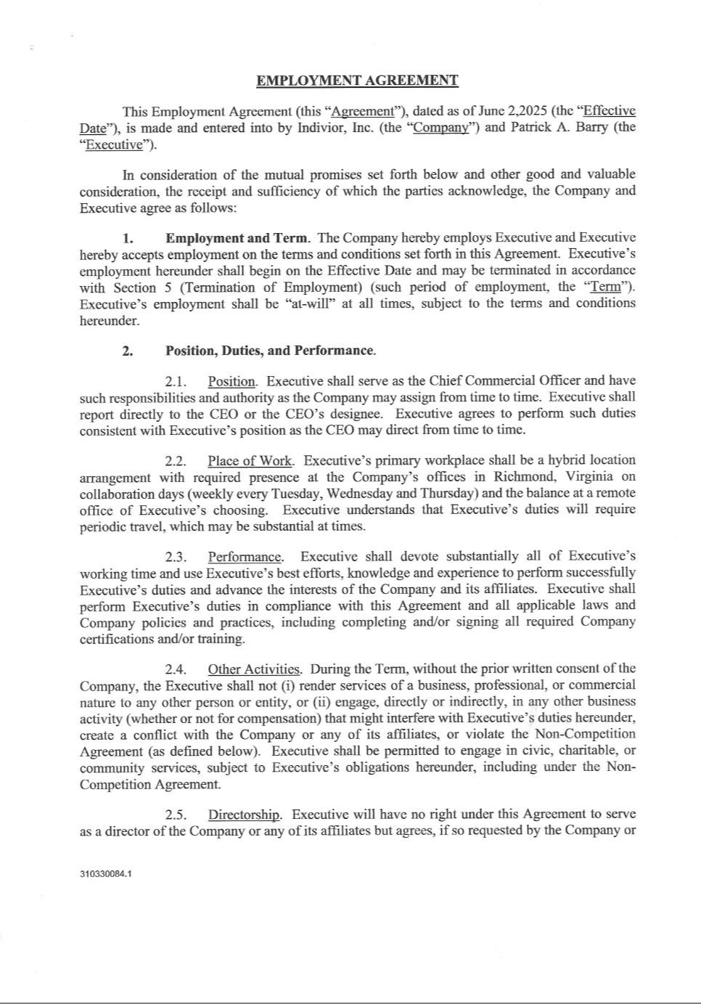

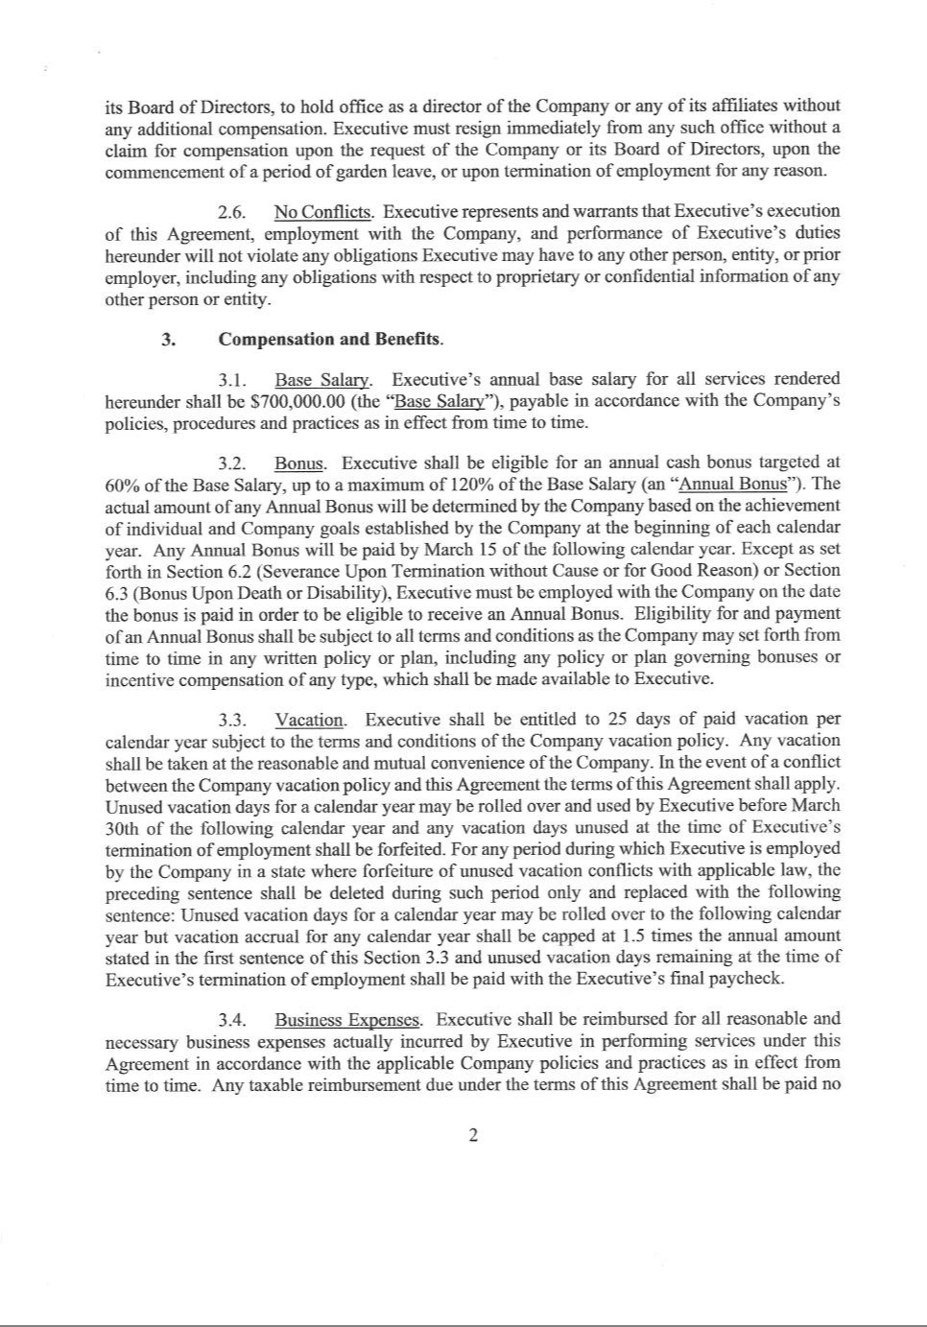

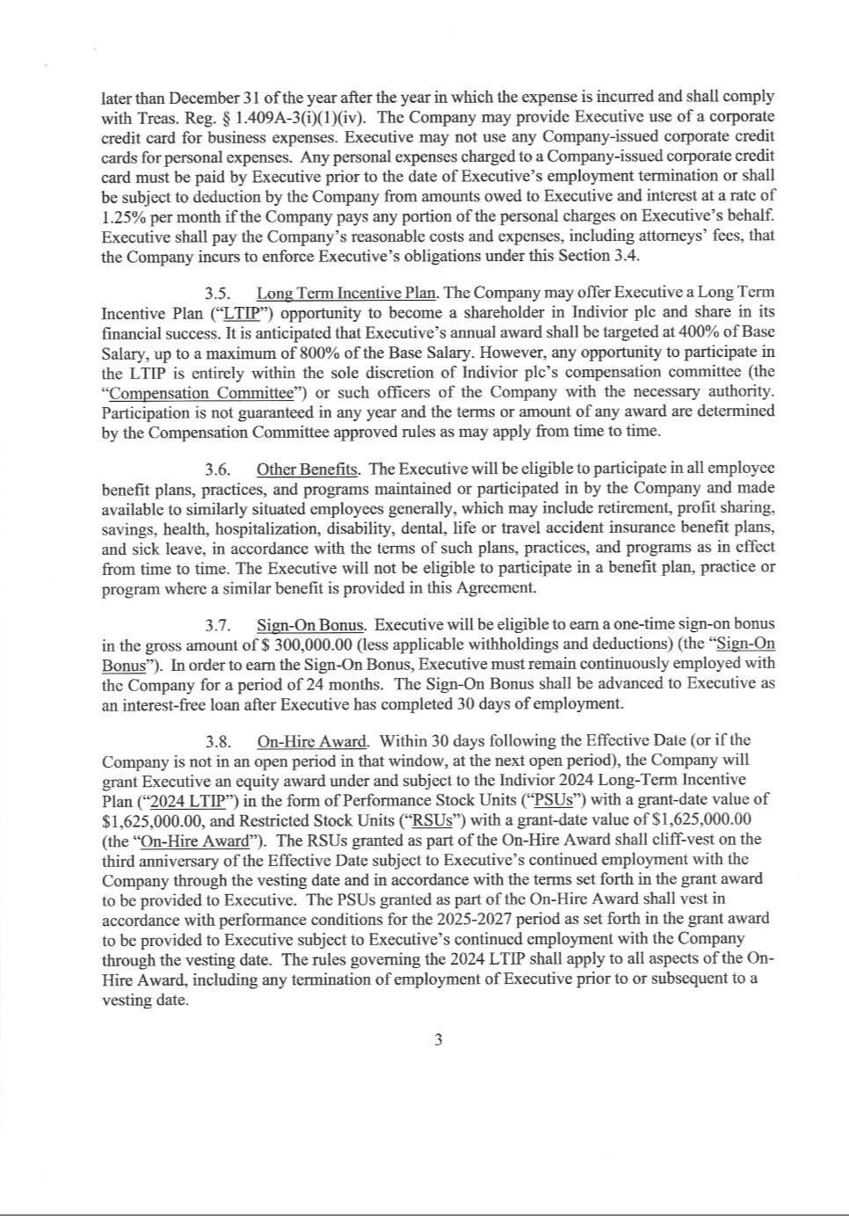

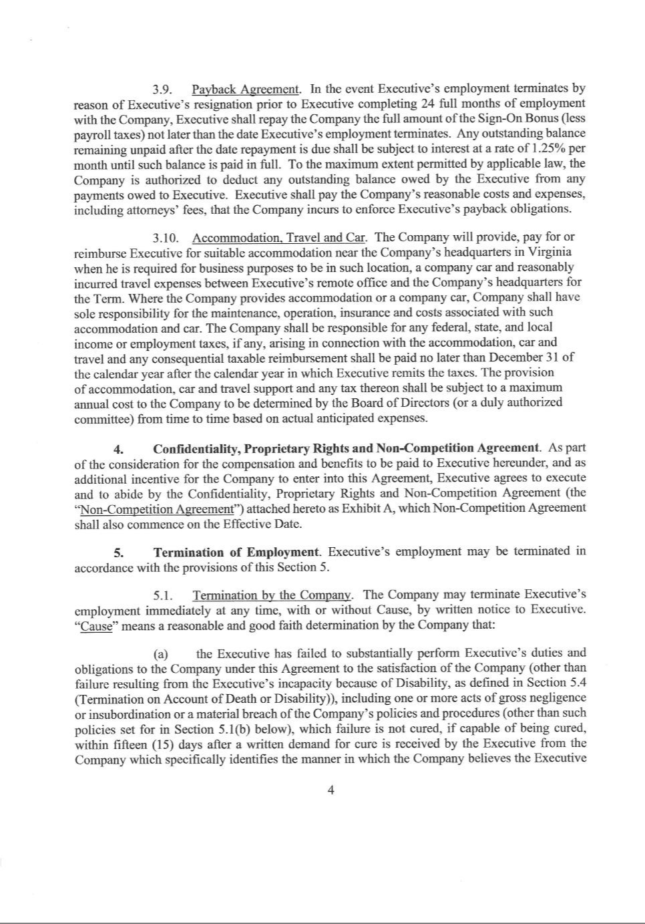

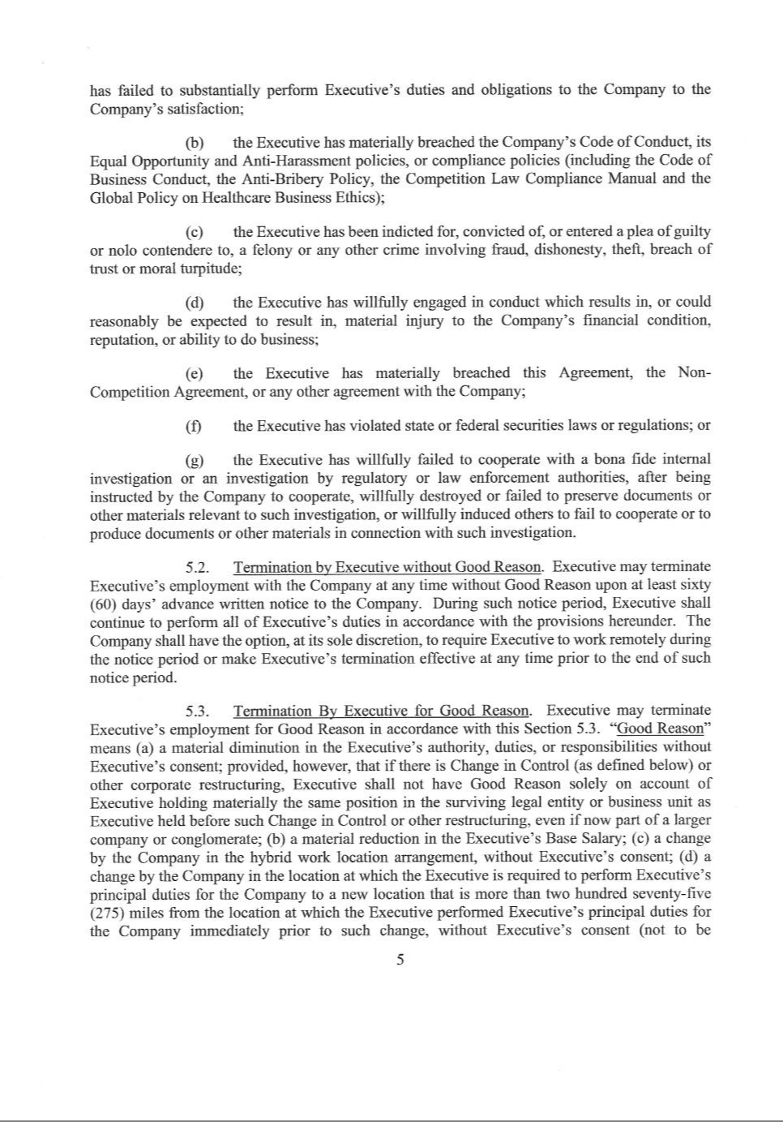

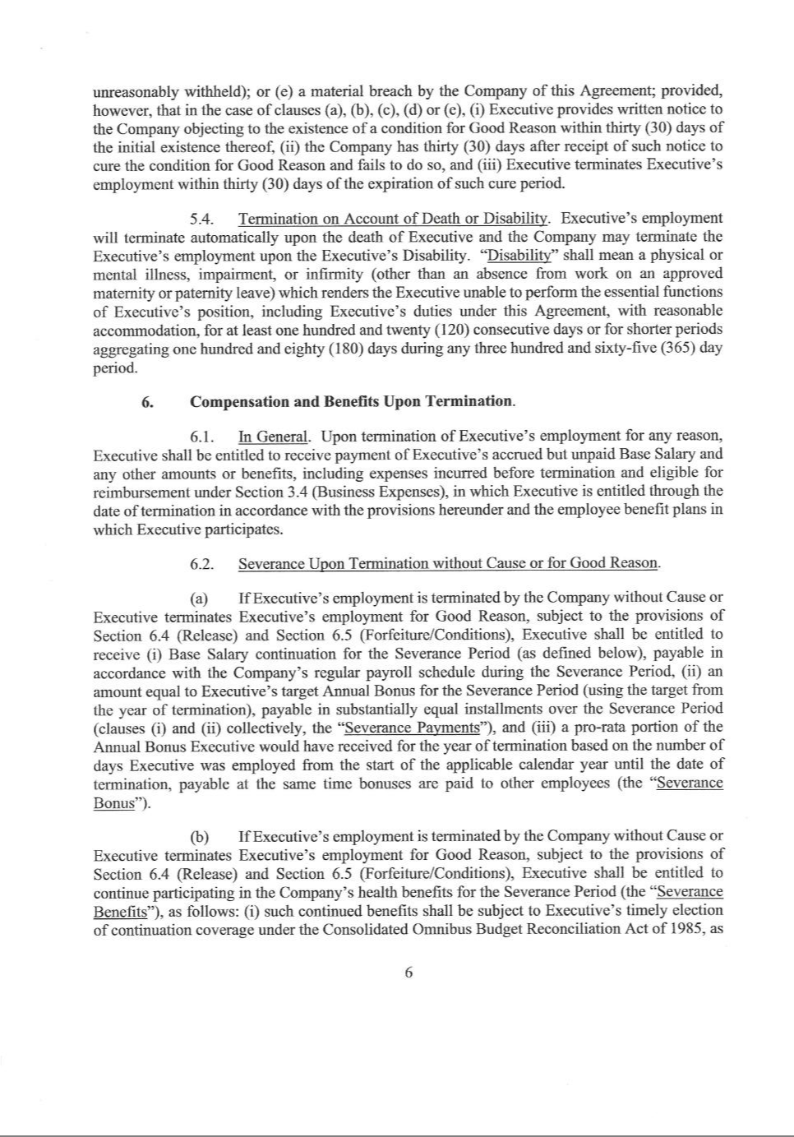

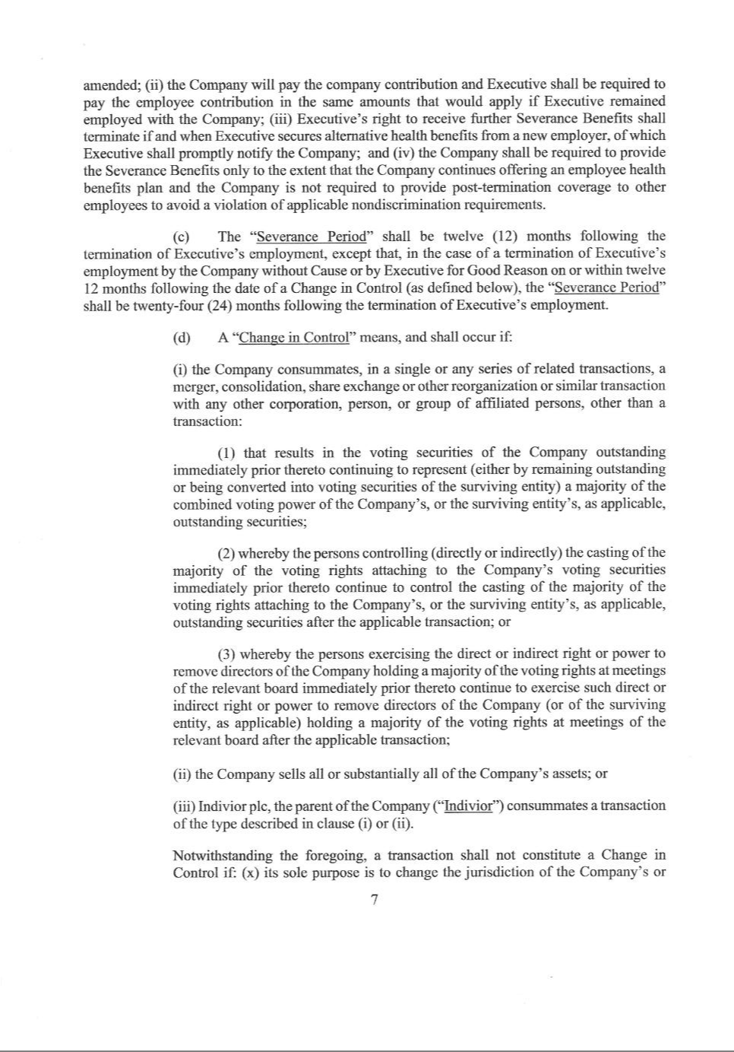

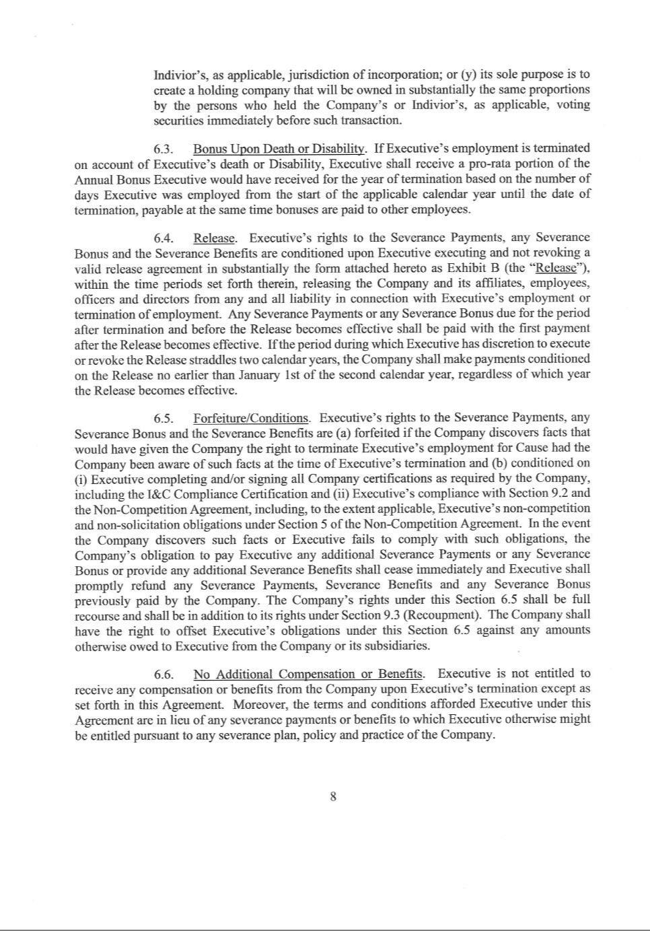

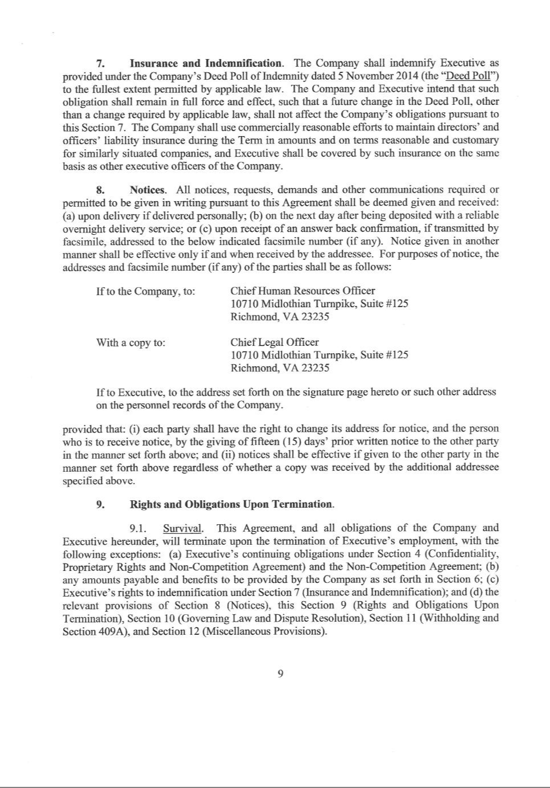

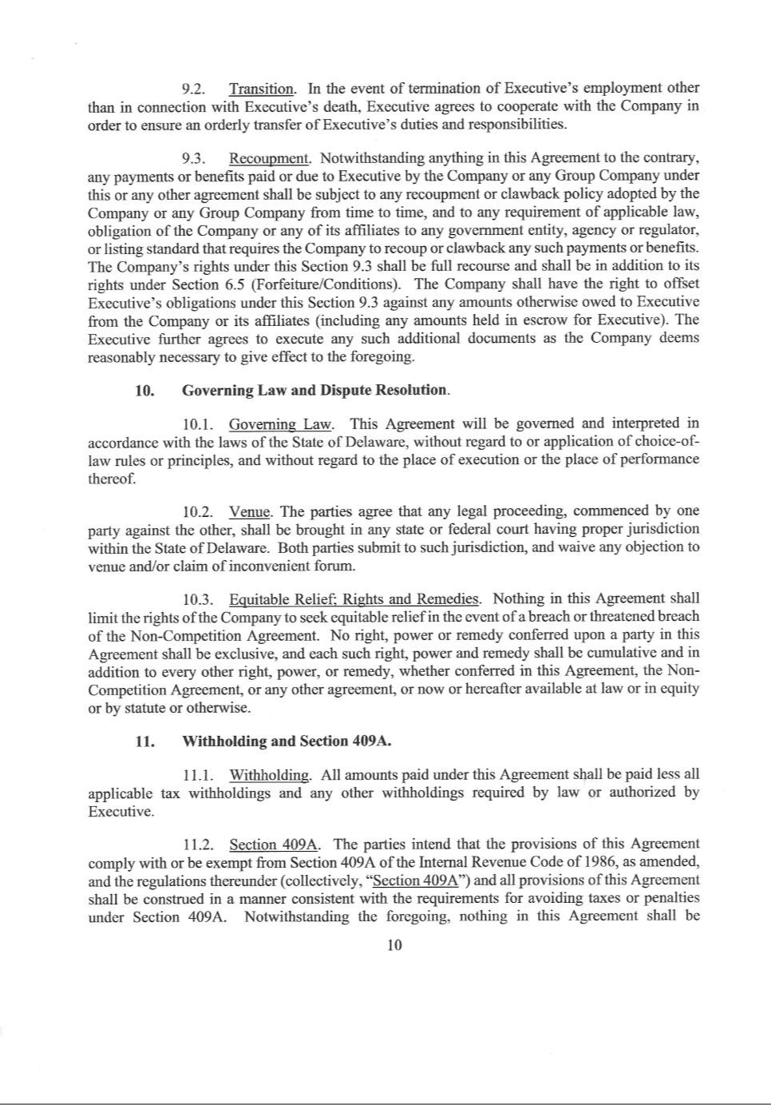

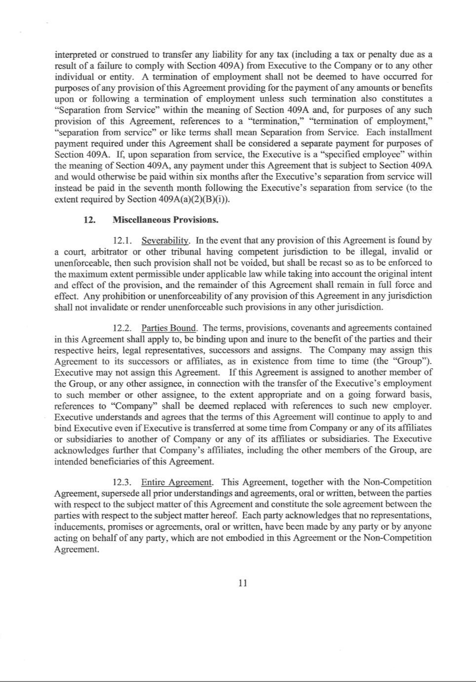

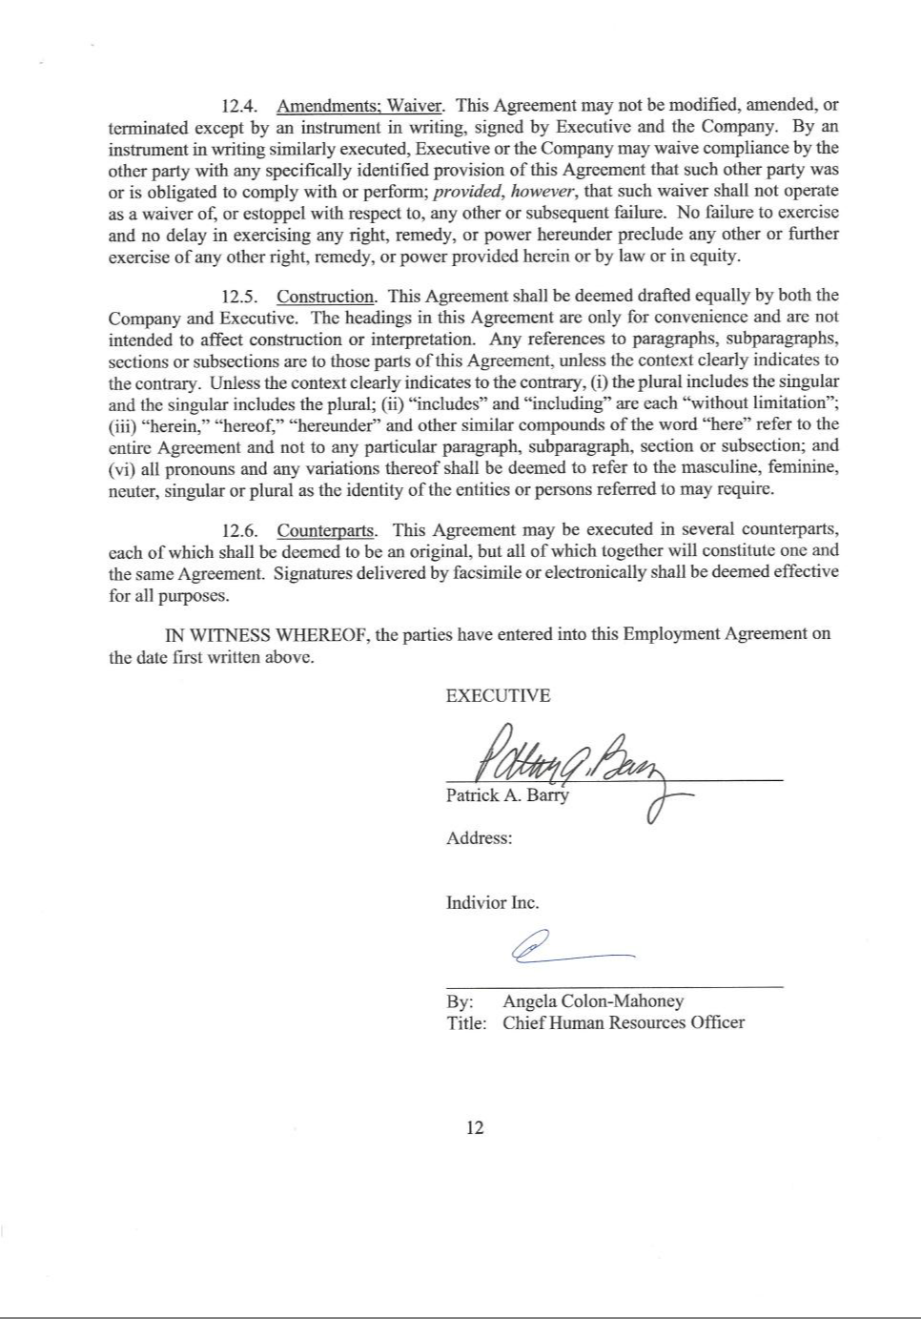

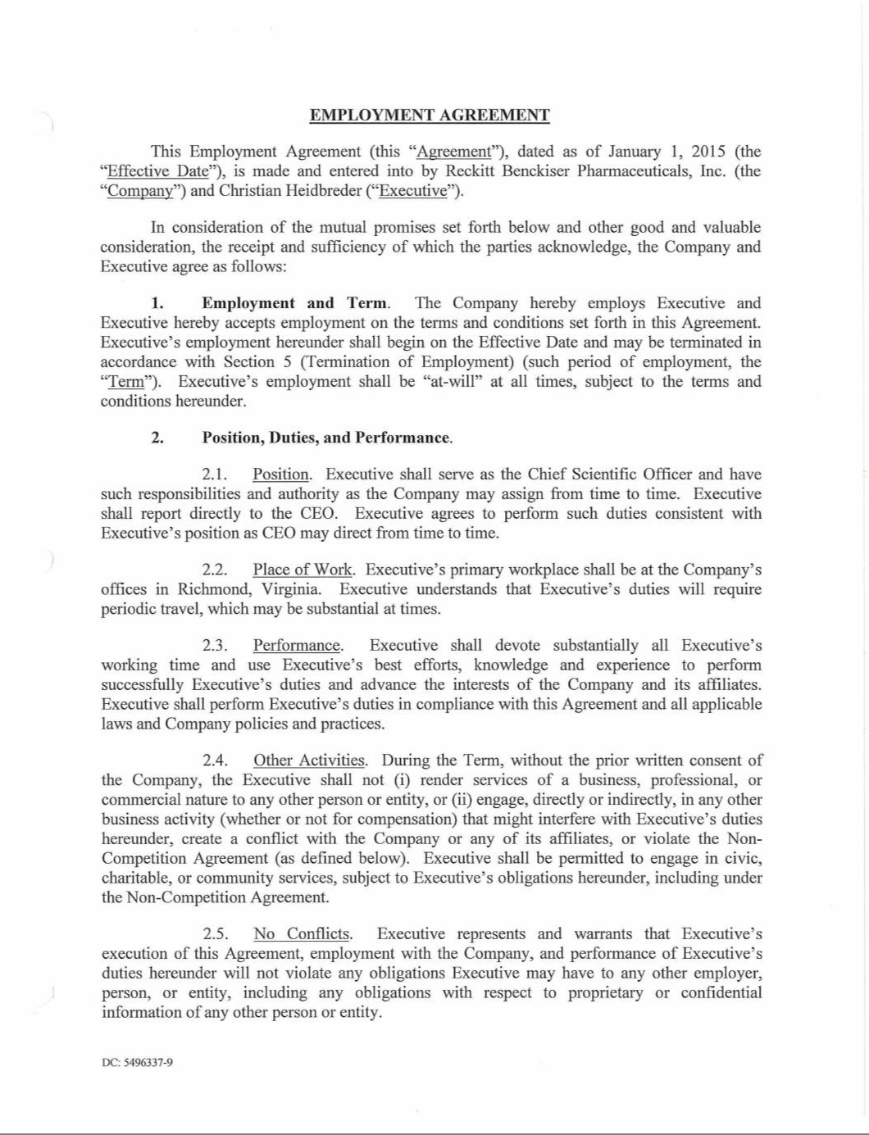

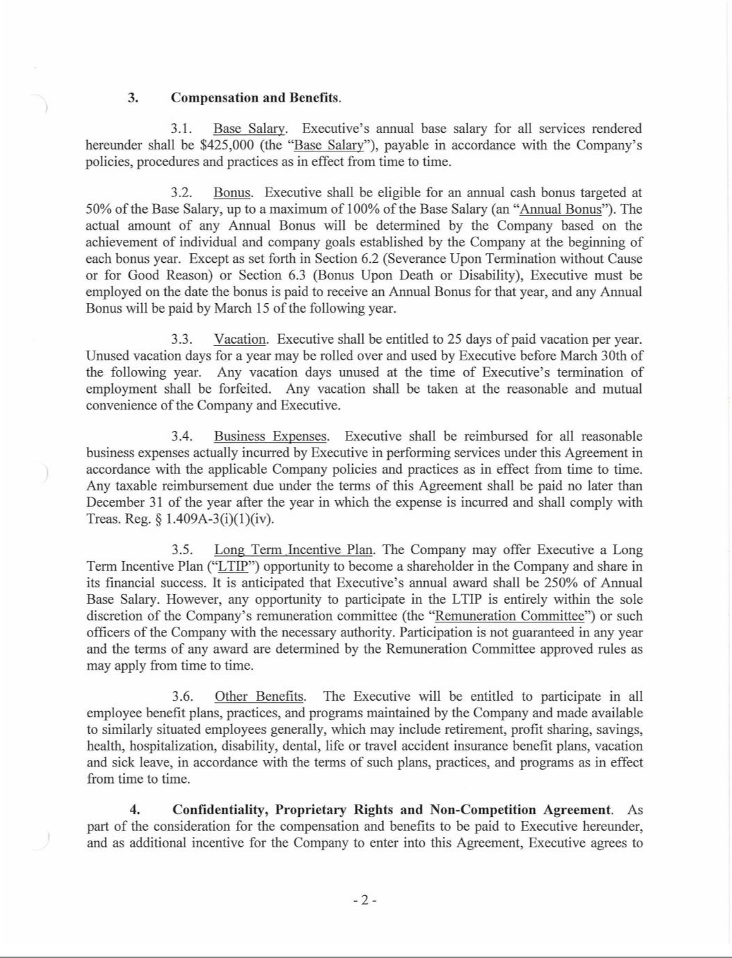

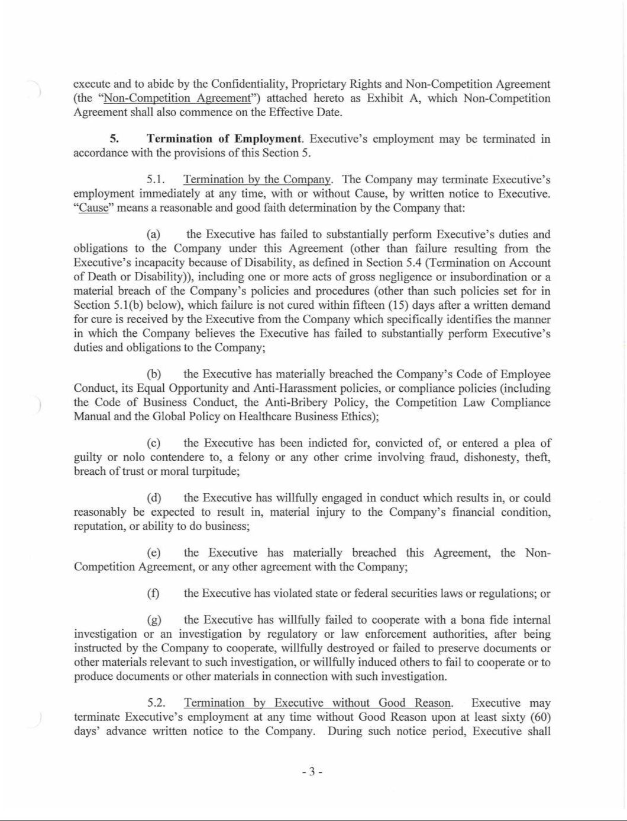

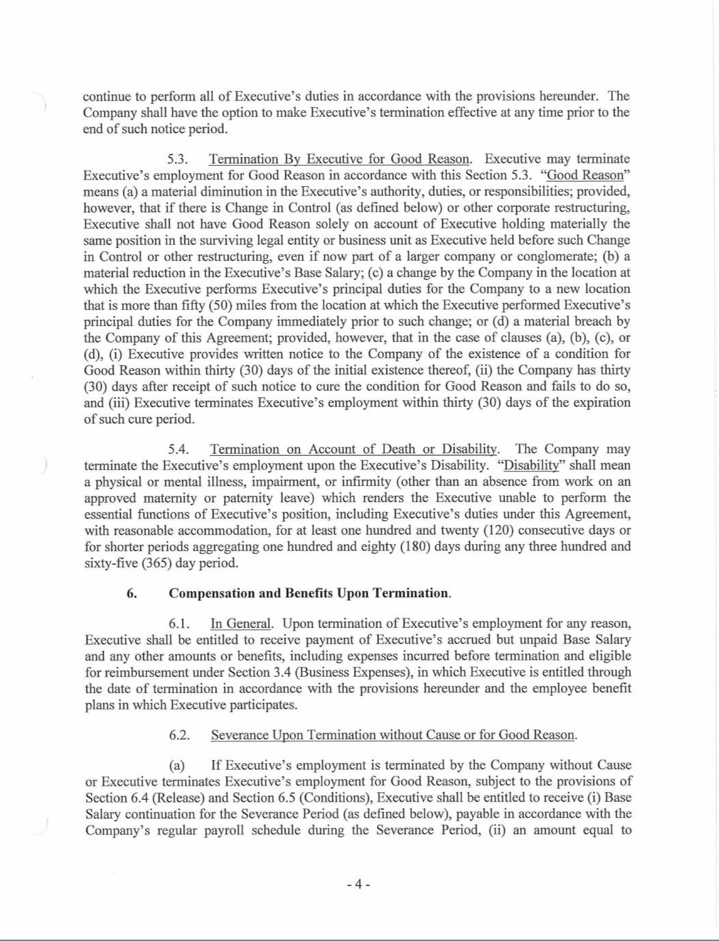

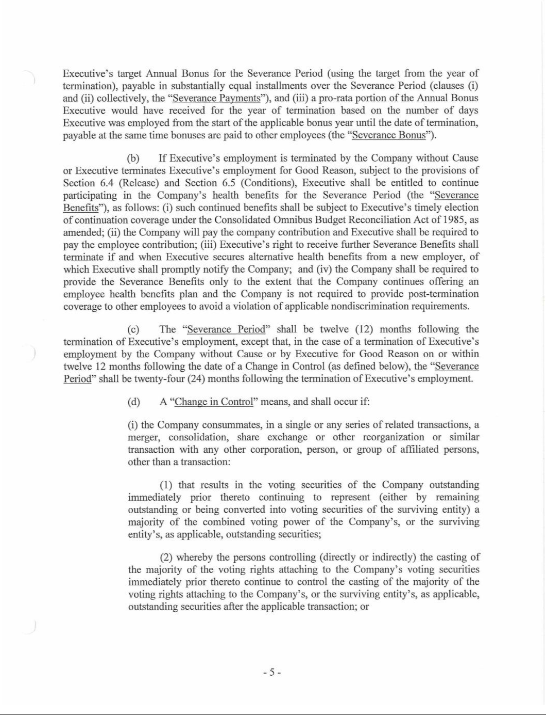

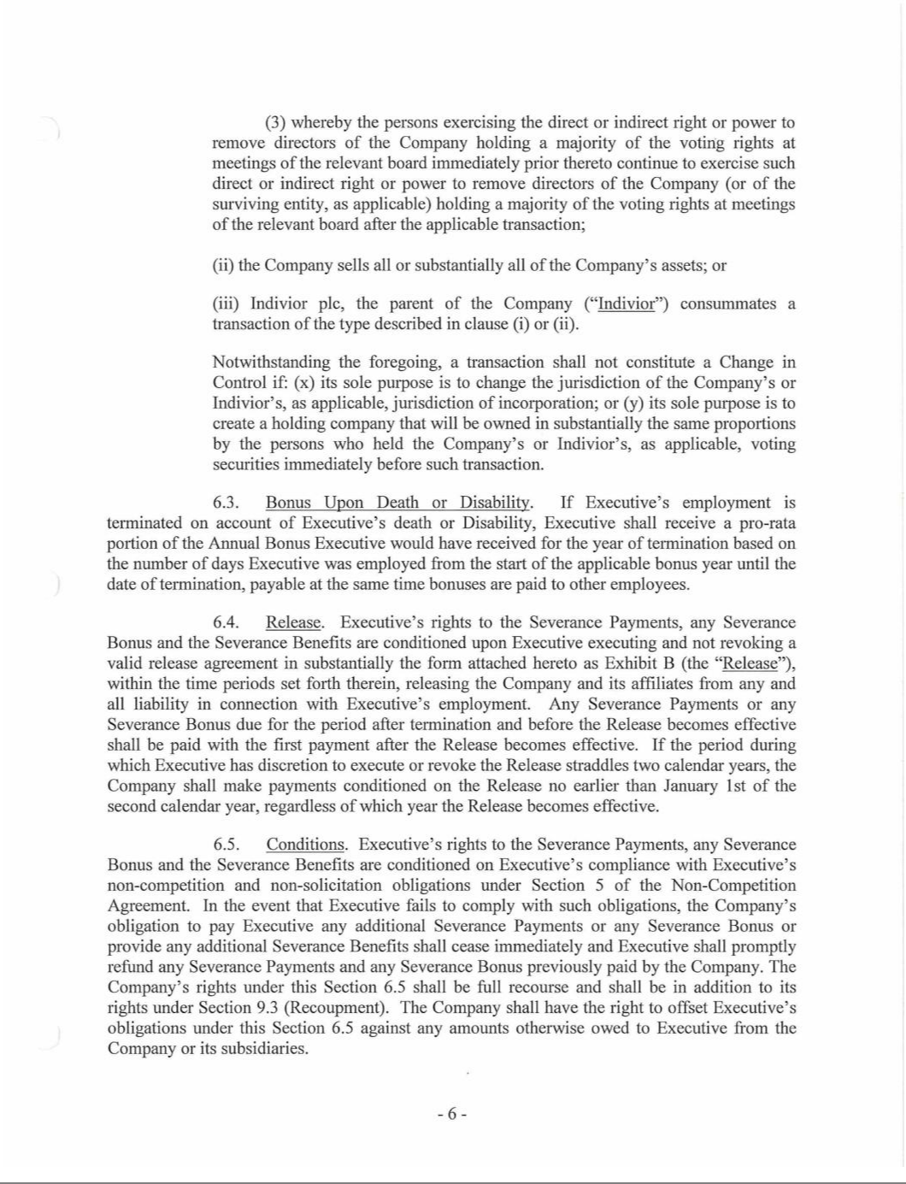

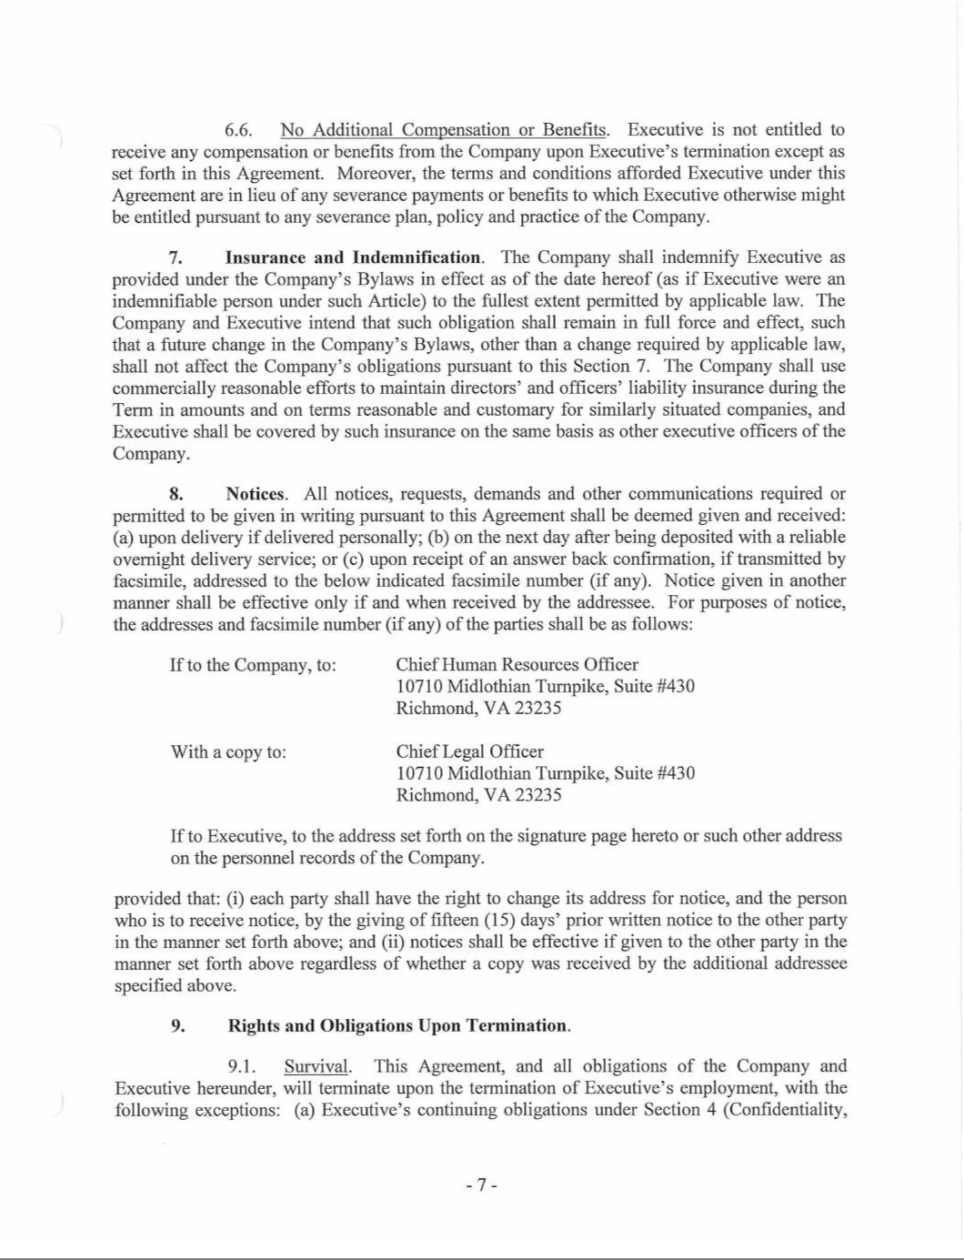

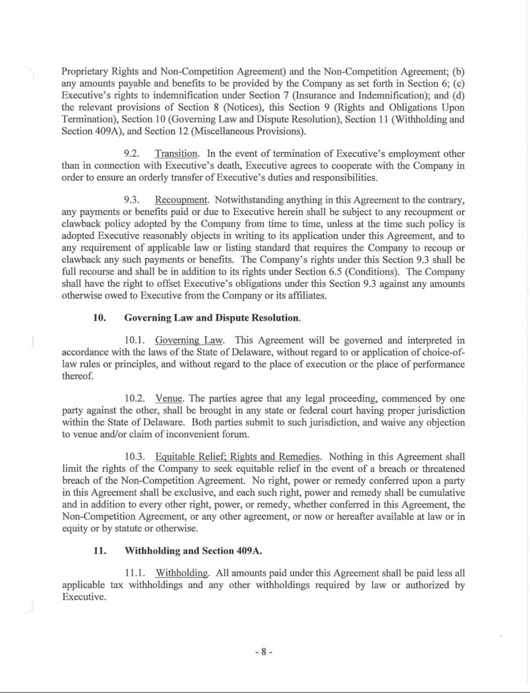

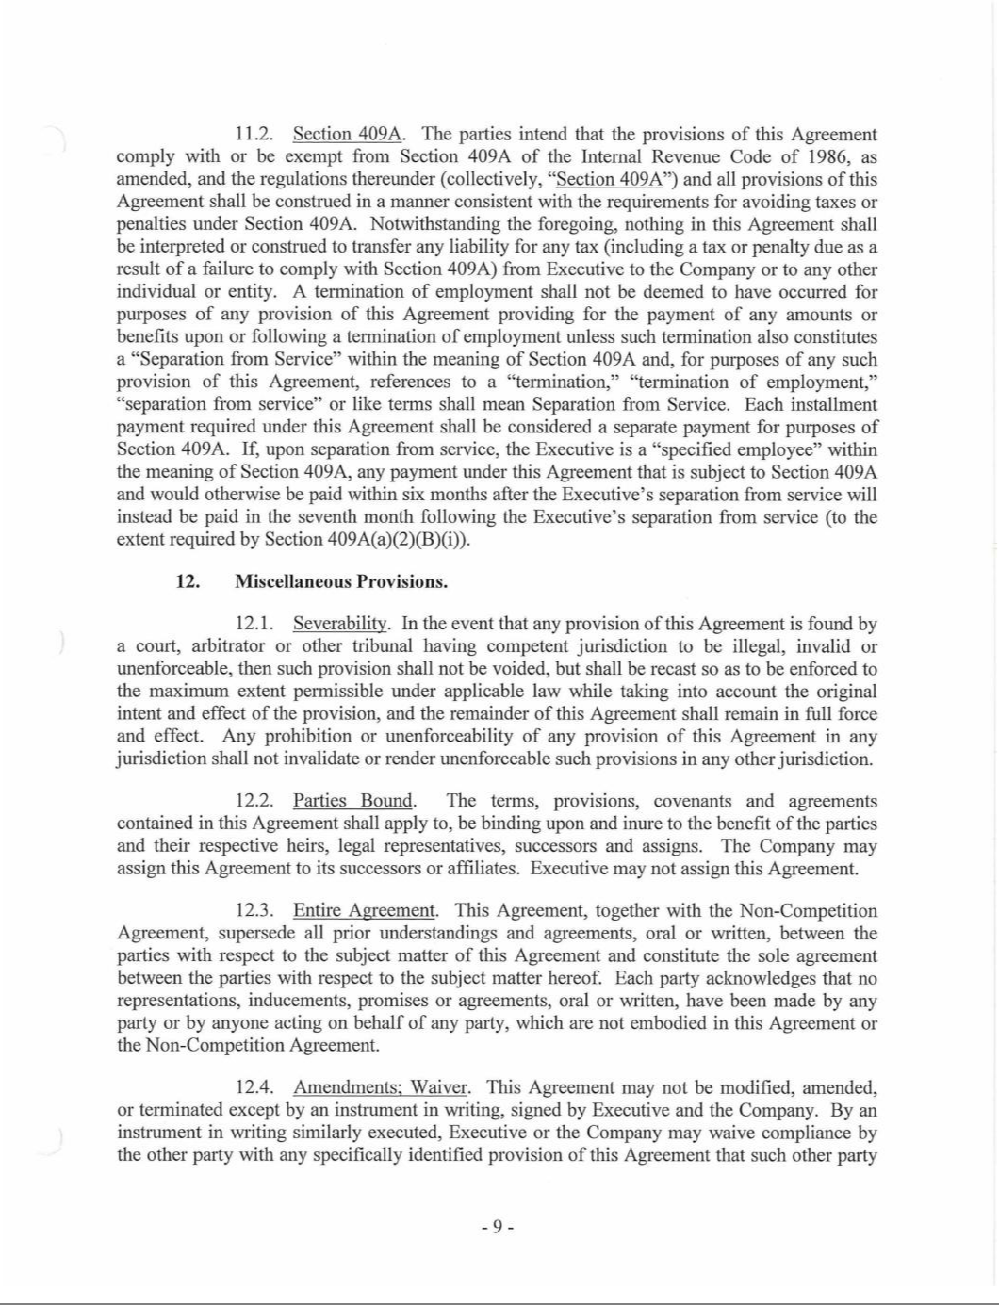

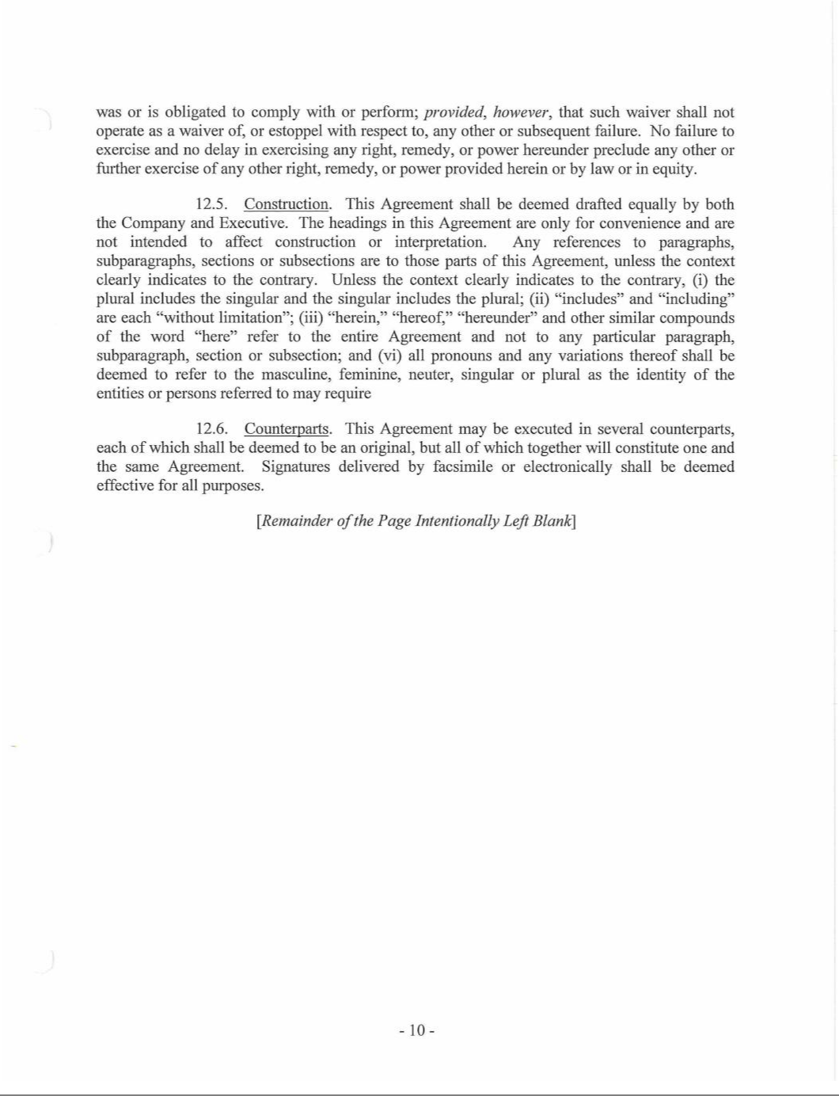

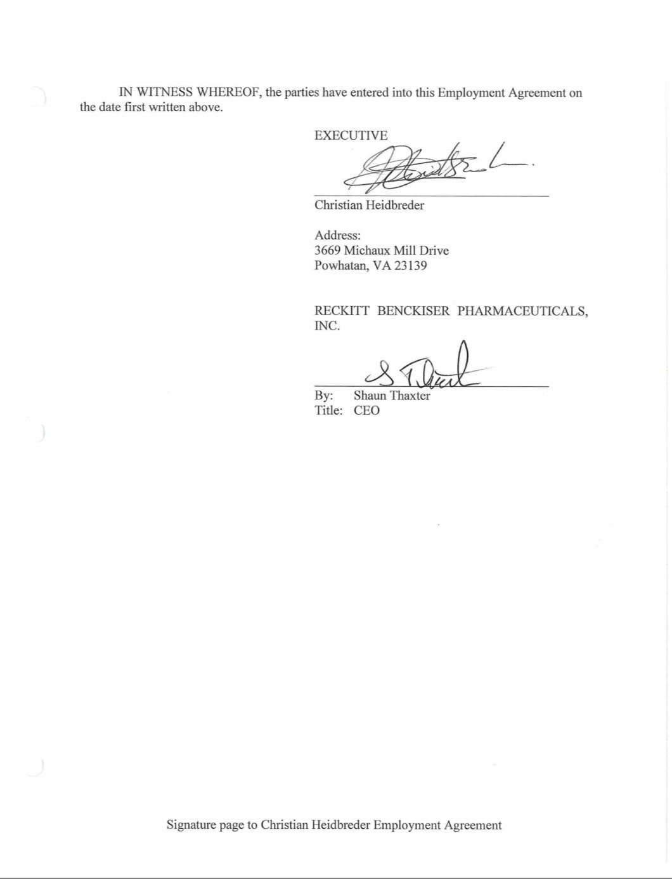



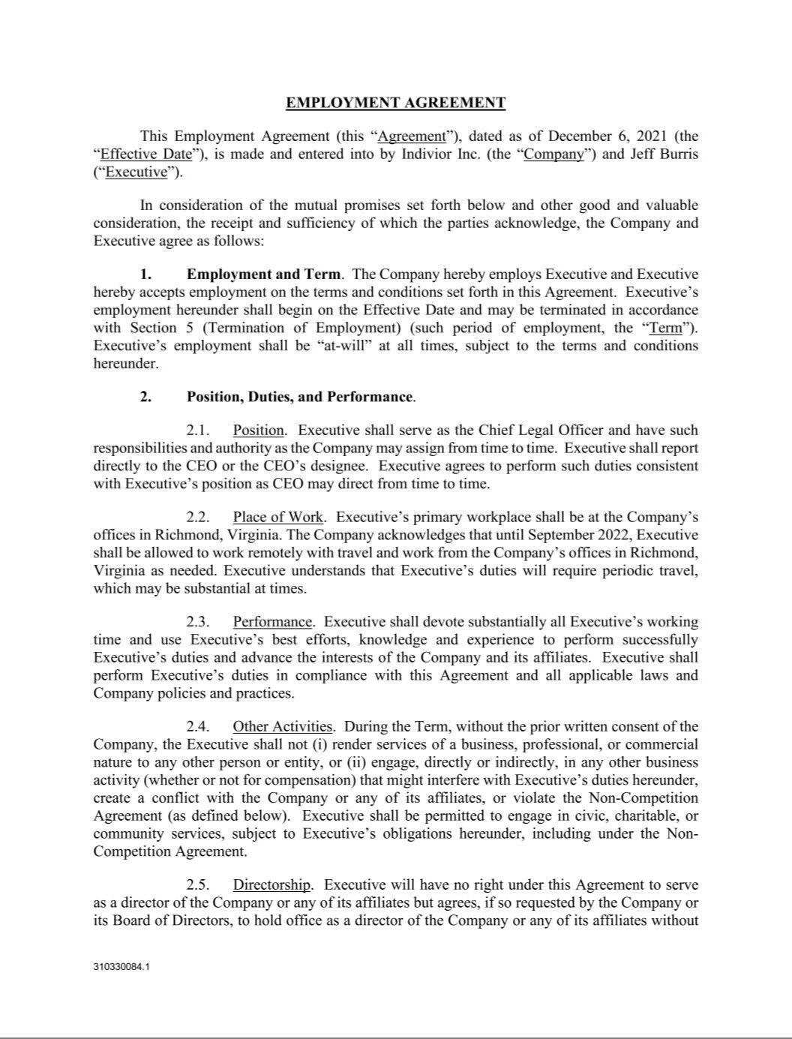

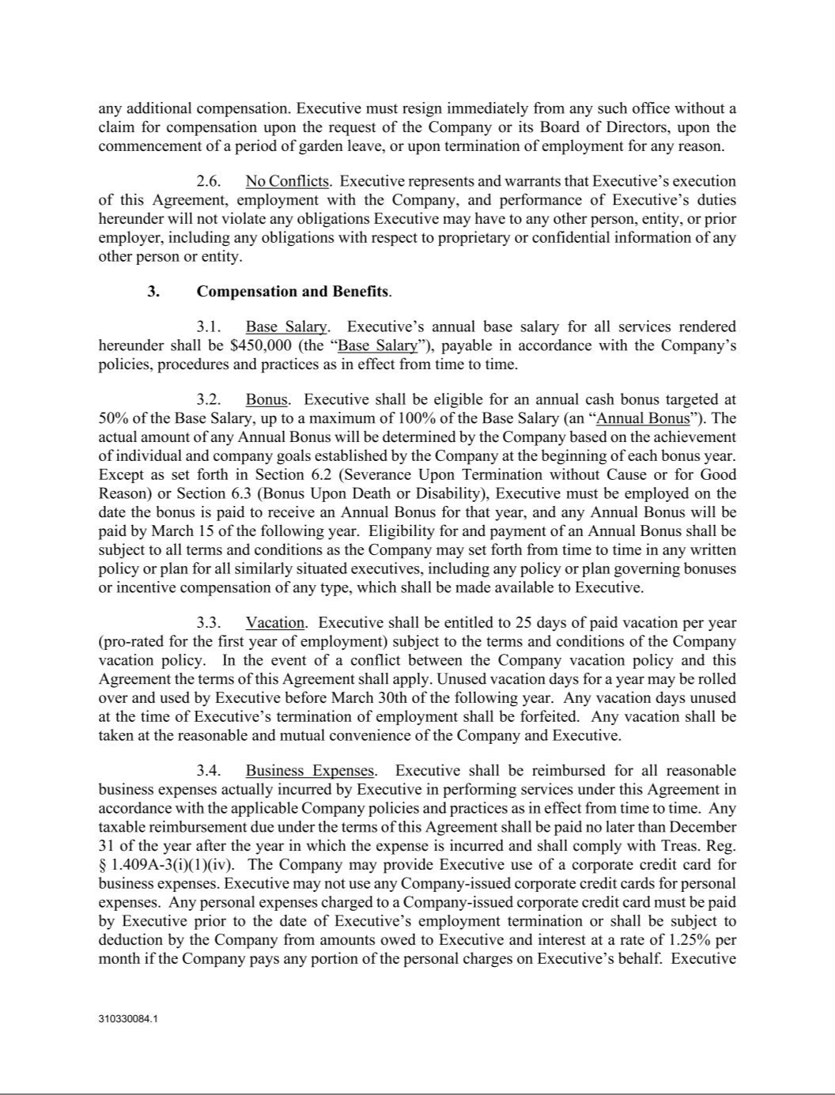

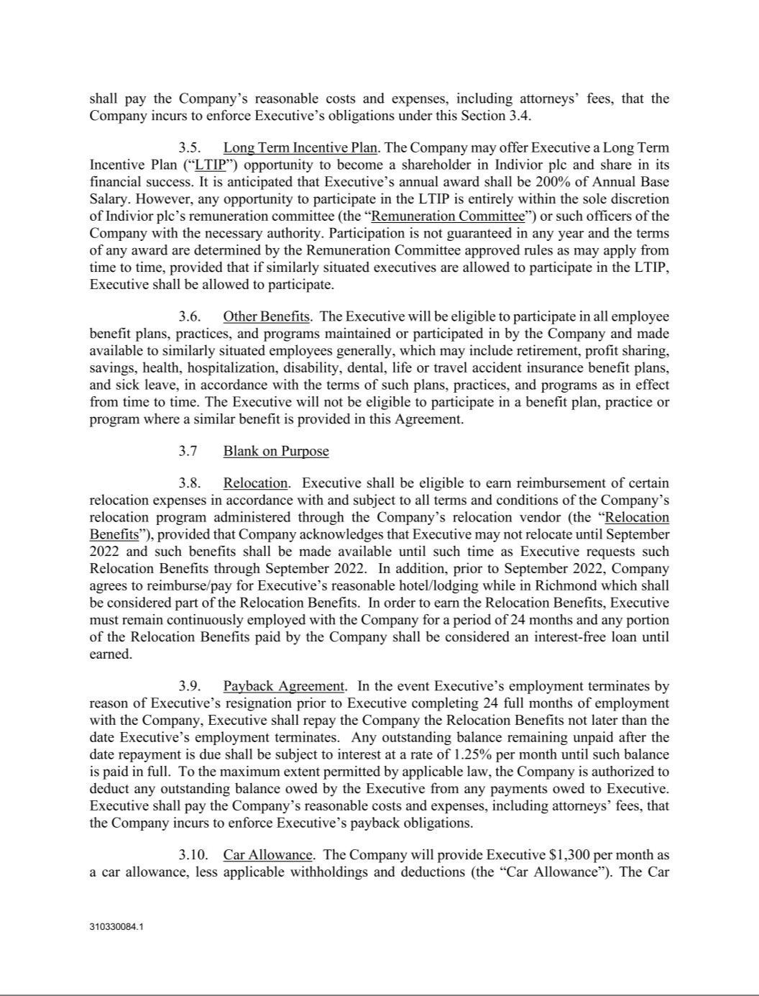

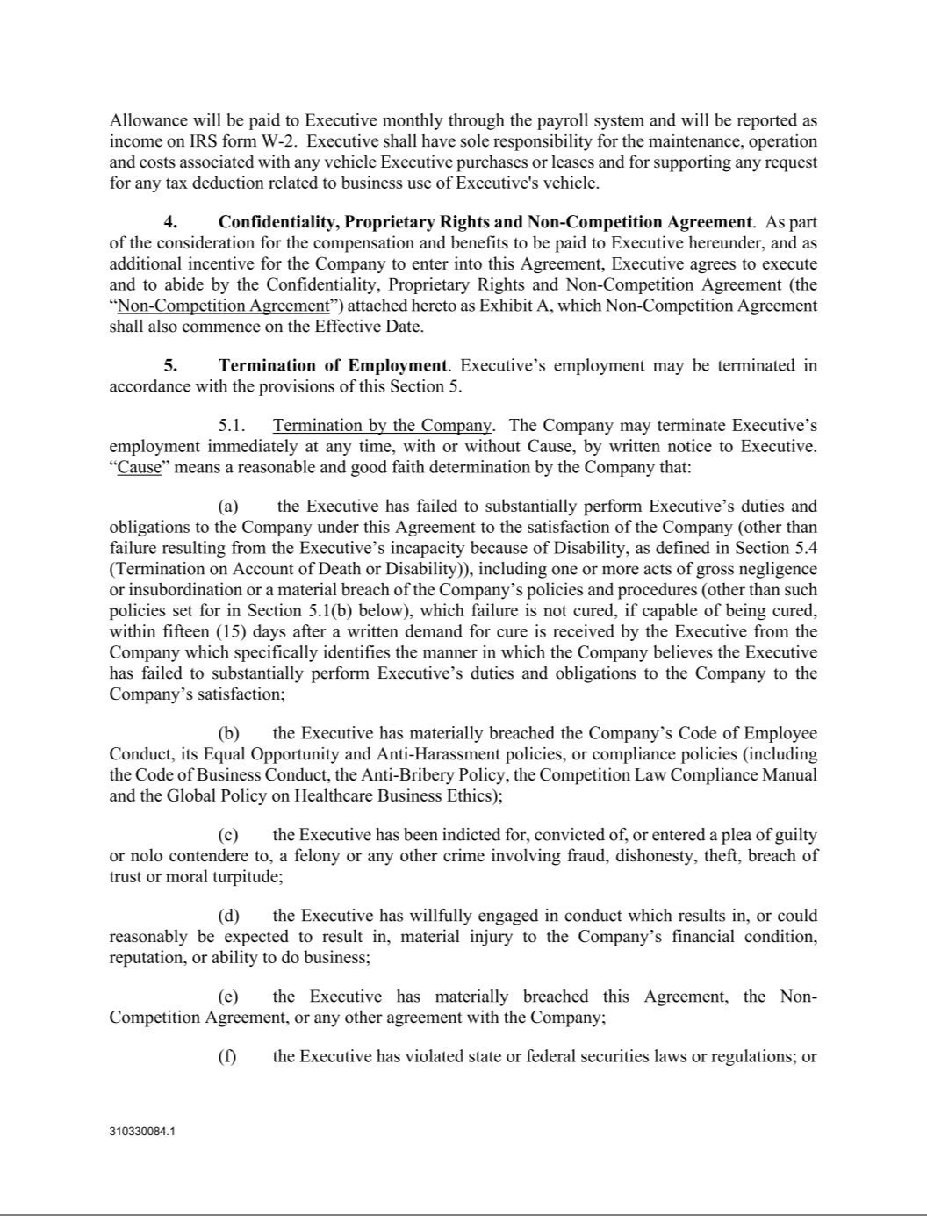

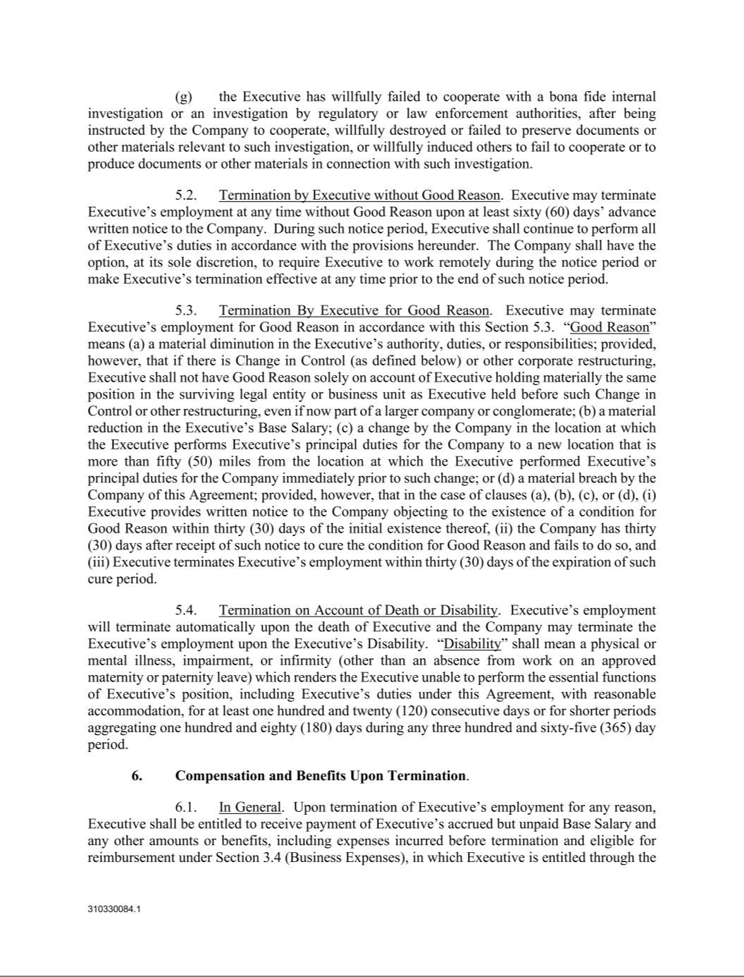

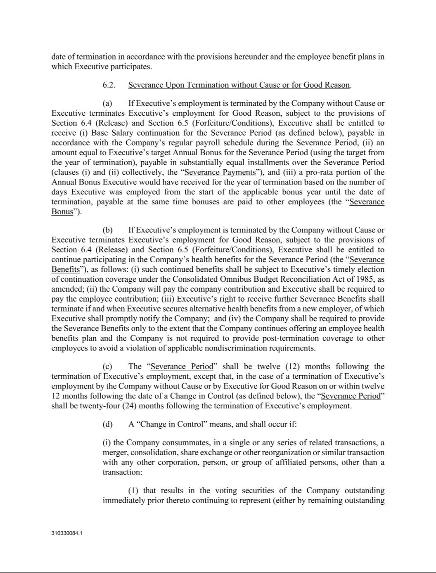

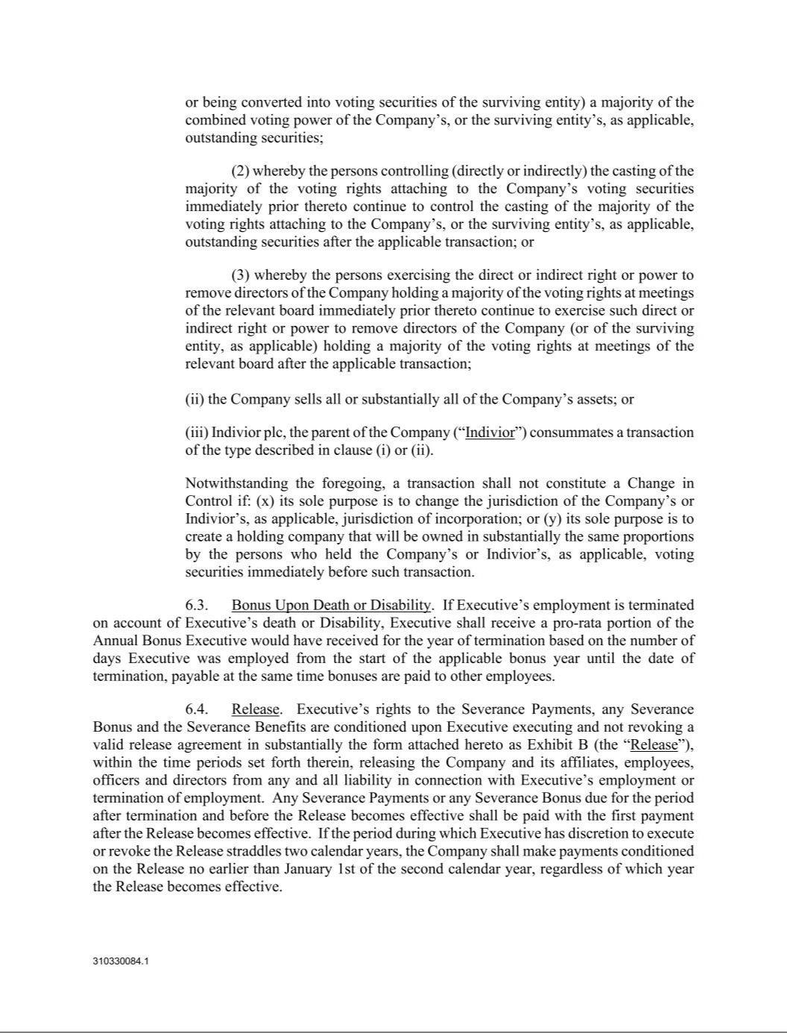

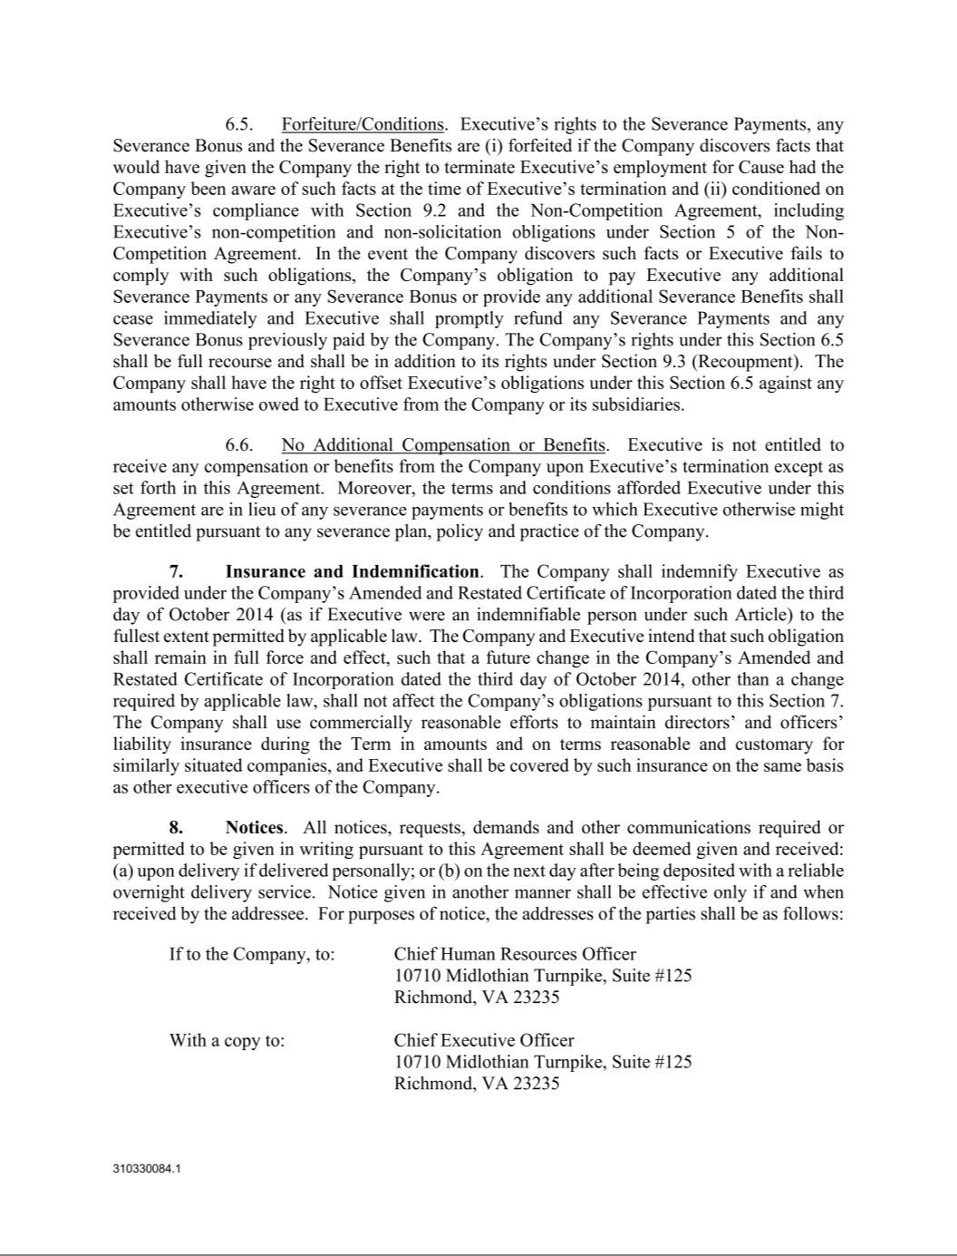

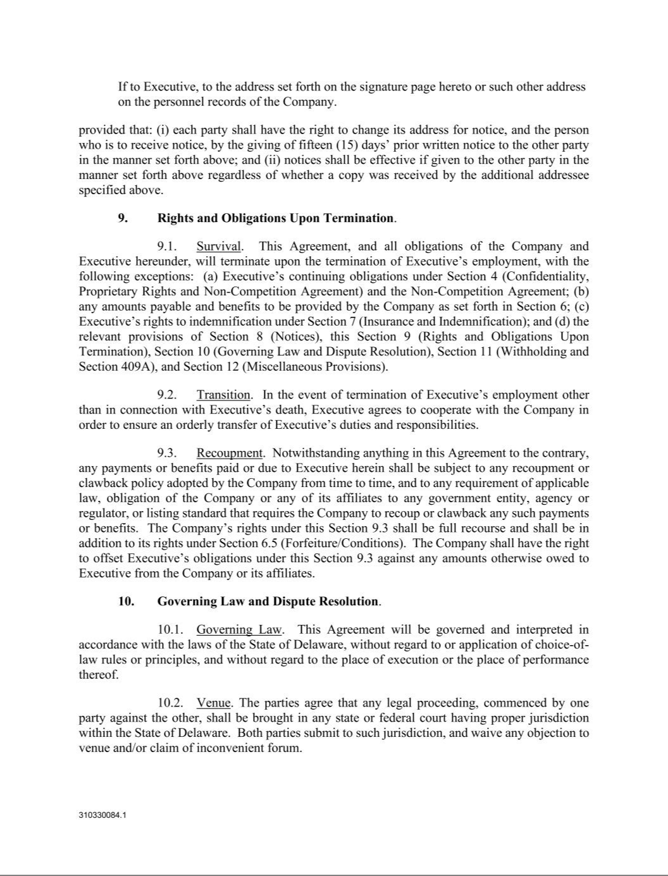

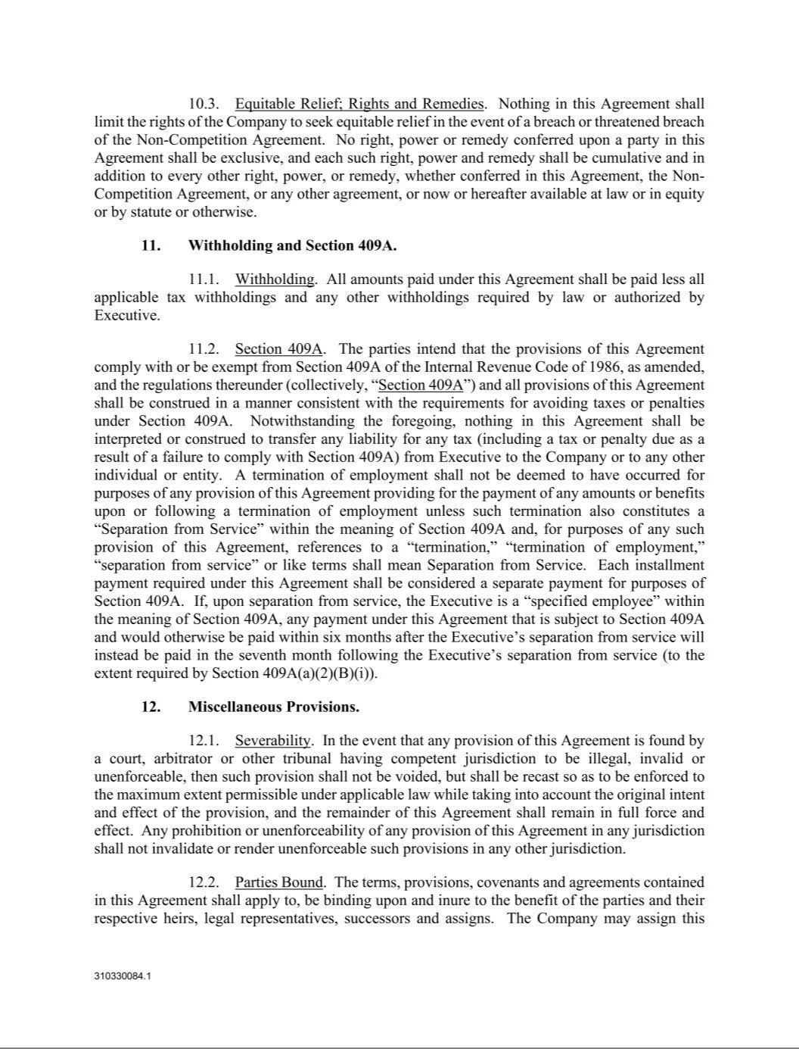

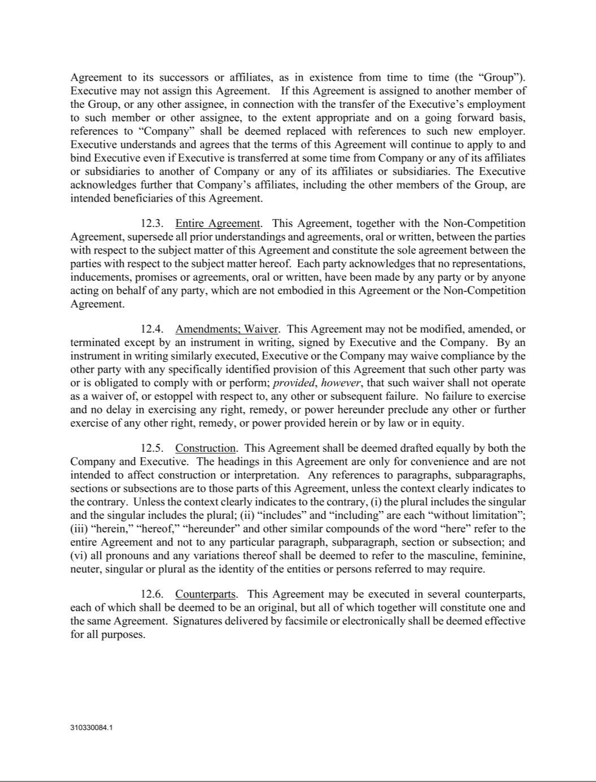

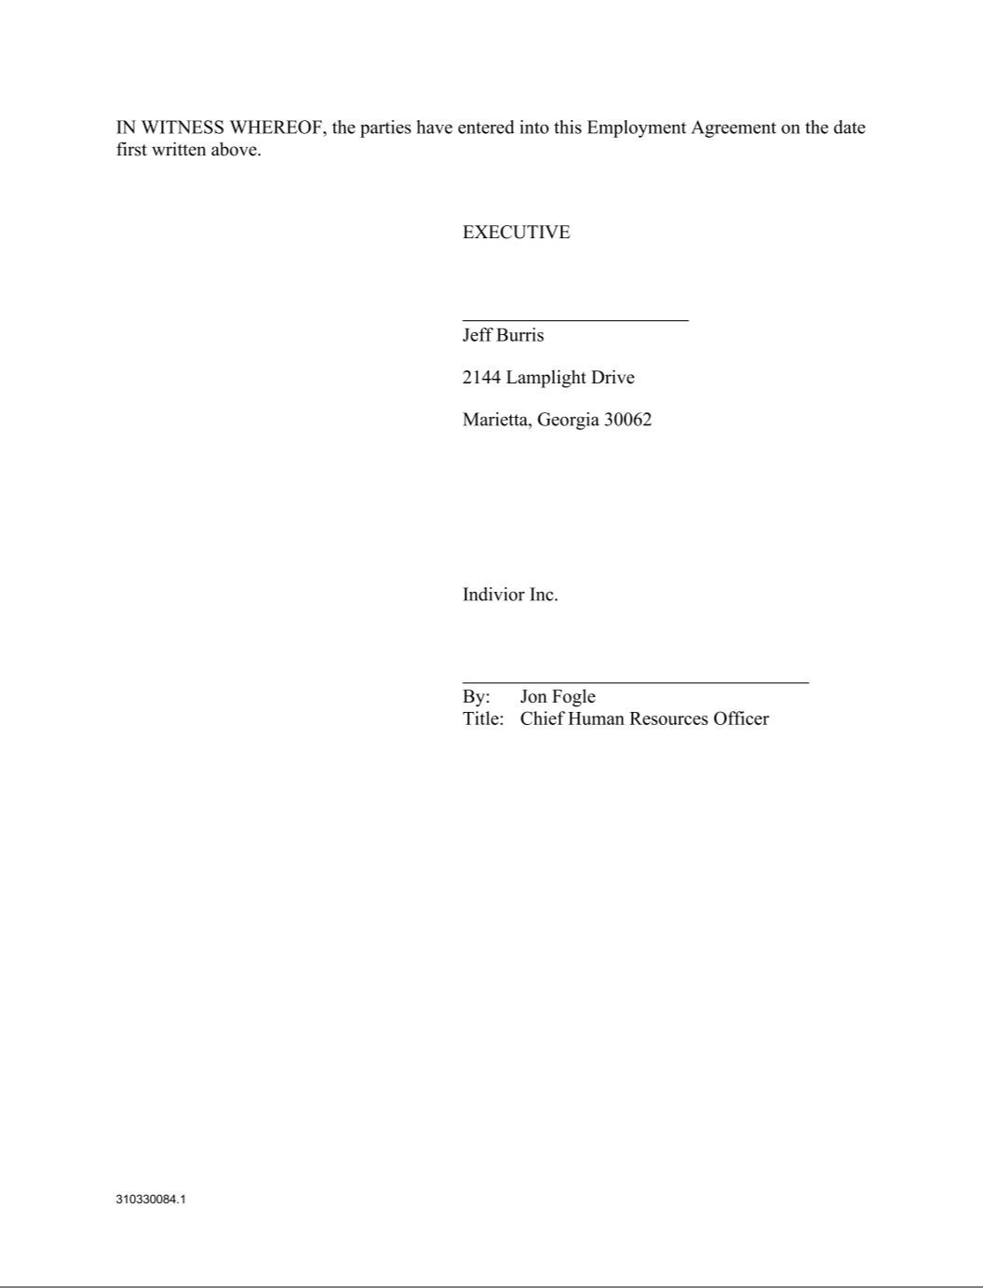





Exhibit 21.1

SUBSIDIARIES OF THE REGISTRANT

Shown below are the subsidiaries of the Registrant as of December 31, 2025, except where otherwise indicated).
 | Name |  | Jurisdiction of Incorporation
 | Indivior Limited |  | England and Wales (as of January 26, 2026).
 | Indivior Canada Ltd |  | Canada
 | Indivior Deutschland GmbH |  | Germany
 | Indivior España S.L.U. |  | Spain
 | Indivior EU Limited |  | England and Wales
 | Indivior Europe Limited |  | Ireland
 | Indivior Finance LLC |  | Delaware (US)
 | Indivior Finance (2014) LLC |  | Delaware (US)
 | Indivior France SAS |  | France
 | Indivior Global Holdings Limited |  | England and Wales
 | Indivior Inc. |  | Delaware (US)
 | Indivior Israel Ltd |  | Israel
 | Indivior Italia S.r.l |  | Italy
 | Indivior Jersey Finance LLC |  | Delaware (US)
 | Indivior Jersey Finance (2021) Limited |  | Jersey
 | Indivior Manufacturing LLC |  | Delaware (US)
 | Indivior Nordics ApS |  | Denmark
 | Indivior Pty Ltd |  | Australia
 | Indivior Schweiz AG |  | Switzerland
 | Indivior SMTM LLC |  | Delaware (US)
 | Indivior Solutions Inc. |  | Delaware (US)
 | Indivior South Africa (Pty) Ltd |  | South Africa
 | Indivior Treatment Services, Inc. |  | Delaware (US)
 | Indivior UK Limited |  | England and Wales
 | Indivior UK Finance No1 Limited |  | England and Wales
 | Indivior UK Finance No2 Limited |  | England and Wales
 | Indivior UK Finance No3 Limited |  | England and Wales
 | Indivior US Holdings Inc. |  | Delaware (US)
 | Indy 1 (UK) Limited |  | England and Wales
 | Opiant Pharmaceuticals UK Limited |  | England and Wales
 | RBP Global Holdings Limited |  | England and Wales

Exhibit 23.1

CONSENT OF INDEPENDENT REGISTERED PUBLIC ACCOUNTING FIRM

We hereby consent to the incorporation by reference in the Registration Statements on Form S-8 (File Nos. 333-292954, 333-272596, and 333-282815) of Indivior Pharmaceuticals, Inc. of our report dated February 26, 2026 relating to the financial statements, financial statement schedule and the effectiveness of internal control over financial reporting, which appears in this Form 10-K.

/s/ PricewaterhouseCoopers LLP

Richmond, Virginia

February 26, 2026

Exhibit 31.1

I, Joseph Ciaffoni, certify that:

- I have reviewed this annual report on Form 10-K of Indivior Pharmaceuticals, Inc.;

- Based on my knowledge, this report does not contain any untrue statement of a material fact or omit to state a material fact necessary to make the statements made, in light of the circumstances under which such statements were made, not misleading with respect to the period covered by this report;

- Based on my knowledge, the financial statements, and other financial information included in this report, fairly present in all material respects the financial condition, results of operations and cash flows of the company as of, and for, the periods presented in this report;

- The company’s other certifying officer(s) and I are responsible for establishing and maintaining disclosure controls and procedures (as defined in Exchange Act Rules 13a-15(e) and 15d-15(e)) and internal control over financial reporting (as defined in Exchange Act Rules 13a-15(f) and 15d-15(f)) for the company and have:

  - Designed such disclosure controls and procedures, or caused such disclosure controls and procedures to be designed under our supervision, to ensure that material information relating to the company, including its consolidated subsidiaries, is made known to us by others within those entities, particularly during the period in which this report is being prepared;

  - Designed such internal control over financial reporting, or caused such internal control over financial re- porting to be designed under our supervision, to provide reasonable assurance regarding the reliability of financial reporting and the preparation of financial statements for external purposes in accordance with generally accepted accounting principles;

  - Evaluated the effectiveness of the company’s disclosure controls and procedures and presented in this report our conclusions about the effectiveness of the disclosure controls and procedures, as of the end of the period covered by this report based on such evaluation; and

  - Disclosed in this report any change in the company’s internal control over financial reporting that occurred during the period covered by the annual report that has materially affected, or is reasonably likely to materially affect, the company’s internal control over financial reporting; and

- The company’s other certifying officer(s) and I have disclosed, based on our most recent evaluation of internal control over financial reporting, to the company’s auditors and the audit committee of the company’s board of directors (or persons performing the equivalent functions):

- All significant deficiencies and material weaknesses in the design or operation of internal control over financial reporting which are reasonably likely to adversely affect the company’s ability to record, process, summarize and report financial information; and

- Any fraud, whether or not material, that involves management or other employees who have a significant role in the company’s internal control over financial reporting.

Date: February 26, 2026.

/s/ Joseph Ciaffoni

Joseph Ciaffoni,

Chief Executive Officer

Exhibit 31.2

I, Ryan Preblick, certify that:

- I have reviewed this annual report on Form 10-K of Indivior Pharmaceuticals, Inc.;

- Based on my knowledge, this report does not contain any untrue statement of a material fact or omit to state a material fact necessary to make the statements made, in light of the circumstances under which such statements were made, not misleading with respect to the period covered by this report;

- Based on my knowledge, the financial statements, and other financial information included in this report, fairly present in all material respects the financial condition, results of operations and cash flows of the company as of, and for, the periods presented in this report;

- The company’s other certifying officer(s) and I are responsible for establishing and maintaining disclosure controls and procedures (as defined in Exchange Act Rules 13a-15(e) and 15d-15(e)) and internal control over financial reporting (as defined in Exchange Act Rules 13a-15(f) and 15d-15(f)) for the company and have:

  - Designed such disclosure controls and procedures, or caused such disclosure controls and procedures to be designed under our supervision, to ensure that material information relating to the company, including its consolidated subsidiaries, is made known to us by others within those entities, particularly during the period in which this report is being prepared;

  - Designed such internal control over financial reporting, or caused such internal control over financial re-porting to be designed under our supervision, to provide reasonable assurance regarding the reliability of financial reporting and the preparation of financial statements for external purposes in accordance with generally accepted accounting principles;

  - Evaluated the effectiveness of the company’s disclosure controls and procedures and presented in this report our conclusions about the effectiveness of the disclosure controls and procedures, as of the end of the period covered by this report based on such evaluation; and

  - Disclosed in this report any change in the company’s internal control over financial reporting that occurred during the period covered by the annual report that has materially affected, or is reasonably likely to materially affect, the company’s internal control over financial reporting; and

- The company’s other certifying officer(s) and I have disclosed, based on our most recent evaluation of internal control over financial reporting, to the company’s auditors and the audit committee of the company’s board of directors (or persons performing the equivalent functions):

- All significant deficiencies and material weaknesses in the design or operation of internal control over financial reporting which are reasonably likely to adversely affect the company’s ability to record, process, summarize and report financial information; and

- Any fraud, whether or not material, that involves management or other employees who have a significant role in the company’s internal control over financial reporting.

Date: February 26, 2026.

/s/ Ryan Preblick

Ryan Preblick,

Chief Financial Officer

Exhibit 32.1

CERTIFICATION PURSUANT TO 18 U.S.C. SECTION 1350,
AS ADOPTED PURSUANT TO SECTION 906 OF THE SARBANES-OXLEY ACT OF 2002

Pursuant to 18 U.S.C. Section 1350, as adopted pursuant to Section 906 of the Sarbanes-Oxley Act of 2002, the undersigned, Chief Executive Officer of Indivior Pharmaceuticals, Inc. (the "Company"), does hereby certify that:

- The Annual Report on Form 10-K for the fiscal period ended December 31, 2025 (the "Form 10-K") of the Company fully complies with the requirements of Section 13(a) or 15(d) of the Securities Exchange Act of 1934; and

- The information contained in the Form 10-K fairly presents, in all material respects, the financial condition and results of operations of the Company.

Date: February 26, 2026.

/s/ Joseph Ciaffoni

Joseph Ciaffoni,

Chief Executive Officer

Exhibit 32.2

CERTIFICATION PURSUANT TO 18 U.S.C. SECTION 1350,
AS ADOPTED PURSUANT TO SECTION 906 OF THE SARBANES-OXLEY ACT OF 2002

Pursuant to 18 U.S.C. Section 1350, as adopted pursuant to Section 906 of the Sarbanes-Oxley Act of 2002, the undersigned, Chief Financial Officer of Indivior Pharmaceuticals, Inc. (the "Company"), does hereby certify that:

- The Annual Report on Form 10-K for the fiscal period ended December 31, 2025 (the "Form 10-K") of the Company fully complies with the requirements of Section 13(a) or 15(d) of the Securities Exchange Act of 1934; and

- The information contained in the Form 10-K fairly presents, in all material respects, the financial condition and results of operations of the Company.

Date: February 26, 2026.

/s/ Ryan Preblick

Ryan Preblick,

Chief Financial Officer

