Filed by Indivior Pharmaceuticals, Inc.
(Commission File No.: 001-37835)
Pursuant to Rule 425 under the Securities Act of 1933, as amended
and deemed filed pursuant to Rule 14a-12
under the Securities Exchange Act of 1934
Subject Company: Supernus Pharmaceuticals, Inc.
(Commission File No.: 001-35518)
In connection with the pending transaction between Indivior Pharmaceuticals, Inc. (“Indivior”) and Supernus Pharmaceuticals, Inc. (“Supernus”), the following communications were made available by Indivior on August 3, 2026.

Subject: Indivior and Supernus to Combine, Creating a Leading CNS Company


Team,
Today, we announced that Indivior and Supernus have entered into an agreement to combine our companies in an all-stock merger of equals to create a leading U.S. biopharmaceutical company focused on improving the lives of people living with central nervous system (CNS) diseases. Bringing these two organizations together is intended to deliver greater value to the patients, communities, and shareholders we serve.
Why This, Why Now
Since we launched the Indivior Action Agenda, we have moved with purpose through each phase. First to Generate Momentum, then to Accelerate the capabilities, discipline, and execution required to earn our next chapter. On July 1st, we oﬃcially entered Breakout, the phase focused on enhancing and diversifying our growth profile through commercial stage combinations that expand what we can do for patients.
This transaction is Breakout. Following the close of our proposed deal, the Indivior Action Agenda will have successfully been completed. We enter this combination from a position of strength, backed by today’s strong second-quarter results.
This is what we have been building toward together, and it would not have been possible without the work each of you has done to get us here.
Why We are Combining

 |  |  | A diﬀerentiated commercial portfolio: Together, the combined company brings leading, durable, diﬀerentiated, patent-protected products that provide a platform for growth.

 |  |  | Four established commercial franchises across CNS: The combined company will have four separate, established businesses — SUBLOCADE® in opioid use disorder, Qelbree® in ADHD, Zurzuvae® in postpartum depression, and Onapgo® and GOCOVRI® in Parkinson’s disease.

 |  |  | Pipeline and R&D capabilities: Innovative pipeline in epilepsy, depression, and ADHD as well as R&D capabilities that will create a broader innovation engine, with more potential paths forward across addiction, psychiatry, and neurology.

 |  |  | A strong ﬁnancial proﬁle: The combined company has ﬁnancial strength and ﬂexibility to pursue business development opportunities that neither Indivior nor Supernus could contemplate on their own today, momentum reinforced by the strong second-quarter results released today.
Taken together, this combination moves us from a single-franchise growth story to a diversified platform with the capacity to keep building.
As part of this transaction, Supernus CEO, Jack A. Khattar, will serve as Chief Executive Oﬃcer of the combined company at close. He brings deep experience across CNS and behavioral health, and I am confident in his leadership going forward. The combined company will be headquartered in Rockville, Maryland. Until closing, I will continue as CEO of Indivior, and my focus and the leadership team’s focus remains on delivering our 2026 plan, supporting our people, and preparing the organization for a successful combination.
What Happens Next

 |  |  | This afternoon there will be an all-employee meeting at 1 p.m. A calendar invitation has been sent.

 |  |  | Read the full earnings announcement and second-quarter results on the Indivior website.

 |  |  | Business continues as usual until closing. We will remain separate companies until the transaction closes, which is expected to happen in Q4, 2026. That means we continue to operate as we do today, and we do not coordinate commercially, share competitively sensitive information outside of approved channels, or speak externally about the transaction unless designated to do so. No social media posts, LinkedIn commentary, blog posts, or public statements about the deal.

 |  |  | Please do not reach out to Supernus counterparts about integration, commercial matters, or day-to-day business. Integration planning will happen through a structured process. If you receive unexpected inbound outreach, please contact your manager for directions.

 |  |  | Your focus should remain on serving patients, customers, and our 2026 priorities.

 |  |  | We will communicate openly. There is a great deal that has not yet been decided. Where we have answers, we will share them when appropriate. Where we don’t, we will tell you that too.

 |  |  | We are growing our commitment to patients. The combined company strengthens our ability to improve the lives of people suﬀering from central nervous system diseases through a broader platform and stronger innovation engine.
I know announcements like this bring both excitement and uncertainty. When we laid out the Action Agenda, we said Breakout was something we would have to earn the right to, through execution and discipline. What I am certain of is this: the work you have done to Generate Momentum and to Accelerate has earned us the right to be here. The strong quarter we are reporting today is proof of that.
Thank you for your continued focus, professionalism, and commitment to the people who depend on us.
Sincerely,
Joe

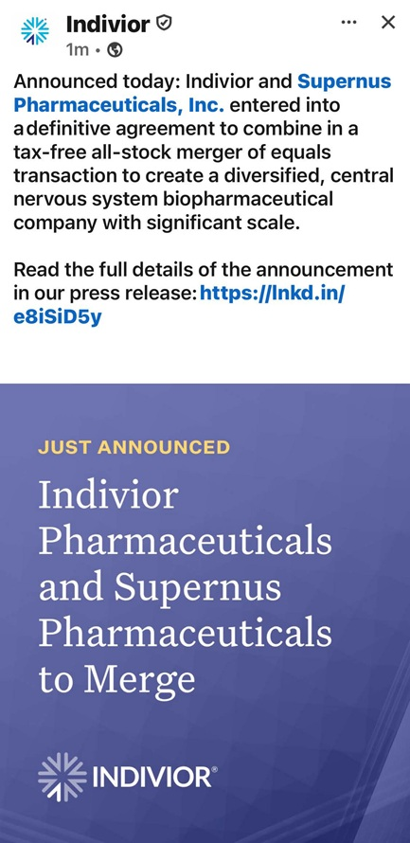
‘2 lndivior 0  x 1m  ® Announced today: lndivior and Supernus Pharmaceuticals, Inc. entered into a definitive agreement to combine in a tax-free all-stock merger of equals transaction to create a diversified, central nervous system biopharmaceutical company with significant scale. Read the full details of the announcement in our press release: https://lnkd.in/ e8iSiD5y JUST ANNOUNCED INDIVIOR®

Important Additional Information and Where to Find It
In connection with the proposed transaction, Indivior Pharmaceuticals, Inc. (“Indivior”) intends to file with the United States Securities and Exchange Commission (“SEC”) a registration statement on Form S-4, which will include a document that serves as a prospectus of Indivior and a joint proxy statement of Indivior and Supernus Pharmaceuticals, Inc. (“Supernus”) (the “joint proxy statement/prospectus”). Each party also plans to file other relevant documents with the SEC regarding the proposed transaction. INVESTORS AND SECURITY HOLDERS ARE URGED TO READ THE JOINT PROXY STATEMENT/PROSPECTUS AND OTHER RELEVANT DOCUMENTS FILED WITH THE SEC WHEN THEY BECOME AVAILABLE, BECAUSE THEY WILL CONTAIN IMPORTANT INFORMATION ABOUT THE PROPOSED TRANSACTION. A definitive joint proxy statement/prospectus will be sent to Indivior’s stockholders and Supernus’ stockholders. Investors and securityholders may obtain a free copy of the joint proxy statement/prospectus (if and when it becomes available) and other relevant documents filed by Indivior and Supernus with the SEC at the SEC’s website at www.sec.gov. Copies of the documents filed by Indivior with the SEC will be available free of charge on Indivior’s website at www.indivior.com or by contacting Indivior’s Investor Relations at InvestorRelations@indivior.com. Copies of the documents filed by Supernus with the SEC will be available free of charge on Supernus’ website at www.supernus.com.
No Offer or Solicitation
This communication and the information contained herein is for informational purposes only and does not constitute an offer to sell or the solicitation of an offer to buy or exchange any securities, or a solicitation of any vote or approval, nor shall there be any sale of securities in any jurisdiction in which such offer, solicitation or sale would be unlawful prior to registration or qualification under the securities laws of any such jurisdiction. This communication does not constitute a prospectus or prospectus equivalent document. No offer of securities shall be made except by means of a prospectus meeting the requirements of Section 10 of the Securities Act of 1933, as amended.
Participants in the Solicitation
Indivior and Supernus and their respective directors, executive officers and other members of management and employees may be deemed to be participants in the solicitation of proxies in respect of the proposed transaction. Information about directors and executive officers of Indivior is available in the Indivior proxy statement for its 2026 Annual Meeting, which was filed with the SEC on March 27, 2026. Information about directors and executive officers of Supernus is available in the Supernus proxy statement for its 2026 Annual Meeting, which was filed with the SEC on April 30, 2026. Other information regarding the participants in the proxy solicitation and a description of their direct and indirect interests, by security holdings or otherwise, will be contained in the joint proxy statement/prospectus and other relevant materials filed with the SEC regarding the proposed transaction when they become available. Investors should read the joint proxy statement/prospectus carefully when it becomes available before making any voting or investment decisions. Investors may obtain free copies of these documents from Indivior and Supernus as indicated above.
Forward-Looking Statements
This communication contains forward-looking statements within the meaning of the U.S. Private Securities Litigation Reform Act of 1995 and other federal securities laws. From time to time, oral or written forward-looking statements may also be included in other information released to the public. These forward-looking statements are intended to provide Supernus’s and Indivior’s respective management’s current expectations or plans for our future operating and financial performance, based on assumptions currently believed to be valid. Words such as “anticipate,” “believe,” “estimate,” “expect,” “intend,” “plan,” “project,” “may,” “will,” “would,” “could,” “should,” and similar expressions are intended to identify forward-looking statements, although not all forward-looking statements contain these words. All forward-looking statements involve risks, uncertainties and other factors that may cause actual results to differ materially from those expressed or implied in the forward-looking statements. These statements, including statements regarding the proposed merger of equals of Supernus and Indivior, the expected timing of the closing, and the anticipated benefits and prospects of the combined company, are based on management’s current expectations and are subject to risks and uncertainties that could cause actual results to differ materially, including, among others: the risk that the proposed merger may not be completed in a timely manner or at all; the failure to obtain the required approvals of Supernus’ or Indivior’s stockholders; the failure or delay in obtaining required regulatory approvals, or the

imposition of conditions in connection therewith; the failure to satisfy the other conditions to closing; the possibility that a competing or superior acquisition proposal is made; the fact that the exchange ratio is fixed and will not be adjusted for changes in the market price of Supernus or Indivior shares; the effect of the announcement, pendency or completion of the transaction on the market price of Supernus and Indivior shares; the effect of the additional indebtedness incurred to fund the special cash dividend to be paid in connection with the proposed merger on the combined company; the effects of business disruption resulting from the announcement or pendency of the transaction; the diversion of management’s attention and resources from ongoing business operations; the effect of the transaction on the parties’ ability to retain and hire key personnel and to maintain relationships with customers, suppliers and other business partners; restrictions during the pendency of the transaction that may limit the parties’ ability to pursue business opportunities or strategic transactions; the risk that the anticipated benefits, synergies and cost savings may not be realized within the expected timeframe or at all; the difficulties and costs of integrating the two businesses; significant transaction costs and/or unknown or inestimable liabilities; the risk that the merger does not qualify for its intended treatment as a tax-free reorganization; the occurrence of any event that could give rise to termination of the merger agreement, including in circumstances requiring payment of a termination fee; the risk of stockholder litigation in connection with the transaction; the impact of macroeconomic and market conditions, including economic downturns, international conflict, trade disputes and tariffs; and the other risks identified in Supernus’ and Indivior’s filings with the SEC and in the joint proxy statement/prospectus when it becomes available. There can be no assurance that the proposed merger will in fact be consummated in the manner described or at all. These forward looking statements speak only as of the date of this communication and neither Supernus nor Indivior undertakes any obligation to update any forward-looking statement, except as required by applicable law. This communication also contains non-GAAP financial measures, including Adjusted EBITDA, Adjusted EBITDA margin and cost synergies, which are not calculated in accordance with GAAP, should be considered in addition to and not as substitutes for the most directly comparable GAAP measures, and may not be comparable to similarly titled measures used by other companies.

