UNITED STATES
SECURITIES AND EXCHANGE COMMISSION
Washington, D.C. 20549

FORM 8-K

CURRENT REPORT
Pursuant to Section 13 OR 15(d)
of The Securities Exchange Act of 1934
Date of Report (Date of earliest event reported): August 3, 2026

INDIVIOR PHARMACEUTICALS, INC.
(Exact name of registrant as specified in its charter)

Delaware |  | 001-37835 |  | 41-2520873
(State or other jurisdiction  of incorporation) |  | (Commission  File Number) |  | (IRS Employer  Identification No.)

10710 Midlothian Turnpike, Suite 125  North Chesterfield, VA |  | 23235
(Address of principal executive offices) |  | (Zip Code)
Registrant’s telephone number, including area code: 804-379-1090

n/a
(Former name or former address, if changed since last report.)

Check the appropriate box below if the Form 8-K filing is intended to simultaneously satisfy the filing obligation of the registrant under any of the following provisions (see General Instruction A.2. below):

☒ | Written communications pursuant to Rule 425 under the Securities Act (17 CFR 230.425)

☒ | Soliciting material pursuant to Rule 14a-12 under the Exchange Act (17 CFR 240.14a-12)

☐ | Pre-commencement communications pursuant to Rule 14d-2(b) under the Exchange Act (17 CFR 240.14d-2(b))

☐ | Pre-commencement communications pursuant to Rule 13e-4(c) under the Exchange Act (17 CFR 240.13e-4(c))
Securities registered pursuant to Section 12(b) of the Act:

Title of each class |  | Trading  Symbol(s) |  | Name of each exchange  on which registered
common stock, $0.001 par value per share |  | INDV |  | The Nasdaq Stock Market LLC
Indicate by check mark whether the registrant is an emerging growth company as defined in Rule 405 of the Securities Act of 1933 (§230.405 of this chapter) or Rule 12b-2 of the Securities Exchange Act of 1934 (§240.12b-2 of this chapter).
Emerging growth company
☐
If an emerging growth company, indicate by check mark if the registrant has elected not to use the extended transition period for complying with any new or revised financial accounting standards provided pursuant to Section 13(a) of the Exchange Act.
☐

Item 2.02 | Results of Operations and Financial Condition.
On August 3, 2026, Indivior Pharmaceuticals, Inc. (“Indivior” or the “Company”) issued a press release reporting its financial results for the period ended June 30, 2026. The press release is furnished as Exhibit 99.1 to this Current Report on Form 8-K.

Item 7.01 | Regulation FD Disclosure.
On August 3, 2026, the Company posted presentation materials on its website. The presentation materials are furnished as 99.2 to this Current Report on Form 8-K.

Item 9.01 | Financial Statements and Exhibits.
(d) Exhibits.

Exhibit  No. |  | Description
99.1 |  | Press Release dated August 3, 2026.
99.2 |  | Presentation materials dated August 3, 2026.
104 |  | Cover page interactive data file (embedded within the Inline XBRL document).

SIGNATURES
Pursuant to the requirements of the Securities Exchange Act of 1934, the registrant has duly caused this report to be signed on its behalf by the undersigned hereunto duly authorized.

 |  |  |  |  |  | Indivior Pharmaceuticals, Inc.
Date: August 3, 2026 |  |  |  | By: |  | /s/ Ryan Preblick
 |  |  |  |  |  | Name: Ryan Preblick
 |  |  |  |  |  | Title: Chief Financial Officer

Exhibit 99.1


Indivior Reports Second Quarter 2026 Financial Results and Raises Full-Year 2026 Guidance
 Q2’26 Total Net Revenue of $343 Million, Up 14% YoY
 Record Quarterly Total SUBLOCADE® Net Revenue of $253 Million in Q2’26, Up 21% YoY
 Record Quarterly GAAP Net Income of $122 Million and Record Non-GAAP Net Income of $142 Million in Q2’26
 Record Quarterly Adjusted EBITDA of $186 Million in Q2’26, Up 111% YoY
 Repurchased Approximately 4.7 Million Shares in Q2’26 for $175 Million
Richmond, VA, August 3, 2026 – Indivior Pharmaceuticals, Inc. (Nasdaq: INDV) today reported its financial results for the second quarter ended June 30, 2026, and raised its full-year 2026 financial guidance.
“Exceptional operational execution in Phase II – Accelerate – of the Indivior Action Agenda fueled strong SUBLOCADE performance in the quarter and is the primary driver of our raised 2026 guidance,” said Joe Ciaffoni, Chief Executive Officer. “We remain focused on Phase II – Accelerate – for the remainder of 2026 and look forward to closing our proposed merger with Supernus, which is expected in the fourth quarter. Upon the close of our proposed merger, all three Phases of the Indivior Action Agenda will have been successfully completed.”
“We delivered record SUBLOCADE net revenue and adjusted EBITDA in the quarter leading us to raise our 2026 guidance,” said Ryan Preblick, Chief Financial Officer. “We now expect 2026 total SUBLOCADE net revenue growth of 20% year-over-year and adjusted EBITDA growth of 68% year-over-year at the midpoint of our guidance ranges. We returned capital to our shareholders through the repurchase of $175 million in shares during the quarter. We are committed to creating long-term shareholder value.”
Q2 2026 Business Highlights:

 |  |  | As of June 30, 2026, over 545,000 patients in the U.S. have been prescribed SUBLOCADE since launch.

 |  |  | Grew total SUBLOCADE net revenue 21% year-over-year to $253 million. U.S. SUBLOCADE net revenue increased 22% year-over-year to $238 million versus the prior year, driven by 18% dispense unit volume growth. New patient starts of 32,816 were a record. Net revenue also benefited from more favorable price/mix and gross-to-net adjustments.

 |  |  | In the second quarter, Indivior repurchased 4,664,540 shares at an average price of $37.52 for a total of $175 million. Year-to-date, the Company has repurchased 8,638,693 shares at an average price of $34.73 for a total of $300 million.

 |  |  | Announced findings from two new real-world evidence studies showing that adherence to SUBLOCADE is associated with lower relapse risk, fewer infection-related complications, and reduced healthcare utilization among people living with opioid use disorder (OUD).

 |  |  | Indivior Pharmaceuticals, Inc. and Supernus Pharmaceuticals, Inc. today announced a definitive agreement to combine in an all-stock merger of equals transaction to create a leading, diversified, scaled, CNS-focused biopharmaceutical company. For additional information on the transaction, please reference the announcement press release at Indivior.com.
Raising Full-Year 2026 Financial Guidance:
Full-year financial guidance assumes no material change in exchange rates for key currencies compared with 2025 average rates, notably USD/GBP and USD/EUR.

 |  | Prior FY 2026 Guidance (4/30/2026) |  | Revised FY 2026 Guidance
Net Revenue |  | $1,215 million to $1,285 million |  | $1,295 million to $1,365 million
Total SUBLOCADE Net Revenue |  | $950 million to $990 million |  | $1,010 million to $1,050 million
Non-GAAP Operating Expenses* |  | $430 million to $450 million |  | $430 million to $450 million
Adjusted EBITDA* |  | $620 million to $660 million |  | $700 million to $740 million

* | We have not provided the forward-looking U.S. GAAP equivalents for certain forward-looking non-U.S. GAAP metrics as a result of the uncertainty and potential variability of reconciling items. Accordingly, the Company has relied upon the exception in Item 10(e)(1)(i)(B) of Regulation S-K to exclude such reconciliations, as the reconciliations of these non-U.S. GAAP guidance metrics to their corresponding U.S. GAAP equivalents are not available without unreasonable effort.

1

Financial Results for Quarter Ended June 30, 2026:

 |  |  | Total net revenue was $343 million for the quarter ended June 30, 2026 (the 2026 quarter), compared to $302 million for the quarter ended June 30, 2025 (the 2025 quarter), representing a 14% increase year-over-year.

 |  |  | Total SUBLOCADE net revenue was $253 million for the 2026 quarter, compared to $209 million for the 2025 quarter, representing a 21% increase year-over-year.

 |  |  | GAAP operating expenses were $134 million for the 2026 quarter, compared to $179 million for the 2025 quarter, representing a 25% decrease year-over-year. Non-GAAP operating expenses, which exclude stock-based compensation expense and other adjustments to reflect changes that occur in our business but do not represent ongoing operations, were $112 million for the 2026 quarter, compared to $167 million for the 2025 quarter, representing a 33% decrease year-over-year.

 |  |  | GAAP net income for the 2026 quarter was $122 million ($0.98 diluted earnings per share), compared to GAAP net income for the 2025 quarter of $18 million ($0.14 diluted earnings per share). Non-GAAP net income for the 2026 quarter was $142 million ($1.15 diluted earnings per share), compared to non-GAAP net income for the 2025 quarter of $64 million ($0.51 diluted earnings per share).

 |  |  | Adjusted EBITDA for the 2026 quarter was $186 million, compared to $88 million for the 2025 quarter, representing a 111% increase year-over-year.

 |  |  | The Company ended the 2026 quarter with cash and investments of $249 million.
Financial Results for Six Months Ended June 30, 2026:

 |  |  | Total net revenue was $660 million for the six months ended June 30, 2026 (the 2026 period), compared to $568 million for the six months ended June 30, 2025 (the 2025 period), representing a 16% increase year-over-year.

 |  |  | Total SUBLOCADE net revenue was $486 million for the 2026 period, compared to $385 million for the 2025 period, representing a 26% increase year-over-year.

 |  |  | GAAP operating expenses were $273 million for the 2026 period, compared to $334 million for the 2025 period, representing an 18% decrease year-over-year. Non-GAAP operating expenses, which exclude stock-based compensation expense and other adjustments to reflect changes that occur in our business but do not represent ongoing operations, were $229 million for the 2026 period, compared to $313 million for the 2025 period, representing a 27% decrease year-over-year.

 |  |  | GAAP net income for the 2026 period was $211 million ($1.67 diluted earnings per share), compared to GAAP net income for the 2025 period of $65 million ($0.52 diluted earnings per share). Non-GAAP net income for the 2026 period was $266 million ($2.10 diluted earnings per share), compared to non-GAAP net income for the 2025 period of $121 million ($0.96 diluted earnings per share).

 |  |  | Adjusted EBITDA for the 2026 period was $350 million, compared to $165 million for the 2025 period, representing a 112% increase year-over-year.
Conference Call and Webcast Details:
As a result of the transaction announcement today, Indivior will host a joint transaction conference call with Supernus in lieu of its previously scheduled second quarter 2026 earnings conference call.
A live webcast will be available here or from the Investor Relations section of both companies’ website at Supernus Events & Presentations and www.indivior.com.
Participants may also pre-register any time before the call here. Once registration is completed, participants will be provided a dial-in number with a personalized conference code to access the call. Please dial in 15 minutes prior to the start time.
A replay of the webcast will be available following the event.
An investor presentation, which will be referenced during the webcast, is also available from the Investor Relations section of both companies’ websites.

2

About Indivior
As the leader in long-acting injectable treatments for opioid use disorder (OUD), Indivior is singularly focused on delivering evidence-based treatment and advancing understanding of OUD as a chronic but treatable brain disease. For more than 25 years, we have revolutionized the science of addiction medicine — developing treatments that help people move toward long-term recovery with independence and dignity. Building on this heritage, we are ushering in a new era, renewing our commitment to individuals living with OUD and carrying forward what matters most: compassion, integrity, and science. Together – with science, people living with OUD, public health champions, and communities, we are powering recovery and renewing hope. Visit www.indivior.com to learn more. Connect with Indivior on LinkedIn by visiting www.linkedin.com/company/Indivior.
Columns and rows within financial tables may not foot due to rounding. Percentages and per share data in the financial tables have been calculated using actual, non-rounded figures.
Non-GAAP Financial Measures:
Non-GAAP financial measures adjust for non-recurring items and other items representing expenses or income that we believe do not reflect the Company’s ongoing operations or the adjustment of which may help with the comparison to prior periods. The Company believes its non-GAAP financial measures may be useful to investors to understand the Company’s performance. In addition, the Company uses “Adjusted EBITDA” in its annual incentive plan in which all executive officers participate.
Important Cautionary Note Regarding Forward-Looking Statements:
This announcement contains certain statements that are forward-looking statements. All statements other than statements of historical fact are forward-looking statements. Forward-looking statements include, among other things, express and implied statements regarding: our 2026 financial guidance including with respect to net revenue, total SUBLOCADE net revenue, non-GAAP operating expenses, and adjusted EBITDA; potential business development opportunities to acquire the next commercial stage growth drivers; potential expense reductions; expected acceleration in SUBLOCADE net revenue and dispense unit growth; expected growth in adjusted EBITDA, cash flow, and our bottom line, and expected acceleration of such growth; potential future share repurchases; expected creation of shareholder value; anticipated benefits of the proposed merger with Supernus, the expected timing of completion of the proposed merger, estimated costs associated with the proposed merger, and other statements containing the words “believe,” “anticipate,” “plan,” “expect,” “intend,” “estimate,” “forecast,” “strategy,” “target,” “guidance,” “outlook,” “potential,” “project,” “priority,” “may,” “will,” “should,” “would,” “could,” “can,” the negatives thereof, and variations thereon and similar expressions. By their nature, forward-looking statements involve risks and uncertainties as they relate to events or circumstances that may or may not occur in the future.
Prospective investors are cautioned that any such forward-looking statements are not guarantees of future performance and only express management’s beliefs regarding future results or events which, by their nature, are inherently uncertain and outside of management’s control or ability to predict. Actual results may differ materially from those expressed or implied in these forward-looking statements due to a number of factors, including but not limited to: lower than expected future sales of our products; greater than expected impacts from competition; and unanticipated costs including the effects of potential tariffs and potential retaliatory tariffs; market conditions; the decisions of third parties outside of our control with respect to potential business development opportunities; the risk that the proposed merger with Supernus may not be completed on the anticipated timeline or at all; the failure to obtain required stockholder or regulatory approvals for the merger, or the imposition of conditions in connection with such approvals; the restrictions during the pendency of the transaction that may limit the parties’ ability to pursue business opportunities or strategic transactions; the risk that the anticipated benefits, synergies, growth, profitability, cash flow generation and earnings accretion of the merger are not realized or are realized more slowly than expected; and the difficulties, costs and risks relating to the integration of the two businesses. For additional information about some of the risks and important factors that could affect our future results and financial condition, see “Important Cautionary Note Regarding Forward-looking Statements” and “Risk Factors” in Indivior’s Annual Report on Form 10-K filed February 26, 2026, and our other filings with the U.S. Securities and Exchange Commission.
We have based the forward-looking statements in this report on our current expectations and beliefs concerning future events. Forward-looking statements contained in this report speak only as of the day they are made and, except as required by law, we undertake no obligation to update or revise any forward-looking statement, whether due to new information, or to reflect events or developments that occur after the date the statement was made.

3

Important Additional Information and Where to Find It
In connection with the proposed transaction, Indivior intends to file with the SEC a registration statement on Form S-4, which will include a document that serves as a prospectus of Indivior and a joint proxy statement of Indivior and Supernus (the “joint proxy statement/prospectus”). Each party also plans to file other relevant documents with the SEC regarding the proposed transaction. INVESTORS AND SECURITY HOLDERS ARE URGED TO READ THE JOINT PROXY STATEMENT/PROSPECTUS AND OTHER RELEVANT DOCUMENTS FILED WITH THE SEC WHEN THEY BECOME AVAILABLE, BECAUSE THEY WILL CONTAIN IMPORTANT INFORMATION ABOUT THE PROPOSED TRANSACTION. A definitive joint proxy statement/prospectus will be sent to Indivior’s stockholders and Supernus’ stockholders. Investors and securityholders may obtain a free copy of the joint proxy statement/prospectus (if and when it becomes available) and other relevant documents filed by Indivior and Supernus with the SEC at the SEC’s website at www.sec.gov. Copies of the documents filed by Indivior with the SEC will be available free of charge on Indivior’s website at www.indivior.com or by contacting Indivior’s Investor Relations at InvestorRelations@indivior.com. Copies of the documents filed by Supernus with the SEC will be available free of charge on Supernus’ website at www.supernus.com.
No Offer or Solicitation
This communication is for informational purposes only and does not constitute an offer to sell or the solicitation of an offer to buy or exchange any securities, or a solicitation of any vote or approval, nor shall there be any sale of securities in any jurisdiction in which such offer, solicitation or sale would be unlawful prior to registration or qualification under the securities laws of any such jurisdiction. This communication does not constitute a prospectus or prospectus equivalent document. No offer of securities shall be made except by means of a prospectus meeting the requirements of Section 10 of the Securities Act of 1933, as amended.
Participants in the Solicitation
Indivior and Supernus and their respective directors, executive officers and other members of management and employees may be deemed to be participants in the solicitation of proxies in respect of the proposed transaction. Information about directors and executive officers of Indivior is available in the Indivior proxy statement for its 2026 Annual Meeting, which was filed with the SEC on March 27, 2026. Information about directors and executive officers of Supernus is available in the Supernus proxy statement for its 2026 Annual Meeting, which was filed with the SEC on April 30, 2026. Other information regarding the participants in the proxy solicitation and a description of their direct and indirect interests, by security holdings or otherwise, will be contained in the joint proxy statement/prospectus and other relevant materials filed with the SEC regarding the proposed transaction when they become available. Investors should read the joint proxy statement/prospectus carefully when it becomes available before making any voting or investment decisions. Investors may obtain free copies of these documents from Indivior and Supernus as indicated above.
For Further Information

Investors |  | Jason Thompson |  | VP, Investor Relations |  | +1 804 402 7123  jason.thompson@indivior.com
Media |  | Cassie France-Kelly |  | VP, Communications |  | +1 804 594 0836  Indiviormediacontacts@indivior.com

4

Indivior Pharmaceuticals, Inc.
(Amounts in millions, except per share data and percentages)
(Unaudited)
Condensed consolidated statements of operations

 |  | Three Months Ended June 30, |  |  |  |  |  |  |  | Six Months Ended June 30,
 |  | 2026 |  |  |  | 2025 |  |  |  | 2026 |  |  |  | 2025
Net revenue |  | $ | 343 |  |  | $ | 302 |  |  | $ | 660 |  |  | $ | 568
Cost of sales |  |  | 50 |  |  |  | 52 |  |  |  | 90 |  |  |  | 96
Gross profit |  |  | 294 |  |  |  | 250 |  |  |  | 570 |  |  |  | 472
Selling, general and administrative |  |  | 122 |  |  |  | 158 |  |  |  | 245 |  |  |  | 291
Research and development |  |  | 12 |  |  |  | 21 |  |  |  | 28 |  |  |  | 43
Total operating expenses |  |  | 134 |  |  |  | 179 |  |  |  | 273 |  |  |  | 334
Operating income |  |  | 160 |  |  |  | 72 |  |  |  | 297 |  |  |  | 138
Interest (income) |  |  | (3 | ) |  |  | (6 | ) |  |  | (5 | ) |  |  | (10 | )
Interest expense |  |  | 2 |  |  |  | 15 |  |  |  | 9 |  |  |  | 27
Loss on debt extinguishment |  |  | — |  |  |  | — |  |  |  | 18 |  |  |  | —
Income before income taxes |  |  | 160 |  |  |  | 62 |  |  |  | 276 |  |  |  | 121
Income tax expense |  |  | 38 |  |  |  | 44 |  |  |  | 65 |  |  |  | 56
Net income |  | $ | 122 |  |  | $ | 18 |  |  | $ | 211 |  |  | $ | 65
Earnings per share
Basic |  | $ | 1.02 |  |  | $ | 0.15 |  |  | $ | 1.73 |  |  | $ | 0.53
Diluted |  | $ | 0.98 |  |  | $ | 0.14 |  |  | $ | 1.67 |  |  | $ | 0.52

5

Indivior Pharmaceuticals, Inc.
(Amounts in millions, except per share data and percentages)
(Unaudited)
Condensed consolidated balance sheets

 |  | June 30, 2026 |  |  |  | December 31, 2025
Assets
Current assets
Cash and cash equivalents |  | $ | 222 |  |  | $ | 195
Accounts receivable, net of allowances of $3 (2026) and $4 (2025) |  |  | 271 |  |  |  | 253
Inventories |  |  | 150 |  |  |  | 153
Prepaid expenses |  |  | 14 |  |  |  | 34
Current tax receivable |  |  | 16 |  |  |  | 2
Other current assets |  |  | 54 |  |  |  | 16
Total current assets |  |  | 725 |  |  |  | 652
Long-term investments |  |  | 27 |  |  |  | 28
Property, plant and equipment, net |  |  | 162 |  |  |  | 144
Operating lease right of use assets, net |  |  | 21 |  |  |  | 26
Goodwill and other intangible assets, net |  |  | 2 |  |  |  | 2
Deferred tax assets |  |  | 271 |  |  |  | 323
Other noncurrent assets |  |  | 24 |  |  |  | 27
Total assets |  | $ | 1,233 |  |  | $ | 1,201
Liabilities and stockholders’ deficit
Current liabilities
Accrued rebates and product returns |  | $ | 610 |  |  | $ | 582
Accounts payable and accrued expenses |  |  | 206 |  |  |  | 250
Accrued litigation settlement expenses, current |  |  | 14 |  |  |  | 42
Current portion of long-term debt |  |  | — |  |  |  | 29
Operating lease liabilities, current |  |  | 9 |  |  |  | 10
Income taxes payable |  |  | 30 |  |  |  | 2
Total current liabilities |  |  | 868 |  |  |  | 914
Long-term debt, less current portion |  |  | 487 |  |  |  | 290
Accrued litigation settlement expenses, noncurrent |  |  | 42 |  |  |  | 52
Operating lease liabilities, noncurrent |  |  | 13 |  |  |  | 22
Other noncurrent liabilities |  |  | 31 |  |  |  | 21
Total liabilities |  |  | 1,441 |  |  |  | 1,300
Stockholders’ deficit
Common stock, par value $0.001 per share (2026) and $0.50 per share (2025)  Issued shares: 118 (2026) and 125 (2025) |  |  | — |  |  |  | 62
Additional paid-in capital |  |  | 155 |  |  |  | 112
Accumulated other comprehensive loss |  |  | (28 | ) |  |  | (30 | )
Accumulated deficit |  |  | (334 | ) |  |  | (243 | )
Total stockholders’ deficit |  |  | (208 | ) |  |  | (98 | )
Total liabilities and stockholders’ deficit |  | $ | 1,233 |  |  | $ | 1,201

6

Indivior Pharmaceuticals, Inc.
(Amounts in millions, except per share data and percentages)
(Unaudited)
Condensed consolidated statements of cash flows

 |  | Six Months Ended June 30,
 |  | 2026 |  |  |  | 2025
Cash flows from operating activities:
Net income |  | $ | 211 |  |  | $ | 65
Adjustments to reconcile net income to net cash from operating activities:
Depreciation and amortization |  |  | 4 |  |  |  | 5
Amortization of right-of-use assets |  |  | 3 |  |  |  | 5
Stock-based compensation expense |  |  | 20 |  |  |  | 14
Impairment of tangible and intangible assets |  |  | 8 |  |  |  | —
Loss on debt extinguishment |  |  | 18 |  |  |  | —
Unrealized loss on equity investments |  |  | — |  |  |  | 1
Deferred income taxes |  |  | 52 |  |  |  | 7
Impact from foreign exchange movements |  |  | 1 |  |  |  | (5 | )
Other adjustments, net |  |  | — |  |  |  | 1
Change in operating assets and liabilities |  |  | (99 | ) |  |  | 139
Net cash provided by operating activities |  |  | 220 |  |  |  | 233
Cash flows from investing activities:
Purchases of property and equipment |  |  | (27 | ) |  |  | (22 | )
Purchases of in-process research and development and intangible assets |  |  | — |  |  |  | (1 | )
Purchases of investments in debt securities |  |  | (8 | ) |  |  | (11 | )
Sales and maturities of debt securities |  |  | 9 |  |  |  | 11
Net cash used in investing activities |  |  | (27 | ) |  |  | (22 | )
Cash flows from financing activities:
Proceeds from the issuance of common stock |  |  | — |  |  |  | 1
Cash paid for repurchases of common stock |  |  | (302 | ) |  |  | (11 | )
Proceeds from debt, net |  |  | 489 |  |  |  | —
Repayments of debt |  |  | (333 | ) |  |  | (8 | )
Transaction costs related to debt refinancing |  |  | (5 | ) |  |  | —
Settlement of equity awards |  |  | (21 | ) |  |  | (3 | )
Other |  |  | 5 |  |  |  | —
Net cash used in financing activities |  |  | (166 | ) |  |  | (22 | )
Net increase in cash and cash equivalents |  |  | 28 |  |  |  | 189
Exchange differences |  |  | — |  |  |  | 1
Cash and cash equivalents at beginning of period |  |  | 195 |  |  |  | 319
Cash and cash equivalents at end of period |  | $ | 222 |  |  | $ | 510

7

Indivior Pharmaceuticals, Inc.
(Amounts in millions, except per share data and percentages)
(Unaudited)
Selected revenue information

 |  | Three Months Ended June 30, |  |  |  |  |  |  |  | Six Months Ended June 30,
 |  | 2026 |  |  |  | 2025 |  |  |  | 2026 |  |  |  | 2025
US:
SUBLOCADE* |  | $ | 238 |  |  | $ | 195 |  |  | $ | 455 |  |  | $ | 359
Sublingual & other |  |  | 57 |  |  |  | 52 |  |  |  | 107 |  |  |  | 107
PERSERIS1 |  |  | 5 |  |  |  | 8 |  |  |  | 10 |  |  |  | 12
Total U.S. |  |  | 300 |  |  |  | 256 |  |  |  | 572 |  |  |  | 478
Rest of World |  |  | 43 |  |  |  | 46 |  |  |  | 88 |  |  |  | 90
Net revenue |  | $ | 343 |  |  | $ | 302 |  |  | $ | 660 |  |  | $ | 568
*Total SUBLOCADE net revenue |  | $ | 253 |  |  | $ | 209 |  |  | $ | 486 |  |  | $ | 385

1 | Marketing and promotion activities for PERSERIS were discontinued in 2024.
Reconciliation of GAAP to non-GAAP financial information

 |  | Three Months Ended June 30, |  |  |  |  |  |  |  | Six Months Ended June 30,
 |  | 2026 |  |  |  | 2025 |  |  |  | 2026 |  |  |  | 2025
GAAP operating expenses |  | $ | 134 |  |  | $ | 179 |  |  | $ | 273 |  |  | $ | 334
Stock-based compensation |  |  | 11 |  |  |  | 8 |  |  |  | 20 |  |  |  | 14
Corporate initiative transition1 |  |  | 10 |  |  |  | 4 |  |  |  | 24 |  |  |  | 5
Litigation settlement expense |  |  | — |  |  |  | — |  |  |  | — |  |  |  | 1
Less: Adjustments in operating expenses |  |  | 22 |  |  |  | 12 |  |  |  | 45 |  |  |  | 20
Non-GAAP operating expenses |  | $ | 112 |  |  | $ | 167 |  |  | $ | 229 |  |  | $ | 313

1 | Includes severance, consulting, impairment, and costs related to planned facility closures.
Non-GAAP diluted earnings per share
Management believes that non-GAAP diluted earnings per share, which excludes the impact of certain non-recurring items and other adjustments, net of applicable tax effects, may provide useful information to shareholders regarding underlying trends in earnings per share. A reconciliation of GAAP net income to non-GAAP net income, as well as the weighted average shares used in computing non-GAAP diluted earnings per share, is included in the table below.

 |  | Three Months Ended June 30, |  |  |  |  |  |  |  | Six Months Ended June 30,
 |  | 2026 |  |  |  | 2025 |  |  |  | 2026 |  |  |  | 2025
GAAP net income |  | $ | 122 |  |  | $ | 18 |  |  | $ | 211 |  |  | $ | 65
Adjustments in cost of sales1 |  |  | 4 |  |  |  | 2 |  |  |  | 5 |  |  |  | 2
Adjustments in operating expenses |  |  | 22 |  |  |  | 12 |  |  |  | 45 |  |  |  | 20
Adjustments in interest expense |  |  | — |  |  |  | 4 |  |  |  | — |  |  |  | 4
Loss on debt extinguishment |  |  | — |  |  |  | — |  |  |  | 18 |  |  |  | —
Adjustments in tax expenses |  |  | (5 | ) |  |  | 28 |  |  |  | (14 | ) |  |  | 29
Non-GAAP net income |  | $ | 142 |  |  | $ | 64 |  |  | $ | 266 |  |  | $ | 121
Shares used in computing diluted non-GAAP earnings per share |  |  | 124 |  |  |  | 126 |  |  |  | 127 |  |  |  | 125
Non-GAAP diluted earnings per share |  | $ | 1.15 |  |  | $ | 0.51 |  |  | $ | 2.10 |  |  | $ | 0.96

1 | Includes manufacturing transition and other costs

8

Indivior Pharmaceuticals, Inc.
(Amounts in millions, except per share data and percentages)
(Unaudited)
Adjusted EBITDA
Adjusted EBITDA is a non-GAAP financial measure that represents GAAP net income adjusted to exclude interest expense, interest income, income tax expense or benefit, depreciation and amortization, stock-based compensation, and other adjustments reflecting changes in our business that do not represent ongoing operations. Adjusted EBITDA, as used by us, may be calculated differently from, and therefore may not be comparable to, similarly titled measures used by other companies.

 |  | Three Months Ended June 30, |  |  |  |  |  |  |  | Six Months Ended June 30,
 |  | 2026 |  |  |  | 2025 |  |  |  | 2026 |  |  |  | 2025
Net income |  | $ | 122 |  |  | $ | 18 |  |  | $ | 211 |  |  | $ | 65
Interest (income) |  |  | (3 | ) |  |  | (6 | ) |  |  | (5 | ) |  |  | (10 | )
Interest expense |  |  | 2 |  |  |  | 15 |  |  |  | 9 |  |  |  | 27
Income tax expense |  |  | 38 |  |  |  | 44 |  |  |  | 65 |  |  |  | 56
Depreciation and amortization |  |  | 2 |  |  |  | 3 |  |  |  | 4 |  |  |  | 5
Stock-based compensation |  |  | 11 |  |  |  | 8 |  |  |  | 20 |  |  |  | 14
Corporate initiative transition |  |  | 11 |  |  |  | 4 |  |  |  | 26 |  |  |  | 5
Manufacturing transition |  |  | 2 |  |  |  | 2 |  |  |  | 4 |  |  |  | 2
Loss on debt extinguishment |  |  | — |  |  |  | — |  |  |  | 18 |  |  |  | —
Litigation settlement expense |  |  | — |  |  |  | — |  |  |  | — |  |  |  | 1
Adjusted EBITDA |  | $ | 186 |  |  | $ | 88 |  |  | $ | 350 |  |  | $ | 165

9


Q2 2026 Financial Results August 3, 2026 Indivior, Powering Recovery, Renewing Hope. Exhibit 99.2

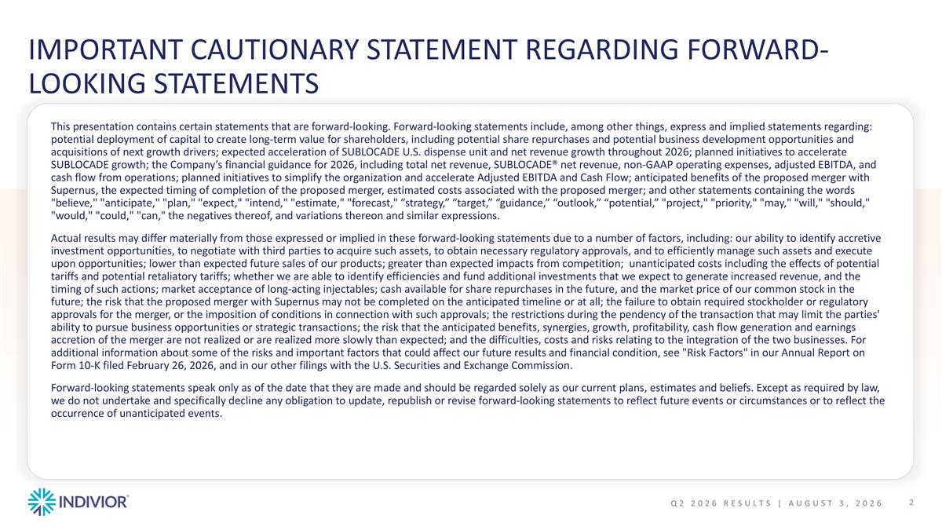
IMPORTANT CAUTIONARY STATEMENT REGARDING FORWARD-LOOKING STATEMENTS Q2 2026 Results | August 3, 2026 This presentation contains certain statements that are forward-looking. Forward-looking statements include, among other things, express and implied statements regarding: potential deployment of capital to create long-term value for shareholders, including potential share repurchases and potential business development opportunities and acquisitions of next growth drivers; expected acceleration of SUBLOCADE U.S. dispense unit and net revenue growth throughout 2026; planned initiatives to accelerate SUBLOCADE growth; the Company’s financial guidance for 2026, including total net revenue, SUBLOCADE® net revenue, non-GAAP operating expenses, adjusted EBITDA, and cash flow from operations; planned initiatives to simplify the organization and accelerate Adjusted EBITDA and Cash Flow; anticipated benefits of the proposed merger with Supernus, the expected timing of completion of the proposed merger, estimated costs associated with the proposed merger; and other statements containing the words "believe," "anticipate," "plan," "expect," "intend," "estimate," "forecast," “strategy,” “target,” “guidance,” “outlook,” “potential,” "project," "priority," "may," "will," "should," "would," "could," "can," the negatives thereof, and variations thereon and similar expressions. Actual results may differ materially from those expressed or implied in these forward-looking statements due to a number of factors, including: our ability to identify accretive investment opportunities, to negotiate with third parties to acquire such assets, to obtain necessary regulatory approvals, and to efficiently manage such assets and execute upon opportunities; lower than expected future sales of our products; greater than expected impacts from competition; unanticipated costs including the effects of potential tariffs and potential retaliatory tariffs; whether we are able to identify efficiencies and fund additional investments that we expect to generate increased revenue, and the timing of such actions; market acceptance of long-acting injectables; cash available for share repurchases in the future, and the market price of our common stock in the future; the risk that the proposed merger with Supernus may not be completed on the anticipated timeline or at all; the failure to obtain required stockholder or regulatory approvals for the merger, or the imposition of conditions in connection with such approvals; the restrictions during the pendency of the transaction that may limit the parties' ability to pursue business opportunities or strategic transactions; the risk that the anticipated benefits, synergies, growth, profitability, cash flow generation and earnings accretion of the merger are not realized or are realized more slowly than expected; and the difficulties, costs and risks relating to the integration of the two businesses. For additional information about some of the risks and important factors that could affect our future results and financial condition, see "Risk Factors" in our Annual Report on Form 10-K filed February 26, 2026, and in our other filings with the U.S. Securities and Exchange Commission. Forward-looking statements speak only as of the date that they are made and should be regarded solely as our current plans, estimates and beliefs. Except as required by law, we do not undertake and specifically decline any obligation to update, republish or revise forward-looking statements to reflect future events or circumstances or to reflect the occurrence of unanticipated events.

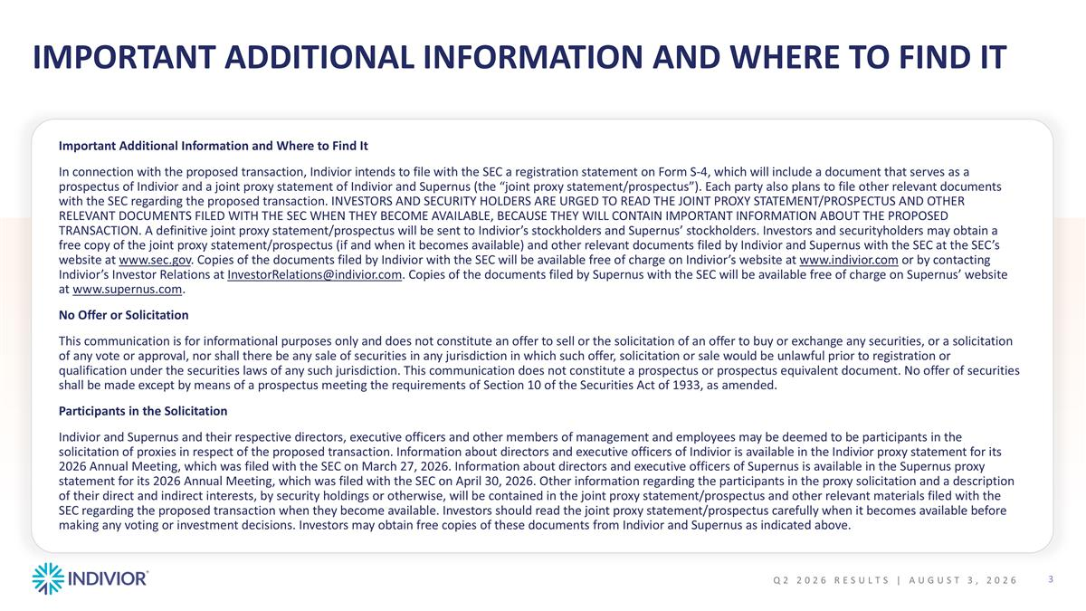
Important Additional Information and Where to Find It Important Additional Information and Where to Find It In connection with the proposed transaction, Indivior intends to file with the SEC a registration statement on Form S-4, which will include a document that serves as a prospectus of Indivior and a joint proxy statement of Indivior and Supernus (the “joint proxy statement/prospectus”). Each party also plans to file other relevant documents with the SEC regarding the proposed transaction. INVESTORS AND SECURITY HOLDERS ARE URGED TO READ THE JOINT PROXY STATEMENT/PROSPECTUS AND OTHER RELEVANT DOCUMENTS FILED WITH THE SEC WHEN THEY BECOME AVAILABLE, BECAUSE THEY WILL CONTAIN IMPORTANT INFORMATION ABOUT THE PROPOSED TRANSACTION. A definitive joint proxy statement/prospectus will be sent to Indivior’s stockholders and Supernus’ stockholders. Investors and securityholders may obtain a free copy of the joint proxy statement/prospectus (if and when it becomes available) and other relevant documents filed by Indivior and Supernus with the SEC at the SEC’s website at www.sec.gov. Copies of the documents filed by Indivior with the SEC will be available free of charge on Indivior’s website at www.indivior.com or by contacting Indivior’s Investor Relations at InvestorRelations@indivior.com. Copies of the documents filed by Supernus with the SEC will be available free of charge on Supernus’ website at www.supernus.com. No Offer or Solicitation This communication is for informational purposes only and does not constitute an offer to sell or the solicitation of an offer to buy or exchange any securities, or a solicitation of any vote or approval, nor shall there be any sale of securities in any jurisdiction in which such offer, solicitation or sale would be unlawful prior to registration or qualification under the securities laws of any such jurisdiction. This communication does not constitute a prospectus or prospectus equivalent document. No offer of securities shall be made except by means of a prospectus meeting the requirements of Section 10 of the Securities Act of 1933, as amended. Participants in the Solicitation Indivior and Supernus and their respective directors, executive officers and other members of management and employees may be deemed to be participants in the solicitation of proxies in respect of the proposed transaction. Information about directors and executive officers of Indivior is available in the Indivior proxy statement for its 2026 Annual Meeting, which was filed with the SEC on March 27, 2026. Information about directors and executive officers of Supernus is available in the Supernus proxy statement for its 2026 Annual Meeting, which was filed with the SEC on April 30, 2026. Other information regarding the participants in the proxy solicitation and a description of their direct and indirect interests, by security holdings or otherwise, will be contained in the joint proxy statement/prospectus and other relevant materials filed with the SEC regarding the proposed transaction when they become available. Investors should read the joint proxy statement/prospectus carefully when it becomes available before making any voting or investment decisions. Investors may obtain free copies of these documents from Indivior and Supernus as indicated above. Q2 2026 Results | August 3, 2026


Execution Against the Indivior Action Agenda

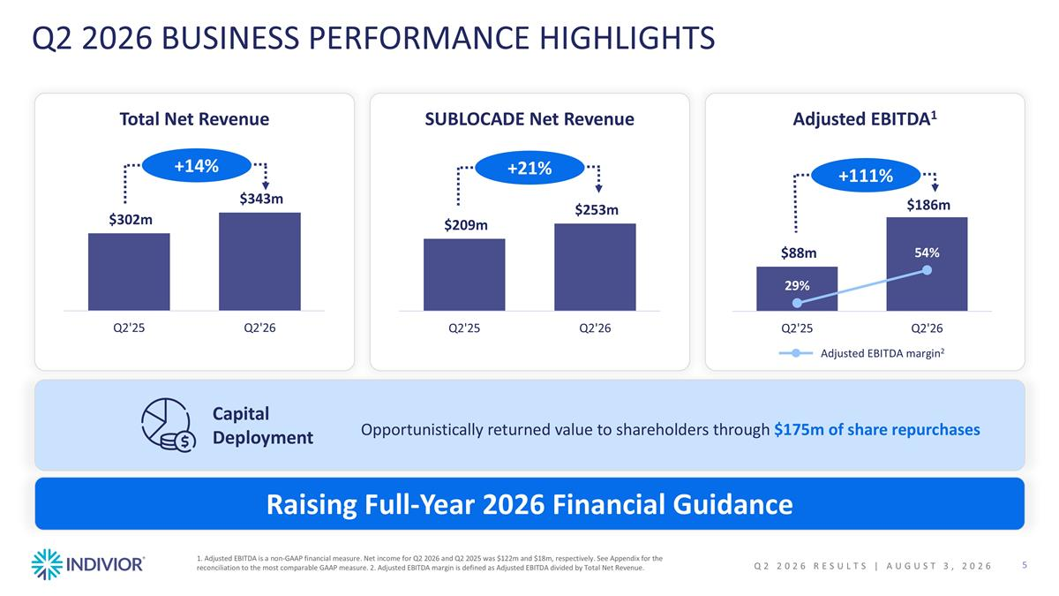
Q2 2026 BUSINESS PERFORMANCE HIGHLIGHTS SUBLOCADE Net Revenue Total Net Revenue Adjusted EBITDA1 Raising Full-Year 2026 Financial Guidance +21% +14% +111% Adjusted EBITDA margin2 1. Adjusted EBITDA is a non-GAAP financial measure. Net income for Q2 2026 and Q2 2025 was $122m and $18m, respectively. See Appendix for the reconciliation to the most comparable GAAP measure. 2. Adjusted EBITDA margin is defined as Adjusted EBITDA divided by Total Net Revenue. Capital Deployment Opportunistically returned value to shareholders through $175m of share repurchases Q2 2026 Results | August 3, 2026

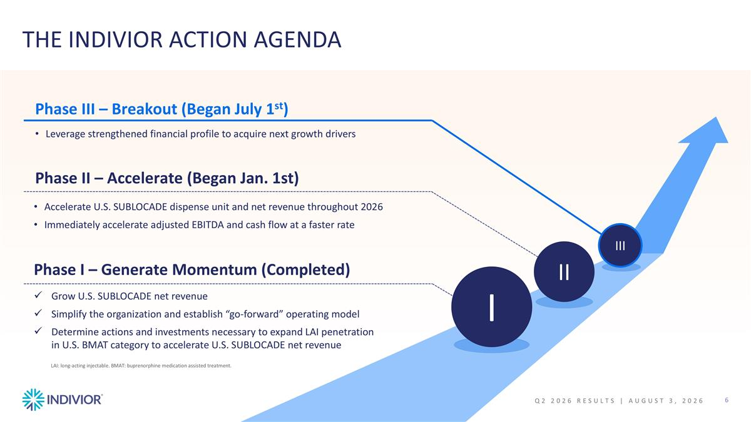
THE INDIVIOR ACTION AGENDA I II III Grow U.S. SUBLOCADE net revenue Simplify the organization and establish “go-forward” operating model Determine actions and investments necessary to expand LAI penetration in U.S. BMAT category to accelerate U.S. SUBLOCADE net revenue Accelerate U.S. SUBLOCADE dispense unit and net revenue throughout 2026 Immediately accelerate adjusted EBITDA and cash flow at a faster rate Phase II – Accelerate (Began Jan. 1st) Leverage strengthened financial profile to acquire next growth drivers Phase III – Breakout (Began July 1st) Phase I – Generate Momentum (Completed) LAI: long-acting injectable. BMAT: buprenorphine medication assisted treatment. Q2 2026 Results | August 3, 2026

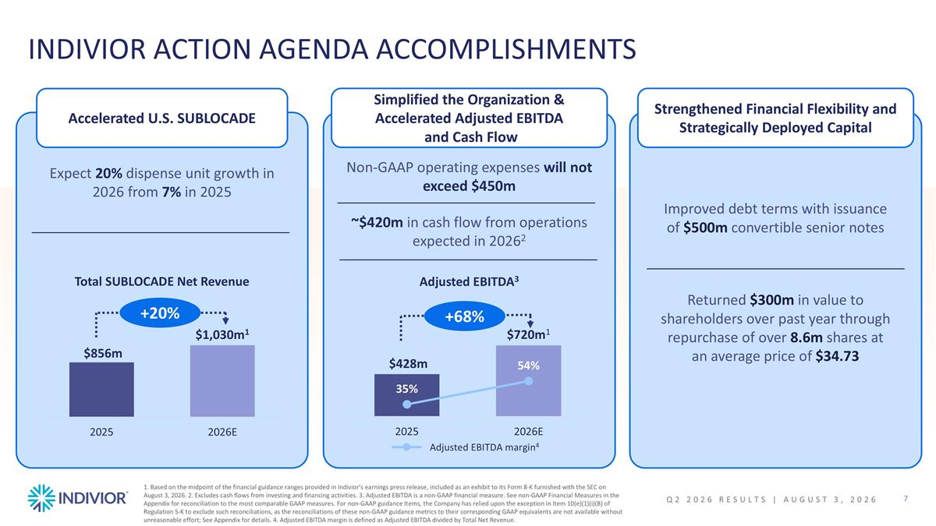
INDIVIOR ACTION AGENDA ACCOMPLISHMENTS Accelerated U.S. SUBLOCADE Non-GAAP operating expenses will not exceed $450m ~$420m in cash flow from operations expected in 20262 Total SUBLOCADE Net Revenue Adjusted EBITDA3 1. Based on the midpoint of the financial guidance ranges provided in Indivior’s earnings press release, included as an exhibit to its Form 8-K furnished with the SEC on August 3, 2026. 2. Excludes cash flows from investing and financing activities. 3. Adjusted EBITDA is a non-GAAP financial measure. See non-GAAP Financial Measures in the Appendix for reconciliation to the most comparable GAAP measures. For non-GAAP guidance Items, the Company has relied upon the exception in Item 10(e)(1)(i)(B) of Regulation S-K to exclude such reconciliations, as the reconciliations of these non-GAAP guidance metrics to their corresponding GAAP equivalents are not available without unreasonable effort; See Appendix for details. 4. Adjusted EBITDA margin is defined as Adjusted EBITDA divided by Total Net Revenue. Simplified the Organization & Accelerated Adjusted EBITDA and Cash Flow Adjusted EBITDA margin4 Expect 20% dispense unit growth in 2026 from 7% in 2025 Improved debt terms with issuance of $500m convertible senior notes Returned $300m in value to shareholders over past year through repurchase of over 8.6m shares at an average price of $34.73 Strengthened Financial Flexibility and Strategically Deployed Capital +20% +68% Q2 2026 Results | August 3, 2026

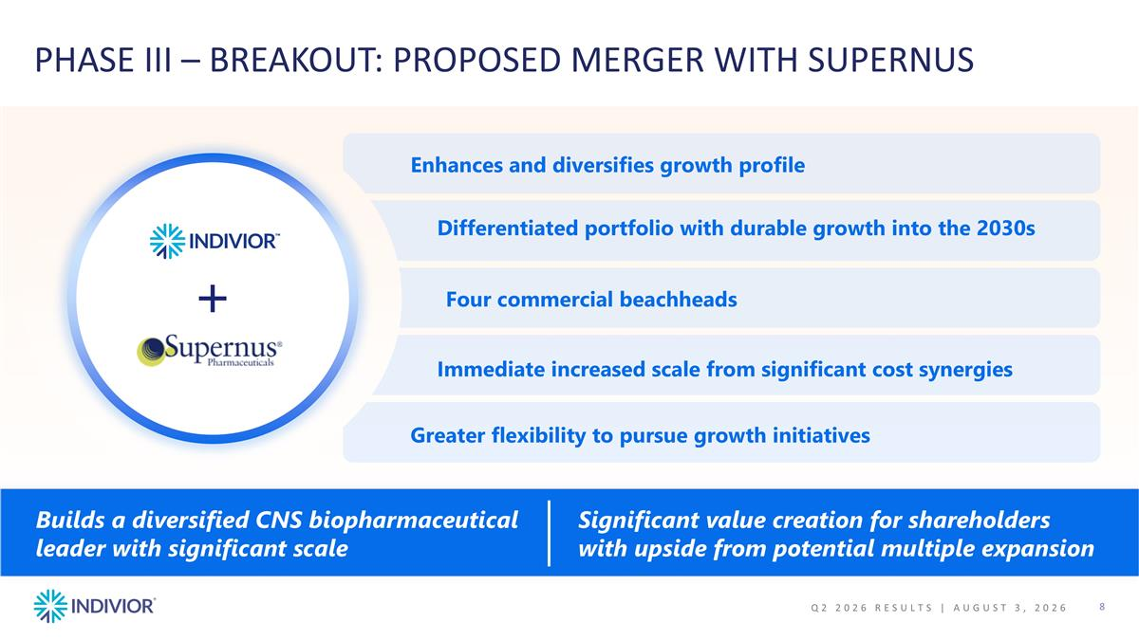
PHASE III – BREAKOUT: PROPOSED MERGER WITH SUPERNUS Enhances and diversifies growth profile Differentiated portfolio with durable growth into the 2030s Four commercial beachheads Immediate increased scale from significant cost synergies Greater flexibility to pursue growth initiatives Significant value creation for shareholders with upside from potential multiple expansion​ Q2 2026 Results | August 3, 2026 Builds a diversified CNS biopharmaceutical leader ​with significant scale​


SUBLOCADE® Commercial Update

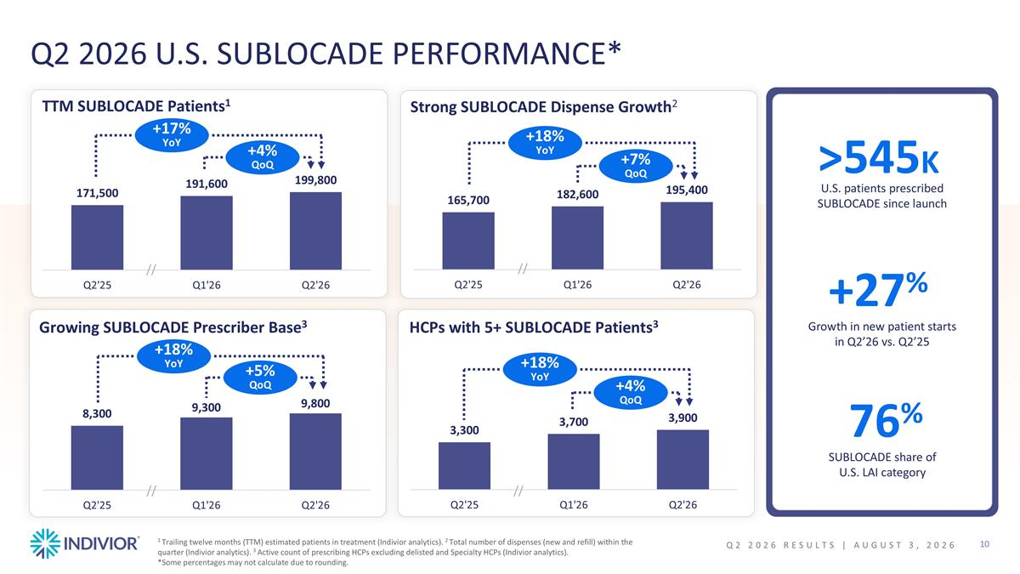
~ Q2 2026 U.S. SUBLOCADE PERFORMANCE* 1 Trailing twelve months (TTM) estimated patients in treatment (Indivior analytics). 2 Total number of dispenses (new and refill) within the quarter (Indivior analytics). 3 Active count of prescribing HCPs excluding delisted and Specialty HCPs (Indivior analytics). *Some percentages may not calculate due to rounding. HCPs with 5+ SUBLOCADE Patients3 Strong SUBLOCADE Dispense Growth2 Growing SUBLOCADE Prescriber Base3 // +18% YoY +7% QoQ +18% YoY +5% QoQ // // +27% Growth in new patient starts in Q2’26 vs. Q2’25 +18% YoY +4% QoQ U.S. patients prescribed SUBLOCADE since launch >545K 76% SUBLOCADE share of U.S. LAI category TTM SUBLOCADE Patients1 // +17% YoY +4% QoQ Q2 2026 Results | August 3, 2026

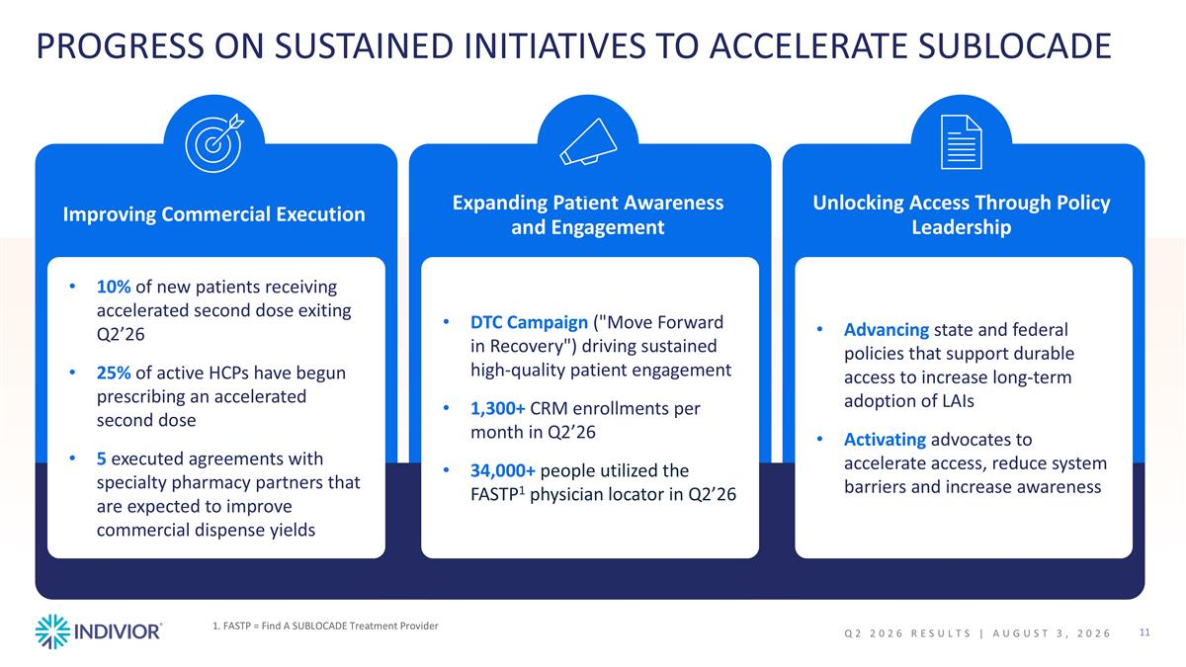
PROGRESS ON SUSTAINED INITIATIVES TO ACCELERATE SUBLOCADE Unlocking Access Through Policy Leadership Advancing state and federal policies that support durable access to increase long-term adoption of LAIs Activating advocates to accelerate access, reduce system barriers and increase awareness Expanding Patient Awareness and Engagement DTC Campaign ("Move Forward in Recovery") driving sustained high-quality patient engagement 1,300+ CRM enrollments per month in Q2’26 34,000+ people utilized the FASTP1 physician locator in Q2’26 Improving Commercial Execution 10% of new patients receiving accelerated second dose exiting Q2’26 25% of active HCPs have begun prescribing an accelerated second dose 5 executed agreements with specialty pharmacy partners that are expected to improve commercial dispense yields 1. FASTP = Find A SUBLOCADE Treatment Provider Q2 2026 Results | August 3, 2026


Q2 2026 Performance & FY 2026 Guidance

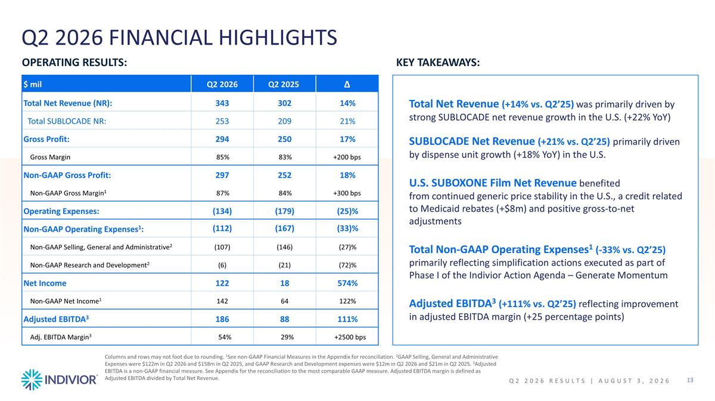
Q2 2026 FINANCIAL HIGHLIGHTS OPERATING RESULTS: KEY TAKEAWAYS: Total Net Revenue (+14% vs. Q2’25) was primarily driven by strong SUBLOCADE net revenue growth in the U.S. (+22% YoY) SUBLOCADE Net Revenue (+21% vs. Q2’25) primarily driven by dispense unit growth (+18% YoY) in the U.S. U.S. SUBOXONE Film Net Revenue benefited from continued generic price stability in the U.S., a credit related to Medicaid rebates (+$8m) and positive gross-to-net adjustments Total Non-GAAP Operating Expenses1 (-33% vs. Q2’25) primarily reflecting simplification actions executed as part of Phase I of the Indivior Action Agenda – Generate Momentum Adjusted EBITDA3 (+111% vs. Q2’25) reflecting improvement in adjusted EBITDA margin (+25 percentage points) Columns and rows may not foot due to rounding. 1See non-GAAP Financial Measures in the Appendix for reconciliation. 2GAAP Selling, General and Administrative Expenses were $122m in Q2 2026 and $158m in Q2 2025, and GAAP Research and Development expenses were $12m in Q2 2026 and $21m in Q2 2025. 3Adjusted EBITDA is a non-GAAP financial measure. See Appendix for the reconciliation to the most comparable GAAP measure. Adjusted EBITDA margin is defined as Adjusted EBITDA divided by Total Net Revenue. $ mil Q2 2026 Q2 2025 Δ Total Net Revenue (NR): 343 302 14% Total SUBLOCADE NR: 253 209 21% Gross Profit: 294 250 17% Gross Margin 85% 83% +200 bps Non-GAAP Gross Profit: 297 252 18% Non-GAAP Gross Margin1 87% 84% +300 bps Operating Expenses: (134) (179) (25)% Non-GAAP Operating Expenses1: (112) (167) (33)% Non-GAAP Selling, General and Administrative2 (107) (146) (27)% Non-GAAP Research and Development2 (6) (21) (72)% Net Income 122 18 574% Non-GAAP Net Income1 142 64 122% Adjusted EBITDA3 186 88 111% Adj. EBITDA Margin3 54% 29% +2500 bps Q2 2026 Results | August 3, 2026

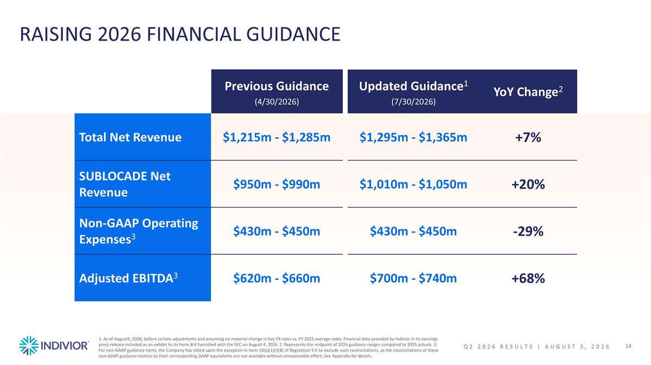
RAISING 2026 FINANCIAL GUIDANCE Previous Guidance (4/30/2026) Updated Guidance1 (7/30/2026) YoY Change2 Total Net Revenue $1,215m - $1,285m $1,295m - $1,365m +7% SUBLOCADE Net Revenue $950m - $990m $1,010m - $1,050m +20% Non-GAAP Operating Expenses3 $430m - $450m $430m - $450m -29% Adjusted EBITDA3 $620m - $660m $700m - $740m +68% 1. As of August3, 2026, before certain adjustments and assuming no material change in key FX rates vs. FY 2025 average rates. Financial data provided by Indivior in its earnings press release included as an exhibit to its Form 8-K furnished with the SEC on August 4, 2026. 2. Represents the midpoint of 2026 guidance ranges compared to 2025 actuals. 3. For non-GAAP guidance items, the Company has relied upon the exception in Item 10(e)(1)(i)(B) of Regulation S-K to exclude such reconciliations, as the reconciliations of these non-GAAP guidance metrics to their corresponding GAAP equivalents are not available without unreasonable effort; See Appendix for details. Q2 2026 Results | August 3, 2026

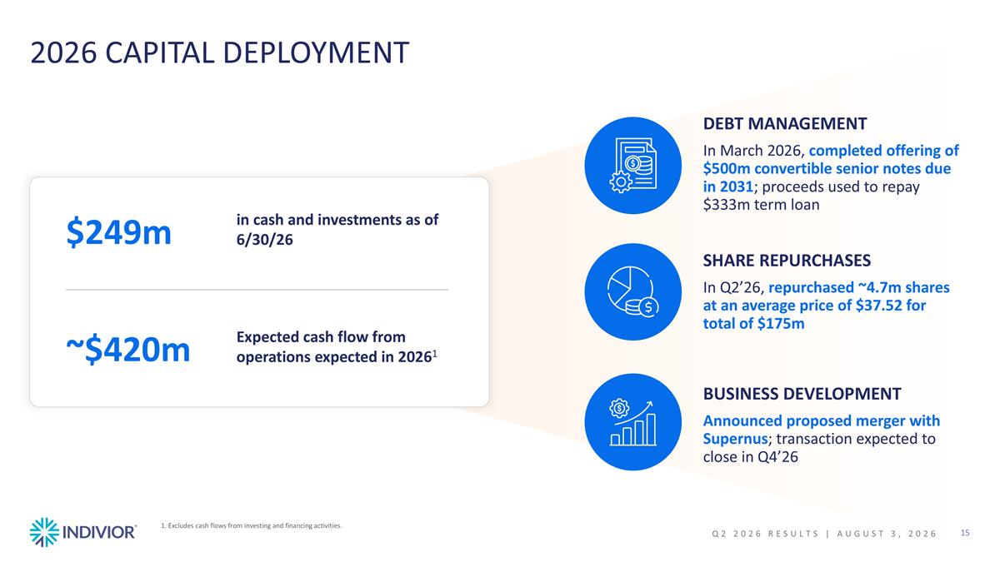
2026 CAPITAL DEPLOYMENT $249m in cash and investments as of 6/30/26 ~$420m Expected cash flow from operations expected in 20261 DEBT MANAGEMENT In March 2026, completed offering of $500m convertible senior notes due in 2031; proceeds used to repay $333m term loan SHARE REPURCHASES In Q2’26, repurchased ~4.7m shares at an average price of $37.52 for total of $175m BUSINESS DEVELOPMENT Announced proposed merger with Supernus; transaction expected to close in Q4’26 1. Excludes cash flows from investing and financing activities. Q2 2026 Results | August 3, 2026


Conclusion

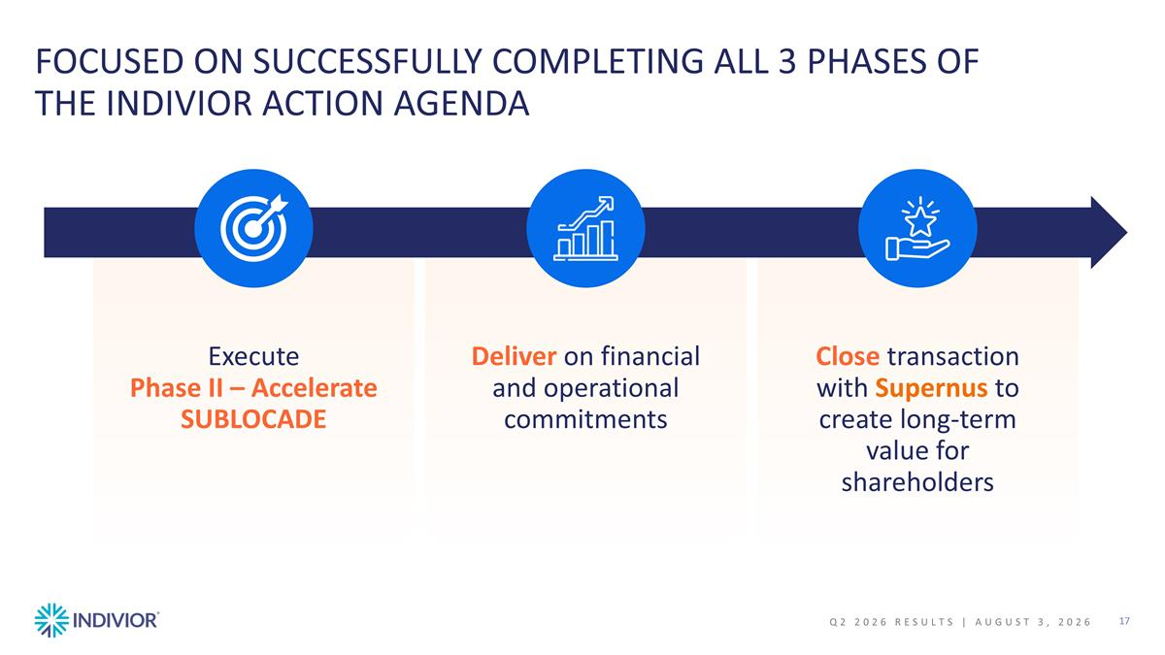
FOCUSED ON SUCCESSFULLY COMPLETING ALL 3 PHASES OF THE INDIVIOR ACTION AGENDA Deliver on financial and operational commitments Close transaction with Supernus to create long-term value for shareholders Execute Phase II – Accelerate SUBLOCADE Q2 2026 Results | August 3, 2026


Appendix

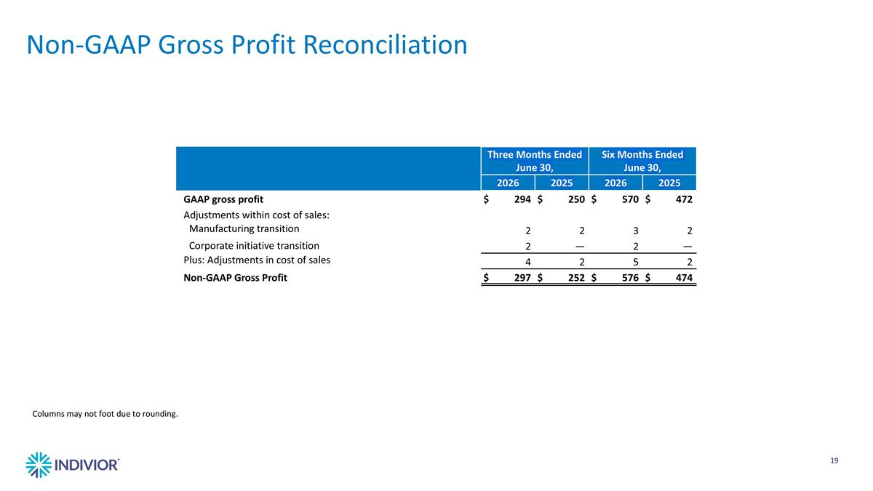
Non-GAAP Gross Profit Reconciliation Three Months Ended June 30, Six Months Ended June 30, 2026 2025 2026 2025 GAAP gross profit $294 $250 $570 $472 Adjustments within cost of sales: Manufacturing transition 2 2 3 2 Corporate initiative transition 2 — 2 — Plus: Adjustments in cost of sales 4 2 5 2 Non-GAAP Gross Profit $297 $252 $576 $474 Columns may not foot due to rounding.

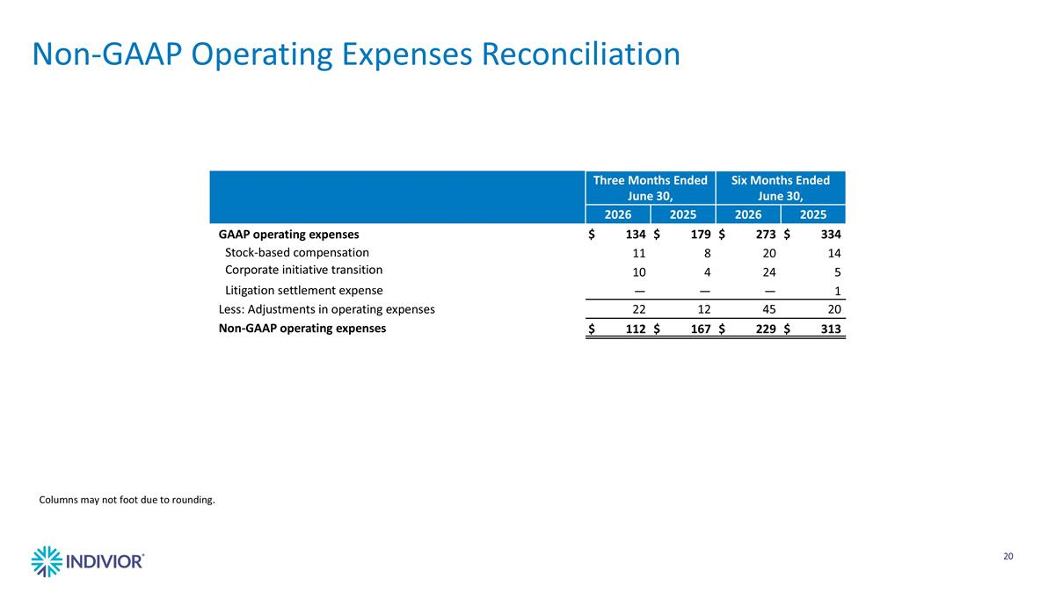
Three Months Ended June 30, Six Months Ended June 30, 2026 2025 2026 2025 GAAP operating expenses $134 $179 $273 $334 Stock-based compensation 11 8 20 14 Corporate initiative transition 10 4 24 5 Litigation settlement expense — — — 1 Less: Adjustments in operating expenses 22 12 45 20 Non-GAAP operating expenses $112 $167 $229 $313 Columns may not foot due to rounding. Non-GAAP Operating Expenses Reconciliation

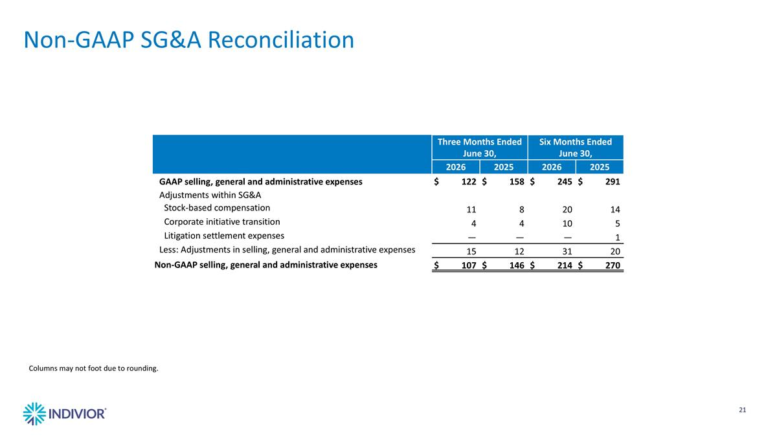
Three Months Ended June 30, Six Months Ended June 30, 2026 2025 2026 2025 GAAP selling, general and administrative expenses $122 $158 $245 $291 Adjustments within SG&A Stock-based compensation 11 8 20 14 Corporate initiative transition 4 4 10 5 Litigation settlement expenses — — — 1 Less: Adjustments in selling, general and administrative expenses 15 12 31 20 Non-GAAP selling, general and administrative expenses $107 $146 $214 $270 Columns may not foot due to rounding. Non-GAAP SG&A Reconciliation

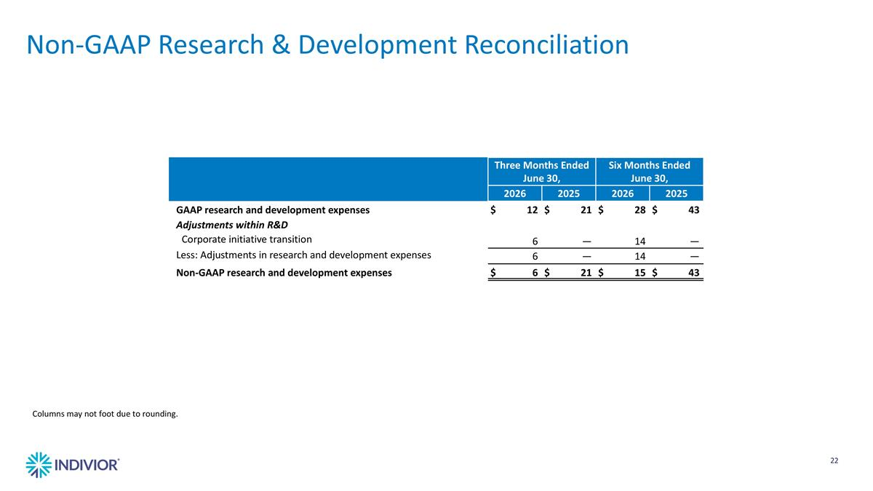
Three Months Ended June 30, Six Months Ended June 30, 2026 2025 2026 2025 GAAP research and development expenses $12 $21 $28 $43 Adjustments within R&D Corporate initiative transition 6 — 14 — Less: Adjustments in research and development expenses 6 — 14 — Non-GAAP research and development expenses $6 $21 $15 $43 Columns may not foot due to rounding. Non-GAAP Research & Development Reconciliation

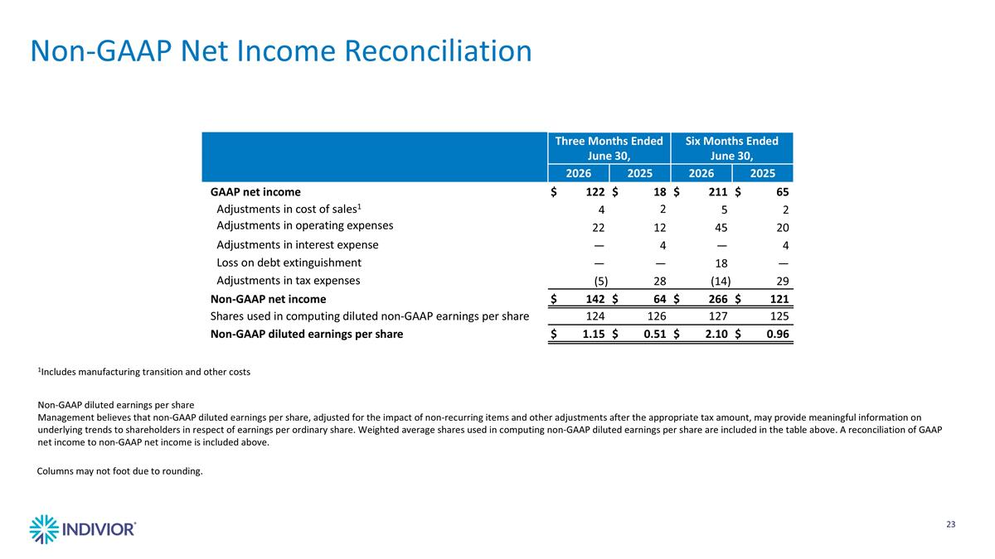
Three Months Ended June 30, Six Months Ended June 30, 2026 2025 2026 2025 GAAP net income $122 $18 $211 $65 Adjustments in cost of sales1 4 2 5 2 Adjustments in operating expenses 22 12 45 20 Adjustments in interest expense — 4 — 4 Loss on debt extinguishment — — 18 — Adjustments in tax expenses (5) 28 (14) 29 Non-GAAP net income $142 $64 $266 $121 Shares used in computing diluted non-GAAP earnings per share 124 126 127 125 Non-GAAP diluted earnings per share $1.15 $0.51 $2.10 $0.96 1Includes manufacturing transition and other costs Non-GAAP diluted earnings per share Management believes that non-GAAP diluted earnings per share, adjusted for the impact of non-recurring items and other adjustments after the appropriate tax amount, may provide meaningful information on underlying trends to shareholders in respect of earnings per ordinary share. Weighted average shares used in computing non-GAAP diluted earnings per share are included in the table above. A reconciliation of GAAP net income to non-GAAP net income is included above. Columns may not foot due to rounding. Non-GAAP Net Income Reconciliation

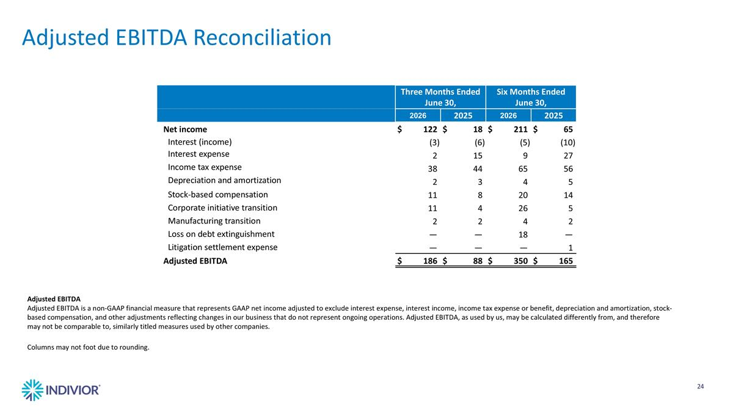
Three Months Ended June 30, Six Months Ended June 30, 2026 2025 2026 2025 Net income $122 $18 $211 $65 Interest (income) (3) (6) (5) (10) Interest expense 2 15 9 27 Income tax expense 38 44 65 56 Depreciation and amortization 2 3 4 5 Stock-based compensation 11 8 20 14 Corporate initiative transition 11 4 26 5 Manufacturing transition 2 2 4 2 Loss on debt extinguishment — — 18 — Litigation settlement expense — — — 1 Adjusted EBITDA $186 $88 $350 $165 Adjusted EBITDA Adjusted EBITDA is a non-GAAP financial measure that represents GAAP net income adjusted to exclude interest expense, interest income, income tax expense or benefit, depreciation and amortization, stock-based compensation, and other adjustments reflecting changes in our business that do not represent ongoing operations. Adjusted EBITDA, as used by us, may be calculated differently from, and therefore may not be comparable to, similarly titled measures used by other companies. Columns may not foot due to rounding. Adjusted EBITDA Reconciliation

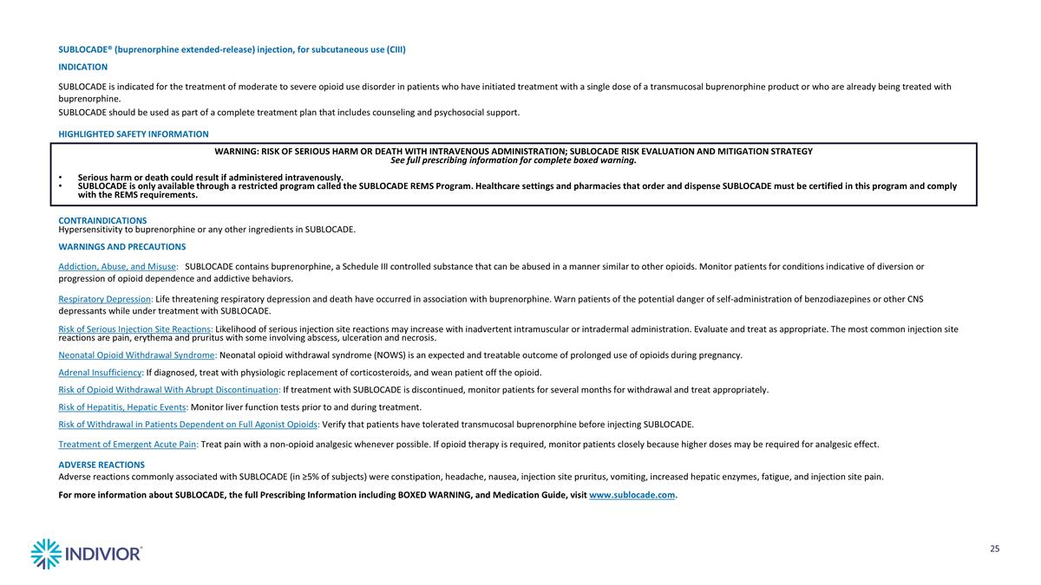
SUBLOCADE® (buprenorphine extended-release) injection, for subcutaneous use (CIII) INDICATION SUBLOCADE is indicated for the treatment of moderate to severe opioid use disorder in patients who have initiated treatment with a single dose of a transmucosal buprenorphine product or who are already being treated with buprenorphine. SUBLOCADE should be used as part of a complete treatment plan that includes counseling and psychosocial support. HIGHLIGHTED SAFETY INFORMATION WARNING: RISK OF SERIOUS HARM OR DEATH WITH INTRAVENOUS ADMINISTRATION; SUBLOCADE RISK EVALUATION AND MITIGATION STRATEGY See full prescribing information for complete boxed warning. Serious harm or death could result if administered intravenously. SUBLOCADE is only available through a restricted program called the SUBLOCADE REMS Program. Healthcare settings and pharmacies that order and dispense SUBLOCADE must be certified in this program and comply with the REMS requirements. CONTRAINDICATIONS Hypersensitivity to buprenorphine or any other ingredients in SUBLOCADE. WARNINGS AND PRECAUTIONS Addiction, Abuse, and Misuse: SUBLOCADE contains buprenorphine, a Schedule III controlled substance that can be abused in a manner similar to other opioids. Monitor patients for conditions indicative of diversion or progression of opioid dependence and addictive behaviors. Respiratory Depression: Life threatening respiratory depression and death have occurred in association with buprenorphine. Warn patients of the potential danger of self-administration of benzodiazepines or other CNS depressants while under treatment with SUBLOCADE. Risk of Serious Injection Site Reactions: Likelihood of serious injection site reactions may increase with inadvertent intramuscular or intradermal administration. Evaluate and treat as appropriate. The most common injection site reactions are pain, erythema and pruritus with some involving abscess, ulceration and necrosis. Neonatal Opioid Withdrawal Syndrome: Neonatal opioid withdrawal syndrome (NOWS) is an expected and treatable outcome of prolonged use of opioids during pregnancy. Adrenal Insufficiency: If diagnosed, treat with physiologic replacement of corticosteroids, and wean patient off the opioid. Risk of Opioid Withdrawal With Abrupt Discontinuation: If treatment with SUBLOCADE is discontinued, monitor patients for several months for withdrawal and treat appropriately. Risk of Hepatitis, Hepatic Events: Monitor liver function tests prior to and during treatment. Risk of Withdrawal in Patients Dependent on Full Agonist Opioids: Verify that patients have tolerated transmucosal buprenorphine before injecting SUBLOCADE. Treatment of Emergent Acute Pain: Treat pain with a non-opioid analgesic whenever possible. If opioid therapy is required, monitor patients closely because higher doses may be required for analgesic effect. ADVERSE REACTIONS Adverse reactions commonly associated with SUBLOCADE (in ≥5% of subjects) were constipation, headache, nausea, injection site pruritus, vomiting, increased hepatic enzymes, fatigue, and injection site pain. For more information about SUBLOCADE, the full Prescribing Information including BOXED WARNING, and Medication Guide, visit www.sublocade.com.

